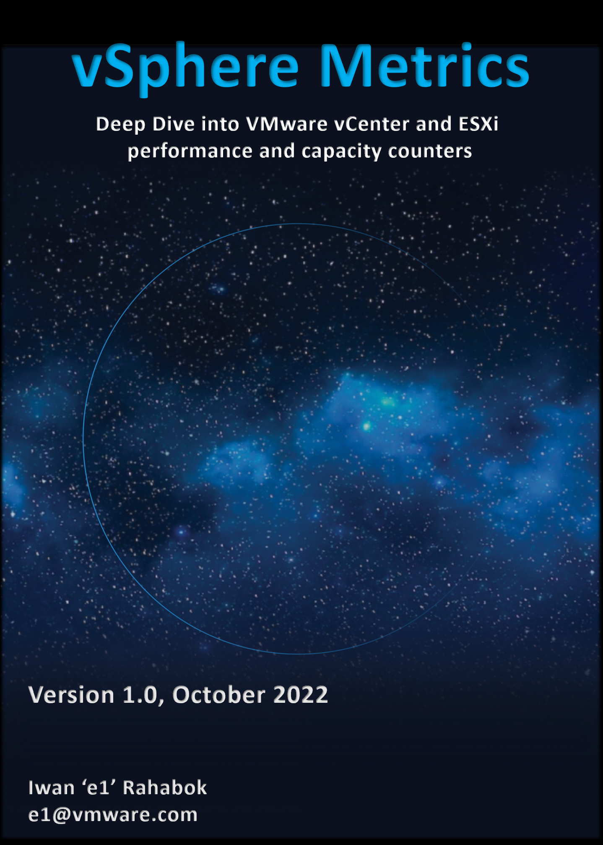



*The book is dedicated to the loving memory of Mama and Papa…   
for your love and sacrifice in raising me in the old town of* [*Surabaya*](https://www.youtube.com/watch?v=5KNb8r5mqNg)*.*

Preface

Metric is essentially an accounting of systems in operation. To understand the counter hence requires a knowledge of how the system works. Without internalizing the mechanics, you will have to rely on memorizing. In my case, memorizing is only good for exam. So grab a cup of your favourite drink, and do take time to truly understand the reasons behind the metrics. You will appreciate the threshold better when you know how it was calculated.

There is so much theory can cover, as there are just too many permutations of how things can go wrong in production. Spend time doing actual troubleshooting to complement the theoretical knowledge. The book has numorous examples of real-life troubleshooting.

To keep the book size manageable, I do not include all metrics. To see the full list, see VMware Operations Transformation, 4th Edition.

The book is a living document, so it will get regular updates over time. You will find the update at [VMware Ops Guide](https://www.vmwareopsguide.com/) website by [Stellios Williams](https://www.linkedin.com/in/stellios-williams/).

The book is not a product book. It does not cover how to use esxtop. There are better documentations on that already 😊

**Consumption:** The book is designed to be consumed in as local Microsoft Word file, not web-based Office 365. So download it, then open the side **Navigation** of Microsoft Word. Use the navigation as a dynamic table of content, else it’s easy to be lost in the pages even when using 43” monitor.

**Acknowledgement:** a technical book like this took a lot of contribution from many people. I’m indebted to the advice and help from folks like Kalin Tsvetkov, Valentin Bondzio, Branislav Abadzhimarinov, Prabira Acharya, Paul James, Stellios Williams, Brandon Gordon, George Stephen Manuel, Sandeep Byreddy, Gayane Ohanyan, Hakob Arakelyan, Ming Hua Zhou and and many others.

Chapter 1

# Overview

## Why Metrics are Complex?

vSphere and vSAN counters are more complex than physical machine counters because there are many components as well as inconsistencies that are caused by virtualization. When virtualized, the 4 elements of infrastructure (CPU, RAM, Disk, Network) behave *differently*.

The complexity created by a new layer because it impacts the adjacent layers below and above it. So the net effect is you need to learn 3 layers. That’s why from a monitoring and troubleshooting viewpoint, Kubernetes and [container](https://en.wikipedia.org/wiki/OS-level_virtualization) technology require an even deeper knowledge as the boundary is even less strict. Think of all the [problems](https://www.settlersoman.com/ftf-012-resource-pools-in-practice/) you have with vSphere Resource Pool performance troubleshooting, and now make it granular at process level.

I find it useful to know the subtle differences in the behaviour of the metrics and properties. By knowing their difference, you can apply the appropriate solution.

### Nuances in Name

|  |  |
| --- | --- |
| **Same name, same object, different formula** | The counters have the same name, belong to the same object, yet they have a different formula depending on where in the object you measure it.  Example: VM CPU Used in vCPU level does not include System time but at the VM level it does. The reason is that System time does not exist at vCPU level since the accounting is charged at the VM level. |
| **Same name, different formula** | Counters with the same name do not always have the same formula in different vSphere objects.  Memory Usage: in VM this is mapped to Active, while in ESXi Host this is mapped to Consumed. In Cluster, this is Consumed + Overhead. [1] vRealize Operations uses Guest OS data for Usage, and falls back to Active if it’s not available.  Memory Consumed: in ESXi this includes memory consumed by ESXi, while in Cluster it only includes memory consumed by VM.  Memory Consumed: in VM this does not include overhead, while in Cluster it does.  VM Used includes Hyper Threading but penalty is 37.5%. ESXi Used is also aware of HT but the penalty is 50%.  Steal Time in Linux only includes CPU Ready, while Stolen time in VM include many other factors including CPU frequency. |
| **Same name, different meaning** | Counters with the same name, yet different meaning. Be careful as you may misinterpret them.  VM CPU Usage (%) shows 62.5% when ESXi CPU Usage (%) shows 100%. This happens since VM CPU Usage considers Hyper Threading, while ESXi CPU Usage does not. It happens when the ESXi core that the VM vCPU runs is also running another thread.  Another example is Latency. Disk Latency and Memory Latency indicate a performance problem. They are in fact the primary counter for how well the VM is being served by the underlying IaaS. But CPU Latency does not *always* indicate a performance problem. Its value is affected by Hyper-Threading and CPU Frequency, which can go up or down. Sure, the VM is running at a higher or lower CPU speed, or run less efficiently, but it is not waiting to be served. It’s the equivalent on running on older CPU. |
| **Same name, different behaviour** | Memory and CPU Reservations have different behaviors from monitoring viewpoint.  VM RAM Reservation is permanent, hence impacts memory utilization. The Memory Consumed counter includes it even though the page is not actually consumed yet. If you power on a 16 GB RAM VM into a BIOS state, and it has 10 GB Memory Reservation, the VM Consumed memory counter will jump to 10 GB. It has not actually consumed the 10 GB, but since ESXi has reserved the space, it is not available to other VMs.  VM CPU Reservation is on demand, hence it does not impact CPU utilization. Run, Used, Demand, Usage do not include it. Their value will be 0 or near 0 if the Guest OS is not running.  In Microsoft Windows, the CPU queue includes only counts the queue size, while the disk queue excludes the IO commands being processed. |
| **Same purpose, different name** | You would expect if the purpose is identical then the label or name would be identical.  Swapped Memory in VM is called Swapped, while in ESXi is called Swap Used.  Static frequency CPU utilization in VM is called Run, while ESXi calls it Utilization.  What vCenter calls Logical Processor (in the client UI) is what ESXi calls Physical CPU (in esxtop panel)  vCenter uses Consumed (%) and Usage (%) for the same ESXi CPU utilization. |
| **Confusing name** | The name of the counter may not be clear.  VM CPU Wait counter includes Idle time. Since many VMs do not run at 100%, you will see CPU Wait counter to be high. You may think it’s waiting for something (e.g. Disk or Memory) but it’s just idle. If we see from the viewpoint of VMkernel schedule, that vCPU is waiting to be used. So the name is technically correct.  The term virtual disk actually includes RDM. It’s not just VMDK. The reason is RDM appears as virtual disk when you browse the directory in the datastore, even though the RDM file is just a pointer to an external LUN. |
| **Confusing formula** | ESXi CPU Idle (ms) includes CPU Frequency. |
| **Inconsistent implementation** | There is reservation for CPU, memory and network, but not for Disk.  There is limit for disk IOPS, but not for disk throughput. |

### Other Nuances

Beside the confusion in names, there are other nuances. The following tables shows some of them:

|  |  |
| --- | --- |
| **Confusing roll up** | Why is VM CPU Ready above 100%? If you look at esxtop, many VM level counters are >100%.  vCenter measures every 20000 ms, but the maximum value for a completely idle thread is 10000. The reason is 20000 is the value set at the core level. Since a core has 2 threads when HT enabled, each was allocated 10000. |
| **Confusing unit** | Why are CPU counters expressed in milliseconds instead of percentage or GHz? How can a time counter (milliseconds in this case) account for CPU Frequency? There is a good reason for that!  Is 1 Giga = 1000 Mega or 1024 Mega?  Esxtop and vSphere Client use different units for the same metric. For example, esxtop use megabit while vCenter UI use kilobyte for networking counter. |
| **“Missing” Counters** | You will find VM CPU Demand, but not VM Memory Demand. Demand does not apply to memory as it’s a form of storage, just as there is no such thing as a Demand metric for your laptop disk space. |
| **Too many choices** | When you have two watches showing different time, you becomes unsure which watch is the correct one.  There are five counters for VM CPU “utilization”: Run, Used, Usage, Usage in MHz, and Demand. Why so many counters just to track utilization, different to what Windows or Linux tracks?  There are 6 counters for ESXi CPU “utilization”: Core Utilization, Utilization, Used, Usage, Usage in MHz, and Demand.  You must remember that the counters are not just created for vSphere administrators. They are also used by the VMkernel scheduler itself as input. CPU Latency is one such counter. |

And lastly, beyond metrics there are also further complications such as:

|  |  |
| --- | --- |
| **VM vs ESXi** | The CPU metrics from a VM viewpoint differs to the CPU metrics from ESXi viewpoint. A VM is a consumer. Multiple VMs can share the same physical core, albeit at the price of performance. So counters such as Ready does not apply to ESXi. The core and the thread are always ready. |
| **ESXi vs vCenter** | While ESXi is the source of counters, vCenter may add its own counters and the formula don’t always match 100% in all scenarios, such as Used vs Usage.  ESXi provides Run (ms), Used (ms), Demand (MHz) for VM CPU. vCenter adds Usage (MHz) and Usage (%), which create confusion as there are now 5 choices.  ESXi shows Used (%), while vCenter shows Used (ms). The first one affected by CPU frequency and can go beyond 100%. |
| **ESXi ≠ VMs + VMkernel** | The counters at ESXi is more complex than the sum of its VM + VMkernel. The reason is there are additional parameters that must be taken into account. For example, the impact of CPU SMP (or Hyper Threading as Intel calls it) is not measured at the VM level. Be careful when summing VM counters and assume it’s ESXi counter. |
| M:N relationship | A VM with multiple virtual disks can span across multiple datastores, and even RDMs. On the other hand, a datastore typically hosts many VMs. An ESXi may mount multiple LUNs and a LUN is typically presented into multiple ESXi or even multiple clusters. These many to many relationships make the counters across VM, datastore, ESXi and Cluster inconsistent when viewed overall. Each of them is correct as each has to look from their own vantage point. |
| Windows vs Linux | Windows CPU queue excludes the running thread, Linux includes the threads being executed.  Windows memory metrics are different to Linux memory metrics. |
| vRealize vs “Source” | As far as possible, vRealize Operations shows the raw counters as what you see them in the source (e.g. vCenter, vSAN, NSX, Windows). This prevents confusion. This is not 100% possible. For example, we do not reproduce the %VMWait counter of esxtop. We have another counter called Other Wait instead. |

Complicated stuff, isn’t it?

Not all vSphere-specific characteristics are well understood by management tools that are not purpose-built for it. Partial understanding can lead to misunderstanding as wrong interpretation of counters can result in wrong action taken.

There is also a scalability concern. In vCenter, there are 17 CPU counters available at the VM level, and 12 of them are available at a vCPU level too. In addition, each VM comes with 28 memory counters. That means a VM with 4 vCPUs will have 93 counters (17 + 4 x 12 + 28). A vSphere environment with 1,000 VMs with 4 vCPUs as the average VM size will have process 93K counters each time it collects. If you do that every minute, you will collect almost 134 million metrics per day. Since many customers like to keep for at least 6 months, that’s 24+ billion metrics!

With so many metrics, the amount of business value received becomes a valid concern.

vRealize Operations does not *regurgitate* the counters that vCenter has. It starts by understanding the unique behaviour of vSphere, then simplifying it by consolidating and standardizing the counters. For example, vRealize Operations creates derived counters such as KPI and capacity metrics, then applies them to CPU, RAM, disk, and network as appropriate.

### Virtualization Nuances

Guest OS and VM are 2 closely related but different entities. They are adjacent layers in SDDC stacks. The two layers are distinct, each provide unique visibility that the other layer may not be able to give. Resource consumed by Guest OS is not the same as resource consumed by the underlying VM. Other factors such as power management and CPU SMT also contribute to the differences.

They are even the same type of object, even though they are often used interchangeably (due to their 1:1 mapping). For example, you generally do not talk about these types of system-level metrics in VM:

* Processes
* Threads
* System Calls/sec

The reason these OS-level metrics are not relevant is because a VM is not an OS. It’s just a collection of processes, technically speaking.

The following diagram uses *the English words* demand and usage to explain the concept, where demand consists of usage and unmet demand. It does not mean the demand and usage counters in vSphere and vRealize Operations, meaning don’t assume these counters actually mean this. They were created for a different purpose.



I tried adding application into the above diagram, but that complicated the whole picture that I removed it. So just take note that some applications such as Java VM and database manage their own resources. Another virtualization layer such as Container certainly takes the complexity to another level.

We can see from the above that area A is not visible to the hypervisor.

|  |  |
| --- | --- |
| **Layer A** | Queue inside the Guest OS (CPU Run Queue, RAM Page File, Disk Queue Length, Driver Queue, network card ring buffer). These queues are not visible to the underlying hypervisor as they have not been sent down to the kernel. For example, if Oracle sends IO requests to Windows, and Windows storage subsystem is full, it won’t send this IO to the hypervisor. As a result, the disk IOPS counter at VM level will under report as it has not received this IO request yet. |
| **Layer B** | What the Guest actually uses. This is visible to the hypervisor as a VM is basically a multi-process application. The Guest OS CPU utilization somehow translates into VM CPU Run. I added the word somehow as the two counters are calculated independently of each other, and likely taken at different sampling time and roll up technique. |
| **Layer C** | Hypervisor overhead (CPU System, CPU MKS, CPU VMX, RAM Overhead, Disk Snapshot). This overhead is obviously not visible to the Guest OS. You can get some visibility by installing Tools, as it will add new counters into Windows/Linux. Tools do not modify existing Windows/Linux counters, meaning they are still unaware of virtualization.  From VMkernel viewpoint, a VM is group of processes or user worlds that run in the VMkernel. There are 3 main types of groups:   * VM Executable (VMX) process is responsible for handling I/O to devices that are not critical to performance. The VMX is also responsible for communicating with user interfaces, snapshot managers, and remote console. * VM Monitor (VMM) process is responsible for virtualizing the guest OS instructions, and manages memory mapping. The VMM passes storage and network I/O requests to the VMkernel, and passes all other requests to the VMX process. There is a VMM for each virtual CPU assigned to a VM. * Mouse Keyboard Screen (MKS) process is responsible for rendering the guest video and handling guest OS user input. When you console into the VM via vCenter client, the work done is charged to this process. This in turn is charged to the VM, and not specific vCPU.   If you want to see example of errors in the above process, review [this KB article](https://kb.vmware.com/s/article/1019471). |
| **Layer D** | Unmet Demand (CPU Ready, CPU Co-Stop, CPU Overlap, CPU VM Wait, RAM Contention, VM Outstanding IO).  The Guest OS experiences a frozen time or slowness. It’s unaware what it is, meaning it can’t account for it. |

I’ve covered the difference in simple terms, and do not do justice to the full difference. If you want to read a scientific paper, I recommend [this paper](https://link.springer.com/chapter/10.1007%2F978-3-642-29737-3_26) by Benjamin Serebrin and [Daniel Hecht](https://dblp.org/pid/73/11144.html).

As we cover the CPU, Memory, Disk, Network metrics in their respective sections later in the book, we will explain the differences in more detail. The following table summarizes the mapping. I’ve only listed the primary metrics as it’s obvious VM and Guest OS do not map.

|  |  |  |  |
| --- | --- | --- | --- |
| Category | Type | Guest OS Metric | VM Equivalent |
| CPU | Contention | Run Queue | --- |
| Context Switch | --- |
| Utilization | Usage | Run if Usage is not aware of CPU Frequency.  Used – Overlap, but disable HT as Guest unaware |
| Memory | Contention | Paging | --- |
| Utilization | In Use | --- |
| Cache | --- |
| Free | --- |
| Disk | Contention | OS Queue | --- |
| Driver Queue | --- |
| Utilization | IOPS | They should match with the metrics at VM level. If not, there is something wrong. |
| Throughput |
| Network | Contention | Dropped Packet | None, as the dropped packet at VM is a different level. |
| Utilization | Throughput | They should match with the metrics at VM level. If not, there is dropped packets. |
| Packet/second |

As you can see, there is limited mapping as Guest OS and VM are fundamentally different objects. This means, if we create a table listing VM objects, you will not find mapping to the Guest OS either.

## Types of Metrics

Most raw metrics can be categorized into 3 types[2]:

|  |  |
| --- | --- |
| **Contention** | They measure something bad. They can be further divide by their impact   * Performance. Counters such as contention, latency, and queue, impact the performance of the system. The system is not down, meaning nothing is dropped, but the overall throughput is reduced. * Availability. Counters such as errors and dropped impact the availability. Most system can recover from soft errors by re-attempting the operations (e.g. retransmit the dropped packet, recalculate the cache, resend the SCSI command). There is lack of observability for such automatic-recovery, and the even the logs may not reveal. For additional reading, I recommend this article by [Brendan Gregg](https://www.linkedin.com/in/brendangregg/). |
| **Consumption** | They measure something good (e.g. utilization, consumption, allocation, reservation). A high number is good for the business, if the load is useful (e.g. not a DDOS attack).  Consumption, better known as utilization, is a family of metrics. It comes in many different names (IOPS, throughput, usage, demand, active, consumed, etc.). Utilization is the main input for the capacity family of counters (Capacity Remaining, Time Remaining, VM Remaining, Recommended Size).  Most administrators look at utilization, because they fear something wrong will happen if it’s high. That “something” is contention. Contention manifests in different forms. It can be queue, latency, loss, dropped, aborted, context switch. |
| **Context** | They account for something (e.g. inventory, configuration) and provide context.  The context is obviously only useful to someone who can derive insight from that context, else there is no meaning to it. |

While contention is what you care, consumption gets the limelight as it’s easier to monitor and simpler to explain. There is a tendency to monitor utilization as if it is a pillar of operations. Just like contention, utilization is not something you manage. Yes, you monitor utilization, but you monitor it for a reason. By itself, utilization has no meaning. The meaning depends on the purpose.

Contention is the primary counter for performance. Utilization is the primary counter for capacity. Let’s apply it to IaaS.

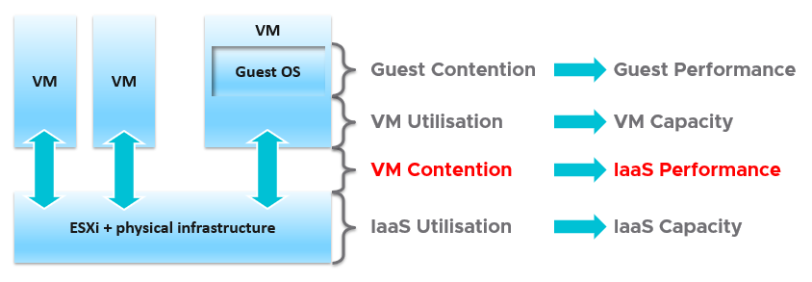

The 1st level is the Guest OS contention. This is beyond the control of the IaaS. It’s completely up to Guest OS to manage their given resources.

The 2nd level is useful for tracking the VM capacity. Say a VM is given 8 vCPU. If you want to know if it’s using it, this is the area where you measure it. Whether you measure it In-Guest or VM level, it depends on the specific use case because each layer lacks visibility into the other.

The 3rd level is where the VM meets the provider. This is where you track if IaaS is serving the VM.

The 4th level is the underlying IaaS. This level is irrelevant to the VM Owner. This is normally the domain of Capacity Planner and troubleshooting specialists.

Let’s drill down further, breaking the layers more.

### IaaS Layers of Metrics

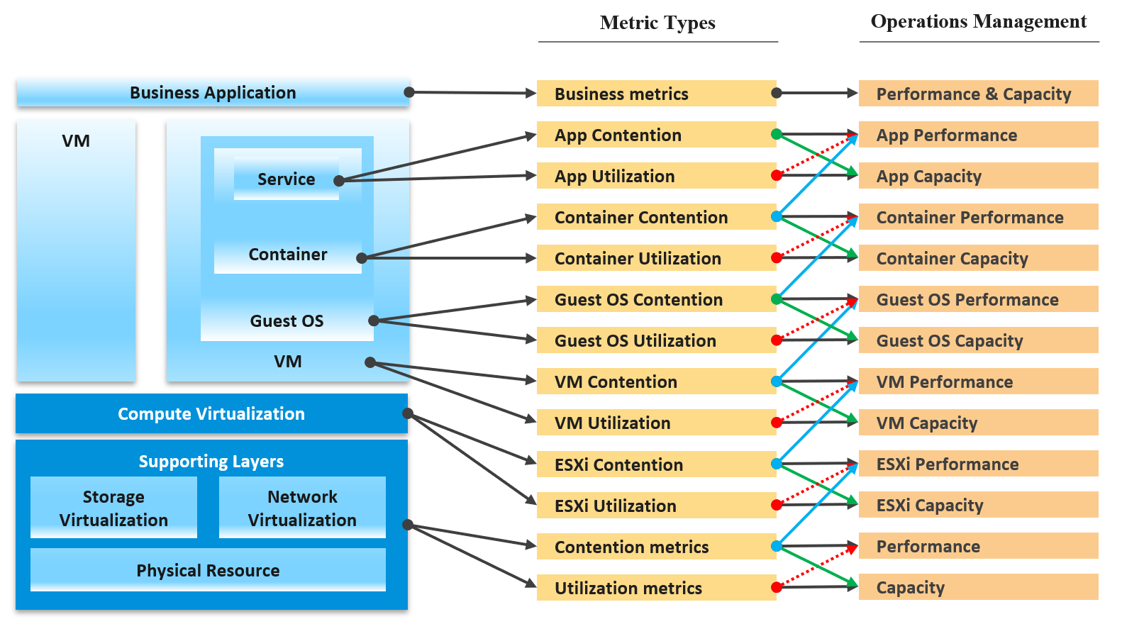

Notice how consumer and provider metrics are intertwined. The consumer contention becomes the performance metric for the provider.

The Consumer group consists of

* Business Application. This can span multiple VM, container and serverless. The metrics here are business metrics, not IT metrics. They are the best at measuring the application performance, but they can’t explain why it’s not performing.
* Service. This is a process running inside Windows or Linux. We normally call this application. An example is a database server.
* Guest OS. There are 2 kinds of performance counters. One at Windows/Linux layer, one at driver layer (e.g. PVSCSI, vmxnet)
* Container. This typically runs inside a VM. If there are more than 1 container in a VM, it makes operations management harder.
* VM.

The Provider group consists of

* Compute virtualization, also known as hypervisor. This is where the VM or container is running.
* Storage and Network virtualization. They act as subsystem, supporting layer. Ideally, they should have VM-level metrics, so you can observe how a single VM performance deep into the storage and networking stack.
* Physical resource. With hyperconverged, the only remaining is basically network equipment, due to their function as interconnect.

Contention is placed above utilization as that’s what you should drive your operations. As [Mark Achtemichuk](https://blogs.vmware.com/vsphere/author/mark_achtemichuk) said in [this article](https://blogs.vmware.com/vsphere/2015/11/vcpu-to-pcpu-ratios-are-they-still-relevant.html), drive by contention. For each layer, you have a set of metrics. The black line indicates that contention is the primary counter for performance, and utilization is the primary metric for capacity.

The green line shows that contention counters give valuable input to capacity by showing how much additional capacity is required. For example, the number of queues in the CPU should be used to determine the amount of CPU to add.

The blue line shows that contention in the underlying layer directly impacts the performance of the layer above. For example, if a Guest OS experiences disk latency, the application will feel the impact. That can result in a ripple effect to the top layer.

The red line is not solid, as it’s showing a misconception. If contention = 0, then utilization at 100% is in fact maximum performance. If we can’t measure the contention, then add the buffer (e.g. 90% utilization) as queue tends to develop at high utilization. On the other hand, you can have poor performance at low utilization. Many things can cause this as there are many possible configuration errors. Here are just some.

#### Impact on Capacity

The following diagram shows 3 different scenarios on how contention and consumption can play out:

* What you think will happen. You theorize that contention will only happen when utilization is high, and the unused capacity acts as cushion to prevent unmet demand from happening.
* What actually happens in most environment. Demand is unmet even though utilization is not high, due to suboptimal configuration or constraint. Imbalance and incorrect cluster configurations are two typical causes of contention at low utilization.
* What would happen if your environment is optimized. You have very high utilization yet you keep unmet demand within the promised SLA.

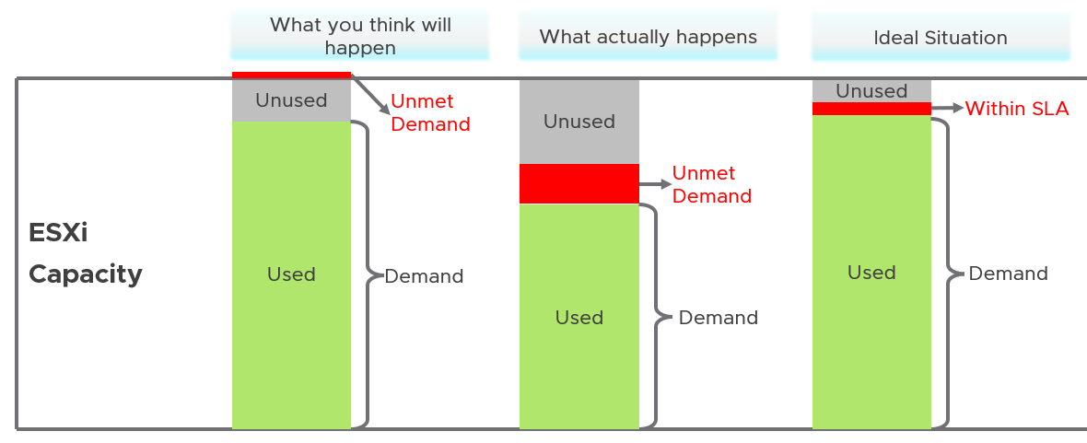

Don’t confuse “**ultra-high**” utilization indicators as a performance problem. High utilization does not compromise performance, so long as there is no queue or contention. Just because an ESXi Host is experiencing ballooning, compression, and swapping does not mean your VM has memory performance problem.

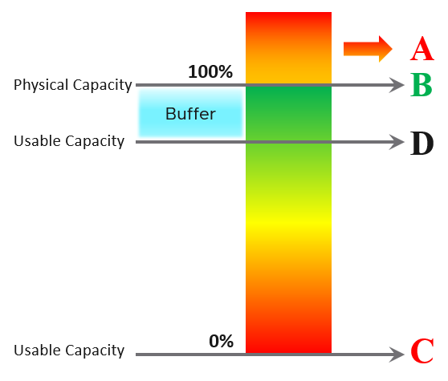

|  |  |
| --- | --- |
| A | It’s a common misperception that performance problem happens mostly here. It actually rarely happens here as utilization rarely exceeds 100% |
| B | Maximum utilization is achieved at 100% utilization. Consequently, the overall Performance is best here as it completes the most amount of work. |
| C | Worst performance actually happens when utilization = 0% as nothing gets done. The demand is not being met at all (for whatever reason). |
| D | This is the threshold of Usable Capacity. It has nothing to do with Performance. Performance is in fact better above this threshold. |

### Utilization vs Contention

There is a common misconception that you cannot have performance issue when cluster has low utilization.

Is there corelation between utilization and cluster contention?

I’ll show 2 opposite examples, using vSphere cluster as an example.

#### Correlation Example

If every VM is given the same treatment by the cluster, then yes you will see a correlation.

Here is a cluster experiencing regular high utilization in the last 7 days. You can clearly see the peak. The cluster has 14 ESXi Hosts.

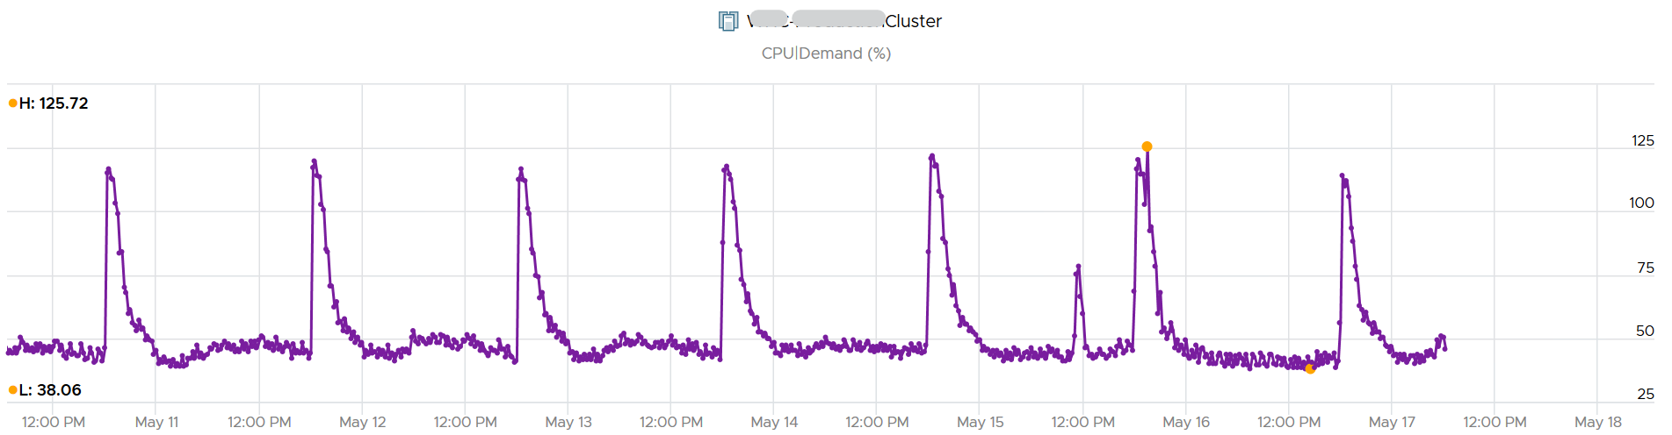

A logical question here would be what’s the impact on VM performance? Are they getting the CPU they asked? The cluster has 550 running VM.

This is where the contention counters come in. One tracks the depth of the problem, the other the breadth of the problem.

The counter Percentage of VMs facing CPU Ready > 1% shows a nearly identical pattern. We can see that a big percentage of the VM population is affected.

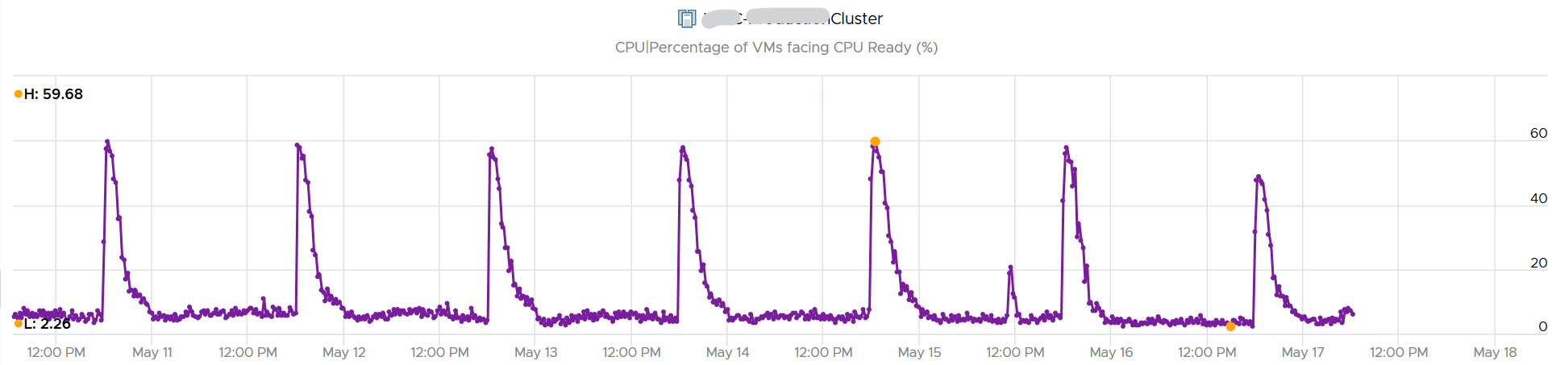

The second counter tracks the depth, giving the absolute worst CPU Ready value experienced by any VM in the cluster.

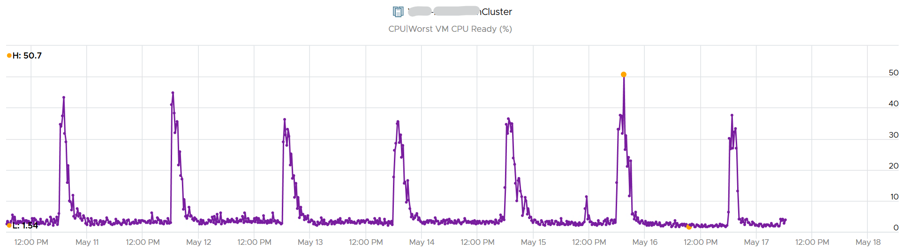

#### No Correlation Example

Performance is unmet demand. VM 007 can face very high contention when all other VMs on the same cluster face no contention.

It is possible for VMs in the cluster to suffer from poor performance, while the cluster utilization is low. One main reason is cluster utilization looks at the provider layer (ESXi), while performance looks at individual consumer (VM).

The following cluster has 32 ESXi supporting 2357 VM. The average demand across the cluster is <40%. Since it has 32 ESXi and 2357 VM, we can retire 8 ESXi or add 1K VM.

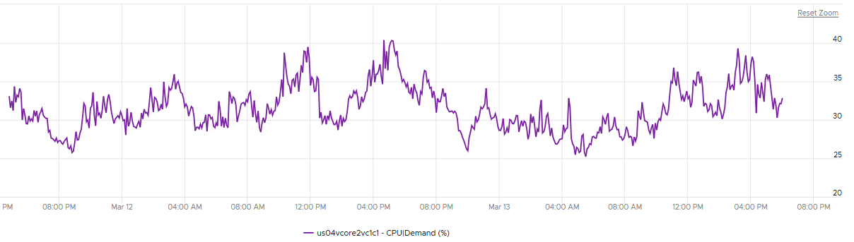

And yet the VMs in the clusters are facing contention. Both VM CPU Ready and CPU CoStop are high.

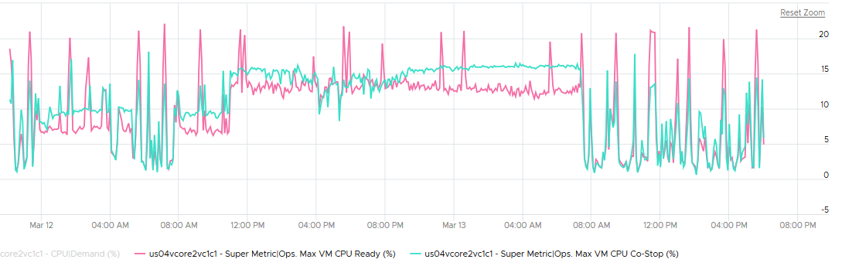

Let me take another example, where you can see the corelation between cluster utilization and VM contention in the cluster. My apology that the picture is not sharp. You can see the cluster has 774 running VM at the start. One month later it has dropped to 629, a drop of 145 VM or 19%. The second line chart reveals the number of running vCPU dropped from 3019 to 1980, a whopping 1039 vCPU or 34%. That indicates the big VMs were moved out.

This cluster was running mission critical VMs. What’s going on?! What caused the mass evacuation.

Notice the mass evacuation happened multiple times, so it’s not accidental.

Looking at the last chart. It has 2 line. Maroon showing utilization, blue showing contention. Can you figure out what happened?

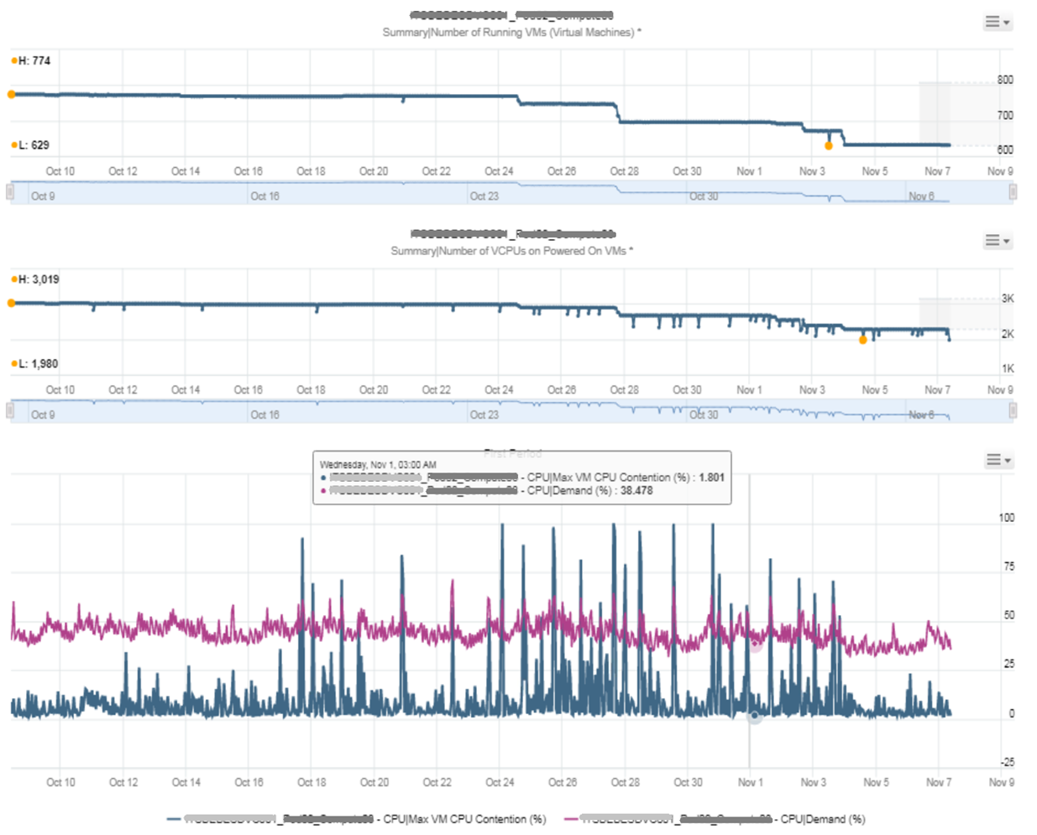

The cluster utilization was hovering around 50%. In that entire month, it barely moved. This cluster was probably 16 nodes, so 50% utilization means you can easily take out a few ESXi hosts actually.

The Max VM CPU Contention told a different story. Notice it spiked well above 75%. That impacted at least 1 VM. There were multiple spikes, leading to multiple complaints, and eventually infrastructure was forced to evacuate the cluster to fix the performance problem. Notice the counter dropped gradually in November, despite utilization remains fairly stable.

#### Example for Memory

We covered 2 examples for CPU. What about memory, since it’s a form storage. It’s just a disk space basically, so can VM experience contention when Cluster consume metric is not high?

I’d zoom into ESXi, so it’s easier to see. What do you deduce from this ESXi? This chart shows 1 month worth of data.

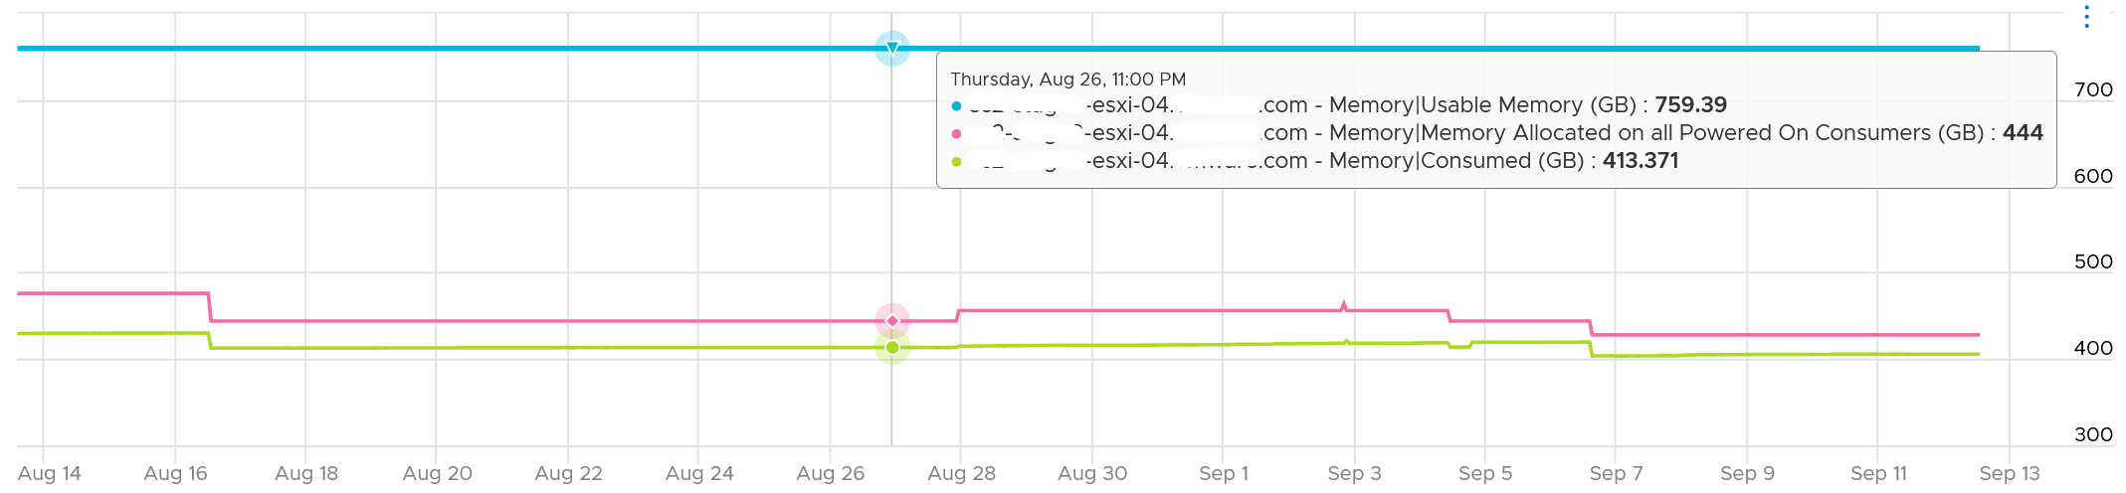

It has 759 GB of usable memory. All the powered on VM has 444 GB configured, out of which only 413 GB is mapped to physical DIMM. So there is plenty of memory left.

To confirm that it has plenty of memory, let’s plot Balloon. What do you expect?

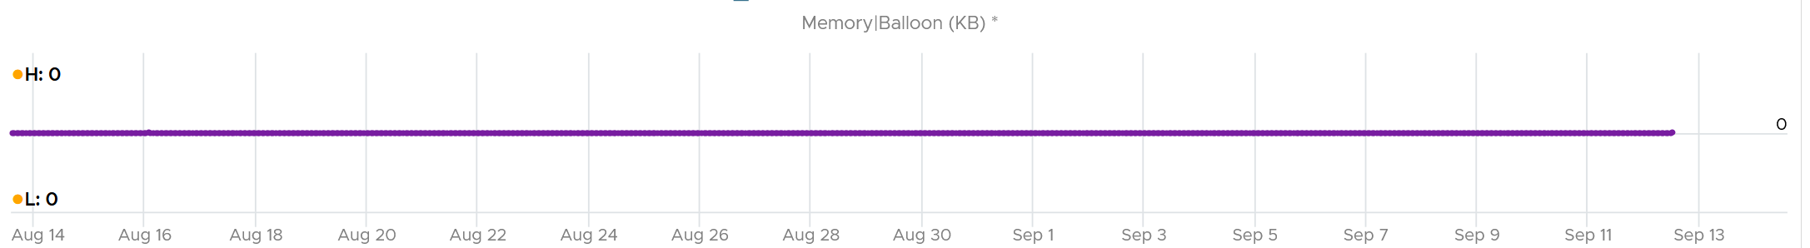

There is no ballooning. ESXi was under no memory pressure whatsoever.

So that’s the situation at provider level. How about consumer level?

vRealize Operations has a metric that tracks the highest memory contention experienced by any VM in the host. This is a good leading indicator as all it takes is 1 VM, it matters not which VM.

As we can see here, there is a problem.

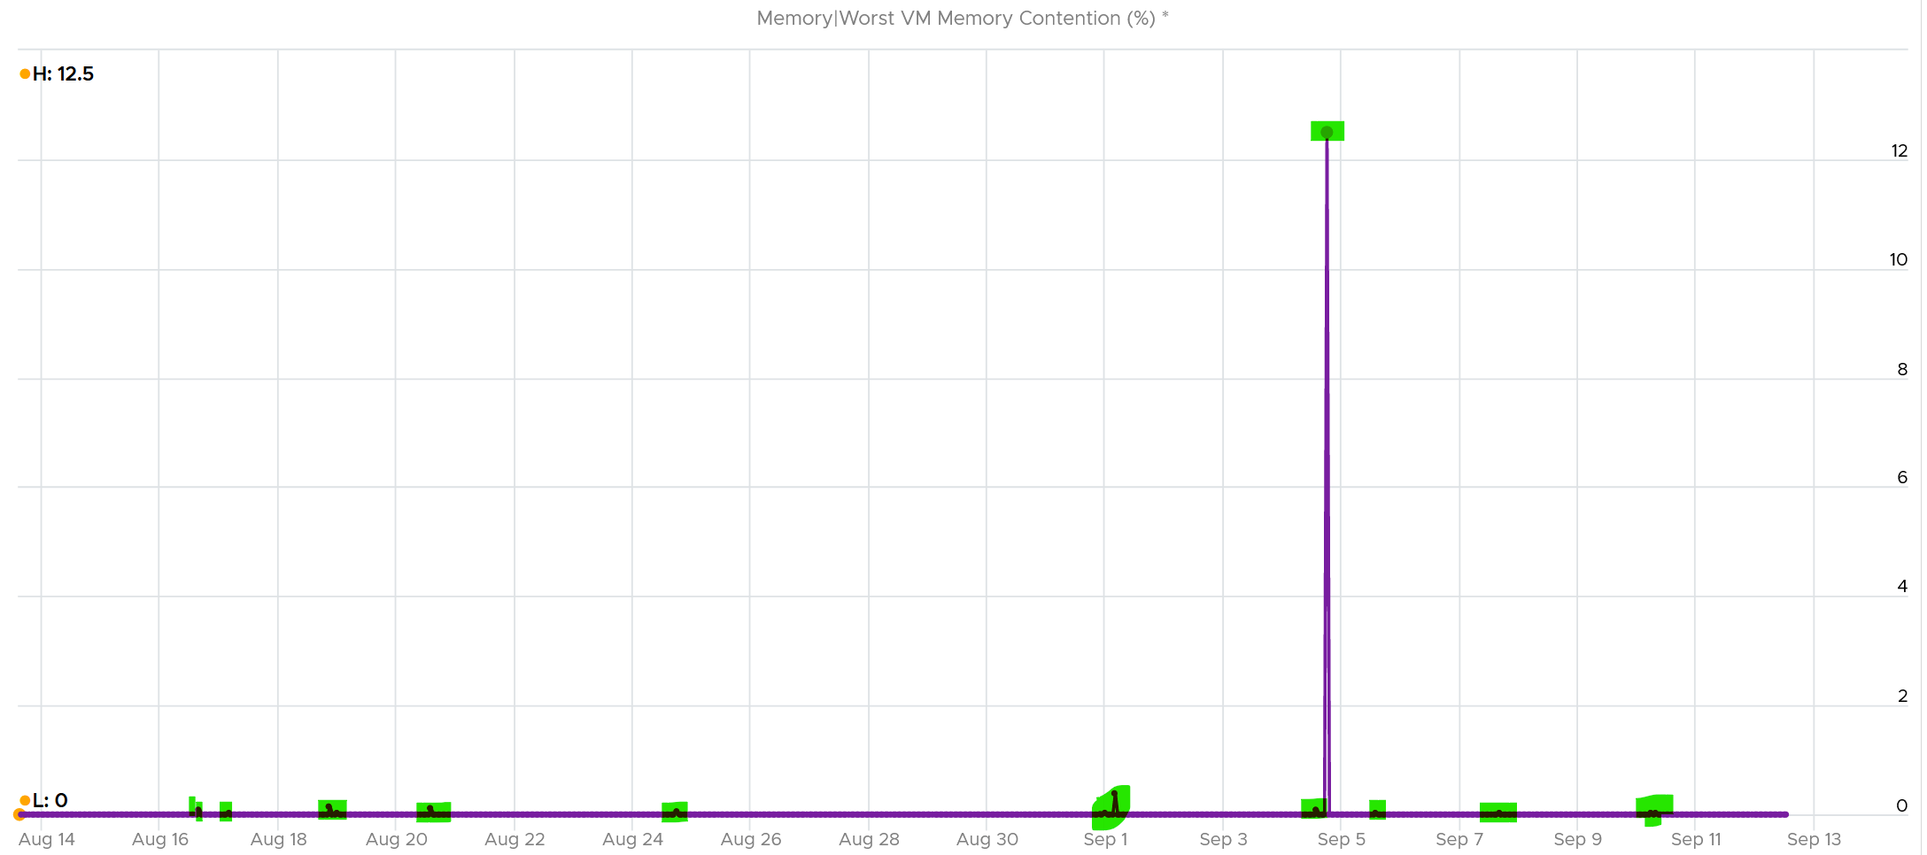

Can you explain why?

A VM experiences contention when the page is not in the DIMM. It was compressed or swapped out. Checking the compressed metric, it reveals that pages had to be brought it. Notice the swap metric lagged a bit, which makes sense.

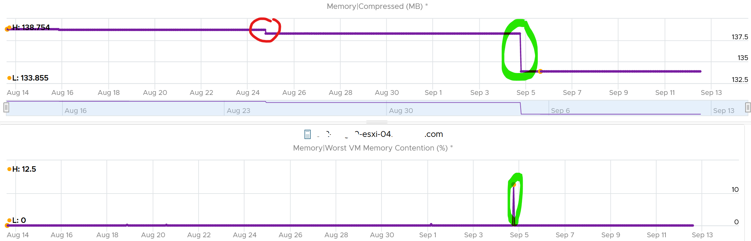

I am not able to explain the earlier dropped, the one in red circle. If you can drop me a note.

Let’s complete by plotting Swapped. I’m plotting all the way to the beginning of tracking.

It’s all 0. What happened?

That means all the pages could be compressed, so ESXi decided to compress instead of putting them into swapped file.

Now that we know it’s due to compression, we know the contention on 5 September was caused by compression. When was that page compressed, no one knows. Plotting back, the compression started around 2 August.

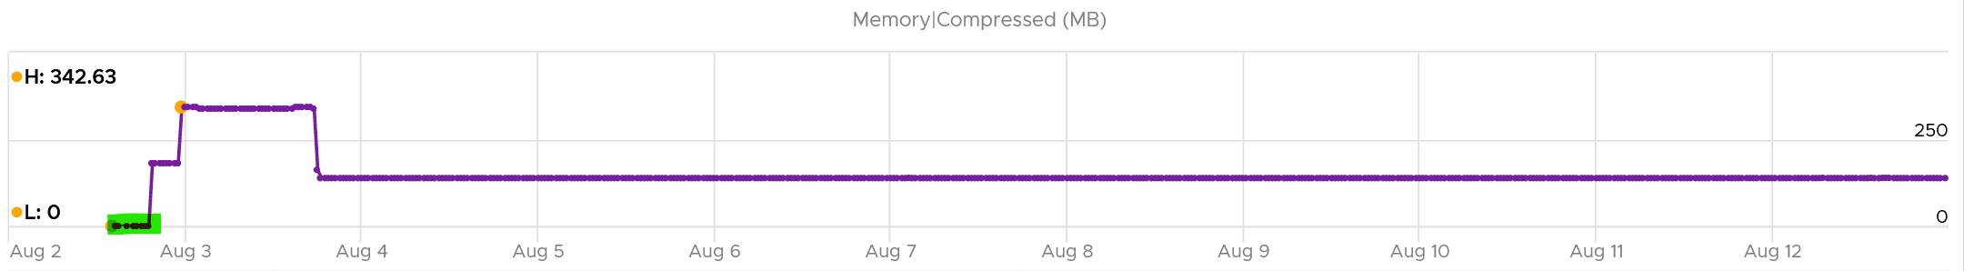

The compression was only 342 MB. Not even 0.1% of consumed memory. But if you are unlucky, it was the active VM that got hit, as in the case here.

The past is harder to debug, as we lack the ability to travel back in time and see the environment as it was. My guess here is the VM had limit, be it indirectly via resource pool or directly.

## Collection | Aggregation

Before we cover the counters, you need to know the various units and how they get

* collected within a collection period (e.g. 20 second)
* rolled up across time (e.g. from 20 second to 5 minutes)
* aggregated to higher level object (e.g. from ESXi to Cluster)

### Collection

When you collect a metric you have a choice on what to collect:

1. Collect the data at that point in time.
2. Collect the average of all the data within the collection cycle.
3. Collect the maximum (or minimum) of all the data within the collection cycle.

The 1st choice is the least ideal, as you will miss majority of the metric. For example, if you collect every 5 minutes, that means you collect the data of the 300th second, and miss 299 seconds worth of data points. Unfortunately, many softwares have chosen this choice.

The 2nd choice gives you the complete picture, as no data is missing. The limitation is your collection interval can’t be too long for the use case you’re interested in.

The 3rd choice complements the 2nd choice by picking the worst. That means you need 2 number per metrics for certain use case.

As you collect regularly, you also need to decide if you reset to 0, or you continue from previous cycle. Most counters reset to 0 as accumulation is less useful in operations.

Let’s take a look at what you see at vCenter UI, when you open the performance dialog box. What do the columns Rollups and Stat Type mean? Why do we have milliseconds for CPU metric?



Stat Type explains the nature of the metrics. There are 3 types:

|  |  |
| --- | --- |
| **Delta** | The value is derived from a running counter that perpetually accumulates over time. What you see is difference between 2 points in time. All the units in milliseconds are of delta type. |
| **Rate** | The value measures the rate of change, such as throughput per second. Rate is always the average across the 20 second period.  Note: there are metrics with percentage as unit and rate as stat type. I’m puzzled why. |
| **Absolute** | The value is a standalone number, not relative to other numbers.  Absolute can be latest value at 20th second or the average value across the 20 second period. |

Stat Type has impacts on the units. Some common units are milliseconds, MHz, percent, KBps, and KB. Some counters are shown in MHz, which means you need to compare with the ESXi physical CPU *static* frequency[3]. In large environments, this can be operationally difficult as you have different ESXi hosts from different generations (and hence, are likely to sport a different GHz). This is also the reason why cluster is the smallest logical building block. If your cluster has ESXi hosts with different frequencies, these MHz-based counters can be difficult to use, as the VMs get vMotion-ed by DRS.

#### Why Milliseconds as Unit?

Time as a unit to measure CPU utilization does not seem logical. Where does it come from and why?

Hint: the stat type is Delta.

To answer that, we need to go deep to the ESXi VMkernel scheduler. Think in terms of the passage of time and the amount of CPU cycles that get completed during that time. A CPU core running at 2 GHz will get 2x CPU cycles completed compared with a core running at 1 GHz. The same goes with Hyper Threading. You get less cycles completed when there is a peer thread competing at the same time.

What you think as utilization or usage or demand or used, it will be easier if you see them as cycles, once you make that small paradigm shift.

Let’s take VM CPU Ready. The following is taken from ESXi [vsish](https://williamlam.com/2010/08/what-is-vmware-vsish.html)[4] command. It shows that the original, raw counter is actually a running number. To calculate the CPU ready of a given time period, we need to subtract the last number from the first number. To convert to percentage, we divide over the collection, which is 20000 ms in the screenshot.

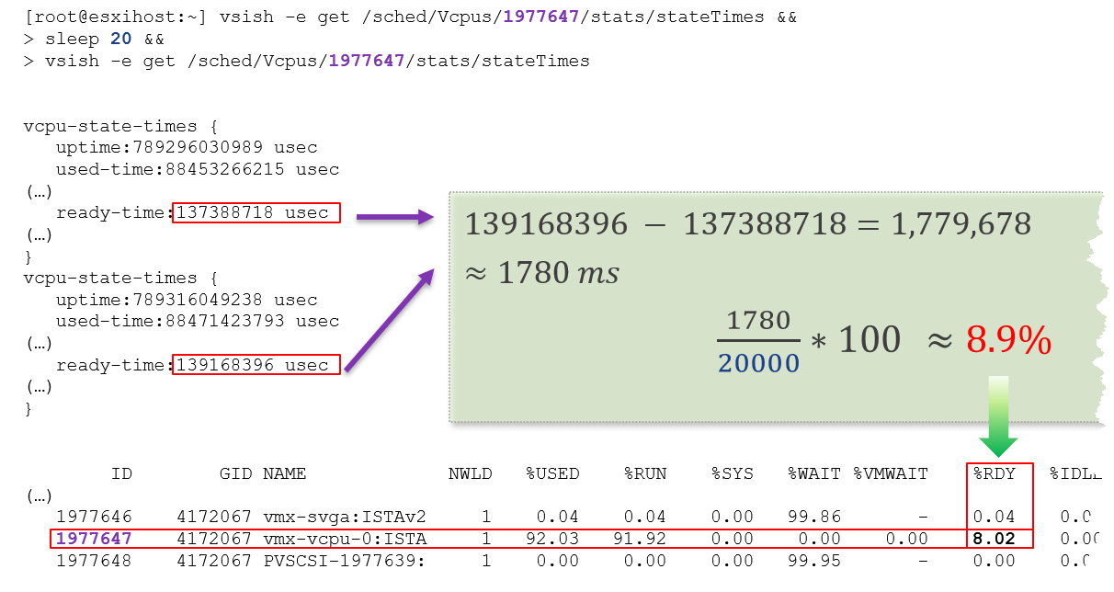

In the above, the slightly different values are due to different time in sample interval start and end.

I’ll take another example, to show that the original unit is time (microsecond, not millisecond).

/sched/groups/169890525/stats/cpuStatsDir/> cat /sched/groups/169890525/stats/cpuStatsDir/cpuStats  
group CpuStats {  
   number of vsmps:7  
   size:19  
   used-time:905379300543 usec  
   latency-stats:latency-stats {  
      cpu-latency:798578245914 usec   
      memory-latency:memory-latency {  
         swap-fault-time:0 usec  
         swap-fault-count:0  
         compress-fault-time:0 usec  
         compress-fault-count:0  
         mem-fault-time:17939139 usec  
         mem-fault-count:3834600  
      }  
      network-latency:0 usec  
      storage-latency:0 usec

In vSphere UI and API, the counter for CPU Latency is percentage. But in the above, you can see that it’s true unit is microseconds.

#### Summation

The **Rollups** column tells you how the data is rolled up to longer time period. Average means the average of 5 minutes in the case of vRealize Operations. What about **Summation**? Why does the number keep going up as you roll up?

It is actually average for those counters where accumulation makes more sense. Let’s take an example. CPU Ready Time gets accumulated over the sampling period. vCenter reports counters every 20 seconds, which is 20000 milliseconds. The following table shows a VM has different CPU Ready Time on each second. It has 900 ms CPU Ready on the 5th and 6th second, but has lower number on the remaining 18 seconds.



Over a period of 20 seconds, a VM may accumulate different CPU Ready Time for each second. vCenter sums all these numbers, then divides it by 20,000. This is actually an average, as you lose the peak within the period.

**Latest**, on the other hand, is different. It takes the last value of the sampling period. For example, in the 20-second sampling, it takes the value between 19th and 20th seconds. This value can be lower or higher than the average of the entire 20 seconds period. Latest is less popular compared with average as you miss 95% of the data.

Rolling up from 20 seconds to 5 minutes or higher results in further averaging, regardless whether the rollup technique is summation or average. This is the reason why it is better to use vRealize Operations than vCenter for data older than 1 day, as vCenter averages the data further, into a 0.5 hour average.

Because the source data is based on 20-second, and vRealize Operations by default averages these data, the “100%” of any millisecond data is 20,000 ms, not 300,000 ms. When you see CPU Ready of 3000 ms, that’s actually 15% and not 1%.

By default, vRealize Operations takes data every 5 minutes. This means it is *not* suitable to troubleshoot performance that does not last for 5 minutes. In fact, if the performance issue only lasts for 5 minutes, you may not get any alert, because the collection could happen exactly in the middle of those 5 minutes. For example, let's assume the CPU is idle from 08:00:00 to 08:02:30, spikes from 08:02:30 to 08:07:30, and then again is idle from 08:07:30 to 08:10:00. If vRealize Operations is collecting at exactly 08:00, 08:05, and 08:10, you will not see the spike as it is spread over two data points. This means, for vRealize Operations to pick up the spike in its *entirety* without any idle data, the spike *may* have to last for 10 minutes.

vRealize Operations is capable of storing the individual 20-seconds data. But that would result in 15x more data. In most cases, what you want is the peak among the 15 data points. This is where a new set of troubleshooting metrics come in.

The [Collection Level](https://docs.vmware.com/en/VMware-vSphere/7.0/com.vmware.vsphere.monitoring.doc/GUID-25800DE4-68E5-41CC-82D9-8811E27924BC.html) in vCenter, shown in the following table, does *not* apply to vRealize Operations. Changing the collection level does not impact what counters get collected by vRealize Operations. It collects majority of counters from vCenter using its own filter, which you can customize via policy.

|  |  |
| --- | --- |
| Statistics Levels | Metrics |
| Level 1 | Cluster Services (VMware Distributed Resource Scheduler) – all metrics  CPU –entitlement, total MHz, usage (average), usage MHz  Disk – capacity, max Total Latency, provisioned, unshared, usage (average), used  Memory – consumed, mem entitlement, overhead, swap in Rate, swap out Rate, swap used, total MB, usage (average), balloon, total bandwidth (DRAM or PMem)  Network – usage (average), IPv6  System – heartbeat, uptime  VM Operations – num Change datastore, num Change Host, num Change Host datastore |
| Level 2 | Level 1 metrics, plus the following:  CPU – idle, reserved Capacity  Disk – All metrics, excluding number Read and number Write.  Memory – All metrics, excluding Used, maximum and minimum rollup values, read or write latency (DRAM or PMem).  VM Operations – All metrics |
| Level 3 | Level 2 metrics, plus the following:  Metrics for all counters, excluding minimum and maximum rollup values.  Device metrics |
| Level 4 | All metrics, including minimum and maximum rollup values. |

Take note: vSAN API, Telegraf API, and Horizon API give you the last data, not the average or peak of the entire period. Since vRealize Operations collect every 5 minute, you get the data of the 300th second.

### Real Time Collection

Do we really need real-time collection and analysis for every single metrics, on every single objects, 24 x 7?

We collect the metrics for a reason, such as performance and capacity. The reasons dictate the frequency for each type of metrics.

Take note that how frequent you collect is not the same with how granular the data points. For example, vRealize Operations collect every 5 minute by default from vCenter, but it grabs 15 data points in 1 collection cycle. For majority of the data, it averages these 15 data points and store as 1 number.

|  |  |  |
| --- | --- | --- |
| Use Case | Collection Point | Collection Frequency |
| Performance: Troubleshooting | 1 - 20 second for raw contention, 5 minute for everything else. More explanation after this table. | 5 minutes for both |
| Performance: SLA | 5 minute. Why SLA differs to troubleshooting and why 5-minute is the sweet spot is covered here. | 5 – 15 minutes |
| Capacity | 15 minute for all. Value is the average over 15 minutes, not the peak.  Functionally, you do not need 15-minute granularity. Operationally, it’s safer to do 15 minutes. If there is collection failure, you only lose 15 minutes worth of data. | |
| Cost |
| Compliance |
| Sustainability |
| Inventory |

#### Performance Troubleshooting

For troubleshooting, you want per-second data. Who does not want sharper visibility? However, there are 3 potentialproblems:

1. It’s expensive. Your monitoring system might grow to be as large as the systems being monitored. You could be better off spending the money on buying more hardware, preventing the problem to begin with.
2. You get diminishing return. The first data point is the most valuable. Subsequent data points are less valuable if they are not providing new information.
3. The remediation action is likely the same as there are only a handful of things you can do to fix the problem. The number of problems outweigh the actual solution.

So what can you do instead?

Begin with the end in mind. Look at the solution (e.g. add hardware, change some settings) and ask what metrics are required. For each required metrics, ask what granularity is required.

I find that 1 – 20 second is only required for the contention-type of metrics. For utilization-type and contextual-type, I think 5 minute is enough. You need higher resolution when the contention-type metrics do not exist. For example, there is no metric for network latency and packet retransmit at VM level. All you have is packet dropped. To address the missing metrics, use utilization metric such as packet per second and network throughput.

We’ve done the analysis of what metrics are required and document them here.

### Units

Before we cover aggregation, we need to clarify unit as aggregation often using a different unit.

#### 1000 vs 1024

There is confusion between 1024 and 1000. Is 1 gigabyte = 1024 megabyte or 1000 megabyte?

Is 1 Gigabit = 1000 Mb or 1024 Mbit?

The answer is 1000. Because both are byte, so the only change is from giga to mega. The following screenshot is taken from Google.

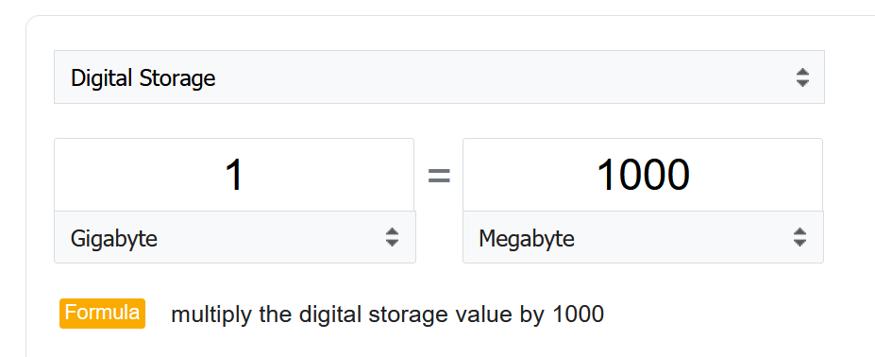

However, many products from many vendors use the binary conversion instead of decimal. This is one of those issue between what’s popular in practice vs what it should be in theory.

To add further confusion, there is consistency among storage and network vendors.

Microsoft Windows use 1024 for storage. My 1,000,202,039,296 bytes physical SSD is shown at 931 GB, not 1024 GB.

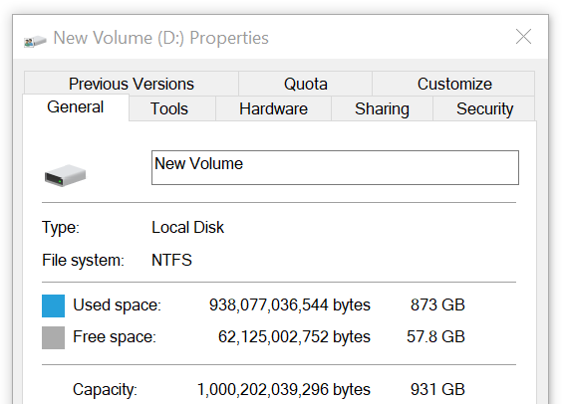

The disk vendor states that’s a 1 TB disk.

Another vendor, Samsung also uses 1000. It states the SSD as 250 GB. Microsoft shows 232.87 GB, including hidden partitions.

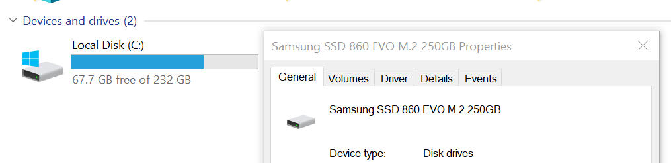

vRealize Operations use 1024. As it’s a universal conversion, it applies 1024 to both disk space and speed.

#### Kilo vs Kibi

To address the confusion, the [International System of Quantities](https://en.wikipedia.org/wiki/International_System_of_Quantities) came up with a new set of name for the binary units. Instead of kilo, mega, giga, they use kibi, mebi and gibi. Personally I’d have preferred kilobi, megabi and gigabi as it shows the relationship to the commonly known units. Or if you want to emphasize the binary nature, perhaps kilo2byte, mega2byte, giga2byte as the name.

Let’s take an example

* 1 Kibibyte = 1024 bytes. That means 1 Kibibyte = 1.024 KB.
* 1 Gibibyte = 1024 Mebibytes = 1,073,741,824 bytes

The abbreviation is also changed from K, M, G to Ki, Mi, Gi, where the letter ***i*** is small case.

Note the conversion from byte to bit remains. 1 byte = 8 bit.

#### Bit vs Byte

Do you use Byte/second or bit/second?

To me, it depends on the context. If you talk about disk space, you should use byte. You measure the amount of disk space read or written per second. If you talk about network line, you should use bit. You measure the amount of SCSI blocks travelling inside ethernet or FC cable. [Pearson](https://qualifications.pearson.com/content/dam/pdf/subject-updates/ICT/KB-vs-kpbs.pdf) uses 1024 for disk space, and 1000 for transmission speed, in their certification. There are other references, such as [gbmb.org](https://www.gbmb.org/gbps-to-mbps), [NIST](https://physics.nist.gov/cuu/Units/prefixes.html), and [Lyberty](http://www.lyberty.com/encyc/articles/kb_kilobytes_archived1.html). In short, there is really no standard.

The following is network transmit. It’s showing 30.81 MBps. So this is a rate, showing bandwidth consumption or network speed.

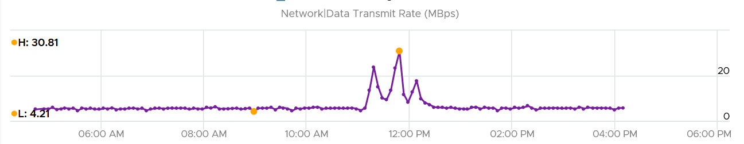

What would it show if you convert into KBps?

30810, if it uses 1000.

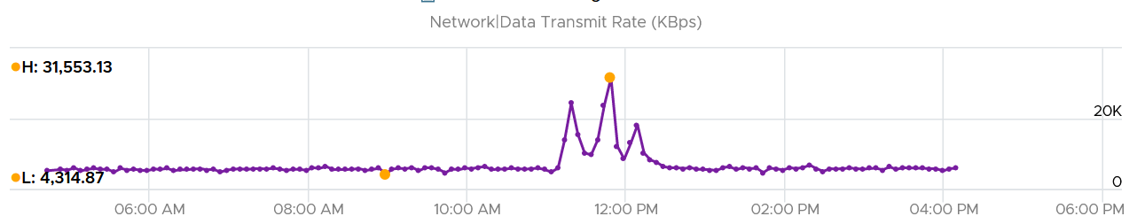

Since vRealize treats 1 Mega = 1024 Kilo, the above is what you get.

Since it’s network, let’s convert into bit.

What do you expect you get in Mbps?

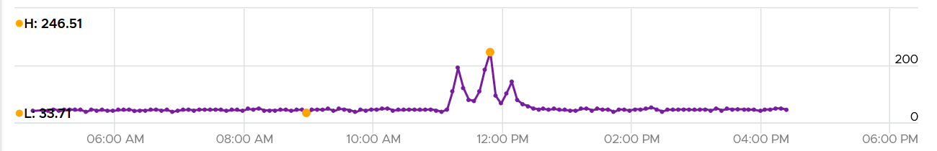

You get 31 x 553.13 x 8 bits / 1024 = 246 / 51

### Aggregation

Aggregating to a higher-level object is complex as there is no lossless solution. You are trying to represent a range of values by picking up 1 value among them, so you tend to lose the details. The choices of techniques are mean, median, max, min, percentile, sum and count of. The default technique used is the average() function. The problem with average is it will mask out the problems unless they are widespread. By the time the average performance of 1000 VMs is bad, you likely have a hundred VMs in bad shape.

Let’s take an example. The following table shows ESXi hosts. The first host has CPU Ready of 149,116.33 ms. Is that a bad number?



It is hard to conclude. It depends on the number of running vCPU, not the number of physical cores.

That host has 67 running VMs, and each of those VMs can have multiple vCPU. In total there are 195 vCPU. Each vCPU could potentially experience CPU Ready of 20,000 ms (which is the worst possible scenario).

If you sum the CPU Ready of the 67 VM, what number would you get?



You’re right, you get the same number reported by the ESXi host.

This means the ESXi CPU Ready = Sum (VM CPU Ready), and the VM CPU Ready = Sum (VM vCPU Ready).

Because it’s a summation of the VMs, to convert into % requires you to divide with the number of running VM vCPU.

ESXi CPU Ready (%) = ESXi CPU Ready (ms) / Sum (vCPU of running VMs)

Are the CPU Ready equally distributed among the VMs? What do you think?

It depends on many settings, so there is a good chance you get something like the following. This heat map shows the 67 VMs on the above host, colored by CPU Ready and sized by VM CPU configuration. You can see that the larger VMs tend to have higher CPU ready, as they have more vCPU.



### “Peak” Utilization

One common requirement is the need to monitor for peak. Be careful in defining what peak actually is, as by default, *averages* get in the way.

How do you define peak utilization or contention without being overly conservative or aggressive?

There are two dimensions of peaks. You can measure them across time or members of the group.

Let's take a cluster with 8 ESXi hosts as an example. The following chart shows the 8 ESXi utilizations.

What’s the cluster peak utilization on that day?

The problem with this question is there are 1440 minutes in a day, so each ESXi Host has at least 288 counters (based on the 5-minute reporting period). So this cluster has 288 x 8 = 2304 metrics on that day. A true peak has to be the highest metric among these 2304 metrics.



To get this true peak, you need to measure across members of the group. For each sample data, take the utilization from the host with the highest utilization. In our cluster example, at 9:05 am, host number 1 has the highest utilization among all hosts. Let’s say it hit 99%. We then take it that the cluster *peak* utilization at 9:05 am is also 99%.

You repeat this process for each sample period (e.g. 9:10 am, 9:15 am). You may get different hosts at different times. You will not know which host provides the peak value as that varies from time to time.

What’s the problem of this true peak?

Yup, it might be too sensitive. All it takes is 1 number out of 2304 metrics. If you want to ignore the outlier, you need to use percentile. For example, if you do 99th percentile, it will remove the highest ~23 datapoints.

Take note that the most common approach is to take the *average* utilization among all the 8 ESXi hosts in the cluster. So you lose the true peak, as each data point becomes an average. For the cluster to hit 80% average utilization, at least 1 ESXi host must have hit over 80%. That means you can't rule out the possibility that one host might hit near 100%.

The same logic applies to a VM. If a VM with 64 vCPUs hits 90% utilization, some cores probably hit 100%. This method results in under-reporting as it takes an average of the “members” at any given moment, then take the peak across time (e.g. last 24 hours).

This “averaging issue” exists basically everywhere in monitoring, as it’s the default technique when rolling up. For a more in-depth reading, look at [this](https://bravenewgeek.com/everything-you-know-about-latency-is-wrong/) analysis by [Tyler Treat](https://bravenewgeek.com/about-me/).

## esxtop

The view from a VM (consumer) and the view from ESXi (provider) are different. vCPU is construct of a VM, while core and thread are construct seen by ESXi. I hope future version of esxtop segregates this better. You get to see both VM level and ESXi level objects at the same time. It could be confusing for newbie, but convenient for power user, and if you’re looking at esxtop, you are a power user 😊

### Metrics Organisation

In esxtop console, pressing the letter **h** will open the Help screen. You will see that there are 10 panels. Each panel is given its own letter to get there.

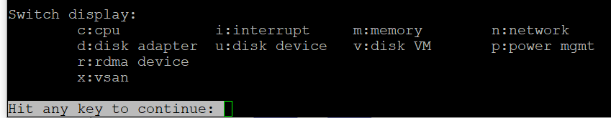

There are relationships among *some* of the 10 panels, but they are not obvious as the UI simply presents them as a list.

Because this documentation is not about how to use esxtop, but what the metrics mean and their relevance in operations management, we need to *group them differently*. This grouping facilitates understanding of the metrics, and the order of importance as not all metrics are equal.

So instead of documenting the 10 panels, I’d group them into 5.

|  |  |  |  |
| --- | --- | --- | --- |
| **Group** | **Consumer** | **Provider** | **Remarks** |
| CPU | Yes | Sort of | The CPU panel has a 4 line summary that provides the provider’s viewpoint.  I moved Power Management panel here as it only covers CPU. It does not cover memory, disk, network and other parts of the box (e.g. fan, motherboard).  The Power Management panel complement the CPU panel as it covers the provider’s viewpoint. Take note that it does not show at socket level. And if you enable HT, it does not show at core level. |
| Memory | 1 shared panel for both | | Provider and Consumer are shown in 1 panel. The panel has a summary at the top, which cover the provider’s viewpoint |
| Storage | Yes | Almost | The Disk VM panel covers from consumer’s viewpoint.  The Disk Adapter panel and Disk Device panel cover from provider’s viewpoint, and are best to be analyzed together. The Path panel is missing.  I moved vSAN here as all the counters are disk counters. There is no vSAN network and CPU counter, but you can see them in the respective network and CPU panel. |
| Network | 1 shared panel for both | | Provider and Consumer are shown in 1 panel |
| Others |  |  | There are only 2 remaining panels (RDMA Device, Interrupt).  I park them under “Others” until I have a use case for them. |

The nature of esxtop meant it is excellent for performance troubleshooting, especially real time and live situation where you know the specific ESXi Host. The tool is not so suitable for capacity management, where you need to look at long term (often weeks or months). As a result, I cover the troubleshooting metrics first.

### VMkernel

To understand esxtop metrics, it’s important to understand VMkernel, especially how it does accounting of its resource allocation. So let’s cover this first.

From VMkernel’s vantage point, a VM is just a collection of process that needs to be run together. Each process is called World. So there is a world for each vCPU of a VM, as each can be scheduled independently. The following screenshot shows both VM and non VM worlds running side by side. I’ve marked the kernel modules with red dot. You can spot familiar process like vpxa and hostd running alongside VM (marked with the yellow line).

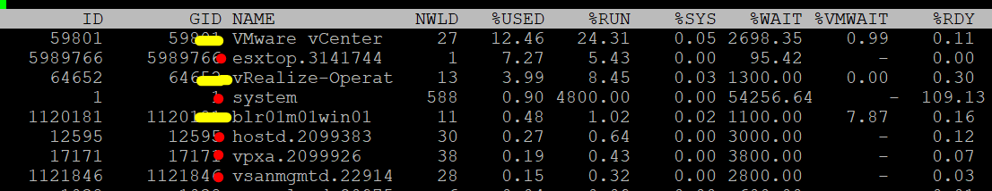

The kernel is an operating system, so it does consume overhead in both CPU and memory. All the processes that run belong to one these four top-level resource groups:

|  |  |
| --- | --- |
| **System** | host/system resource pool for low-level kernel services and drivers. You will find world such as minfree, kernel, helper, ft, vmotion, and drivers.  Compared with the VIM resource, it tends to have much lower CPU reservation but much higher memory reservation |
| **VIM** | host/vim resource pool for host management process such as vpxa, DCUI, and hostd |
| **IO Filter** | host/iofilter resource pool  The IO Filter processes are grouped here. |
| **User** | host/user resource pool  All the running VMs are children of the User resource pool. This includes the VM overhead as it’s part of the VM. |

In the vSphere Client UI, you will see the list of resource grouping in the Target Objects section in the performance chart.

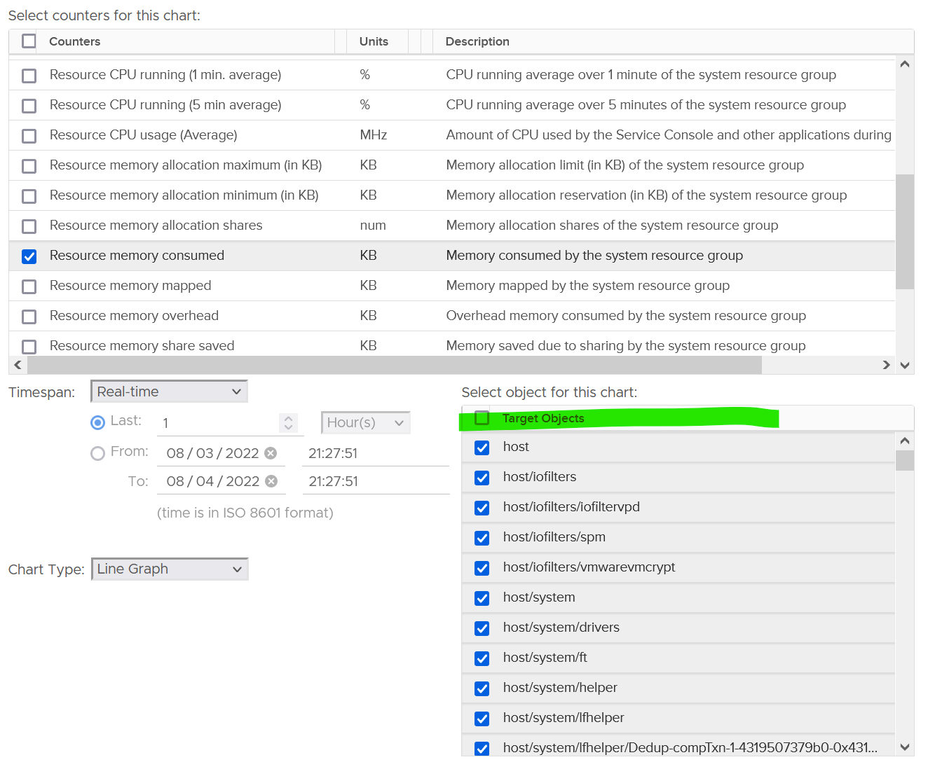

The scheduler uses share, limit and reservation to manage all the above. Processes that run at kernel level does not get its reserved memory up front. It’s granted on demand.

The minimum is guaranteed, and the maximum is the limit that the resource group can go. The actual consumption is a value within this range. I find the maximum reservation and limit are the same, and both are set to no limit. If you plot them in vSphere Client UI, you will find they are either blank or 0.

ESX System Usage = CPU Total Capacity – CPU Capacity Available to VMs

Where capacity available to VMs is the capacity reserved by and available for VMs.

Since it is just a reservation (allocation), the value can exceed Consumed. its not included in the calculation of the parent cluster usable capacity.

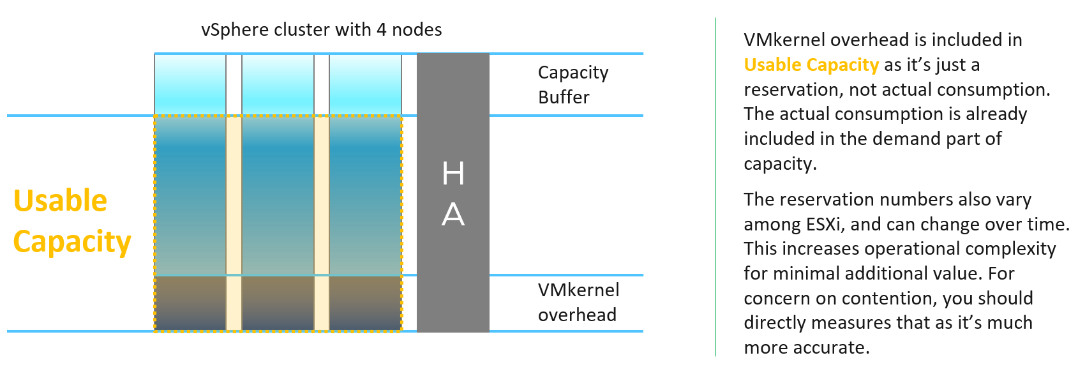

Why is it hard to determine the size of the overhead up front? Taking from page 258 of [Frank Denneman](https://frankdenneman.nl/) and [Niels Hagoort](https://www.linkedin.com/in/nielshagoort/)’s book, with my own addition:

* Some services have static memory reservation regardless of the host configuration. Ok, this is the easy part.
* Some services have relative memory reservation. It scales with the memory configuration of the host. Ok, that means you need to know the percentage for each.
* Some services have relative memory reservation that are tied to the number of active VMs. Ok, that means you need to know how many VMs are active.
* Some services consume more when they do more work. Example is storage and networking stack.
* Some services consume more depending on the configuration. For example, vSAN consumes more when you turn on dedupe and compression.

Because of this behaviour, it is difficult to accurately predict an overhead consumption for each host.

#### VMkernel CPU

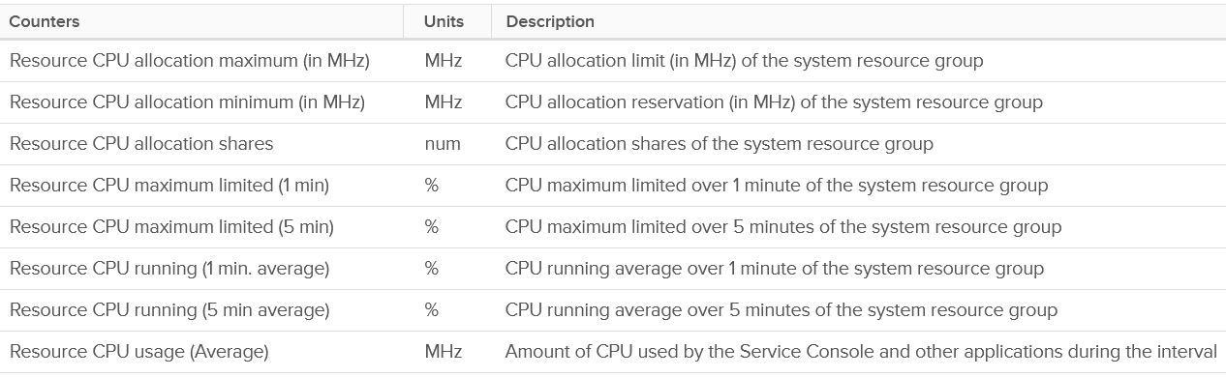

Allocation (MHz): the maximum counter is missing. Only the minimum counter.

Limit (%): they are all 0. I assume this means it's unlimited. Why in percentage?

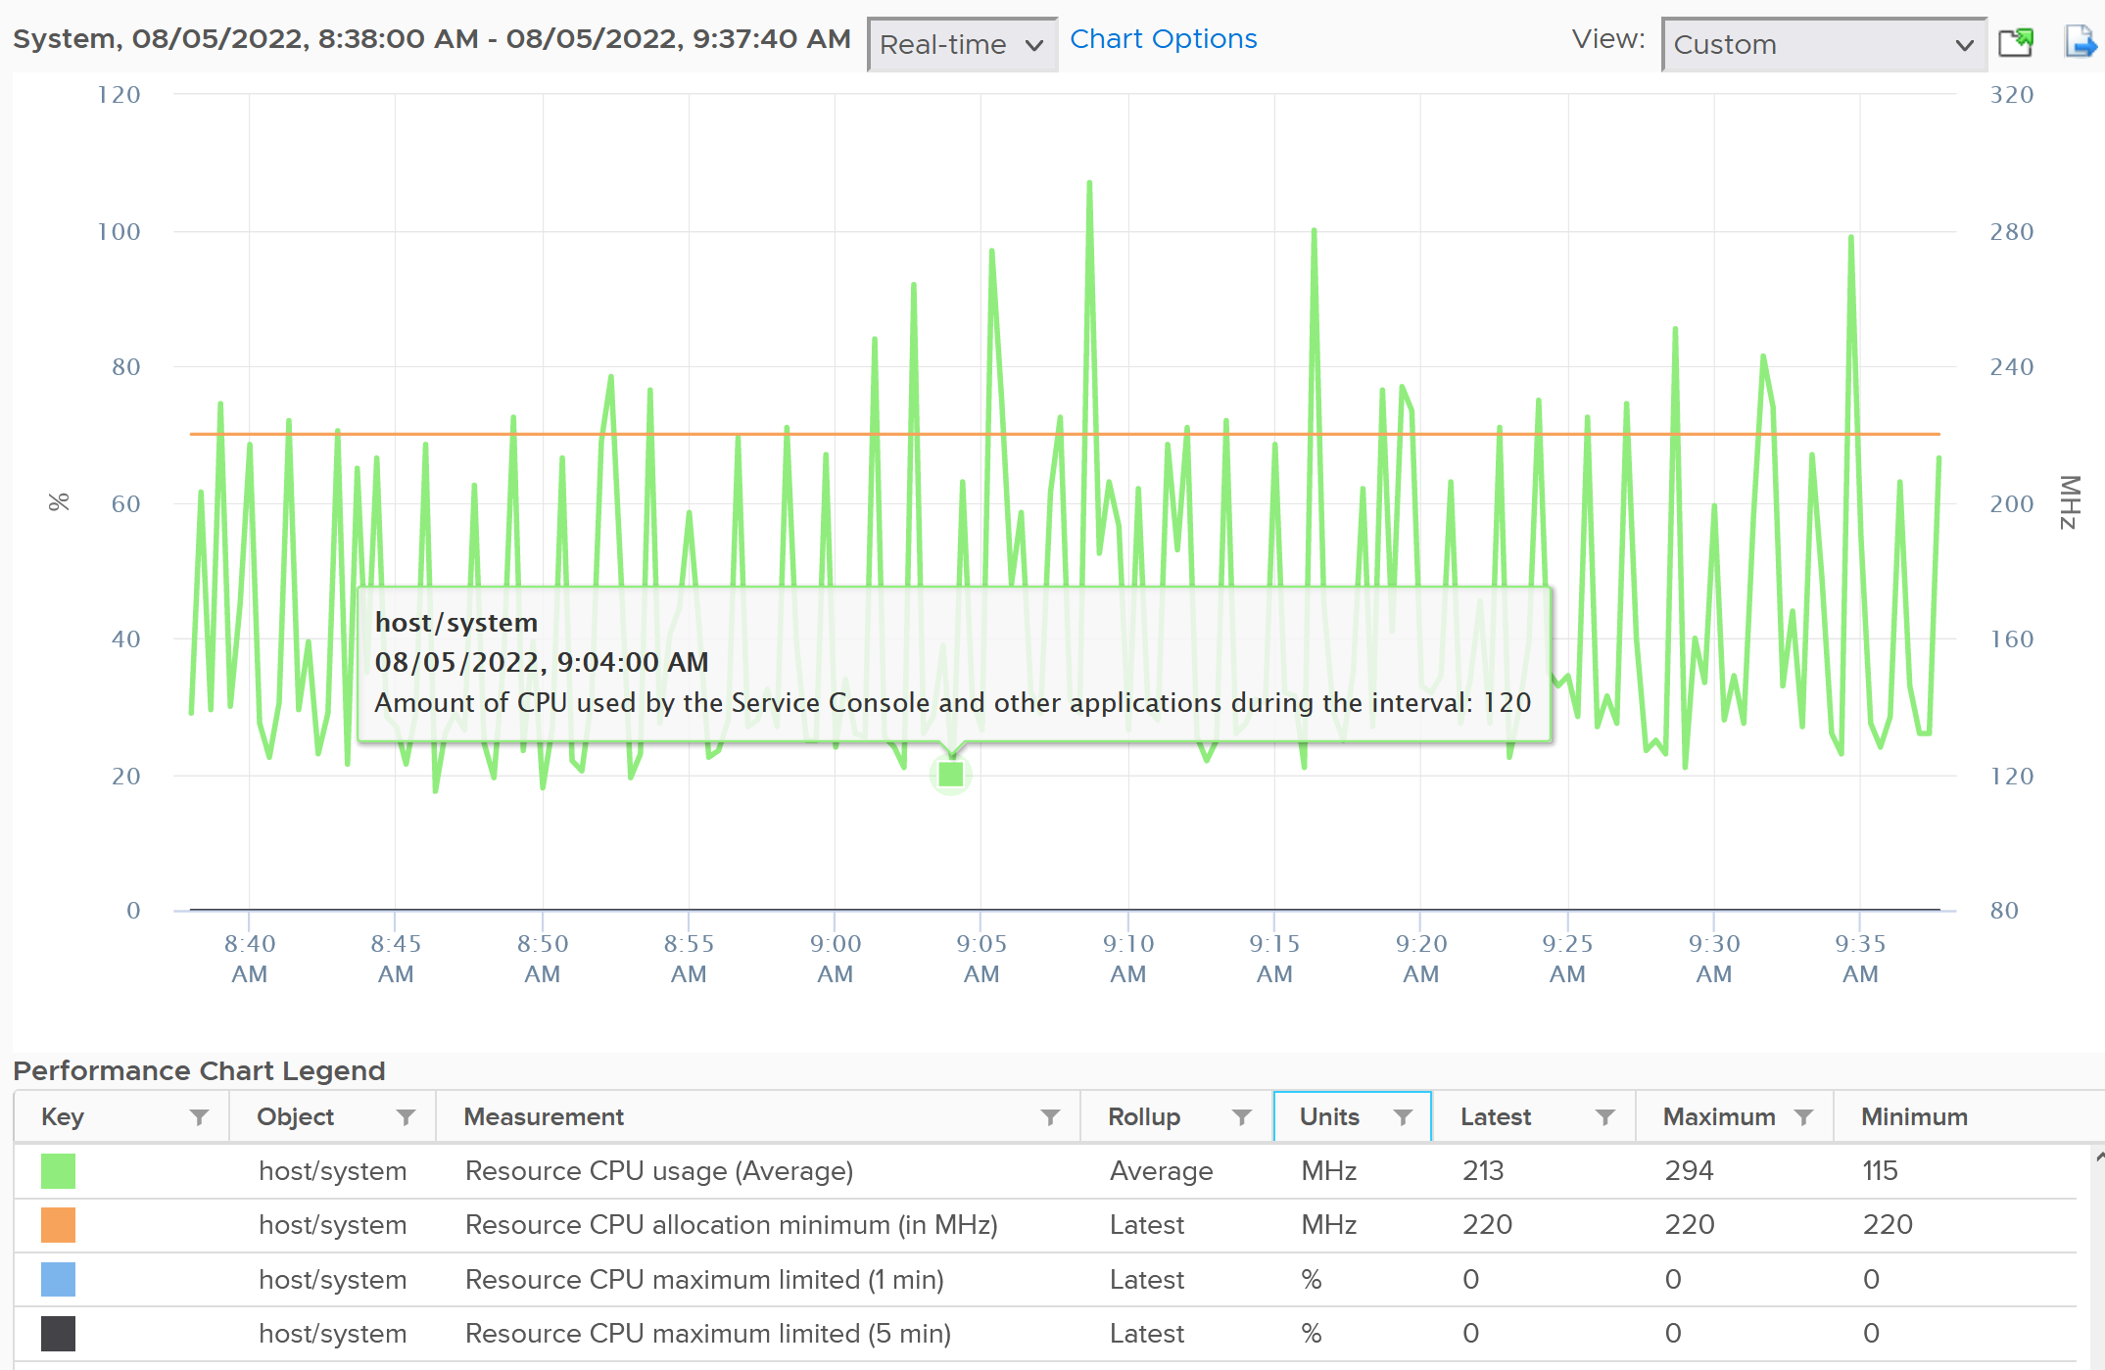

Allocation could be lower as it’s the minimum. It acts like a guaranteed reservation. The usage above that amount needs to compete with other VMkernel resource pools.

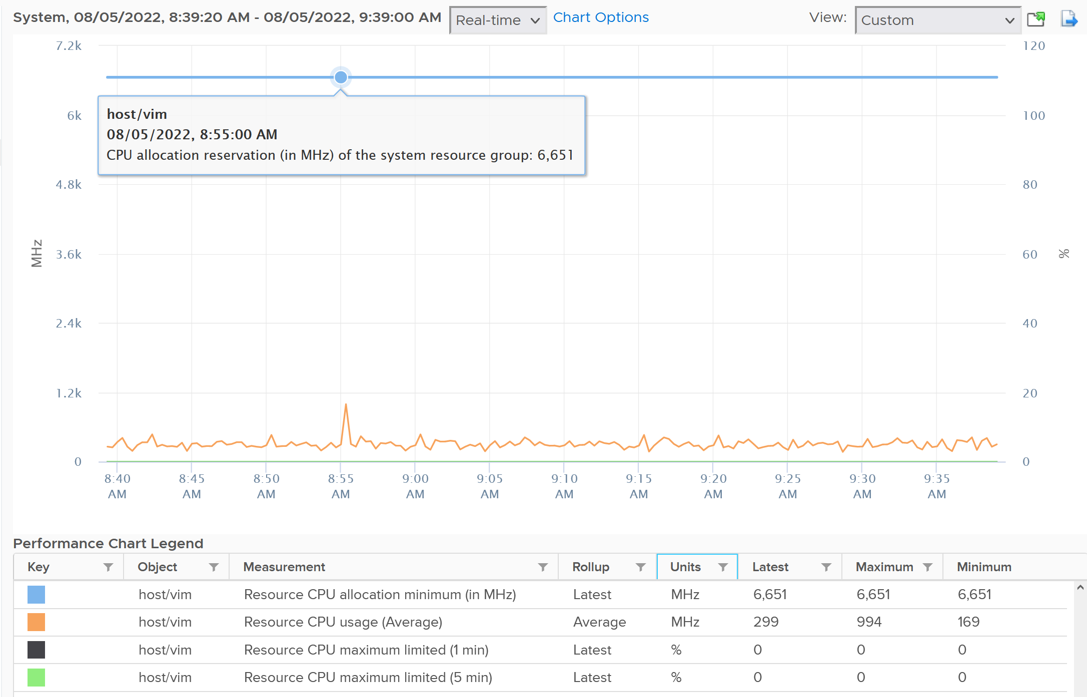

If you are curious about the actual values, they sort of map to the actual size of the ESXi. Based on a sample of almost 400 ESXi in production environment, here is what I got. By far the majority of the value is 6 – 10 GHz.



Their values tend to be stable over days, although from time to time I see fluctuating counters. I’m unsure why they are fluctuating so frequently as it’s a reservation, so if you know let me know. The following chart shows both the fluctuating pattern and steady pattern (most common). They are from 2 ESXi hosts.



What if you want to know the actual consumption? vCenter provides visibility into the VMkernel utilization. It’s available under **System**, and you can get CPU and memory usage and reservation (allocation).



You need to select host/iofilters, host/system, and host/vim.

Everything else runs under one of the three resource pools. You can plot their values in vCenter by stacking up their values, as shown below.



The above is for one ESXi Host. If you have many and want to see all the values in one go, create a view in vRealize Operations. Here is a sample from ~400 ESXi hosts, where I sort the top 7 from highest System usage.

#### VMkernel Memory

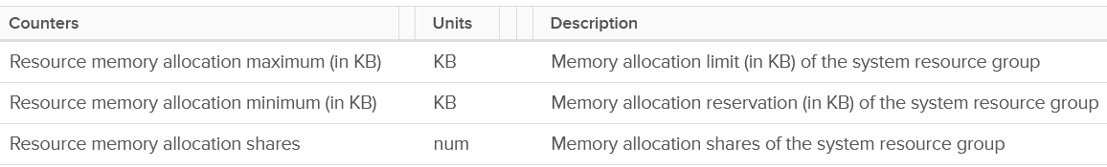

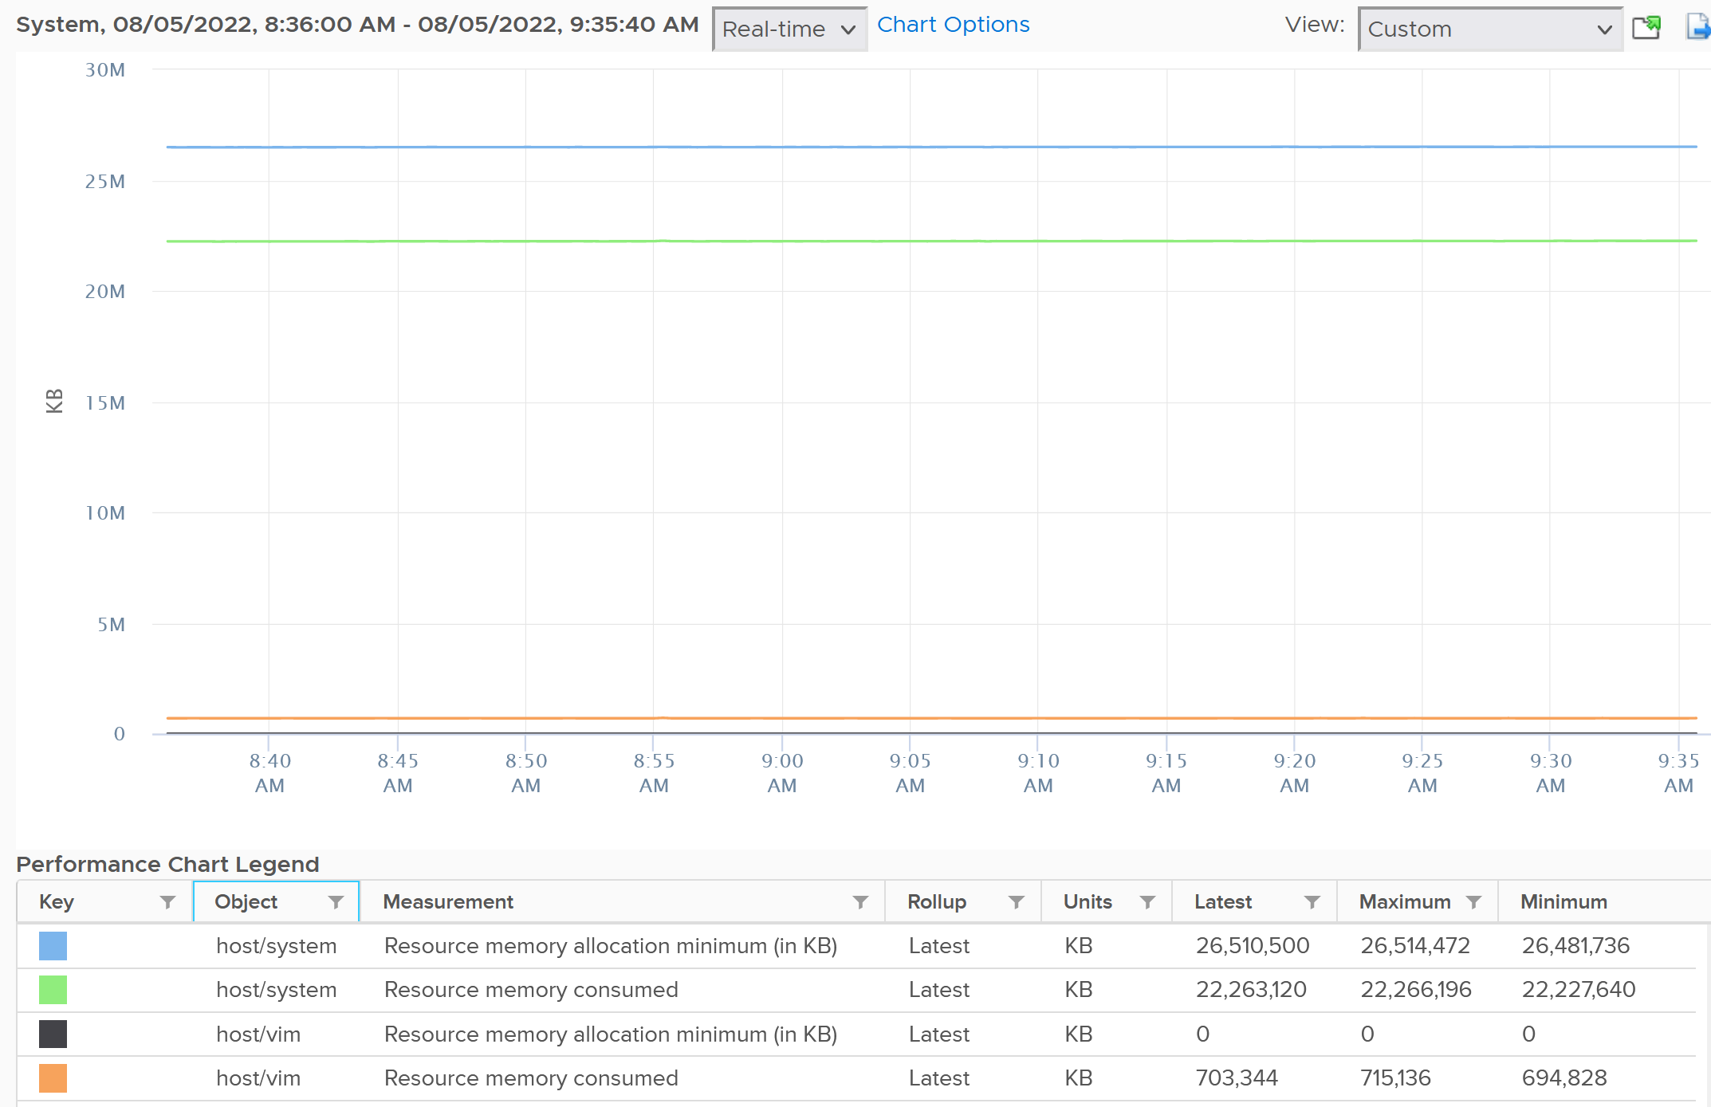

For memory, based on 310 production ESXi, the reservation ranges from 6 GB to 88 GB. The following is an ESXi 6.7 U3 host with 1.5 TB of memory. Notice the VMkernel values remains constant over a long period. The number of running VM eventually dropped to 0. While the Granted counter drops to 1.5 GB (not sure what it is since there is no running VM), the VMkernel did not drop. This makes sense as they are reservation and not the actual usage.

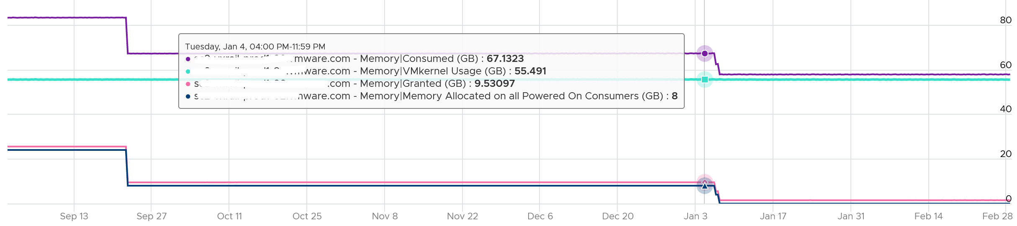

What we have covered so far is a reserved amount. The actual consumption is lower, and in some cases much lower.

The actual amount does not always correspond to the reserved amount. The following chart shows the reservation remains steady when the actual drops by 90%, from 40 GB to single digit.

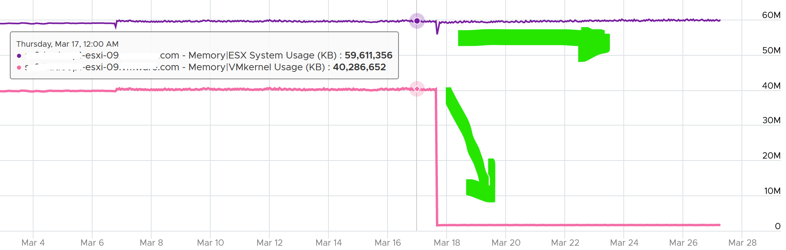

ESXi Consumed includes VMkernel, it can be more than what’s allocated to all running VMs, as shown below.

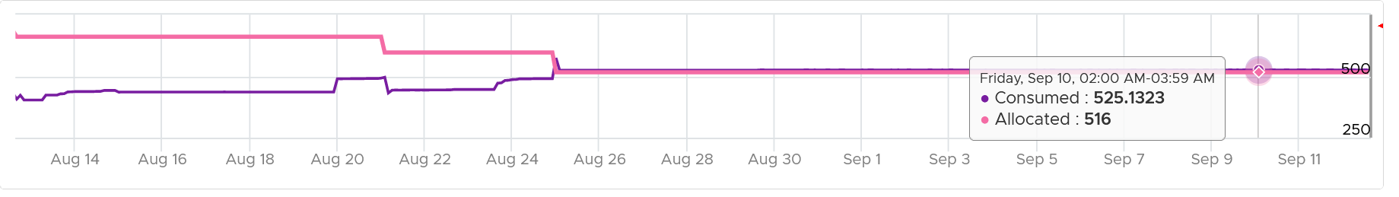

Take note that Consumed includes the actual consumption, not the reservation. The following ESXi has 0 running VM, so the Consumed is just made of VMkernel. You can see the utilization is much lower than the reservation.

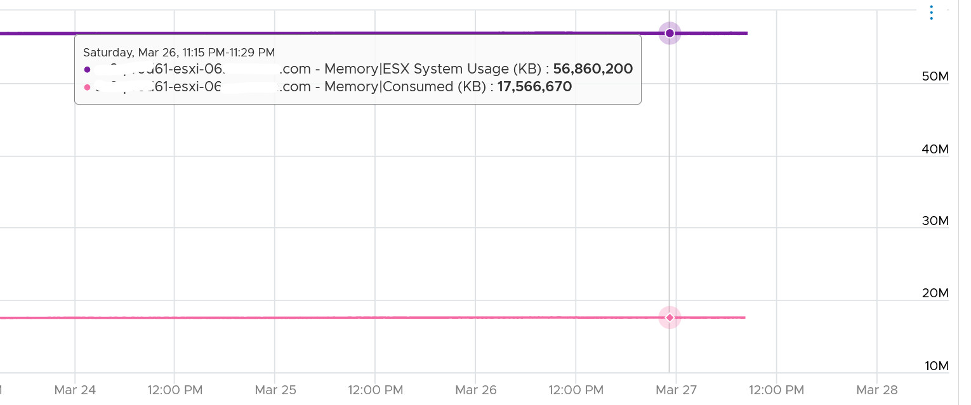

Just like any other modern-day OS, VMkernel uses RAM as cache as it's faster than disk. So the Consumed counter will be near 100% in overcommit environment. This is a healthy utilization.

Unlike Guest OS, ESXi runs VM. It does not have visibility into the Guest OS memory requirement. So it does not have the metric equivalent to In Use in Windows. It has Active, which is not the same thing.

Just because the host is low on free physical RAM does not mean that the VMs are performing poorly. Even the presence of swapping out does not mean VMs are performing poorly when the swapped memory is not being accessed by the OS. Poor VM performance only happens when the VM experiences contention.

For memory, choose the metric Resource Memory Consumed. Stack them, and you see something like this. The system part typically dwarfs the other 2 resources.

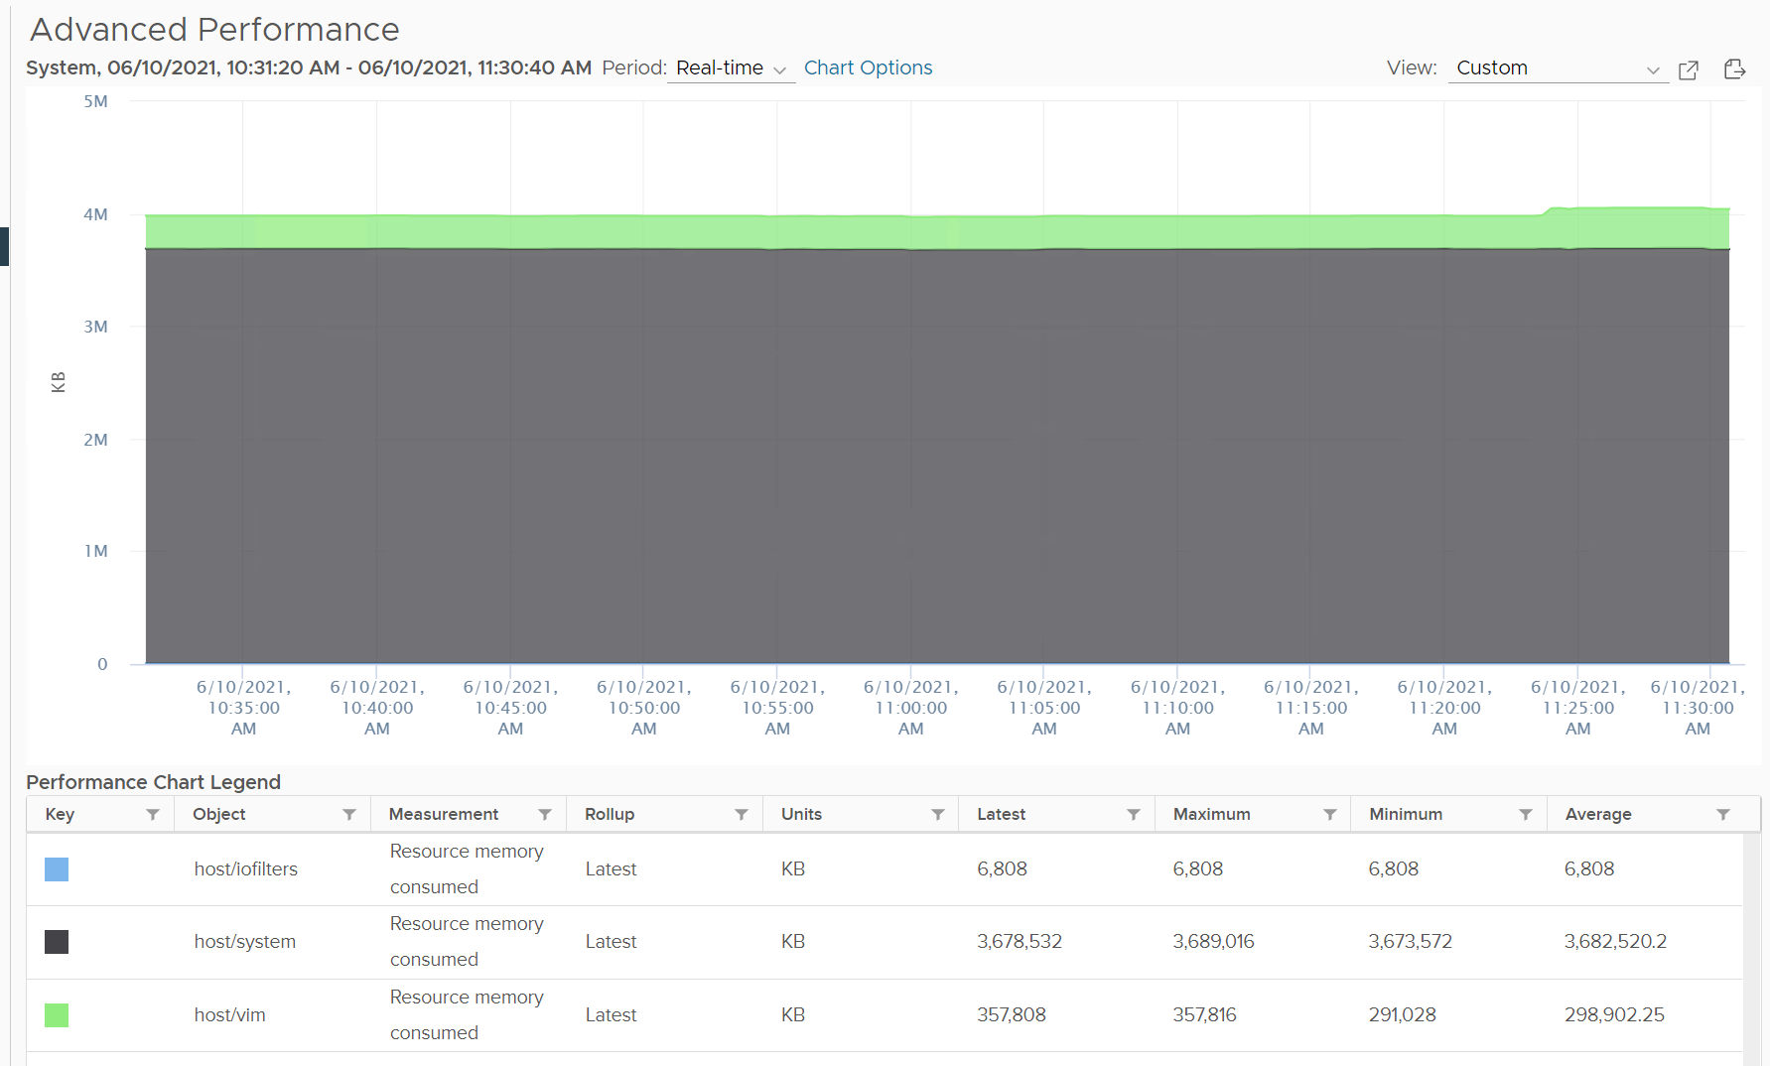

Do not take the value from Memory \ VMkernel consumed counter. That’s only the system resource. You can verify by plotting this and compare against host/system resource. You will get identical charts.

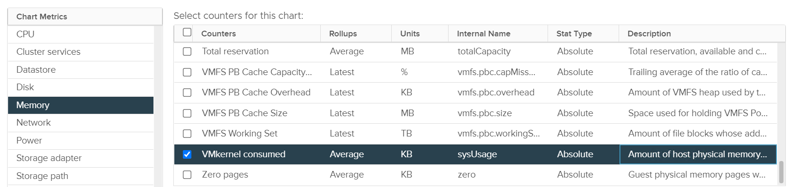



The bottom two rows show the summary. The first summary is the average among all the hosts, while the last row is the highest value.

Chapter 2

# CPU

## Concept

The nuance you saw earlier was due to the nature of additional layer. The following infographic shows there are multiple elements as a result of virtualization. It helps me to understand the metrics, hence the sharing.

[5]

### Guest OS vs VM

CPU counters for a VM differ from those in the Guest OS. For example, vCenter provides 5 counters to account for the utilization of VM CPU, yet none directly maps to Windows/Linux CPU utilization. The CPU counters in ESXi are also more than the summation of its running VM and VMkernel.

The following screenshot shows the CPU counters of a VM. Compared with Guest OS such as Windows, can you notice what’s missing and what’s added? Go ahead and open Windows PerfMon or SysInternal and compare, and you will quickly notice major differences.

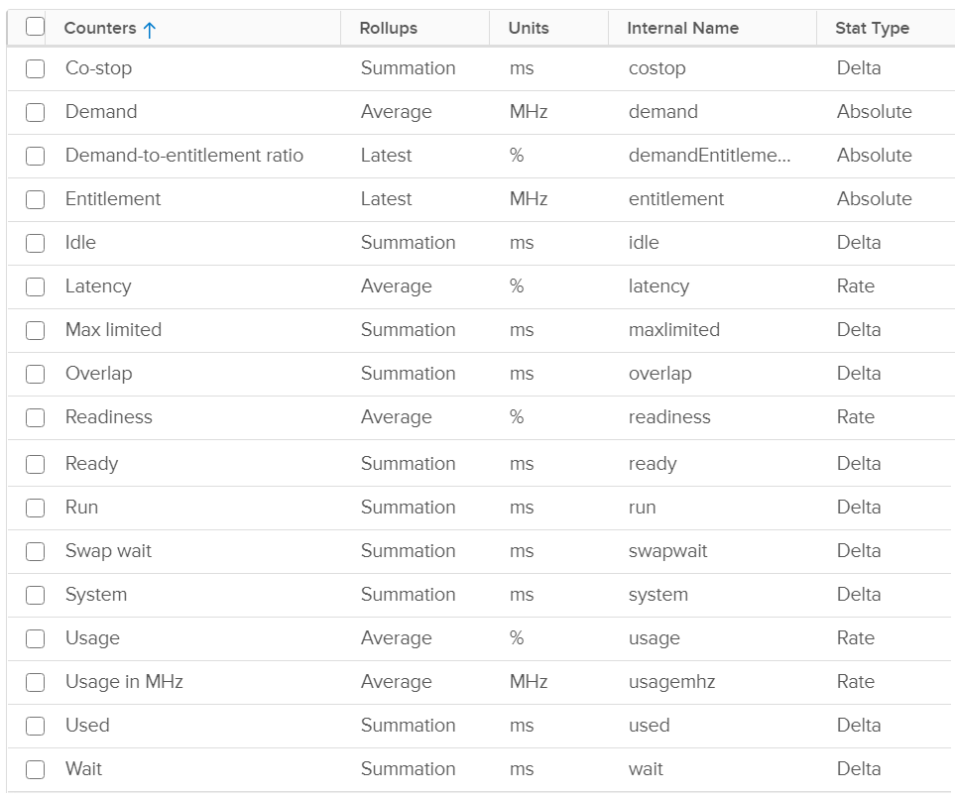

Right off the bat, you will notice that popular counters such as Ready, CoStop, and Overlap do not exist in Windows. The reason is VM and Guest OS have different vantage points.

You need to be aware that there 2 types of counters:

* Static counters. This means their values are not affected by CPU Power Management and Hyper Threading. They are typically measured in millisecond.
* Dynamic counters. This means their values fluctuates depending on CPU clock speed and HT effect. These counters are harder to “figure out” as their value can be greatly impacted. For example, HT can increase the value of CPU Latency from 0% to 37.5%

It’s easier to learn the counters by layers, mimicking the stacks.

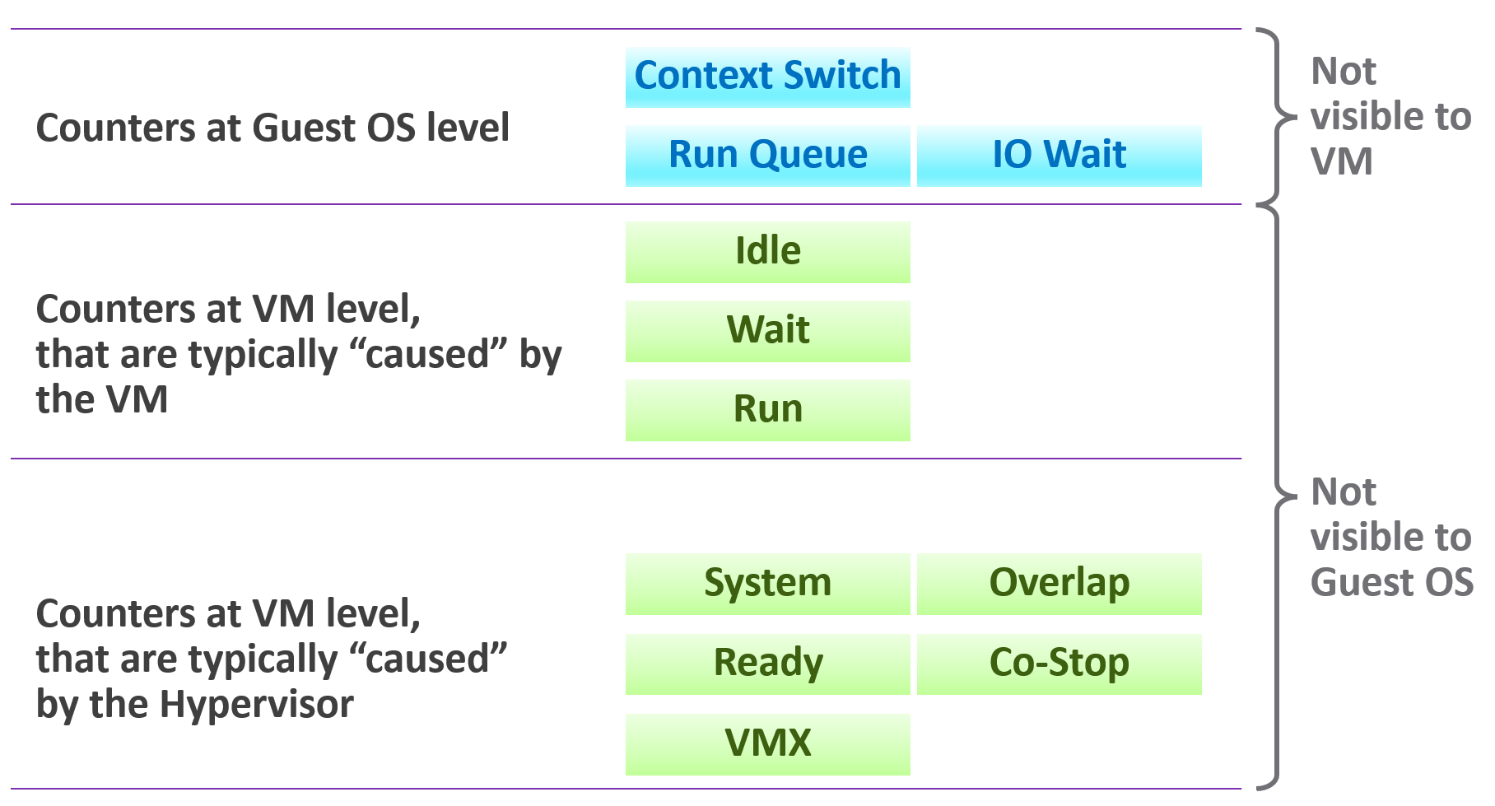

The different vantage points result in different counters. This creates complexity as you size based on what happens inside the VM, but reclaim based on what happens outside the VM footprint on the ESXi. In other words, you size the Guest OS and you reclaim the VM.

When the VMkernel de-schedules a VM to process something else (e.g. other VM, kernel interrupt) on the same physical thread or core, the Guest OS does not know why it is interrupted. In fact, it experiences frozen time for that particular vCPU running on the physical core. Time jumps when it’s scheduled again. Because of this unique visibility, it’s important to use the correct metrics at the correct layers. Here is what the Guest OS can and cannot see:

Both layers need to be monitored, as each measure different performance problems. Hence it’s imperative to install VMware Tools as VMkernel will not provide visibility into the Guest OS. VMware Tools report the statistics about guest to the ESXi host every 20 seconds by default.

### VM vs ESXi

Just like Guest OS and VM have different vantage point, the same complexity happens between VM and ESXi. You have 3 layers. This is not as complex as memory, where you have 4 layers as process running inside a Guest OS represents another layer.

For VM, you discuss vCPU. It has virtual socket and virtual core. Physical cores and physical sockets do not apply, meaning they are referring to different things.

### State of a VM vCPU

ESXi Scheduler keeps in mind the following goals:

* To balance load across physical cores.
* To preserve cache state, minimize migration cost.
* To avoid contention from hardware (hyperthreading, low level cache, etc.) and sibling vCPUs (from the same VM).
* To keep VMs or threads that have frequent communications close to each other.

With the above understanding, now look at the life of a VM vCPU.

At the most basic level, a VM CPU is either being utilized or not being utilized by the Guest OS. At any given moment, it either runs or it does not, there is no walk state.

|  |  |
| --- | --- |
| **Being used** | The hypervisor must schedule the vCPU. A multi vCPU VM has multiple schedules, 1 for each vCPU. For each vCPU:   * If VMkernel has the physical CPUs to run it, then the vCPU gets to **Run**. The Run counter is increased to track this. * If VMkernel has no physical CPUs to run it, then the vCPU is placed into **Ready** State. The VM is ready, but the hypervisor is not. The Ready counter tracks this. |
| **Not being used** | There are 2 possible reasons why it’s used:   * The CPU is truly idle. It’s not doing any work. The **Idle Wait** counter accounts for it. * The CPU is waiting for IO. CPU, being faster than RAM, waits for IO to be brought in. There are 3 sub cases here (CoStop, VM Wait and memory wait), and they will be covered later. |

With the above understanding, we’re ready to examine the following state diagram. The diagram shows a single schedule (1 vCPU, not the whole VM). It’s showing the view from hypervisor (not from inside the Guest OS):

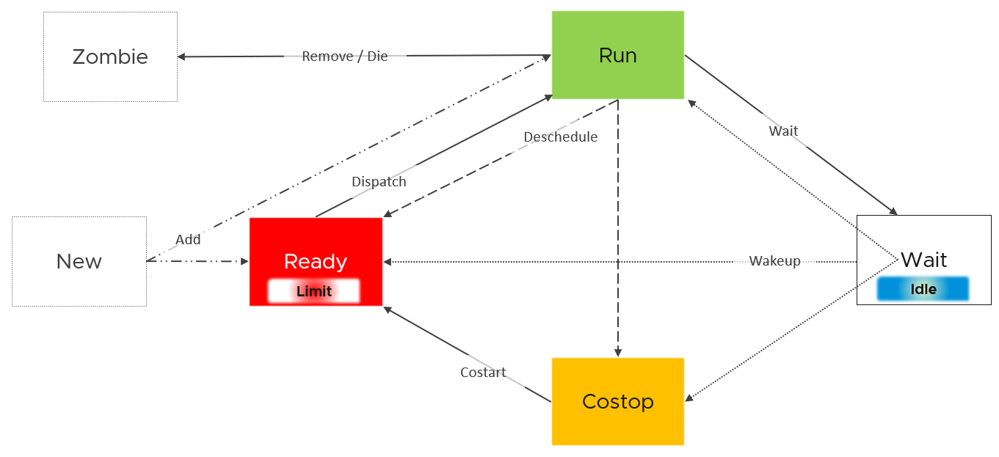

ESXi places each vCPU of the VM in one of the 4 above states. A vCPU cannot be in 2 states *at the same time*. This is fundamental in understanding the formula behind CPU counters.

* Run is when the Guest OS gets to run. It does not check how fast it runs (frequency) or how efficient it runs (hyperthreading). Run measures how long it runs, hence the counter is in milliseconds, not GHz.
* Ready and Co Stop. They are mutually exclusive states. If a vCPU is in CoStop, it is not in Ready state.
* Wait handles both Idle and Wait. The reason is the hypervisor cannot tell whether the Guest OS is waiting for IO or idle. As far as the hypervisor concern, it’s not doing anything. This also measures the state where the wait is due to hypervisor IO.

Those of you familiar with Operating Systems[6] [kernel](https://en.wikipedia.org/wiki/Kernel_(operating_system)) will notice that the diagram is similar with a physical OS scheduler state diagram. I’m taking [Huawei Harmony OS](https://device.harmonyos.com/en/docs/develop/kernel/oem_kernal_user_process-0000001050032733) as an example as it’s the newest OS and it’s designed for a range of device[7].

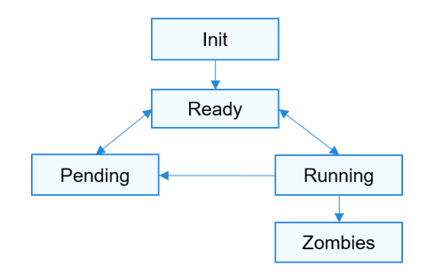

|  |  |
| --- | --- |
| Init | The process is being created.  Maps to New in VMkernel |
| Ready | The process is in the ready list and waits for being scheduled by the CPU.  Maps to Ready in VMkernel |
| Running | Maps to Run in VMkernel |
| Pending | The process is blocked and suspended. When all threads in a process are blocked, the process is blocked and suspended.  Maps to Wait in VMkernel. Notice they also include Idle here in their Wait state. |
| Zombies | Maps to Zombies in VMkernel |
| “none” | Our CoStop is unique as VM is a multi-process scheduled entity |

Back to our VMkernel 4 possible states, you can conclude that:

Run + Ready + CoStop + Wait = 100%

In vCenter, this means 20000, as vSphere UI reports every 20 seconds. vRealize Operations averages 15 of these 20-second averages into a 5-minute average.

VM 2 can run when VM 1 is on CoStop state, Ready state, or Wait state. This is because the physical thread is available.

If you open in esxtop, and you choose State Panel, you see more counters.

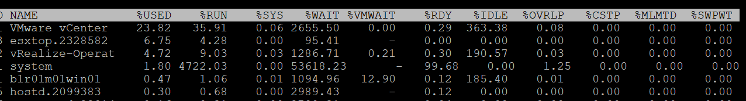

So what does it mean? How come there are more than 4 states?

The answer is below. Some of these counters are included in the other counters.

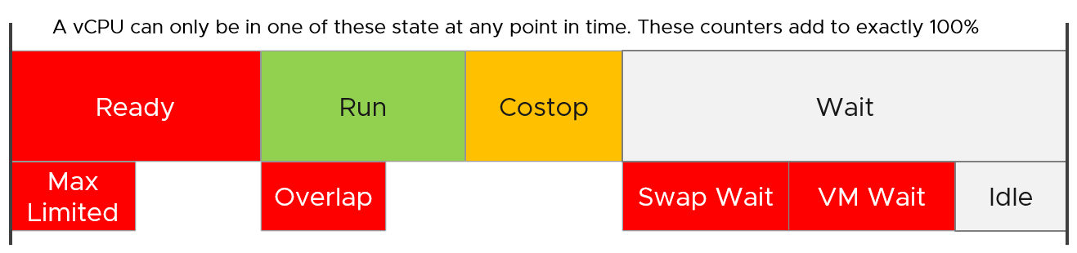

#### State across Time

The above is at any given moment. To measure over time and report it (say every 20 seconds), we need to add a time dimension. The following example shows the above state diagram repeated over time, where each block is 1 second. In reality, the scheduler checks more frequently that this.



vCenter happens to use 20000 milliseconds as the reporting cycle, hence 20000 milliseconds = 100%.

The above visually shows why Ready (%) + CoStop (%) needs to be seen in context of Run. Ready at 5% is low when Run is at 95%. Ready at 2% is very high when Run is only 10%, because 20% of the time when the VM wanted to run it couldn’t.

The above is *per vCPU*. A VM with 24 vCPU will have 480,000 as the total every 20 seconds. It matters not if the VM is configured with 1 vCPU 24 vCores or 24 vCPU with 1 vCore each.

You can prove the above by stacking up the 4 counters over time. In this VM, the total is exactly 80000 ms as it has 4 vCPU. If you wonder why CPU Ready is so high, it’s a test VM where we artificially placed a limit.

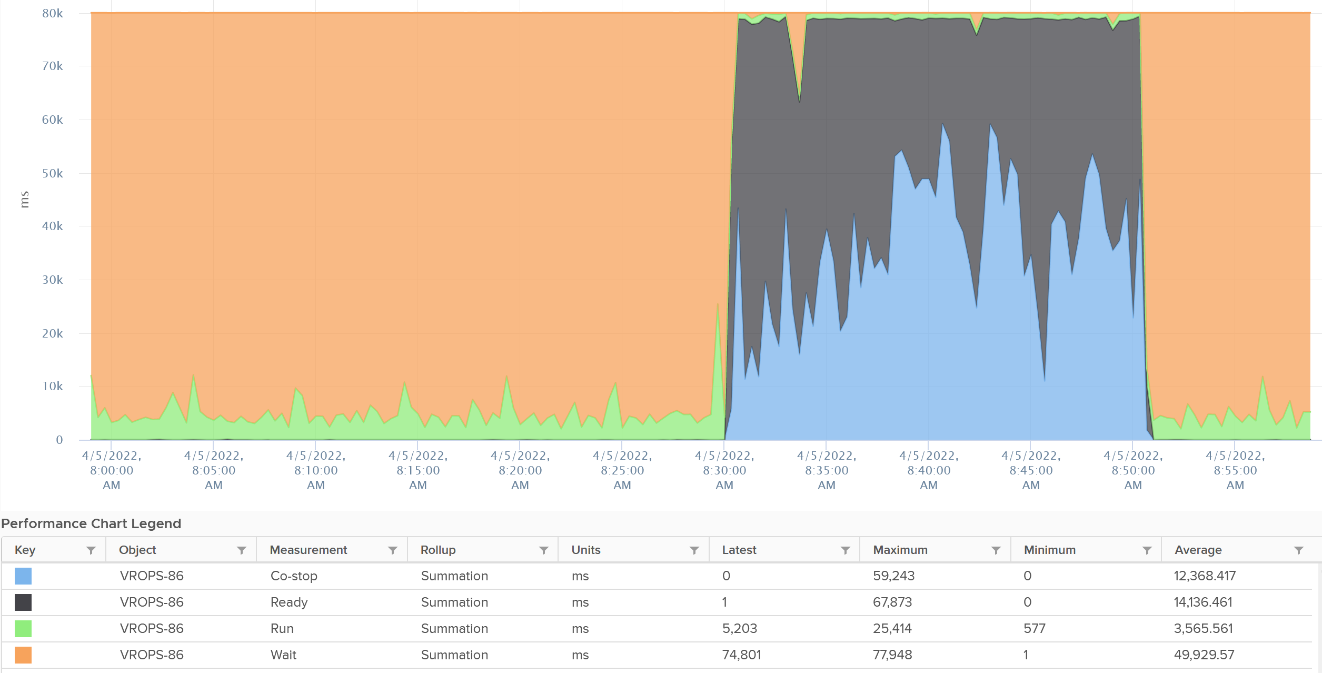

The formula for the millisecond metrics in vRealize Operations are also not normalized by the number of vCPU. The following shows the total adds up to 80000 as the VM has 4 vCPU.



This is why you should avoid using the millisecond counter. Use the % version instead. They have been normalized.

### Simultaneous Multithreading

We’ve covered a lot of counters. Before we cover the rest, we need to cover CPU [SMT](https://en.wikipedia.org/wiki/Simultaneous_multithreading) (Hyper Threading as Intel calls it), as it impacts their value.

SMT is known to deliver higher *overall throughput*. It increases the overall throughput of the core, but at the expense of individual thread performance. The increase varies depending on the load.

Accounting wise, ESXi records this overall boost at 1.25x regardless of the actual increase, which maybe less or more than 1.25x. That means if both threads are running at the same time, the core records 1.25x overall throughput but each thread only gets 62.5% of the shared physical core. This is a significant drop from the perspective of each VM. From the perspective of each VM, it is better if the second thread is not being used, because the VM could then get 100% performance instead of 62.5%. Because the drop could be significant, enabling the latency sensitivity setting will result in a full core reservation. The CPU scheduler will not run any task on the second HT.

The following diagram shows 2 VMs sharing a single physical core. Each run on a thread of the shared core. There are 4 possible combinations of Run and Idle that can happen:



Each VM runs for half the time. The CPU Run counter = 50%, because it’s not aware of HT. But is that really what each VM gets, since they have to fight for the same core?

The answer is obviously no. Hence the need for another counter that accounts for this. The diagram below shows what VM A actually gets. The allocation is fixed.



The CPU Used counter takes this into account. In the first part, VM A only gets 62.5% as VM B is also running. In the second part, VM A gets the full 100%. The total for the entire duration is **40.625**%. CPU Used will report this number, while CPU Run will report **50%**.

If both threads are running all the time, guest what CPU Used and CPU Run will report?

62.5% and 100% respectively.

### Power Management

The 2nd factor that impacts CPU accounting is CPU clock speed. The higher the frequency (GHz), the faster the CPU run. All else being equal, a CPU that run at 1 GHz is 50% slower than when it runs at 2 GHz. On the other hand, Turbo Mode can kick in and the CPU clock speed is higher than stated frequency. Turbo Boost normally happens together with power saving on the same CPU socket. Some cores are put to sleep mode, and the power saving is used to turbo mode other cores. The overall power envelope within the socket remains the same.

Each core can have its own frequency. This makes rolling up the number to ESXi level more complex. You can’t derive one throughput counter from the other. Each has to be calculated independently at core level.

#### CPU Architecture

As CPU architecture moves towards [System on a Chip](https://en.wikipedia.org/wiki/System_on_a_chip) design, it’s important not to assume that a CPU socket is a simple and linear collection of cores. Take a 64-core [AMD EPYC](https://www.amd.com/system/files/documents/overview-amd-epyc7003-series-processors-microarchitecture.pdf) for example. It’s actually made of 8 Core Complex Dies. From the following diagram, you can see that a thread on CCD 0 is relatively close to a thread that runs on the same CCX, but far to a thread that runs on another CCD. You can see an example of the performance impact [here](https://blogs.vmware.com/performance/2020/04/amd-epyc-rome-application-performance-on-vsphere-series-part-1-sql-server-2019.html).



Another consideration you need to be aware of is [NUMA](https://en.wikipedia.org/wiki/Non-uniform_memory_access).

#### CPU States

There are 2 types of power states as defined by [ACPI](https://en.wikipedia.org/wiki/Advanced_Configuration_and_Power_Interface) standard.

|  |  |
| --- | --- |
| **C-State** | There are 3 possible states of a core.  C0 = fully running. Within this C0 state, there is a further dimension called P-State.  C1 = C1 is a shallow state where the clock is gated (switched off). However, all the modules remain active, and the processor can go back to the active C0 state instantaneously. powered on. In power management policies that do not use deep C-states, ESXi uses only C1  C2 - Cn= varying degrees of CPU sections turned off. The higher the C state, the deeper the sleep, so the longer the time to get back to. When a CPU is idle, ESXi applies deep halt states, also known as C-states. The deeper the C-state, the less power the CPU uses, but the longer it takes for the CPU to start running again. ESXi predicts the idle state duration and chooses an appropriate C-state to enter. |
| **P-State** | There are 14 grades of CPU performance, measured by its frequency. You can see all the frequencies in esxtop if your hardware supports it.  P0 state where Turbo Boost happens.  P1 is where it runs at Nominal Frequency (NF).  P13 is the lowest CPU frequency. |

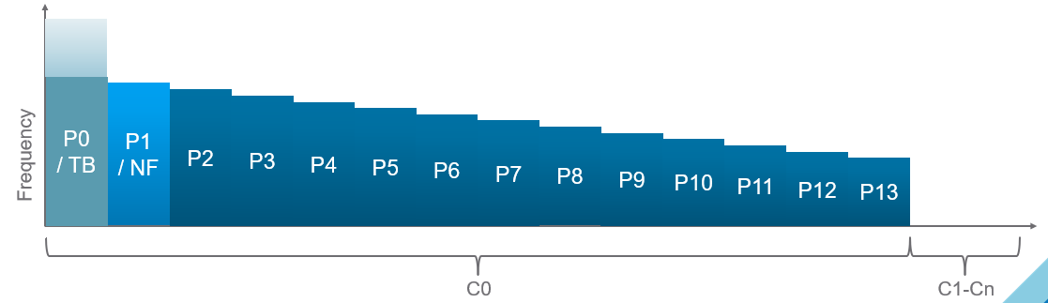

For details on P-State and C-State, see Valentin Bondzio and [Mark Achtemichuk](https://twitter.com/vmMarkA), [VMworld 2017, Extreme Performance Series](https://www.youtube.com/watch?v=EYggYAwjz3g).

#### Impact on Performance

How high can Turbo/Boost go?

High enough that it your performance and capacity need to account for it.

The following diagram is taken from page 12 of **Host Power Management in VMware vSphere 7.0** whitepaper by [Ranjan Hebbar](https://www.linkedin.com/in/ranjan-h-199b9ab2/) and [Praveen Yedlapalli](https://www.linkedin.com/in/praveen-yedlapalli-a9821324/). It shows that Intel Xeon Platinum 8260 can increase its speed by 1.29x (from 2.4 GHz to 3.1 GHz). If it only needs to increase 1 core, that single core can go up by 1.62x. This will be noticeable by application that is CPU intensive. Consider this benefit before you decide to disable power management. The high performance is static, it runs at the same frequency throughout.

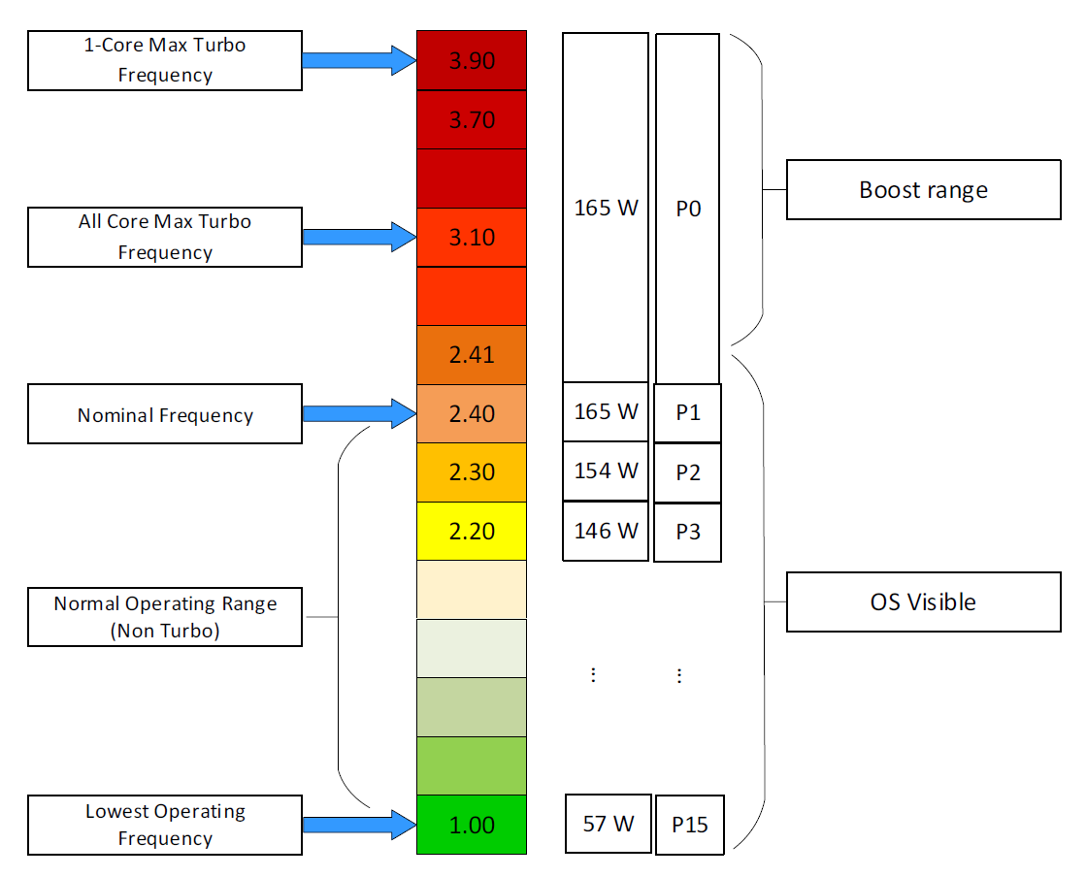

#### Viewing the Impact

The following screenshot shows ESXi with 14 P-States, where P0 is represented as 2401 MHz. Each row is a physical thread as HT is enabled.

See PCPU 10 and 11 (they share core 6). What do you notice?



Utilization (%) shows 100% for both. This means both threads run, hence competing.

The core is in Turbo Boost. The %A/MPERF shows frequency increase of 30% above nominal. The core is in C0 state and P0 state. [This](https://www.vmware.com/content/dam/digitalmarketing/vmware/en/pdf/techpaper/performance/whats-new-vsphere65-perf.pdf) counter was introduced in ESXi 6.5. No they are not in vSphere Client UI.

Why is Used (%) for PCPU 10 and 11 are showing ~63% and 62.9%?

Unlike Utilization (%) which adds up to 200%, Used (%) adds up to 100%. So each thread is maximum 50%

But Used (%) considers frequency scaling. So 50% x 130% = 65%. Pretty close to the numbers shown there.

Does it mean we should always set power management to maximum?

No. ESXi uses power management to save power without impacting performance. A VM running on lower clock speed does not mean it gets less done. You only set it to high performance on latency sensitive applications, where sub-seconds performance matters. VDI, VoIP, video calling, Telco NFV are some examples that are best experienced with low latency.

#### Impact of Low Latency

You can reduce the latency and jitter caused by virtualization by essentially “reserving” the physical resource to a VM. In the vSphere Client UI, edit VM settings, and go to VM Options tab.

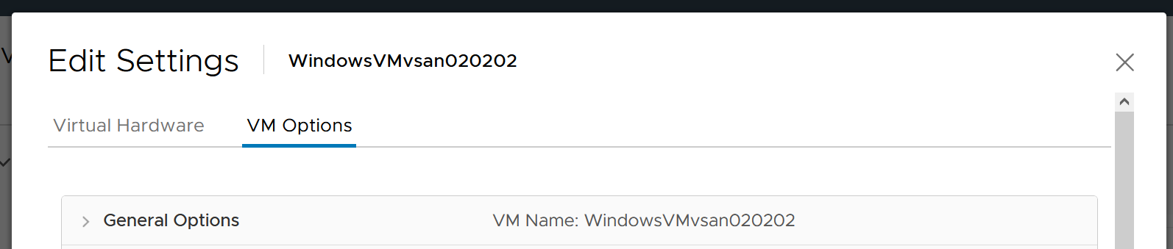

Scroll down until you see this option.

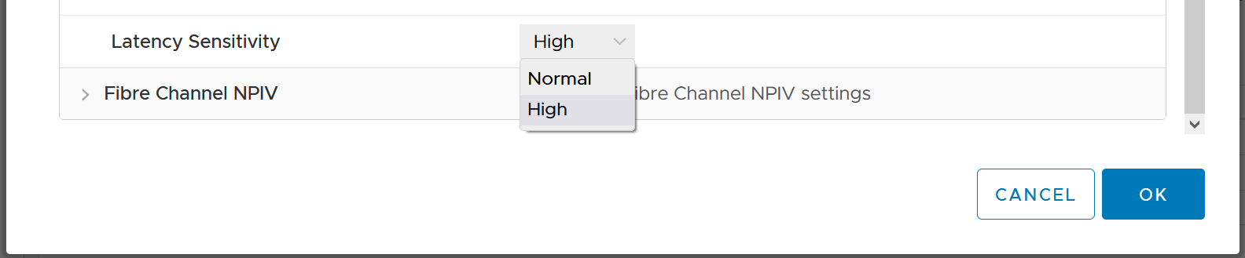

What happens to the counters when you set Latency Sensitivity = High?

##### Memory Impact

Memory is fundamentally storage. So I do not expect any of the counter to go up. They will go up when the VM actually needs them

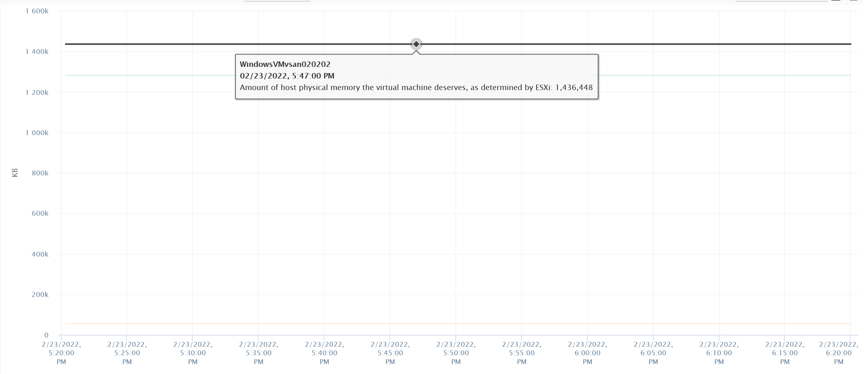

The above VM has 4 GB of RAM, fully reserved. But since it’s basically idle, there is no change on the counter.

##### CPU Impact

CPU is different. That “pipeline” has to be made available. In a sense, the CPU is scheduled 100% of the time. This prevents any wakeup or scheduling latencies that result of having to schedule a vCPU when it wakes up in the first place. Yes, the exclusive bit of exclusive affinity is literal.

Let’s see what it looks like in esxtop. I’ve removed unnecessary information so it’s easier to see. What do you notice?

GID NAME %USED %RUN %SYS %WAIT %IDLE

153670 vmx 0.03 0.03 0.00 100.00 0.00

153670 NetWorld-VM-2127520 0.00 0.00 0.00 100.00 0.00

153670 NUMASchedRemapEpochInitialize 0.00 0.00 0.00 100.00 0.00

153670 vmast.2127520 0.00 0.00 0.00 100.00 0.00

153670 vmx-vthread-212 0.00 0.00 0.00 100.00 0.00

153670 vmx-filtPoll:WindowsTest 0.00 0.00 0.00 100.00 0.00

153670 vmx-mks:WindowsTest 0.00 0.00 0.00 100.00 0.00

153670 vmx-svga:WindowsTest 0.00 0.00 0.00 100.00 0.00

153670 vmx-vcpu-0:WindowsTest 0.31 100.21 0.00 0.00 0.00

153670 vmx-vcpu-1:WindowsTest 0.16 100.21 0.00 0.00 0.00

153670 vmx-vcpu-2:WindowsTest 0.15 100.21 0.00 0.00 0.00

153670 vmx-vcpu-3:WindowsTest 0.15 100.21 0.00 0.00 0.00

153670 LSI-2127520:0 0.00 0.00 0.00 100.00 0.00

153670 vmx-vthread-212:WindowsTest 0.00 0.00 0.00 100.00 0.00

We can see Run shot up to 100%. This means Wait has to go down to 0%.

Strangely, Used remains low, so we can expect that Usage remains low too. This means the formula that connect Run and Used do not apply in this extreme scenario. You’re basically cutting a physical core to the VM.

But what about Demand?

Demand shot up to 100% flat out.

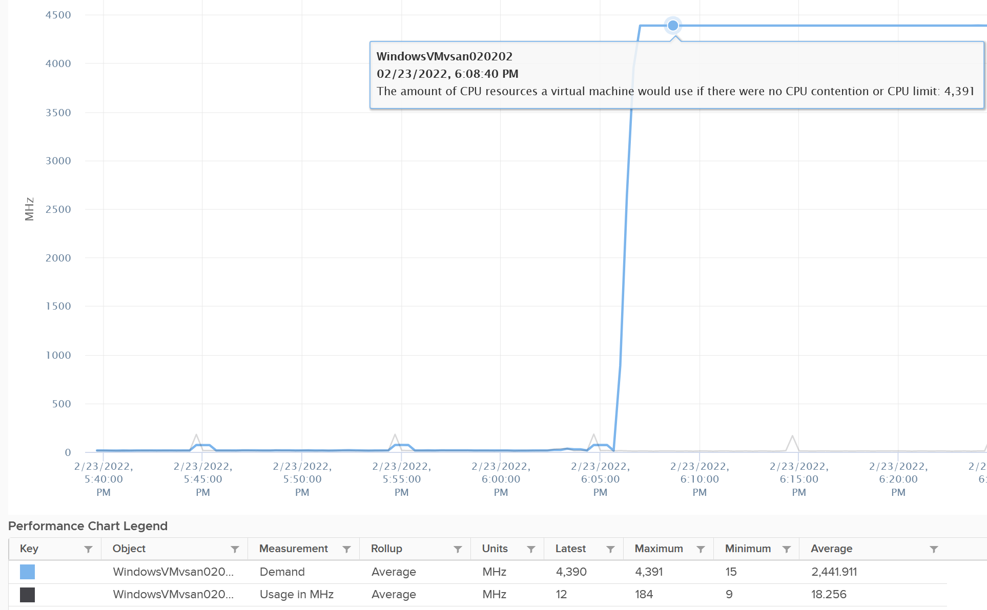

So you have an interesting situation here. Demand is 100%, Usage is 0%, yet Contention is 0%.

Now let’s plot what happened to Wait and Idle. Notice both went from 100% to 0%.

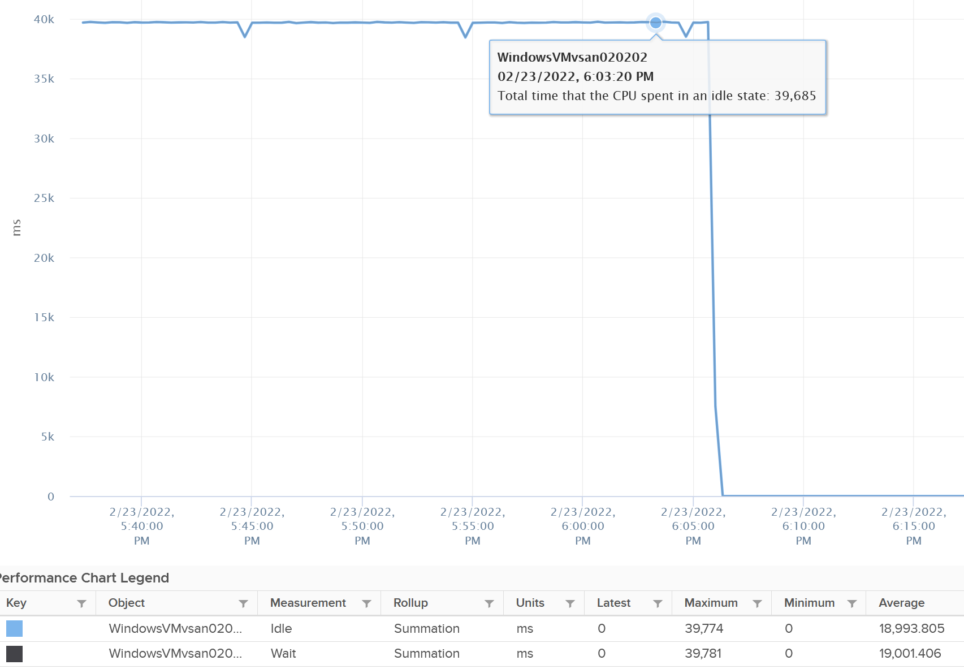

So if you combine Run, Demand, Wait and Usage counters, you can see basically Run and Demand shot up to 100% as Wait drops to 0%, while Usage is oblivious to the change.

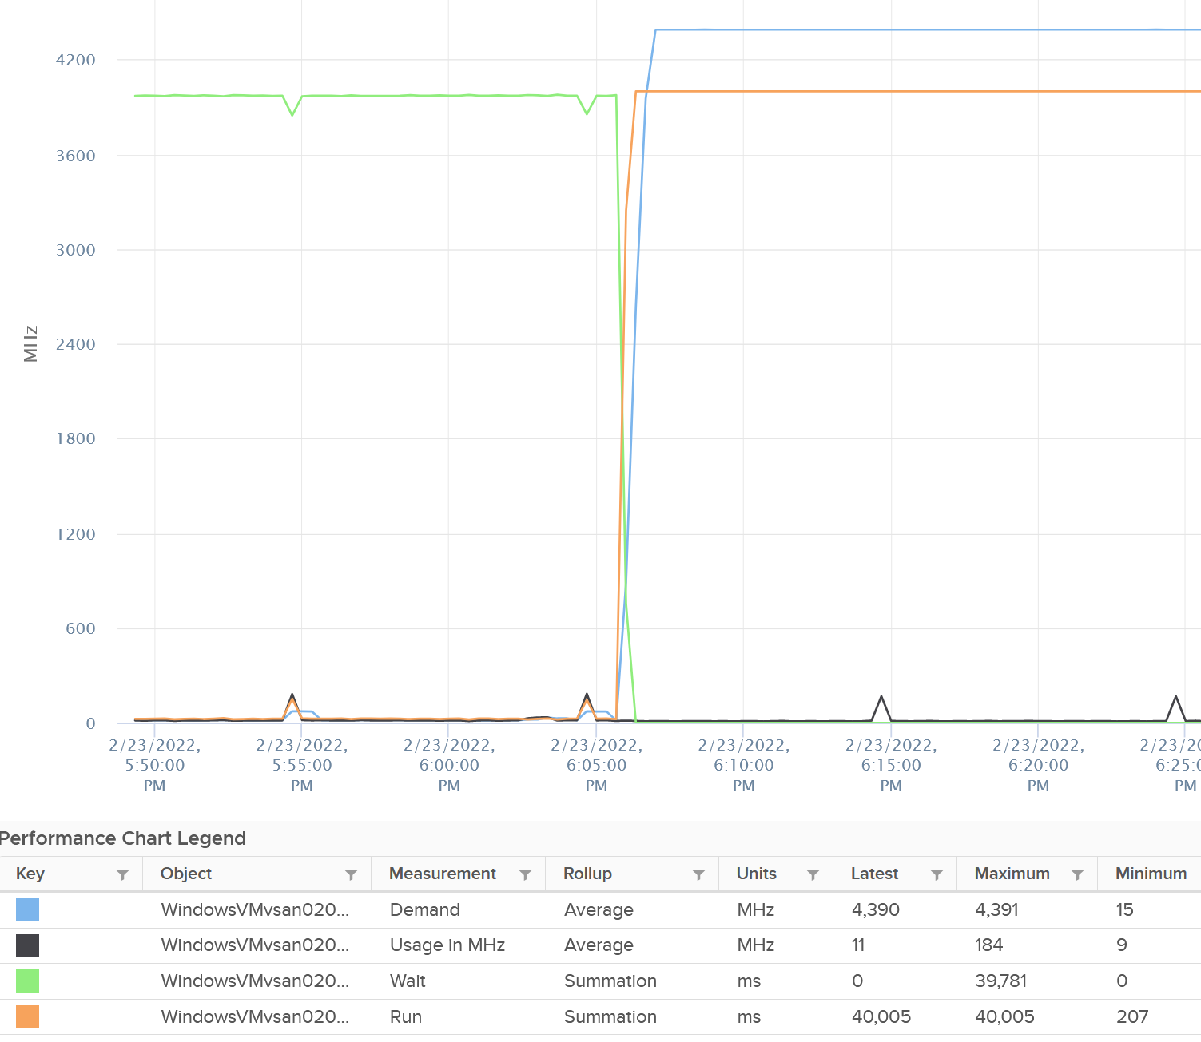

Just for documentation purpose, System and Ready are obviously not affected.

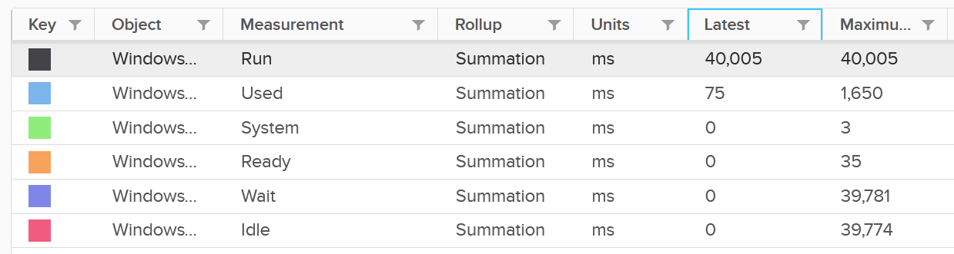

## Guest OS

From what I know, Performance Monitor is still the main tool for Windows. Go to docs.microsoft.com and browse for Windows Server, it took me to [this article](https://docs.microsoft.com/en-us/learn/modules/monitor-windows-server-performance/2-use-performance-monitor-to-identify-performance-problems), which cover PerfMon. The following screenshot shows the counters.

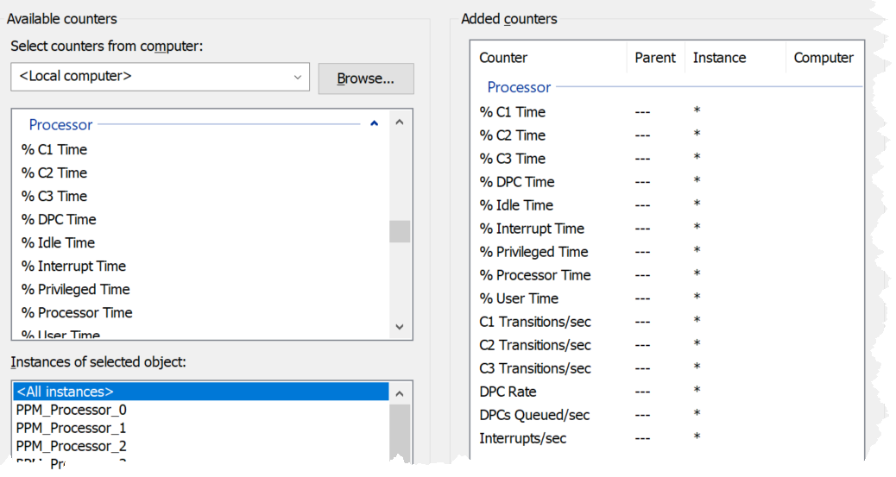

There are also CPU level counters under System group.

* Context Switches/sec
* Processor Queue Length

We start with the contention type of metrics as that’s the primary metric for performance, followed by utilization type of metrics.

ESXi cannot see how the Guest OS schedules its processes, and hence it can’t monitor the Guest OS. ESXi can only see what’s being sent out by the Guest. VMware Tools, which runs inside the Guest OS, is able to see inside the Guest OS. VMware Tools 10.3.5 or later and at least vSphere 6.0 P08, 6.5 P03, and 6.7 U1 are required for this.

### Guest OS CPU Run Queue

Number of threads in the processor queue. For Windows, this counter excludes the threads that are running (being executed). For Linux, it includes the threads in the CPU pipeline.

Let’s take a VM configured with 8 vCPUs. The Guest OS sees 8 threads so it will schedule up to 8 parallel processes. If there is more demand, it will have to queue them. This means the queue needs to be accounted for in Guest OS sizing.

Because it reports the queue, this is the *primary* counter to measure Guest OS performance. It tells you if the CPU is struggling to serve the demand or not.

What is a healthy value?

Windows Performance Monitor UI description is not consistent with MSDN documentation (based on Windows Server 2016 documentation). One document states that a sustained processor queue of greater than 2 threads generally indicates processor congestion. However, another states that “sustained processor queue of less than 10 threads per processor is normally acceptable, dependent of the workload”. SQL Server document states 3 as the threshold. Let me know if you have seen other recommendation from Microsoft or Linux.

Windows or Linux utilization may be 100%, but as long as the queue is low, the workload is running as fast as it can. Adding more vCPU will in fact slow down the performance as you have higher chance of context switching.

There is a single queue for processor time even on computers with multiple processors. Therefore, if a computer has multiple processors, you need to divide this value by the number of processors servicing the workload. That’s why Tools reports the total count of the queues. This counter should play a role in the Guest OS CPU sizing.

You should profile your environment, because the number can be high for some VMs. Just look at the numbers I got below, where some VMs have well over 10 queues per vCPU. Share the finding with the VM Owner, as the remediation to reduce the queue could mean changing the application settings.

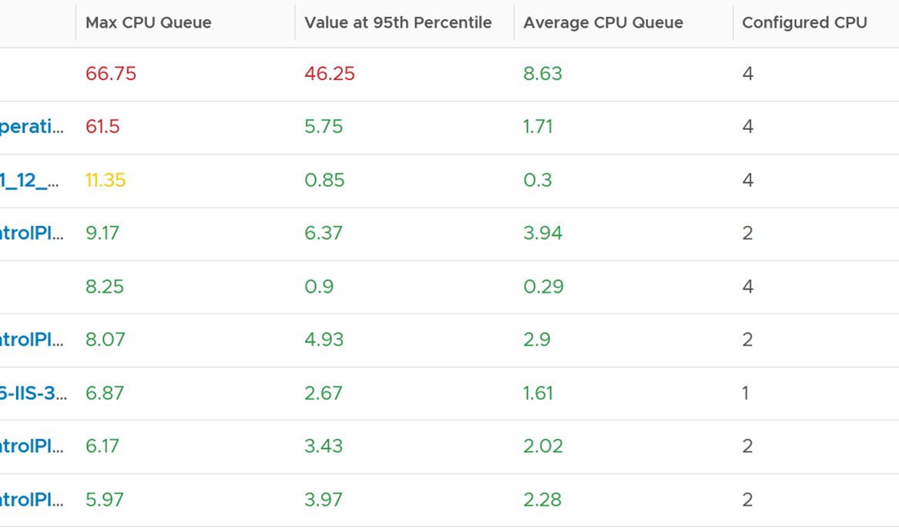

Based on the overall guidance of 3 queue per vCPU, the first 2 VM shows a high value. Both VM are only 4 vCPU, so we expect the queue value to be less than 20, preferably less than 10.

The first VM shows a sustained value as it’s still relatively high at 95th percentile. Let’s drill down to see the first VM.



The CPU Run Queue spikes multiple times. It does not match the CPU Usage and CPU Context Switch Rate in pattern. I’m unsure how to explain this so if you know drop me a note. I notice the data collection is erratic though, so let’s look at another VM.

The following is a 2 vCPU VM running Photon OS. CPU Queue is high, even though Photon is only running at 50%. Could it be that the application is configured with too many threads that the CPU is busy doing context switching? Notice the CPU Queue maps the CPU Context Switch Rate and CPU Run. In this situation, you should bring it up to the application team attention, as it may cause performance problem and the solution is to look inside. As a proof that it’s not because of underlying contention, I added CPU Ready.



This property displays the last observed value only; it is not an average. Windows & Linux do not provide the highest and lowest variants either.

For Linux, we use the value of procs_running from /proc/stat (kernel/system statistics). It shows the number of processes in runnable state. It is same as the value from /proc/loadavg. It is the sum of all CPU thread run queue. The nr_running field includes currently running tasks and ready but not running tasks.

Reference: [Windows](https://msdn.microsoft.com/en-us/library/aa394272(v=vs.85).aspx) and [Linux](http://man7.org/linux/man-pages/man5/proc.5.html).

I can’t find documentation that states if CPU Hyper Threading (HT) technology provides 2x the number of queue length. Logically it should as the threads are at the start of the CPU pipelines, and both threads are interspersed in the core pipeline.

### Guest OS CPU Context Switch

[CPU Context Switch](https://en.wikipedia.org/wiki/Context_switch) costs performance “due to running the [task scheduler](https://en.wikipedia.org/wiki/Scheduling_(computing)), TLB flushes, and indirectly due to sharing the [CPU cache](https://en.wikipedia.org/wiki/CPU_cache) between multiple tasks”. It’s important to track this counter and at least know what’s an acceptable behaviour for that specific application.

Context switches are considered “expensive” operations, as the CPU can complete many instructions within the time taken to switch context from one process to another. If you are interested, I recommend reading [this paper](https://www.inf.ed.ac.uk/teaching/courses/os/coursework/lcpusched-fullpage-2x1.pdf).

Based on Windows 10 Performance Monitor documentation, context switches/sec is the combined rate at which all processors on the computer are switched from one thread to another. All else being equal, the more the processors, the higher the context switch. Note that thread switches can occur either inside of a single multi-thread process or across processes. A thread switch can be caused either by one thread asking another for information, or by a thread being pre-empted by another, higher priority thread becoming ready to run.

There are context switch counters on the System and Thread objects. vRealize Operations only report the total.

The rate of Windows or Linux switching CPU context per second ranges widely. The following is taken from a Windows 10 desktop with 8 physical threads, which runs around 10% CPU. I observe the value hovers from 10K to 50K.



The value should correlate with CPU “utilization”, since in theory the higher the utilization the higher the chance of CPU context switch. The following chart shows a near perfect corelation. Every time CPU Usage went up, CPU Context Switch also.



CPU context switch can happen even in a single thread application. The following shows a VDI VM with 4 vCPU. I plotted the CPU Usage Disparity vs CPU Context Switch. You can see the usage disparity went up to 78%, meaning the gap between the busiest vCPU and the most idle vCPU is 78%. This was running a security agent, which is unlikely to be designed to occupy multiple vCPU.



Let’s plot the context switch at the same period. There is a spike at the same time, indicating that the agent was busy context switching. Note that it does not always have to be this way. The red dot shows there is no spike in context switch even though the vCPU Usage Disparity went up.



The value of CPU Context Switch vary widely. It can go well beyond 0.5 million, as shown in the following table, hence it’s important to profile and establish a normal base line for that specific application. What is healthy for 1 VM may not be healthy for another.



You can see from the table that some VM experience prolonged CPU context switch, while others do not. The VM #4 only has a short burst as the value at 95th percentile dropped to 3796. Momentary peak of context switch may not cause performance problem so in general it’s wiser to take the value somewhere between 95th and 99th percentile.

Let’s drill down to see the first VM. This CentOS VM sporting only 4 vCPU constantly hit almost 1 million context switch. The pattern match CPU Usage.



On the other hand, majority of Guest OS spends well below 10K. I profiled around 2200 production VMs and here is the distribution of their CPU Context Switch. You can see that the values between 0 – 12000 accounts for 80%.



In your environment, you can profile it further. In the following example, I adjusted the bucket threshold by grouping all the values above 10K as one bucket, and splitting 0 – 10K bucket into multiple buckets. You can see more than half has less than 1K CPU Context Switch Rate.



## VM

Guest what’s the primary counter for VM performance? This is the main counter you should check.

My answer is CPU Ready. Let me know if you think differently.

### Ready

Ready tracks the time when a VM vCPU wants to run, but ESXi does not have a physical thread to run it. VMkernel places the VM vCPU into Ready state. Ready also accounts when Limit is applied, as the impact to the vCPU is the same (albeit for a different reason altogether). When a VM is unable to run due to Limit, it accumulates limbo time when sitting in the limbo queue. Be careful when using a Resource Pool, as it can unintentionally cause limits.

Take note that Ready is unaware of contention due to hyperthreading. The vCPU is not placed in ready state because both threads can execute at the same time. The contention for shared resources happens at low level hardware and essentially transparent to ESXi scheduler. If you are concerned about this certain degradation in throughput when two worlds execute at the same time on the same core, what counter should you use?

You’re right. It’s CPU Contention. Different purpose, different counter.

Take a look at the high spikes on CPU Ready value. It hits 40%!



Notice the overall pattern of the line chart correlates very well with CPU Usage and CPU Demand. The CPU Usage hit 3.95 GHz but the Demand shot to 6.6 GHz. This is a 4 vCPU VM running on a 2.7 GHz CPU, so its total capacity is 10.77 GHz. Why did Usage stop at 3.95 GHz?

What’s causing it?

If your guess is Limit you are right. This VM had a limit set at 4 GHz.

Ready also includes the CPU scheduling cost (normally completed in microseconds), hence the value is not a flat 0 on idle VM. You will notice a very small number. Ready goes down when Guest OS is continually busy, versus when a process keeps waking up and going to sleep, causing the total scheduling overhead to be higher. The following shows Ready is below 0.2% on an idle VM (running at only 0.8%). Notice CoStop is basically flat 0.



In rare case where the application has a lot of micro bursts, CPU Ready can be relatively higher to its CPU Run. This is due to the CPU scheduling cost. While each scheduling is negligible, having too many of them may register on the counter. If you suspect that, check esxtop, as shown below:



CPU Ready tends to be higher in larger VMs, because Ready tends to hit all vCPU at the same time. Instead of thinking of CPU ready in 2D (as shown in the first chart below), think in 3D where each vCPU moves across time. The 2nd chart below shows how the 8 vCPUs move across time better.

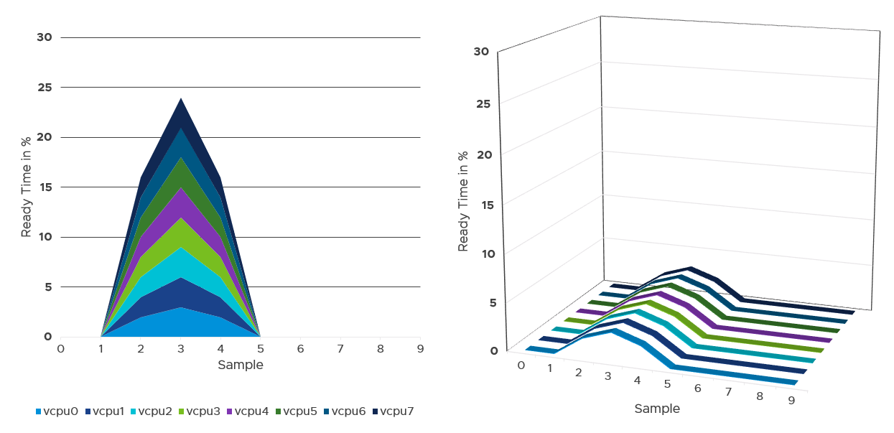

#### Best Practice

I sample 3937 VMs from production environment. For each of them, I took the 20-second peak and not the 5-minute peak.

Why do I take the 20-second?

Because it is 15x sharper in resolution. CPU Ready tends to last relatively short, so this metric will catch it. The following is a typical example.

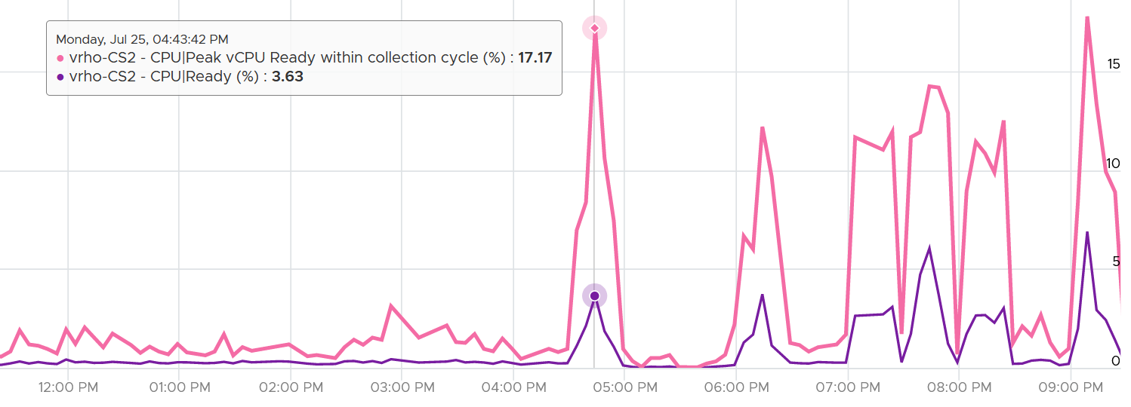

I collected 4 months worth of data, so it’s around 35040 metrics per VM.

Guest what values do we get?

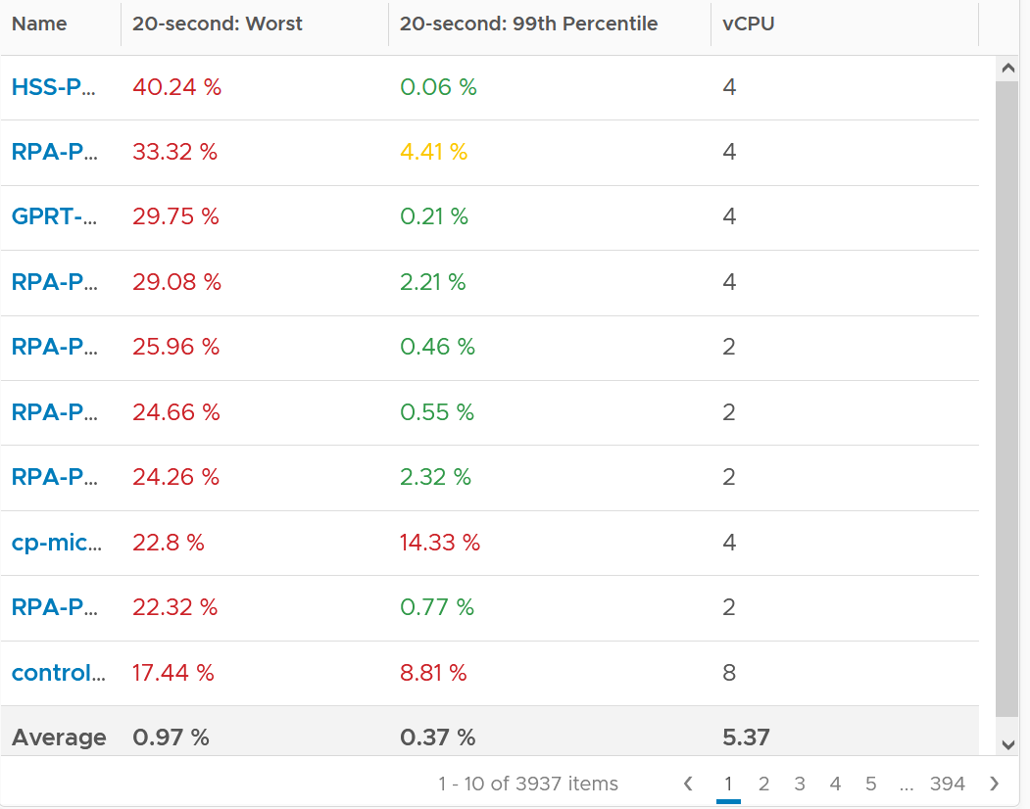

The first column takes the highest value from ~35K data points. The table is sorted by this column, so you can see the absolute worst from 35040 x 3937 = 137 million data points. Unsurprisingly, the number is bad. Going down the table, it’s also not surprising as the worst 10 are bad.

But notice the average of these Worst metric. It’s just 0.97%, which is a great number!

The 2nd column complements the first one. I eliminate the worst 1% of the data, then took the highest. So I took out 350 datapoints. Since vRealize Operations collects every 5 minutes, that eliminates the worst 29 hours in 4 months. As you can expect, for most VMs the values improve dramatically. The 2nd column is mostly green.

#### vCenter Metrics

There are 2 metrics provided: Ready (ms) and Readiness (%).

I plotted both of them. They show identical pattern. This is a 4 vCPU, hence the total is 80000 ms.

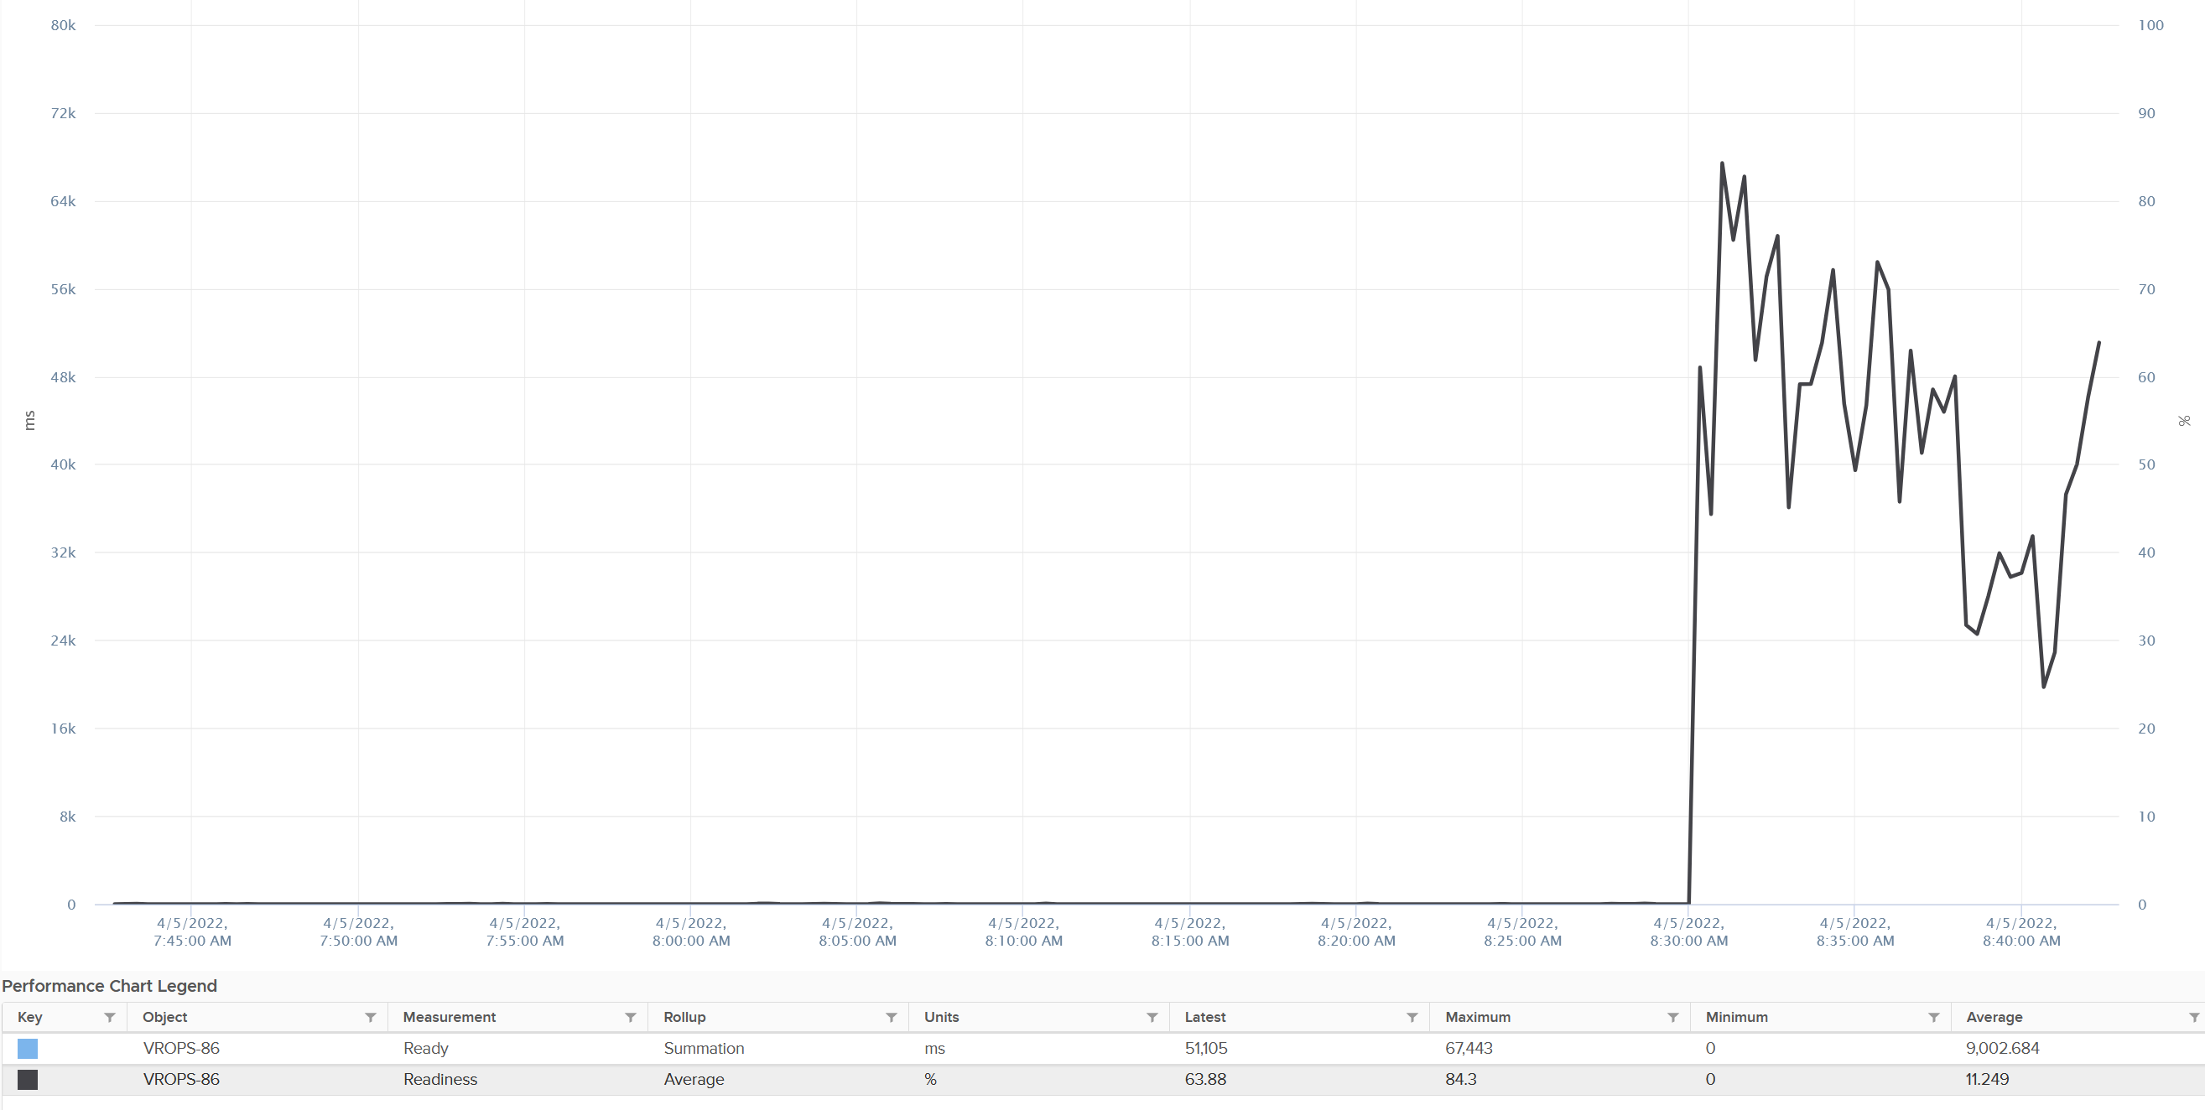

The Readiness (%) has been normalized, taking into account the number of vCPU. Notice 80000 ms matches with 100%. If it is not normalized, you will see 80000 as 400%.

### CoStop

CoStop is a different state than Ready because the cause is different.

CoStop only happens on Simultaneous Multi Processor (SMP) VMs. SMP means that the OS kernel executes parallel threads. This means CoStop does not apply to 1 vCPU VMs, as there is only 1 active process at any given time. It is always 0 on single vCPU VM.

In a VM with multiple vCPUs, ESXi VMkernel is intelligent enough to run some of the VM vCPUs when it does not have all physical threads to satisfy all the vCPU. At some point, it needs to stop the running vCPU, as it’s too far ahead of its sibling vCPU (which it cannot serve, meaning they were in ready state). This prevents the Guest OS from crashing. The CoStop counters track the time when the vCPU is paused due to this reason. This explains why CoStop tends to be higher on a VM with more vCPUs.

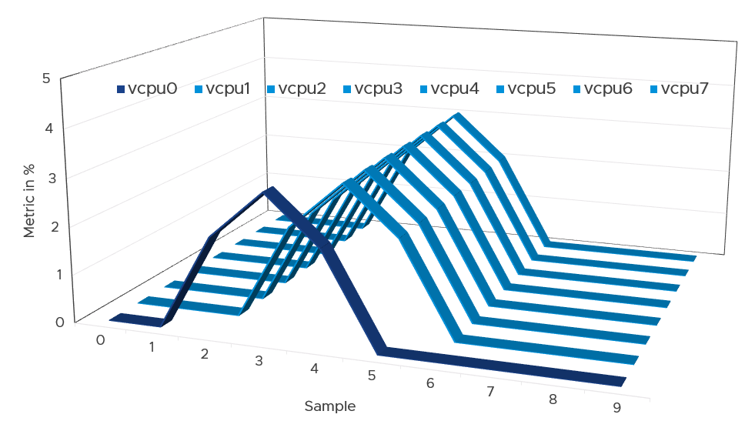

If only one or some vCPU are in ready state, then the remaining ones will soon be co-stopped, until all the vCPU are co-started. The preceding diagram show vCPU 0 hit a ready state first. Subsequently, the remaining 7 vCPU hit a co-stop.

Just like Ready, CoStop happens at the vCPU and not the VM level.

One reason for CoStop is snapshot. Refer to [this KB article](https://kb.vmware.com/s/article/2000058?lang=en_US) for details.

Guest OS is not aware of both CoStop and Ready. The vCPU freezes. “What happens to you when time is frozen?”[8] is a great way to put it. As far as the Guest OS is concerned, time is frozen when it is not scheduled. Time jumps when it’s scheduled again.

The time it spends under CoStop or Ready should be included in the Guest OS CPU sizing formula as the vCPU wants to run actually.

By the way, there is a performance improvement in the VMkernel scheduler in handling CoStop in ESXi 7.0 Update 1. Prior to the improvement, the application performance dropped after 384 vCPU. If you have a monster VM with > 128 vCPU, let me know.

#### Best Practice

The value of CoStop should be <0.5% in healthy situation. This is based on 63.9 million datapoints, as shown on the following pie chart.

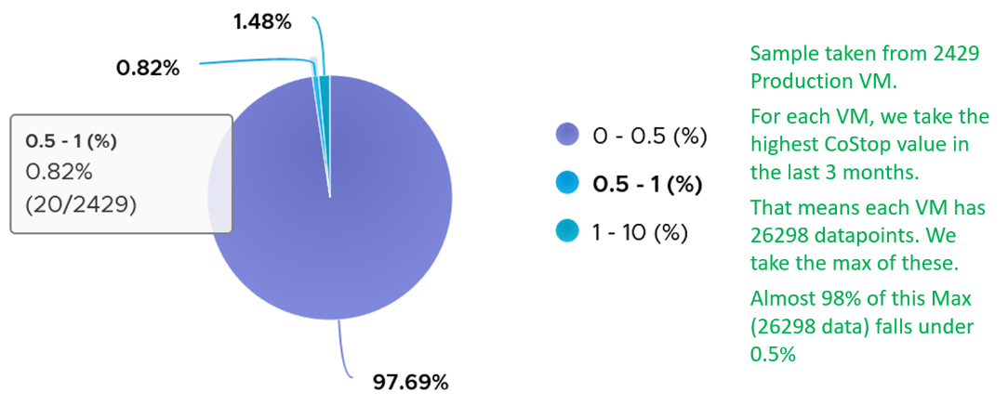

Note that the value of CoStop tends to be larger for large VM. Its value also tends to be smaller than Ready, as shown below. Ready and CoStop may or may not corelate with Usage. In the following chart you can see *both* the correlation and lack of correlation.



### Wait

The English word “wait” means you are in stationary state, because you are waiting for an instruction or being blocked by a process. So this includes idle state. I understand it’s a bit strange in computer science as CPU Wait typically means the CPU is being blocked.

There are 3 sub-counters that make up Wait, as seen by the hypervisor.

* Idle. This could be a genuine idle. The Guest OS itself is not running workload on that vCPU.
* Swap Wait.
* Other Wait. This was called IO Wait in earlier release of vRealize Operations.

CPU is the fastest component among infrastructure resources, so there are times it must wait for data. The data comes from memory, disk or network. There are also times when there is nothing to do, so the CPU is idle. Whether the Guest OS vCPU is idle or waiting for IO, the VMkernel does *not* have this visibility. It can only see it as idle. The Idle counter at VM level tracks this. Regardless of the reason, Idle should not be included in Guest OS sizing as the vCPU is not running. If you are planning to address the IO and memory bottleneck, then yes expect CPU usage to go up too.

Swap Wait tracks the time CPU is waiting for Memory page to come in from ESXi swap. This metric was superseded by Memory Contention metric.

Other Wait tracks the time CPU is being blocked by other things, such as IO and vMotion. For example, the VMM layer is trying to do something and it’s blocked. The number of reasons vary and it’s hard to pinpoint exactly which one, as you need low level debug logs such as stats vmx, schedtraces, and custom vprobes. You’re better off removing the common reasons. Snapshot is a common reason here[9], that it was mistakenly named as IO Wait.

The formula is Wait – Idle, so it includes Swap Wait.

Take note of a [known bug](https://kb.vmware.com/s/article/85393?lang=en_US) that wrongly inflates the value of Other Wait and esxtop %VMWait.

Actions you can do to reduce Other Wait:

* If this happens to multiple VMs, find commonality.
* vMotion the VM.
* Remove Snapshot
* Update to the latest build of ESXi (incl. physical device drivers), virtual HW and VMware Tools (virtual device drivers).
* If the above is not helping in your case, file a Support Request with VMware GSS and tag me. Please mention that you get it from here, so I have a context.

I plotted Other Wait for 4000 production VM. Surprisingly, the value is not low.

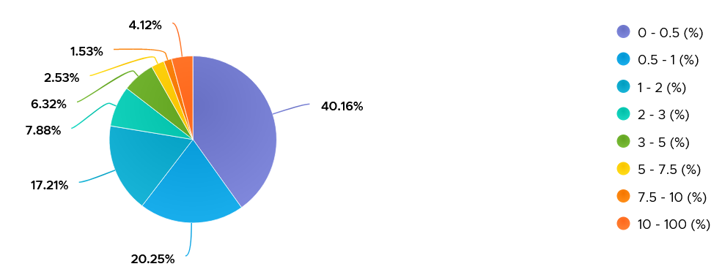

I was curious if the value corelates with CPU Ready or CoStop. From around 4000 production VM in the last 1 month, the answer is a no.

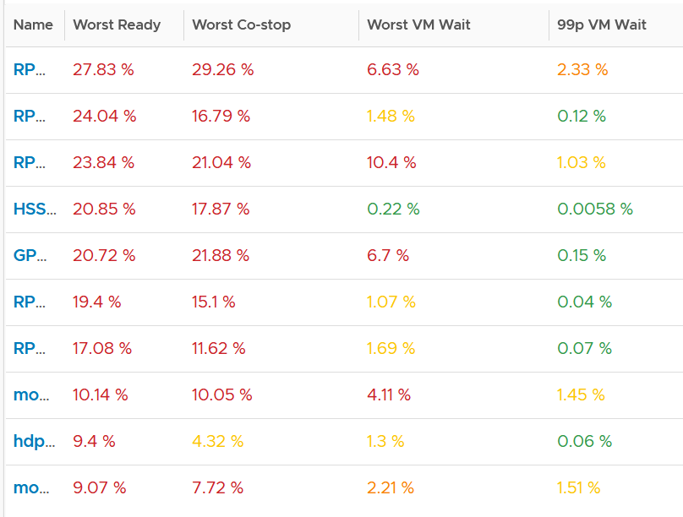

Since snapshot is another potential culprit, let’s compare with disk latency and outstanding IO.

What do you expect?

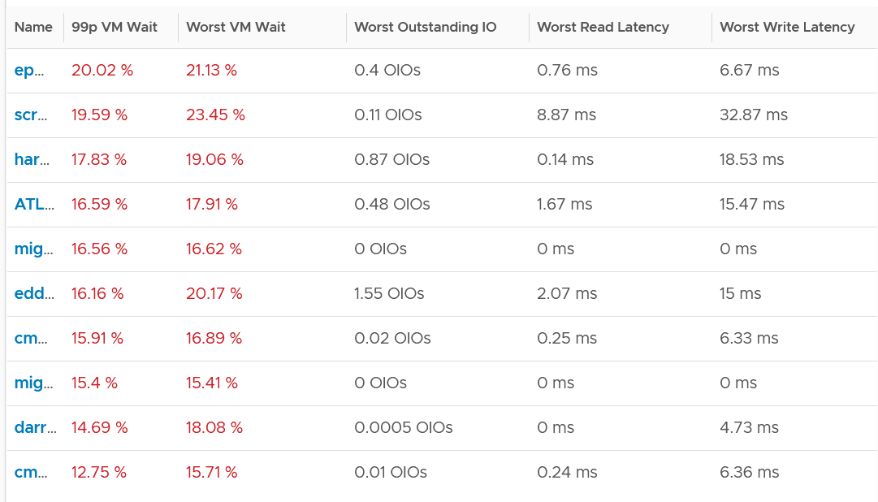

Again, negative corelation. None of the VMs with high VM Wait is experiencing latency. Notice I put a 99th percentile, as I wanted to rule out a one time outlier. I’m plotting the first VM as the value at 99th is very near to the max, indicating sustained problem.

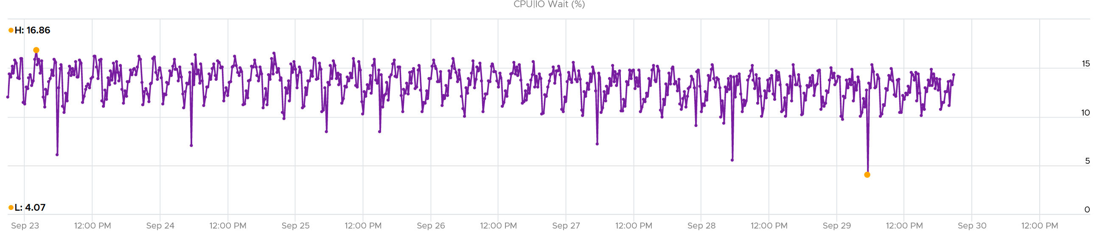

It turned out to be true. It has sustained VM Wait value around 15% (above is zoomed into 1 week so you can see the pattern).

I’m curious why it’s so high. First thing is to plot utilization. I checked Run, Usage and Demand. They are all low.

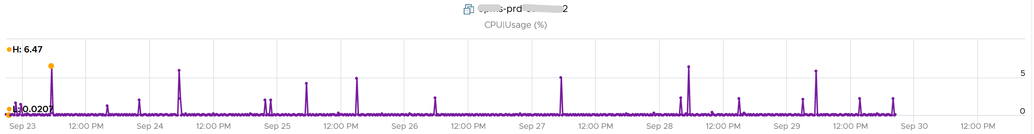

Using vRealize Operations correlation, I checked if it correlates with any other metric. The only metric it founds is Idle, which is logical they basically add up to 100% when Run is low.

[e1: For now, I’m stuck. Not sure why. <https://kb.vmware.com/s/article/85393?lang=en_US> known bug in 7.0 U2 or later]

Guest OS isn’t aware of both VM Wait and Swap Wait. It again experiences freeze. The time it spends under VM Wait and Swap Wait should be included in the Guest OS CPU sizing formula as the VM wants to run actually.

### System

A VM may execute a privilege instruction, or issue IO commands. These 2 activities are performed by the hypervisor, on behalf of the VM.

IO processing differs to non-IO processing as it has to be executed twice. It’s first processed inside the Guest OS, and then in the hypervisor storage subsystems, because each OS has their own storage subsystem. For ESXi, its network stack also have to do processing if it’s a IP-based storage.

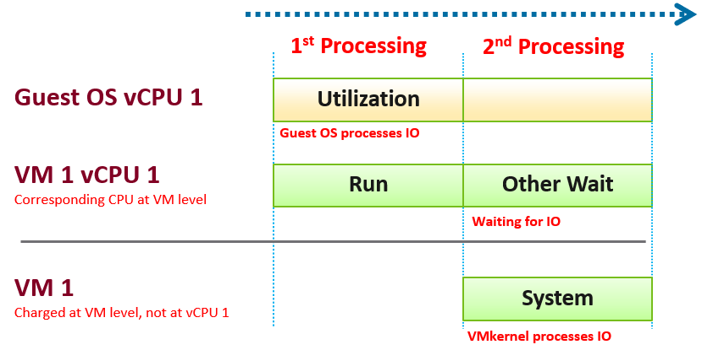

ESXi typically uses another core for this work instead of the VM vCPU, and put that that VM vCPU in wait state. This work has to be accounted for and then charged back to the associated VM. The System counter tracks this. System counter is part of VMX counter.

Guest OS isn’t aware of the 2nd processing. It thinks the disk is slower as it has to wait longer.

If there is snapshot, then VMkernel has to do even more work as it has to traverse the snapshot.

The work has to be charged back to the VM since CPU Run does not account for it. Since this work is not performed by any of the VM CPU, this is charged to the VM CPU 0. The system services are accounted to CPU 0. You may see higher Used on CPU 0 than others, although the CPU Run are balanced for all the VCPUs. So this is not a problem for CPU scheduling. It’s just the way VMkernel does the CPU accounting.

The System counter is not available per vCPU. Reason is the underlying physical core that does the IO work on behalf of the VM may be doing it for more than 1 vCPU. There is no way to break it down for each vCPU. The following vCenter screenshot shows the individual vCPU is not shown when System metric is selected.



ESXi is also performing IOs on behalf of all VMs that are issuing IOs on that same time, not just VM 1. VMkernel may serialize multiple random IO into sequential for higher efficiency.

Note that I wrote to CPU accounting, not Storage accounting. For example, vSphere 6.5 no longer charges the Storage vMotion effort to the VM being vMotion-ed.

Majority of VMs will have System value less than 0.5 vCPU most of the time. The following is the result from 2431 VMs.



On IO intensive VM like NSX Edge, the System time will be noticeable, as reported by [this KB article](https://kb.vmware.com/s/article/59640). In this case, adding more vCPU will make performance worse. The counter inside Linux will differ to the counter in vSphere. The following table shows high system time.



### Run

Run is when the Guest OS gets to run and process instruction. It is the most basic counter among the 4 CPU utilization counters. It’s the *only* counter not affected by CPU frequency scaling and hyper threading. It does not check how fast it runs (frequency) or how efficient it runs (SMT).

Run at VM level = Sum of Run at vCPU levels

This means the value of CPU Run at VM level can exceed 20000 ms in vCenter.

The following screenshot shows CPU Run higher than CPU Used. We can’t tell if the difference is caused by power management or hyperthreading, or mix of both.



If the above was all we need to know, monitoring VMware vSphere would have been easy. You wouldn’t need a book like this. In reality, the following factors must also be considered:

* Interrupt
* System time
* Power Management or CPU Frequency Scaling
* Simultaneous Multithreading (Hyper Threading as Intel calls it)

Because CPU Run do not take into account this external work, and not aware of CPU speed and HT, we will see later in the right-sizing section that this property makes it *suitable* as input to size the Guest OS.

### Overlap

When ESXi is running a VM, this activity might get interrupted with IO processing (e.g. incoming network packets). If there is no other available cores in ESXi, VMkernel has to schedule the work on a busy core. If that core happens to be running VM, the work on that VM is interrupted. The counter Overlap accounts for this, hence it’s useful metric just like Ready and CoStop counter.

The interrupt is to run a system service, and it could be on behalf of the interrupted VM itself or other VM.

Notice the word *system services*, a process that is part of VMkernel. This means it is not for non-system services, such as vCPU world. That’s why the value in general is lower than CPU Ready or even Co-Stop. The value is generally affected by disk or network IO.

Some documentation in VMware may refer to Overlap as Stolen. Linux Guest OS tracks this as Stolen time.

When a vCPU in a VM was interrupted, the vCPU Run counter is unaware of this and continues tracking. To the Guest OS, it experiences freeze. Time stops for this vCPU, as everything is paused. The clock on motherboard does not tick for this vCPU. Used and Demand do account for this interruption, making them useful in accounting the actual demand on the hypervisor. When the VM runs again, the Guest OS experiences a time jump.

Review the following charts. It shows CPU Usage, CPU Overlap and CPU Run. See the green highlights and yellow highlights. What do you notice?

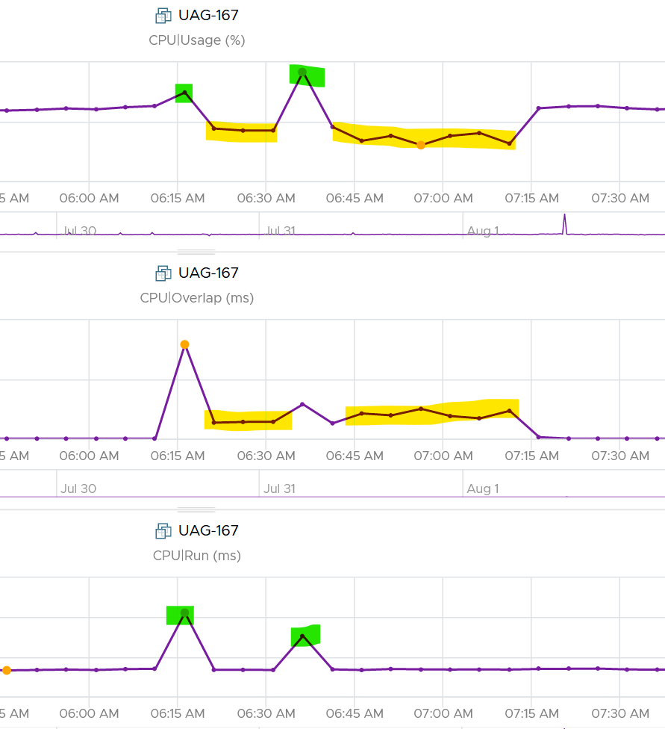

The above prove that Run is not aware of overlap. Notice when overlap went up, Run did not go lower. CPU Usage however, did go down as it’s aware of overlap.

The correlation is not perfect as Usage is also aware of hyperthreading and CPU frequency.

The Overlap counter is useful to troubleshoot performance problem, complementing Ready, CoStop, VM Wait and Swap Wait. Ready does not include Overlap as the VM remains on the Run State (see the CPU State Diagram).

The unit is millisecond, and it’s the summation of the entire 20 seconds. vRealize Operations averages over 300 seconds. So the amount at 300 seconds is max 20000 (this is 100%), and must be multiplied by 15 if we want to see the actual average in the 300 second period.

The amount is the sum of all vCPU, so you need to divide by the number of running vCPU if you are converting into a percentage. Divide over 20000 ms x 100%. When I did that, and plot the highest 5 among ~3K production VMs, I get this.

|  |  |  |
| --- | --- | --- |
| Overlap (ms) | vCPU | Overlap (%) |
| 6,169 | 30 | 1.03% |
| 284 | 2 | 0.71% |
| 509 | 4 | 0.64% |
| 484 | 4 | 0.61% |
| 237 | 2 | 0.59% |

The above indicates the VMs only experienced minimal interruption by VMkernel.

Let’s dive into a single VM. The following is a 68 vCPU VM running Splunk. In the last 7 days, it experienced a low but sizeable CPU overlap. 10K is relatively low for a 68 vCPU VM, but it still represents half a vCPU worth of interruption.



Overlap should be included in **Guest OS sizing** as the Guest OS wants to run actually. The effect is the same with an unmet Demand.

A high overlap indicates the ESXi host is doing heavy IO (Storage or Network). Look at your NSX Edge clusters, and you will see the host has relatively higher Overlap value versus non IO-intensive VM.

### Used | Usage | Demand

As covered earlier, CPU Run does not account for the following:

* How fast is the “run”? All else being equal, a 5 GHz CPU is 5x faster than a 1 GHz CPU. Throughput impacts utilization. The faster it can complete a task, the shorter it has to work. That’s why you see some counters in MHz, because they account for this speed.
* How efficient is the “run”? If there is competing thread running in the same core, the 2 threads have to share the core resource. ESXi accounting records this as 1.25x overall gain, hence each thread drops to 62.5% only. This is a significant drop that should be accounted.
* IO work. IO performed by hypervisor has to be charged to the VM.

This is where Used and Demand come in. vCenter then adds Usage (MHz) and Usage (%) counters. The following table shows the 5 VM utilization counters.

|  |  |  |  |  |  |
| --- | --- | --- | --- | --- | --- |
| **Counter** | **Available at** | **Unit** | **Source** | **CPU Frequency** | **SMT** |
| Run | vCPU level | Millisecond | ESXi | No | No |
| Used | vCPU level  VM level (include System) | Millisecond | ESXi | Yes | Yes |
| Usage | vCPU level | MHz | vCenter | Yes | Yes |
| Usage | VM level | % | vCenter | Yes | Yes |
| Demand | VM level | MHz | ESXi | Yes | No |

### Used

CPU Used covers uses cases that CPU Run does not.

* VM Migration. Moving VM to another ESXi requires that you know the actual footprint of the VM, because that’s what the destination ESXi needs to deal with.
* VM Chargeback. You should charge the full cost of the VM, and not just what’s consumed inside the VM. In fairness, you should also charge the actual utilization, and not rated clock speed.

Here is how Used differs to Run:



Based on the above, you can work out the formula for VM level Used, which is:

VM level Used = Run + System - Overlap + VMX +/- **E**

Where **E** is the combination of

* efficiency gained from CPU Turbo Boost or efficiency loss from power savings. For example, if the frequency is dropped to 40% of the nominal frequency, we consider 60% of the CPU time was stolen.
* 37.5% efficiency loss from CPU SMT.

VMX is typically negligible. It accounts for CPU cycles spent on things like consoling to the VM. In esxtop, System time is charged to the VM VMX world.

Because Used accounts for the actual frequency, you may expect it to be measured in GHz and not millisecond. Think of the number of cycles completed instead of simply frequency. You then convert it back to time. I know it requires a bit of mental mathematics 😊

Quiz:

* Why does the formula state VM level, and not individual vCPU level. What’s the reason?
* How will Used compare with Run in general? Do you expect it to be higher or lower? If it’s higher, what can cause it?

The impact of Power Management can be noticeable. For example, a physical chip comes with 2 GHz as its standard speed. ESXi may increase or decrease this speed dynamically, resulting in Turbo Boost or power saving. If ESXi increases the clock speed to 3 GHz, Used counter will be 50% higher than the Run counter. The Guest OS (e.g. Windows or Linux) is not aware of this performance boost. It reports a value based on the standard clock speed, just like Run does. On the other hand, if ESXi decreases the clock speed to 1.5 GHz, then Used will report a value that is 25% lower than what Run reports.

Let’s take an example. What do you notice?



As you can see from the preceding chart, the impact is noticeable. The System and Overlap counters hovers averages <10 ms (negligible as this VM is basically idle), but the gap between Used and Run averages around 20% Used is ~20% higher than Run, likely due to Turbo Boost.

Let’s take another example, this time from a busy VM. I’ve removed System and Overlap as they are also negligible in this example. This is a 32 vCPU VM running Splunk. Notice Used is consistently higher than Run.



Now let’s look at the opposite scenario. This VM is a 64 bit Ubuntu running 4 vCPU. Used (ms) is around 44% of Run (ms). The VM had minimal System Time (ms) and Overlap (ms), so Used is basically lowered by both power savings and CPU SMT. In this example, if Run is far from 100% and the application team want faster performance, your answer is not to add vCPU. You should check the power management and CPU SMT, assuming the contention counters are low.



Take note: CPU Used has a different formula at VM level and vCPU level. At vCPU level, it does not include System Time. At VM level, it includes the work done by VMkernel that is charged at VM level, such as System and other worlds.

### Usage

There are two counters: Usage (MHz) and Usage (%).

I’m not able to figure out if Usage (%) = Usage (MHz) / VM Static CPU Speed, as I don’t have the need yet to use both counters. From the chart below, it appears that they are not 100% identical, but they are *very* similar.



These 2 counters do not exist in ESXi, meaning they only exist in vCenter.

Let’s compare Usage with Used instead. We will compare Usage MHz as that’s the raw counter. The percentage value is derived from it.



From the preceding chart, we can see they are basically the same, with the difference due to y-axis scales. Formula wise, Usage (MHz) includes all the VM overhead, such as the time spent by VMX process.

vRealize Operations Usage (MHz) and Usage (%) metrics map 1:1 to the respective counters from vCenter.

#### Usage (GHz)

We stated that CPU power management & HT impact Usage.

What value do you expect for the GHz variant?

Let’s see the ESXi only has 12 cores (number of socket does not matter). The Nominal Frequency is 2.4 GHz.

HT is enabled, so the biggest VM you can run is a 24 vCPU.

You run the VM at basically 100%. You enable power management, so naturally Turbo Boost will kick in, albeit not so dramatic as you chew up entire the ESXi.

What is the value of Usage in GHz for the VM?

57.6 GHz? Because it’s 24 vCPU x 2.4 GHz?

No, the answer is much lower than that.

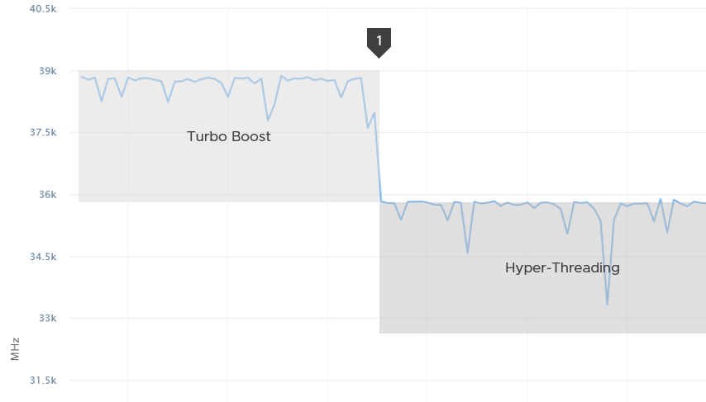

The answer is near 39 GHz. It’s 2.4 GHz x 12 cores x 1.25 HT x 1.08x Turbo Boost. Notice it is 12 not 24. At the end of the day, the one that runs is the physical not virtual.

What happens when we disable turbo boost? That’s what we did at point 1.

CPU Usage drops to slightly below 36 GHz. It’s 2.4 GHz x 12 cores x 1.25 HT.

#### Usage (%)

The following is a single vCPU production Windows Server. Both CPU Usage (MHz) and Demand jump to over 100%. Their values are identical for almost 30 days. The VM had near 0% Contention (not shown in chart), hence the 2 values are identical.



However, when we plot the value in %, we see a different number. Usage (%) is strangely capped at 100%.



The VM experienced some contention around May 12. That’s why Demand was higher than Usage.

### Demand

CPU Demand includes System time, so it reflects the full picture of what VM consumes. It also includes efficiency loss because of frequency scaling. For example, if the frequency is dropped to 40% of the nominal frequency, we consider 60% of the CPU time was stolen. Usage value will be lower by 60% to Demand, all else being equal.

Demand is typically higher than Used by 1.25x. This makes sense as the HT effect is fixed at 1.25x. This means Demand is the counter to use when you suspect the performance drop is caused by hyper threading. If the issue coincides with a sharp gap between Usage and Demand, that’s hyperthreading.

How can Usage be higher than Demand then? Take a look at this vSphere Replication appliance. It replicates every 5 minutes, hence the spike. Notice the spike for Usage is higher but thinner. What’s going on?

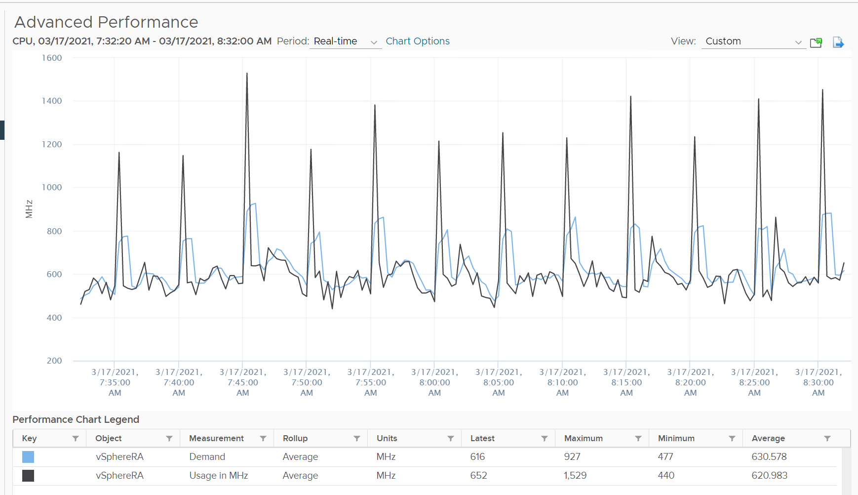

We’ve disabled hyperthreading in the underlying ESXi, so we can isolate and compare better. Notice the pattern is similar. Demand is averaged over a longer time, giving it a more steady value. That’s why the peak is shorter but wider.

Demand could be lower than Run if there is power management savings, as it accounts for speed & efficiency of the run.

Demand (MHz) and Usage (MHz) can exceed 100%. The following is a 32-vCPU hadoop worker node. Notice it exceeds the total capacity multiple times. Demand and Usage are identical as it’s the only VM running and the has more than 32 cores, hence there is 0 contention.



Okay, now that you have some knowledge, let’s test it 😊

Quiz Time! Looking at the chart below, what could be causing it?

Notice Demand jump while Usage dropped. VM CPU Contention (%) jumped even more. What is going on?



And why is that Contention is much more than Demand – Usage?

The reason why Demand metric jumps while Usage drops is contention. The VM experiences contention, which includes hyperthreading sharing. I should have included the screenshot of CPU Ready, CoStop, Overlap, VM Wait and Swap Wait.

From the chart you can see that the formula for VM CPU Contention > Demand – Usage. Contention (%) is around 20% when Demand is 25% and Usage is 15%. The reason is Contention accounts for both CPU frequency and hyper threading, while the difference between Demand and Usage is hyper-threading.

In older release of vRealize Operations, this counter used to be computed as maximum (CPU Utilization for Resources \ CPU Active (1 min. average) / Configuration \ Hardware \ Number of CPUs, CPU Usage) * CPU Total Capacity / 100. This is no longer the case as vRealize Operations now simply maps to vCenter metric.

Source wise, the metric in vRealize Operations simply maps to vCenter counter cpu.demand.average.

### Contention | Latency

This metric tracks the “stolen time”, which measures the CPU cycle that could have been given to the VM in ideal scenario.

The metric is called Contention in vRealize Operations, but Latency in vCenter, which in turns maps to ESXi LAT_C counter.

The diagram shows what it includes. LAT_C excludes Max Limited in Ready, but it includes CoStop even if the CoStop was the result of Limit.

Notice that HT and CPU Frequency are effect and not metrics. You can see the impact of CPU Frequency in [esxtop](http://www.yellow-bricks.com/esxtop/) %A/MPERF counter.



It measures the full possible contention a VM may have, that is not intentionally imposed on the VM by the vSphere Administrator. It considers CPU SMT effect. In ESXi CPU accounting, Hyper Threading is recorded as giving 1.25x throughput. That means when both threads are running, each thread is recorded as only getting 62.5%. This will increase the CPU Contention to 37.5%. All else being equal, VM CPU Contention will be 37.5% when the other HT is running. This is done so Used + Latency = 100%, as Used will report 62.5% when the vCPU has a competing thread running.

In the above scenario, what’s the value of CPU Ready?

Yup, it’s 0%.

CPU Contention also accounts for power management. What happens to its value when frequency drops by 25%. It can’t go to negative right? If you know the answer, let me know!

Because of these 2 factors, its value is more volatile, making it less suitable as a formal Performance SLA. Use CPU Ready for Performance SLA, and CPU contention for performance troubleshooting. You can do a profiling of your environment by calculating the value of CPU Ready at the time CPU Contention hits the highest, and vice versa. The following table only shows 5 VM out of 2500 that I analyzed. These 2 counters do not have good correlation, as they are created for different purpose.



In many cases, the impact of both threads running is not felt by the application running on each thread. If you use CPU Contention as formal SLA, you may be spending time troubleshooting when the business does not even notice the performance degradation.

The following screenshot shows CPU Contention went down when both Ready and CoStop went up.



How about another scenario, where Contention is near 0% but Ready is very high? Take a look at this web server. Both CPU Demand and CPU Usage are similar identical. At around 1:40 am mark, both Demand and Usage showed 72.55%, Contention at 0.29%, but Ready at above 15%. What’s causing it?



The answer is Limit. Unlike CPU Ready, it does not account for Limit (Max Limited) because that’s an intentional constraint placed upon the VM. The VM is not contending with other VMs. [VMware Cloud Director](https://www.vmware.com/products/cloud-director.html) sets limit on VM so this counter will not be appropriate if you aim to track VM performance using Contention (%) metric.

Here is a clearer example showing contention consistently lower than Ready due to limit.

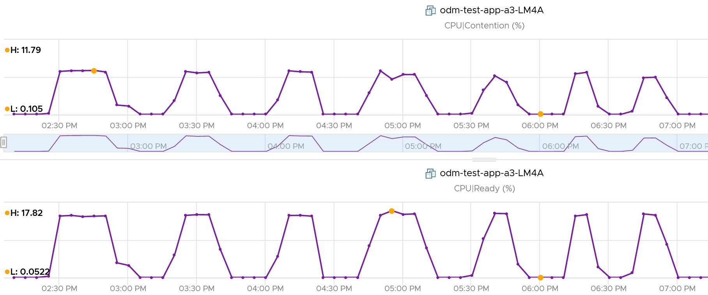

A better and more stable metric to track the contention that a VM experience is Ready + Co Stop + Overlap + VM Wait + Swap Wait. Note that the raw metric for all these are millisecond, not GHz.

Where do you use CPU Contention then?

Performance troubleshooting for CPU-sensitive VM.

If the value is low, then you don’t need to check CPU Ready, CoStop, Power Management and CPU overcommit. The reason is they are all accounted for in CPU Contention.

If the value is high ( > 37.5%), then follow these steps:

* Check CPU Run Queue, CPU Context Switch, “Guest OS CPU Usage“, CPU Ready and CPU CoStop. Ensure all the CPU counters are good. If they are all low, then it’s Frequency Scaling and HT. If they are not low, check VM CPU Limit and CPU Share.
* Check ESXi power management. If they are set to Maximum correctly, then Frequency Scaling is out (you are left with HT as the factor), else HT could be at play. A simple solution for apps who are sensitive to frequency scaling is to set power management to max.
* Check CPU Overcommit at the time of issue. If there is more vCPU than pCore on that ESXi, then HT could be impacting, else HT not impacting. IMHO, it is rare that an application does not tolerate HT as it’s transparent to it. Simplistically speaking, while HT reduces the CPU time by 37.5%, a CPU that is 37.5% faster will logically make up for it.

There is a corner case accounting issue in %LAT_C that was resolved in ESXi 6.7. VMs with Latency Sensitive = High on ESXi 6.5 or older, will show any “guest idle” time of vCPUs as LAT_C, for those VMs the counter should not be relied on. This is a corner case because majority of VM should not be set with this, as it impacts performance of other VMs.

#### Tracking Unmet Demand

Unmet demand should only care about whether the VM gets to run or not. It should not care about how fast it will run when it gets to run, because it does not know. As a result, we should not account for HT. The demand was met, albeit at efficiency dropped by 37.5% due to HT effect.

This is not a built-in counter. I created it using vRealize Operations super metric.

While the need for such counter sounds logical, the detail is more complex. What do we need this counter for?

* If it’s for Cluster Capacity, then CPU Ready caused by Limit should not be considered. You intentionally place the limit, so the CPU Ready is not caused by the inability of the host.
* If it’s for VM Performance, then it’s debatable. If you do not include it, you may miss it. If you include it, the solution is to remove the limit. The problem is the limit could be caused by setting in the resource pool where the VM belongs to. For example, if customer only wants to pay for 10 GHz of resource but insists on running more than that, well, performance will definitely take a hit.

The above 2 counters are for CPU slowness. CPU, being the fastest component, typically wait for RAM, Disk and Network.

* CPU Swap Wait. CPU is waiting for Memory. Had RAM were faster, it would have been executed. For example, adding RAM may result in higher CPU usage.
* CPU Other Wait. CPU is waiting for IO (Disk or Network) and other things (e.g. vMotion stun time). Had they been faster, it would have been executed. For example, replacing storage subsystem with much lower latency would result in CPU completing the task in less time. A 10 hour batch job may take 1 hour, so the CPU usage would be 10x. If disk is outside the ESXi, changing the array can have ramification on ESXi usage. So we should account for it.

Should we account for this wait? They are not real demand. It’s not an unmet demand. It’s a potential demand, which would happen if the other component is improved. Let me know your thought!

The formula I use is Ready + CoStop + Overlap + Swap Wait + Other Wait.

## ESXi Host

Hope you like the tour of VM CPU accounting. Can you apply that knowledge into ESXi and explain the following?



The above is an ESXi host, showing 3 types of utilization counters.

1. One shows 50%, indicating you have capacity.
2. The second one shows 100%, indicating you do not have capacity.
3. The 3rd shows 75%.

Which counters do you take for the ESXi CPU “utilization” then?

Since the graph is a bit small, let’s zoom in

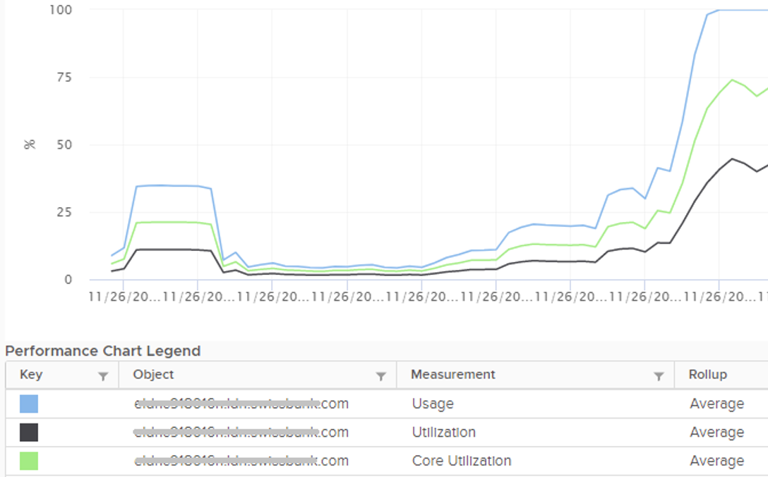

Notice they have similar pattern, but their *sensitivity* differs.

* Why is Usage (%) = 100% when Utilization (%) is around 47%? The gap is more than double. What could be causing it?
* Why is Utilization (%) fluctuating yet Usage (%) remains constant? Notice both Utilization varies between 45% and 55% while Usage remains flat at 100%
* Why is Core Utilization (%) in the “middle”? What does it actually measure then?

To answer the above, we need to cover some fundamental. Note that we must take the vantage point of ESXi, not VM. Don’t mix this with the VM view of the world as they are similar so it’s easy to get mixed up. From ESXi physical threads viewpoint, things such as Ready and CoStop are not applicable as the physical threads are provider of resource.

Unlike RAM, CPU performance varies widely among different CPU models. Speed matters in CPU, whereas in RAM we can generally ignore it. DDR5 RAM is faster than DDR4 but for general monitoring reason it can be ignored. Because of this significant difference in CPU, we need to have counters to account for:

* How often it runs. How much the CPU runs in a time period. E.g. if it runs 60% of the time in the last 100 seconds, that means it runs for 60 seconds accumulatively in that period. That’s why you see many counters in millisecond. They track the utilization over time.
* How fast it runs. All else being equal, a 5 GHz CPU is 5x faster than a 1 GHz CPU. Throughput impacts utilization. The faster it can complete a task, the shorter it has to work. That’s why you see some counters in MHz.
* How efficient it runs. CPU SMP impacts the core efficiency. This is covered more here. This efficiency is then translated into MHz, for ease of accounting.

These 3 dimensions of run are the reason why CPU utilization is hard to measure. It becomes “it depends on what you consider”. It can’t be a single number. Insisting that the CPU has a single, static, total capacity and use this as the only 100% for all use cases will result in confusion in “utilization” numbers.

ESXi uses 3 types of units: millisecond, MHz and %.

Time is the raw unit, meaning the percentage unit is derived from it and the MHz unit is expressed as the average over time. When we see the CPU demand is 2 GHz at 9:00:00 am what vCenter actually means is it the average from 8:59:40 am, assuming you’re looking at the real time chart. Other number on the vCenter UI could be averaged of longer time, else frequent changes could cause unnecessary confusion.

### Utilization and Core Utilization

Let’s dive into the first two fundamental counters. We need to start at esxtop, and then move up to vSphere Client UI. We also need to start at the fundamental, a single physical core of a socket. The socket can have many cores, we are just interested on 1 core only. It has 2 threads as it supports CPU SMT.

In a time period of say 20 seconds[10], this core had the following consumption:



Looking at esxtop, you will see near the top the PCPU Used and PCPU Utilization counters. Note that their values are in percentage, meaning you need to know what they use for 100%.

If you guess that they eventually map into vSphere Client counters Usage (%) and Utilization (%), respectively, you are right. However, you need to know how they map.

PCPU means a physical, hardware execution context. That means it is a physical core if CPU SMT is disabled, or a physical thread inside a core if SMT is enabled. It does not mean CPU socket. A single socket with 10 cores and 20 threads will have 20 PCPU counters.

PCPU Utilization (%) tracks is a physical thread is used or not over time. At any given moment, a thread is either running (unhalted) or not (halted). So it’s binary (0% or 100%). But over the 20 second period, the value is averaged. So when you see the number as 50%, it does not mean it’s running 100% at half the “speed”. It means it’s running half the time, for only 10 seconds. Using a human analogy, think of it as a person who is either running or standing, and never walking. It’s not considering CPU Frequency.

Core Utilization (%) tracks at the core level. If one of the threads is running, then the value is 100%. At the core level, the average utilization in that entire period is 75%. In the last portion, the core still runs at 100%. The CPU Utilization (%) tracks this. As a result, CPU Utilization (%) is only relevant when hyper-threading is enabled.

Going back to our example, here are metrics reported:

* PCPU Utilization (%) for HT 0 = 10 seconds / 20 seconds = 50%
* PCPU Utilization (%) for HT 1 = 10 seconds / 20 seconds = 50%
* Core Utilization (%) for entire core = 15 seconds / 20 seconds = 75%

BTW, in vSphere Client, you can’t choose a core if you enable HT. You choose PCPU, which is a thread. So what happens on the Core Utilization counter at thread level?

Does it get split into half?

As you can see below, no. The value is duplicated.

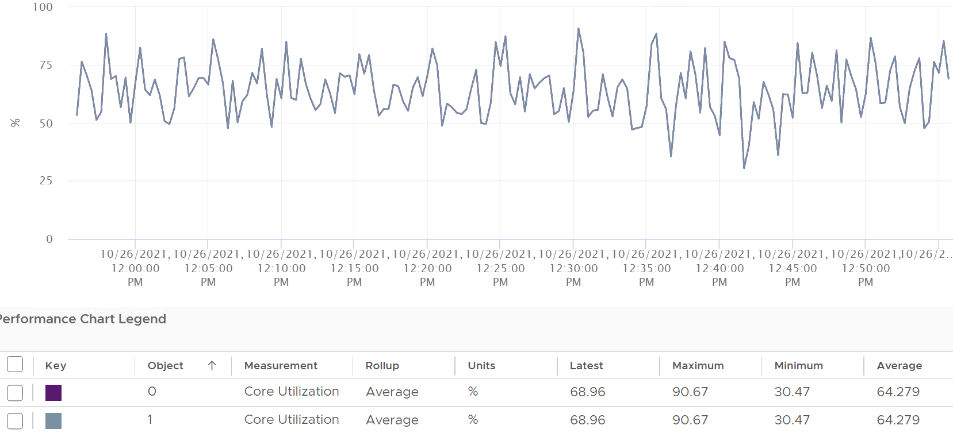

Notice in the above chart, the 2 have identical value.

Utilization (%), on the other hand, will be different. Each thread has different value.

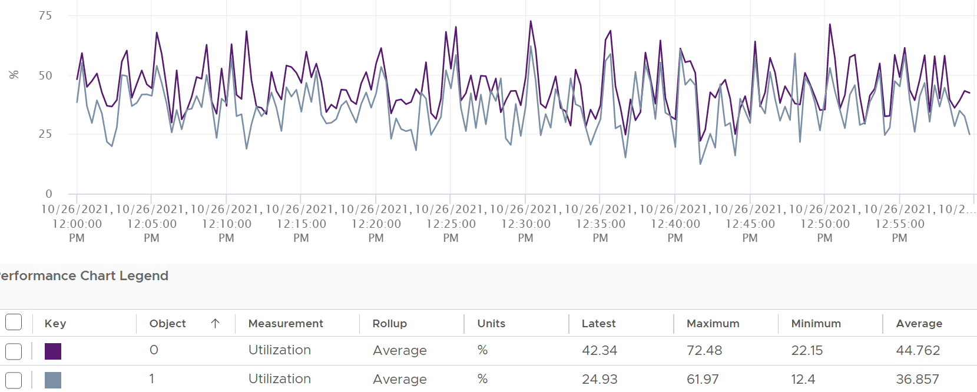

If you simply sum them up, you get more than 100%, so don’t!

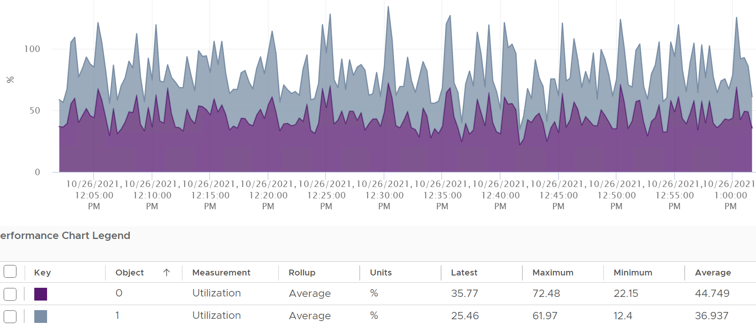

Now let’s roll this up to the ESXi level. The following show a tiny ESXi with 2 cores, where each core has 2 threads.



The metrics at ESXi level is

* CPU Utilization (%) = 40 seconds / **80** seconds = 50%.
* CPU Core Utilization (%) = 30 seconds / **40** seconds = 75%

Utilization = 50% because each thread is counted independently. There are 4 threads in the preceding ESXi, each runs 50%, so the average at ESXi level is 50%. This counter basically disregards that HT does not deliver 2x the throughput.

This is why the Core Utilization (%) will tend to be consistently higher than Utilization (%). The following chart demonstrate that.

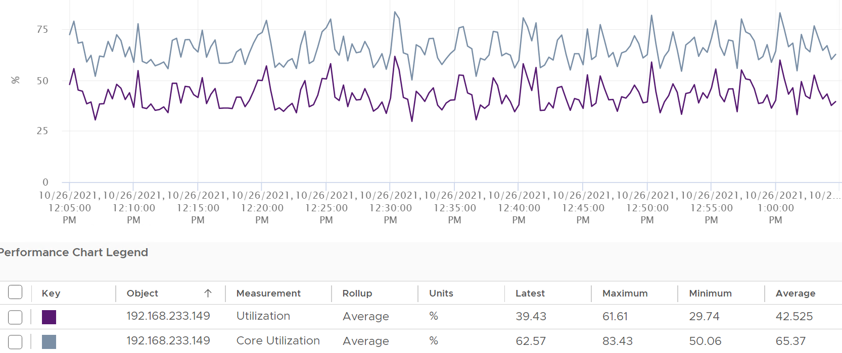

Now let’s go back to the chart shown earlier. Can you now explain Utilization (%) and Core Utilization (%)?

Great! Let’s move to the next one.

In the following example, this ESXi has no hyper-threading. What do you notice?



Yup, the Core Utilization is identical with Utilization.

Great! You are now ready to tackle the next counters, which are Used (%) and Used (ms). Used considers CPU frequency (both Turbo Boost and power saving). Used consider HT, although it assumes it delivers no benefit and halve its value to 50% instead of 62.5%.

Here is how Utilization (%) and Used (%) are related at PCPU level:

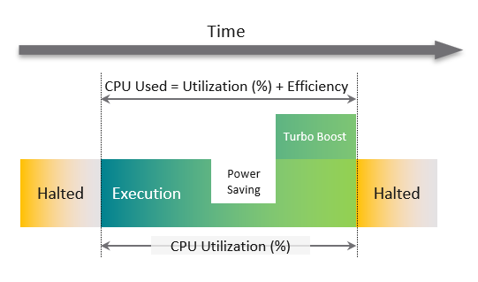

A physical Thread is either executing (running) or halted (idle). While it’s running, it can run at lower/higher CPU clock speed. CPU Used accounts for this.

Its execution will be less efficient if its paired thread is also running at the same time. CPU Used accounts for both.

CPU frequency scaling is caused by power management, so let’s dive into it.

### Used

There are 2 counters. This vCenter counter Used (ms) maps to PCPU Used (%) counter in esxtop.

#### Used (%)

Now that we have covered CPU Clock Speed, we can add this dimension into the same scenario above. For that, we will go back to our tiny ESXi:



In Core 0, the first thread was running at half the CPU frequency in the first period. While Utilization (%) records this as 100% run, Used (%) is aware of this reduction and records 50% instead. The second thread wasn’t running so Used is not impacted.

In the 4th period, the thread is competing with another thread. Used (%) recognises the drop in efficiency and register *50%* instead of 100%. Personally, I’d prefer this to register 62.5% as it’s caused by HT. This will also make it consistent with CPU Latency and VM CPU Demand, which applies 37.5% as HT penalty.

On the other hand, when Turbo Boost increases the clock speed by 1.5x on the 2nd thread, Utilization (%) is unaware and record 100%, but Used registered 150%.

Here is all the possible permutation of a core. Take note that the frequency can be less than 1.

|  |  |  |  |  |  |  |  |  |
| --- | --- | --- | --- | --- | --- | --- | --- | --- |
| Thread 1 | Thread 2 | Thread 1 | Thread 2 | Core | Frequency | Thread 1 | Thread 2 | Core |
| Run | Run | 50% | 50% | 100% | 1.3x | 65% | 65% | 130% |
| Run | Not Run | 100% | 0% | 100% | 1.3x | 130% | 0% | 130% |

So when happens when the CPU frequency goes down?

|  |  |  |  |  |  |  |  |  |
| --- | --- | --- | --- | --- | --- | --- | --- | --- |
| Thread 1 | Thread 2 | Thread 1 | Thread 2 | Core | Frequency | Thread 1 | Thread 2 | Core |
| Run | Run | 50% | 50% | 100% | 0.5x | 25% | 25% | 50% |
| Run | Not Run | 100% | 0% | 100% | 0.5x | 50% | 0% | 50% |

#### Used (ms)

The following is taken from an ESXi with 24 cores and 48 threads. I’m showing logical processor 46 and 47. They are from core no 24, meaning they share a physical core.

I stack the chart. Do you see something strange?

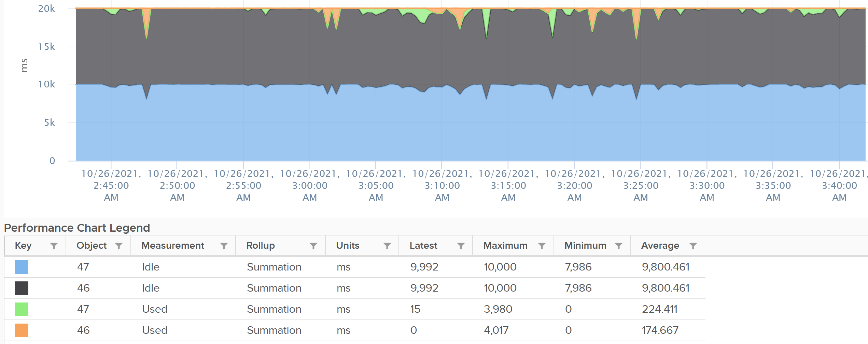

The total is exactly 20000.

Each thread is only given *10000*. This is not intuitive as the data is measured every 20000 ms.

Notice the maximum value for Idle is 10000, not 20000. You expect the total for 2 threads to be 40000 as there are 2 threads.

BTW, this 10000 matches the 50% we covered earlier. So Used (ms) and Used (%) are consistent with each other.

Any other thing you notice from the chart?

The sum of the 4 counters is a perfect line.

CPU Idle (ms) + CPU Used (ms) = 100%.

That’s a bit odd, because power saving brings down the value of Used. So Idle needs to be adjusted if the total has to remain 20000. This is a bit odd, as by definition idle means CPU is not doing work. It’s 0. So the frequency

|  |  |  |  |  |  |  |  |  |
| --- | --- | --- | --- | --- | --- | --- | --- | --- |
| Thread 1 | Thread 2 | Frequency | T1 Used | T2 Used | Core Used | T1 Idle | T2 Idle | Core Idle |
| Run | Run | 0.5x | 5000 | 5000 | 10000 | 5000 | 5000 | 10000 |
| Run | Not Run | 0.5x | 10000 | 0 | 10000 | 0 | 10000 | 10000 |

You can see the peak where Used (ms) shot well above 10000 multiple times.

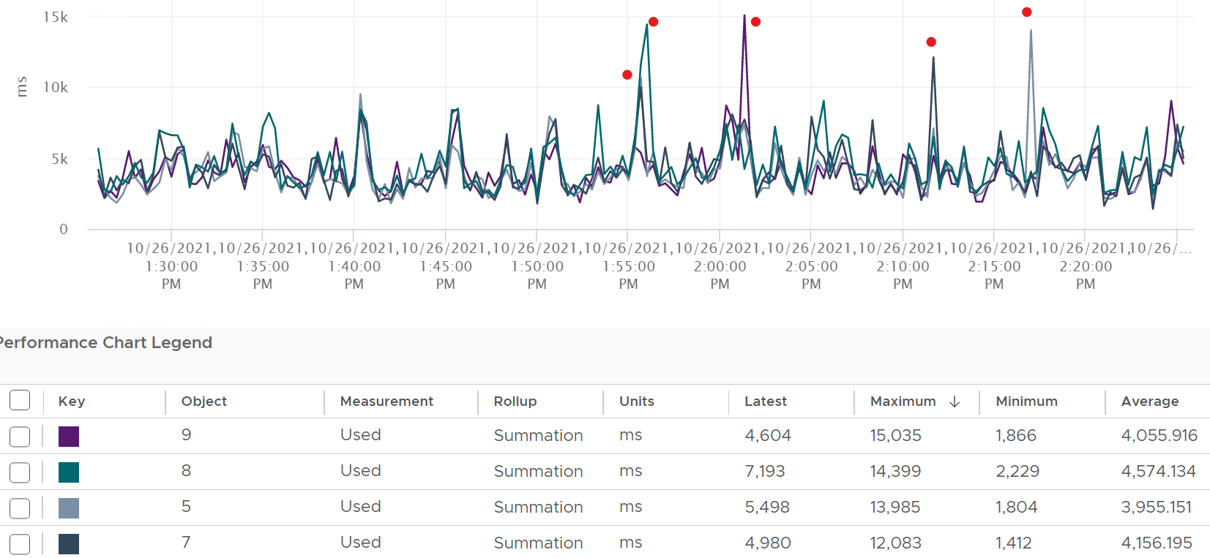

Can you guess how many physical cores the following ESXi has?



Answer: 20 cores, 40 threads.

Notice the total sum is constant at 400K ms. Divide this by 20K ms and you get 20 cores. While the graph visually shows the line is slightly above 400K, the sum of the 2 values shown is actually 400,000.01 ms.

If you want to verify with vCenter, the following ESXi host has 24 cores 48 threads. Notice the sum is 480,000 ms, not 960,000 ms.

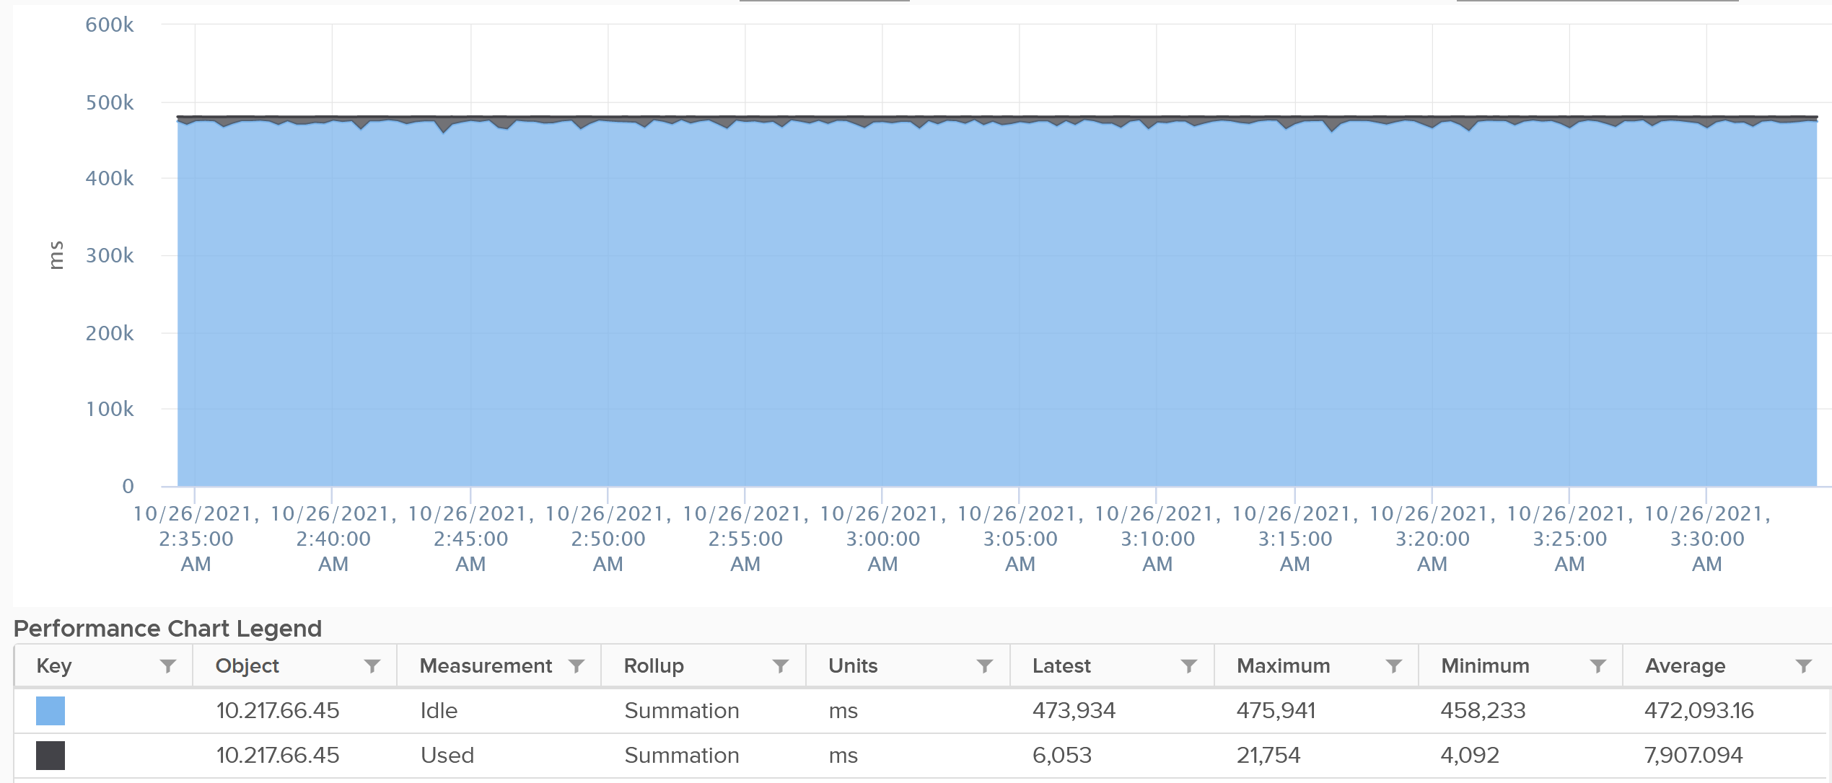

### Usage

vCenter adds this counter, meaning it does not exist at ESXi level. In some parts of the UI, vCenter uses the name Used instead of Usage. But in the metrics chart, it uses Usage. I’m going to assume that Used (MHz) = Usage (MHz) as vCenter does not have Used in MHz.

If you see in esxtop, you will find Used (%) and Utilization (%) but not Usage. Usage basically maps to Used, but showing in MHz and use 20000 as opposed to 10000.

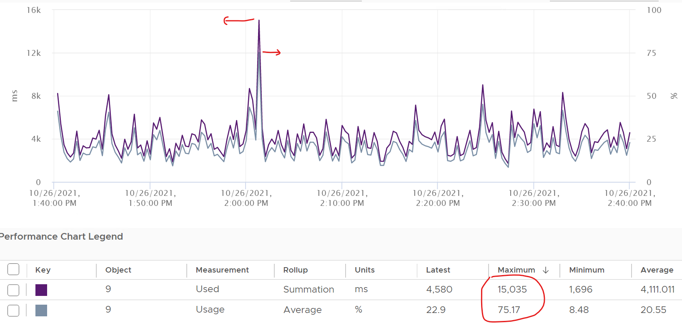

This is great as using millisecond is hard to account for “how fast you run” and “how efficient you run”. With MHz, we can plot the value across time.

With this knowledge, now the screen on vCenter client UI will be clearer.

You see both the Capacity of 35.18 GHz and Used of 11.3 GHz. There is no concept of Usable Capacity in vSphere, so the Free amount is basically Capacity – Used.



vCenter shows Used in GHz. The value is actually CPU Usage, as the Used counter is supposed in percentage or millisecond.

The Used CPU is summary.quickStats.overallCpuUsage.



The value above is likely some average of say 5 minutes as it remains static for a while and it does not exactly match the number below as the roll up period is not the same.

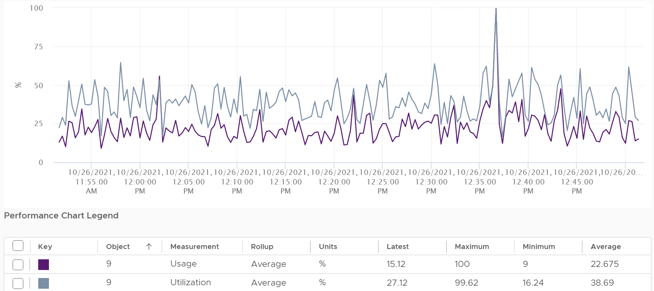

Usage is capped at 100%, even at the thread level.

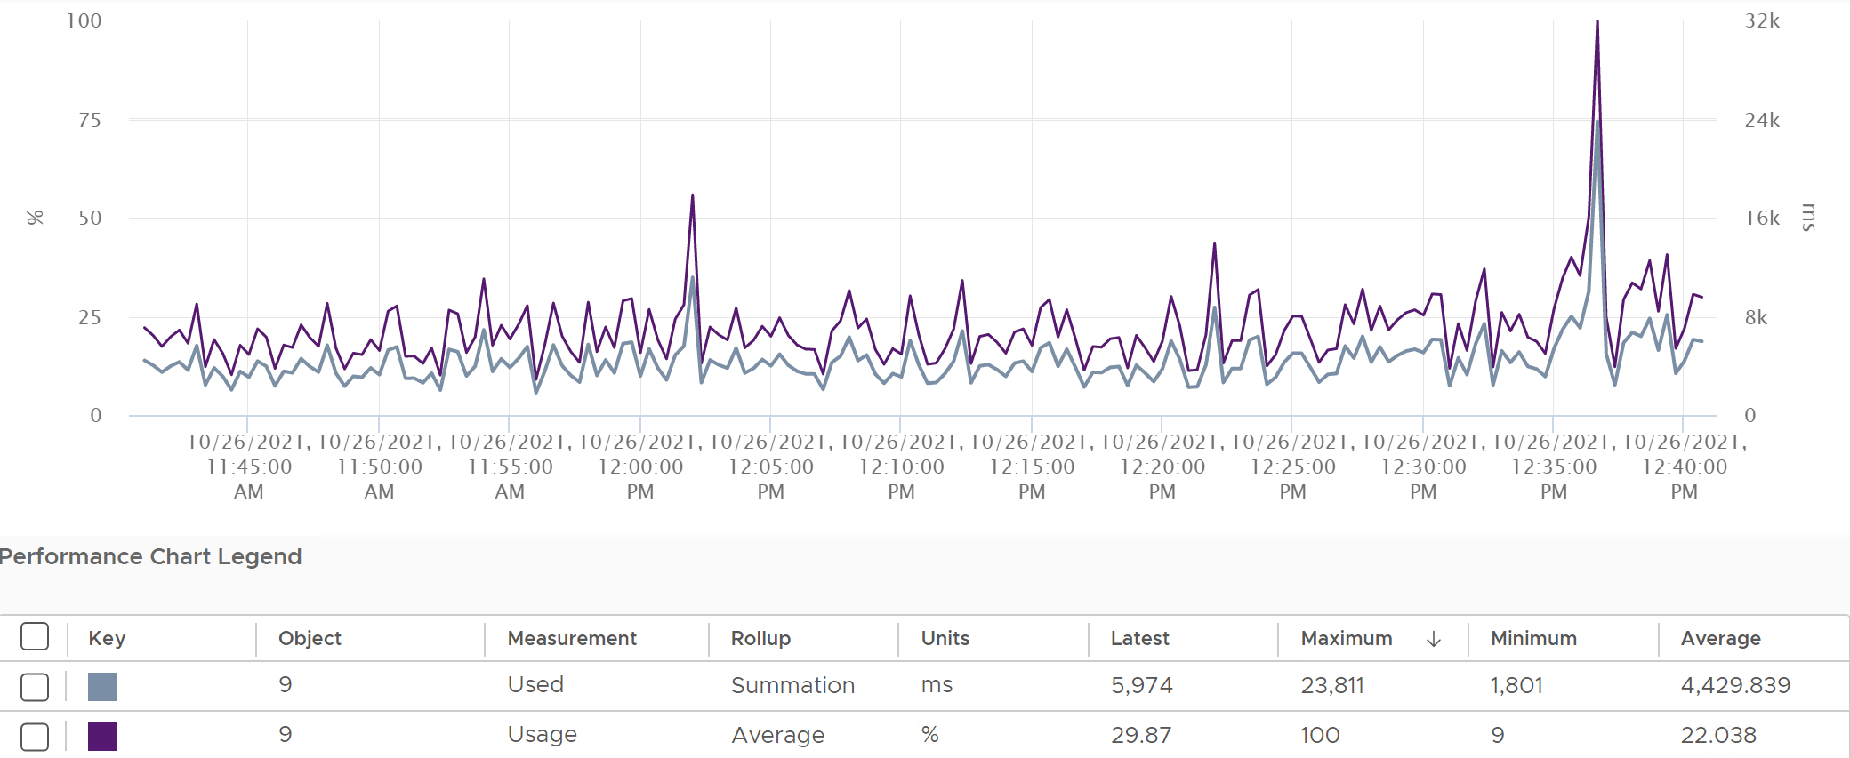



Let’s see if Used (ms) = Usage (MHz).

To prove it, we plot 180 data points from each, and compare the average. For completeness, let’s compare the latest value too.



Let’s compare the above value to prove the formula. We need to translate them into a common unit for comparison.



Bingo!

Both the average values and the latest values match.

Just like Used, Usage tops out at 100% when all cores run at least one thread at nominal frequency, even if there is still "headroom" for Turbo Boost or scheduling "capacity" on other threads. This is why its value will be lower than Core Utilization if there is power savings, as shown below.



ESXi CPU Usage (%) = CPU Usage (MHz) / CPU Total Capacity (MHz), where Total Capacity = total cores x nominal clock speed. It does not consider hyper threading. This accounting technique of removing hyperthreading is consistent with Used.

The following chart prove the above equation.



When is Usage (%) higher than Core Utilization (%)?

The answer has to be Turbo Boost. The following shows an ESXi where Usage is consistently higher than Core Utilization (%) in the last 24 hours. Notice that the value of Usage was capped at 100%. It did not breach 100%



I’ve marked some areas of the above chart with red dot. Those areas is where Usage turns out to be lower than Core Utilization.

Why?

The answer is power saving, which typically happens on low utilization. In an aggressive power savings, Usage can even be lower than Utilization, as shown below. This makes sense, as the idles cores consumes are run at lower frequency, hence the average at ESXi level is low.



### Demand

Demand looks at different context than Utilization/Used/Usage. It looks at the VM world, not the physical cores. That’s why it’s not available at per core or thread level. The value you see at ESXi is the summation of all the VMs, not logical CPU.

Because Demand considers all types of contention, as a result, its value tends to be higher than all the other counters. It does not include the VMkernel load, so at lowly utilization, Demand will be lower than Usage.



One good thing about Demand metric is it can go above 100%. All the other counters are capped at 100%. Demands lets you see how high above 100% the demand. It does not mean the VM is experiencing performance, as there is Turbo Boost and Hyperthreading to assist.

In older release of vRealize Operations, this counter used to be computed as Sum ( VM CPU \ Host Demand for Aggregation ) + CPU Overhead. This is no longer the case as vRealize Operations now simply maps to vCenter metric.

### Utilization vs Contention

ESXi “utilization” does not correlate to ESXi “contention”. The 4 highlighted area are examples where the metrics don’t correlate, even go the opposite way in some of them. Can you guess why?



These are the reasons why they don’t match:

* One looks at physical CPU, the other the virtual CPU. One looks at ESXi, while the other looks at VM.
* Hyperthreading and Power Management.
* Imbalance utilization. There are many VMs in this host. Their experience will not be identical.
* Limit may impact the VM, either directly or via resource pool.
* CPU pinning, although this is rarely happen.

My recommendation is not to look at Contention, but Ready + CoStop + Overlap + Other Wait. Also, complement the ESXi value with the worst among its VM. The value at ESXi level is a summation, which is the average.

### ESXi “Utilization” counters

Let’s summarise the counters we have covered so far. vCenter provides 6 counters to account for the utilization of ESXi CPU. Since esxtop uses the Used (%) metric but ESXi uses the Used (ms) metric in the vCenter client, I’m including both.

|  |  |  |  |  |  |
| --- | --- | --- | --- | --- | --- |
|  | Available at | Unit | Source | HT | CPU Speed |
| Utilization | Thread level | % | ESXi | 2x | No |
| Used | Thread level | ms | vCenter |  | No |
| Used | Thread level | % | esxtop only | 2x | Yes |
| Core Utilization | Core level | % | ESXi | Any | No |
| Usage | Thread level | % | vCenter |  | Yes |
| Usage in MHz | Host level | MHz | vCenter |  | Yes |
| Demand | Host level | MHz | ESXi |  | Yes |

The column HT indicates how the counter treats HT. 2x means it doubles the number of capacity. I put “Any” for Core Utilization because if any of the thread runs, the counter goes up to 100%. If both run, it’s still 100%.

You know that only Utilization (%) and Used (%) exist at the thread level because they are the only one you see at esxtop[11], as shown below.



With so many counters, which one should you choose?

Let’s now evaluate all the possible scenarios so you can compare the values returned by the counters. We will use a simple ESXi with 2 cores. Each core has 2 threads. In each of the scenario, a thread is either running or not running. There is no partial run within a thread as that’s mathematically covered in our scenarios.

I will also use 20000 ms as that’s more familiar. The following table shows an ESXi with 2 cores. There are 6 possible permutations in their utilization.



The table shows clearly that Used splits the Utilization into 2 when both threads are running.

Look at scenario 1. While Utilization charges 20000 ms to each thread, Used charges 10000. This is not intuitive as ESXi considers HT to deliver 1.25x. Personally I find 12500 easier to understand. The good news is this number is normalized back when it is rolled up to the ESXi host level.

How will those scenarios roll up at the ESXi level?

The following table shows the 4 counters (Utilization, Used, Core Utilization, Usage). I have expressed each in % so it’s easier to compare.

There are 6 different scenarios, so logically there should be 6 different values. But they are not, so I added my personal take on what I like them to show. I’m keen to hear your thought.

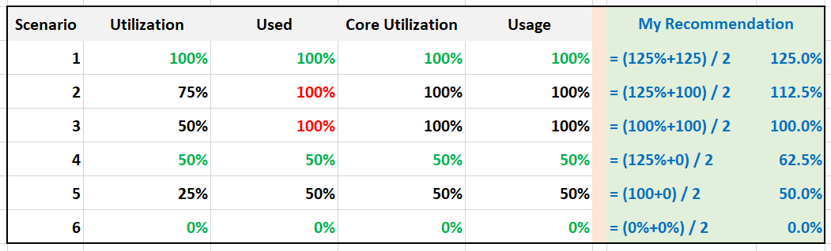

What’s causing the difference?

Yup. Hyper Threading.

Why do I choose 125% instead of 100%?

To me, the 1.25x bonus factor has to be shown. Without HT, it’s 100%. HT is a bonus. While it provides 1.25x overall throughput, each thread pays an expensive price, as each suffers 37.5% penalty.

The other reason is why I choose 125% as the upper limit is it’s easier when thinking in GHz.

Example: say the CPU specification is 3 GHz for its nominal frequency. It has HT enabled, and power management disabled.

What’s the CPU Capacity?

To me, 3 GHz is easier to explain than 3.75 GHz. It’s also more correct, as the CPU does not actually run at 3.75 GHz. It runs 2 threads at 3 GHz each, but at 62.5% efficiency, so accounting wise it’s

= 3 GHz x 62.5% + 3 GHz x 62.5%

= 3.75 GHz, which is 125% of 3 GHz

|  |  |
| --- | --- |
| Scenario | Analysis |
| 1 | Do you notice something strange with the value of Used (%)?  Yes, it’s no longer 50%. It’s 100%. The average of 50% is 100%  The reason is the accounting does not count each thread as 20000. Each core has 20000 and not 40000. If you say that is similar behaviour to Core Utilization, you’re right. |
| 3 | Utilization is only showing 50% when both cores are utilized. I prefer this to show 80% as HT only delivers 1.25x, not 2x.  On the other hand, Usage goes up too fast. It's already showing 100% when there is still 25% room left. |
| 5 | Utilization is again showing too low a value, and Usage too high a value. |

Now let’s add CPU clock speed. What happens when there is power management?

I’d focus on just Used and Usage to highlight the difference.

What do you notice from the table below?

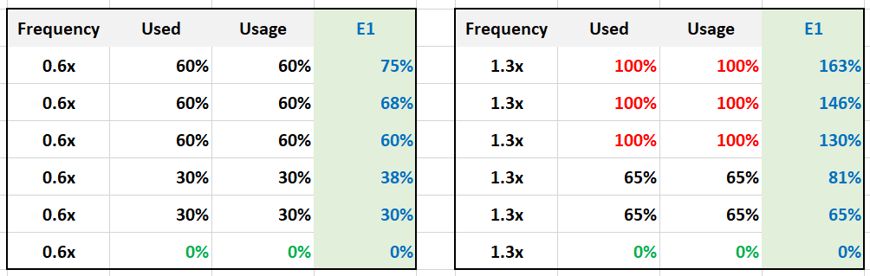

Both Used and Usage are capped at 100%. I prefer this not to be capped, to distinguish it from the other 100%. The good part is Demand metric is not.

For comparison, I put forth what I think the counter should be.

Let’s take some ESXi hosts running production workload to see how the values compare in real world. Each row represents an ESXi host. What’s your conclusion from reviewing the following table?



I’ve marked two of the rows with a red dot.

* The first one happens because of CPU scaling. Not all cores are busy, since Core Utilization shows 72%. The busy ones were dynamically boosted by VMkernel by an average of 21%, hence the Usage counter registers 88%
* The second example is the opposite. This ESXi is not even 50% utilized, as the core utilization shows 48.88%. VMkernel decides that it could complete the job with less power, and clocks down by an average of 43%.

Notice that Usage (%) does not count the hyperthreading. The Total Capacity metric is simply based on cores x nominal speed.

Now that we know more about the metrics, which ones should we use and how?

To answer that, we need to first determine the “100%”. That’s the ceiling, the total capacity.

### Consumed CPU

When vSphere UI lists ESXi Hosts, it typically includes the present utilization. It lists the metrics as Consumed CPU (%) and Consumed Memory (%).

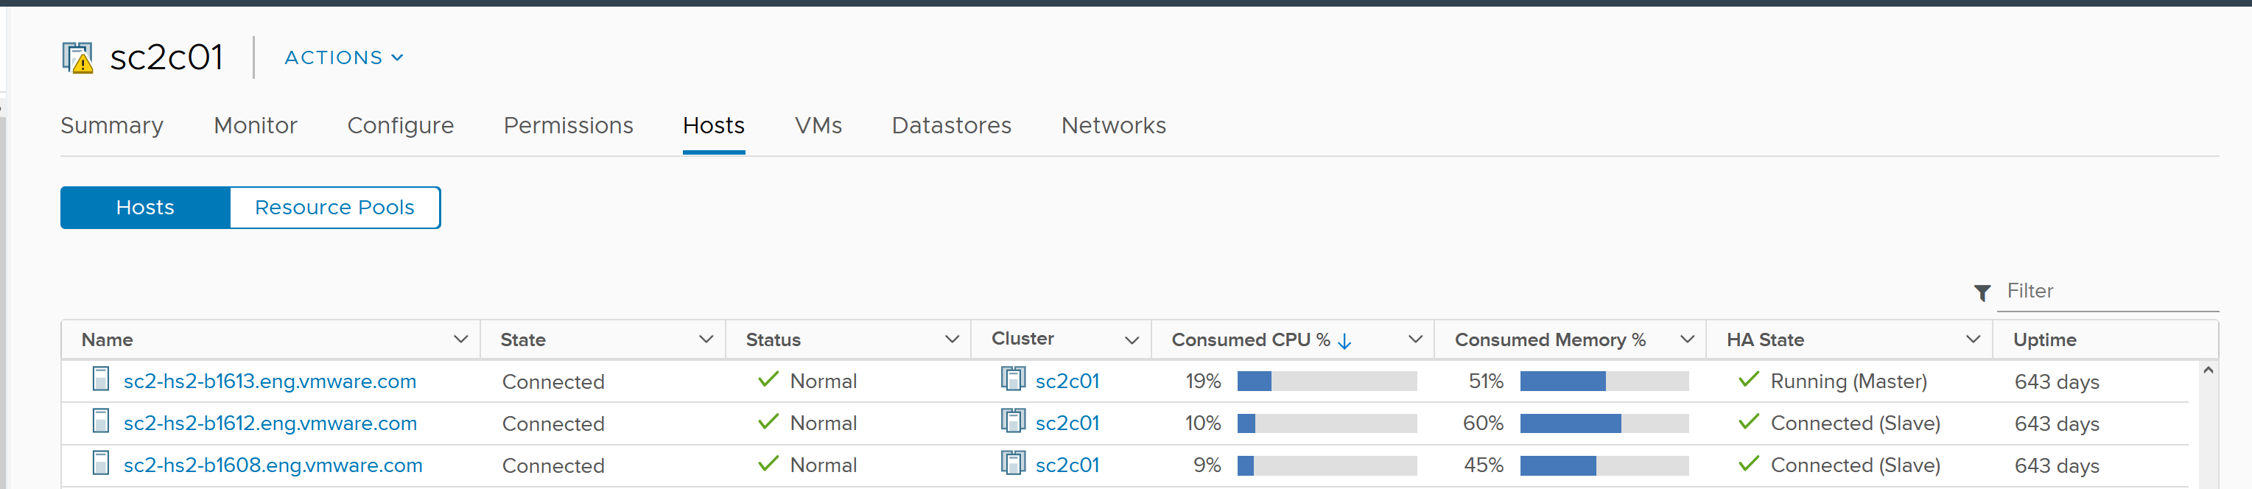

Consumed CPU maps to CPU Usage (%). Consumed Memory (%) maps to Memory Consumed (KB).

To confirm it, simply plot CPU Usage value. The last value is what you see at the table.

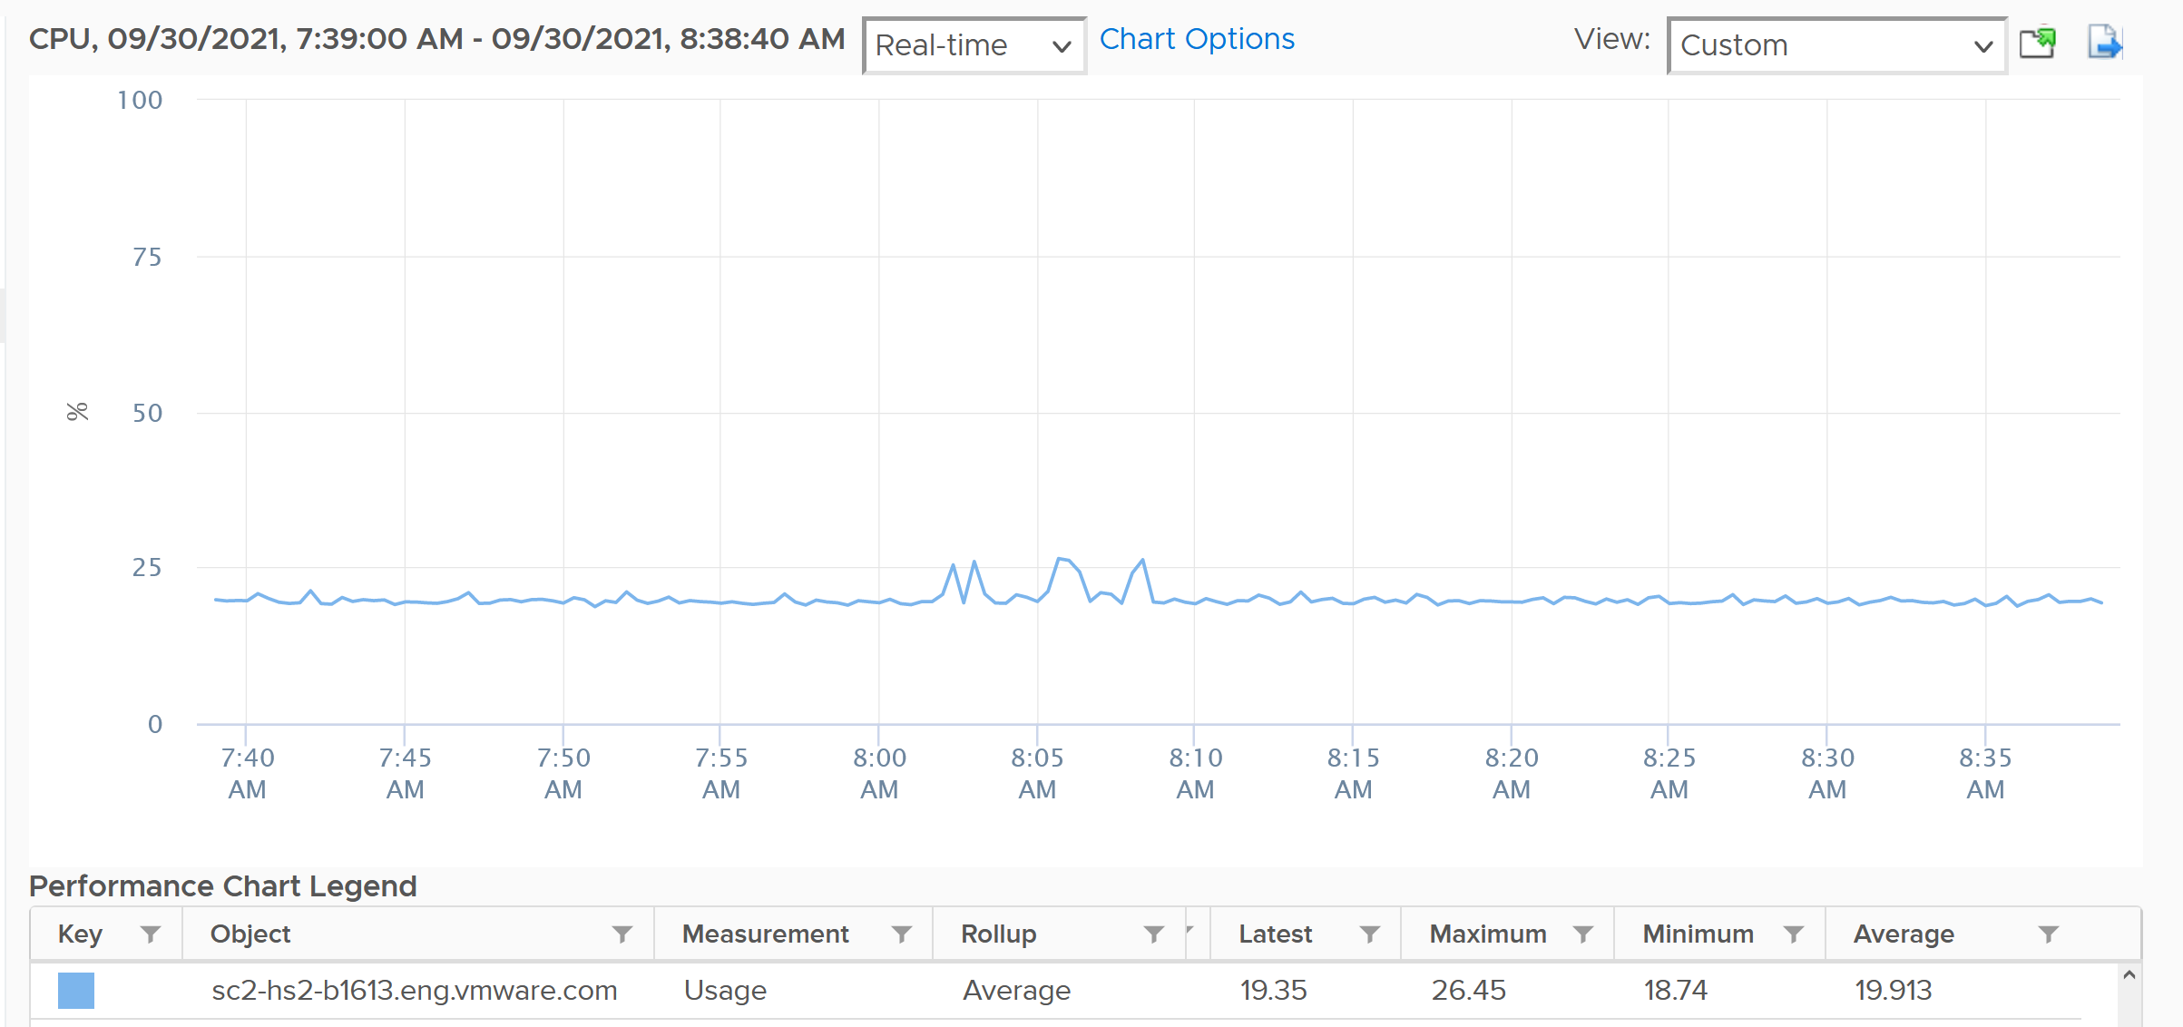

### Total Capacity

When you buy a CPU, what exactly is the capacity?

It is tricky as there are 3 factors to consider:

* 2 units (GHz and cores), where the core is typically used in allocation model.
* Hyperthreading
* Power Management.

A CPU with 28 cores at 1 GHz is not the same with a CPU with 14 cores at 2 GHz.

* You can’t run a 16 vCPU VM on a 14-core (assuming it has no HT).
* On the other hand, a CPU intensive application will prefer faster CPU.

Hyperthreading provides 2x the number of logical processor, but it comes at a high cost. As the core is split into 2, each thread only runs at 62.5% of its potential. That’s 37.5% reduction!

Power Management can dynamically increase or decrease individual cores speed. It does in basically real time, and it varies per core. I recommend you ignore it so the Total Capacity does not become a variable. By fixing your capacity, you can see if the CPU is on Turbo Boost. The limitation of this approach is your demand metric likely exceed 100% when Turbo Boost kicks in. So where do you consider this actual speed? You should consider it in cost, performance and sustainability management.

The good part is the above 3 factors do not alter the fact that the CPU comes with a certain nominal frequency.

Let’s take a simple example. The CPU has 4 cores, sports hyperthreading, and has 1 GHz nominal frequency (the rated speed as per specification).

* Each core runs at 1 GHz. If you enable HT, each core can run 2 threads, at 0.625 GHz, accounting wise. I said accounting wise as each thread actually runs at 1 GHz but at 62.5% efficiency. So you get better throughput at the expense of single thread performance.
* It’s easier to express the above in percentage. Your 100% is 1 GHz, because you do not have a 1.25 GHz CPU. It’s not able to run at that speed. An application expecting 1.25 GHz will not have its expectation met.
* You can produce 125% throughput, but at a high price. That means you can run more comfortably at 100%, knowing that you can push to 125% if you are willing to pay the price. If you are not, then stop at 100%. For workload where performance is highly sensitive, stop at 100% (better still, track the CPU Latency counter).

Since you have 4 cores, your capacity is 4 GHz.

So far so good?

Great, now let’s talk about the cores and thread.

* You have 4 cores, 8 threads. What’s the capacity? 4 logical CPU or 8 logical CPU?
* The CPU can run 8 vCPU worth of VMs concurrently. By that definition, that means you do not overcommit.
* The VMs won’t experience CPU Ready. Sure, they will run slower but that’s a performance, and not capacity question. It would be the same as having a slower hardware, as the VMs are not put in ready state.
* Core and Thread are useful in Allocation Model, where you do not care about clock speed. If you care about clock speed, you would change the VM vCPU depending on the ESXi clock speed. For example, if a 8 vCPU VM is migrated from a 1 GHz ESXi to 4 GHz ESXi, you would change the VM to 2 vCPU. You obviously don’t do this as that’s not the same thing.

#### In summary

Recall that the CPU has 4 cores, 1 GHz nominal clock speed and sports HT.

|  |  |  |
| --- | --- | --- |
| Capacity Model | 100% is | Things to note |
| Demand-based | 4 GHz | Running both threads means 125% |
| Allocation-based | 8 Logical CPU | Running 8 vCPU means it’s 1:1 overcommit.  BTW, this is what AWS uses. Yes, they use allocation model. |

You might be curious. What does vSphere Client use?

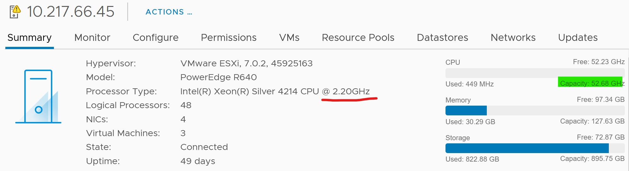

If you divide 52.68 GHz by 2.2 GHz, you get 24. The box has 24 cores. It consist of 2 sockets x 12 cores per socket

The ESXi above has 48 logical processor, because HT is enabled.

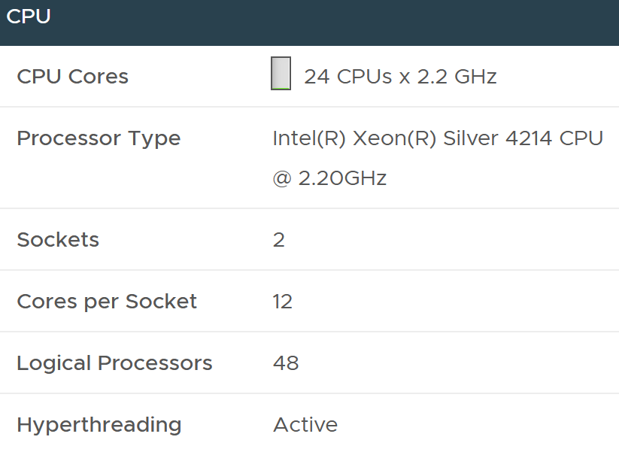

In the vSphere API, the metric for CPU capacity is derived from summary.hardware.numCpuCores x summary.hardware.cpuMhz.

For Capacity, you can also add Demand (%) counter to see how high above 100%. The following shows it exceeds 100% but only marginally and momentarily. When Demand passes 100% it means the CPU is running hot (high power consumption) and both threads are busy. Buying more cores or higher frequency could result in the VMs running faster, assuming CPU is the gating factor.



|  |  |
| --- | --- |
| **Capacity** | I’d use Utilization (%) for aggressive and Core Utilization (%) for conservative. Frequency scaling is not relevant; hence I do not use Usage. Usage will also inflate the numbers as VMkernel will take advantage of turbo boost. The drawback of this approach is you may see a different number to what vCenter uses as it uses Usage.  If Core Utilization is not yet 100% or Utilization is not yet 50% then there is still physical cores available. You can go ahead deploy new VMs.  If Core Utilization = 100% (meaning Utilization is at least 50%) then review Utilization and ensure it’s not passing your threshold. I’d keep it around 80% - 90% per ESXi, meaning the level at cluster level will be lower as we have HA host.  If you want to see the number in GHz, then use Usage and Total Capacity. Just don’t be alarm if Usage hits 100%. Check the contention counters, as always 😊 |
| **Performance** | I’d use Utilization (%) but will accompany it with the contention metrics. Since it’s about performance troubleshooting, I’d set the threshold around 90% - 95%. |

### ESXi Peak Core CPU Usage

Is any of the physical threads running hot?

An ESXi with 72 CPU cores will have 144 logical processors. Hence it’s possible that one of them is running hot, while the rest is not. You will not be able to see that single core peak at ESXi Host level as it’s the average of 144 metrics. If you are concerned that any of them is running hot, you need to track the peak among them.

Peak CPU Core Usage (%) tracks the highest CPU Usage among the CPU cores. A constantly high number indicates that one or more of the physical cores has high utilization. So long the highest among any cores at any given time is low, it does not matter which one at a specific point in time. They can take turn to be hot, it does not change the conclusion of troubleshooting. Max() is used instead of 95thpercentile as both result in the same remediation action, and Max() can give better early warning.

The imbalance value among the cores is not needed because it is expected when utilization is not high. When a VM runs, it runs on a few cores, not spread out to all ESXi cores. It’s more efficient to schedule that way, as will requires less context switches.

### Other Counters

We’ve covered the key counters. Let’s now look at the rest of the counters.

First of all, not all counters are available at core or thread level. They are only available at entire ESXi level.

|  |  |
| --- | --- |
| Contention type of counters | Latency, Readiness, Co-Stop, Ready, Swap Wait, Wait  Do you know why Run and Idle are available per thread, but Ready is not?  Hint: Only the VM is waiting.  Yes, while the physical core run when the VM runs, the physical core does not experience ready. Only the VM experiences it. |
| Utilization type of counters | Demand  Usage in MHz  Reserved Capacity  Total Capacity  Usable Capacity: Total – HA – Buffer.  Workload: this is Demand over Usable Capacity |

Throughout this book, I always cover the contention counters first, then utilization. Why is it that I don’t do it for ESXi Host?

The reason is the built-in metrics are average. As shared, average is a lagging indicators.

So what counters should you use?

The KPI (%) counters. We will cover them in later part of the book. In the meantime, here are the latency counters provided by vSphere Client.

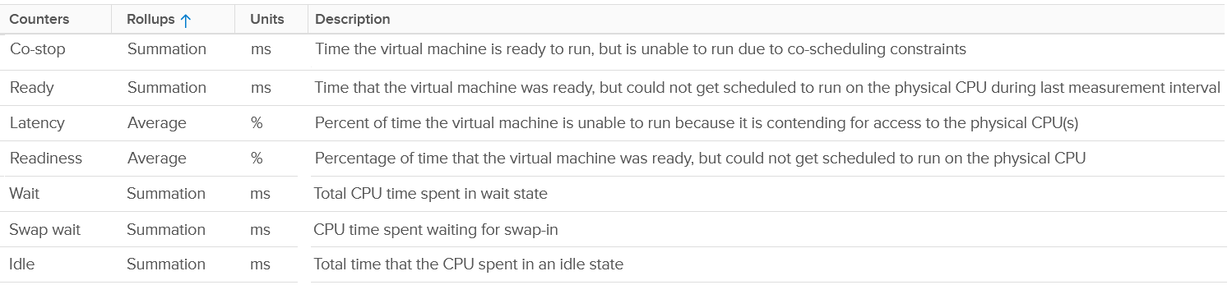

And here are the utilization counters. I’m unsure why total capacity is a counter since it is a property (something that does not change frequently).



## esxtop

The CPU panel begins with a summary of the load average in the last 1 minute, 5 minute and 15 minutes, respectively. As shared, utilization is a secondary counter, supporting contention. So focus on contention first before looking at these 3 numbers. In addition, in a large ESXi with many cores, an imbalance can mask out a busy core.



The next 3 lines covers Used (%), Utilization (%) and Core Utilization (%). The reason why I swapped the order in the book is Used (%) is built upon Utilization, and it’s a more complex counter.

The white vertical line shows where I cut the screenshot, as the text became too small and unreadable if I were to include all of them. Anyway, it’s just repeating for each CPU thread.

At the end of each 3 lines (after the white line in preceding screenshot), there are NUMA information. It shows the average value across each NUMA node (hence there are 2 numbers as my ESXi has 2 NUMA nodes). The number after **AVG** is the whole box, system wide average. The per NUMA node metric values are useful to easily identify if a particular NUMA node is overloaded.

Take a look at the panel below. It mixes VM and non VM processes in a single table.

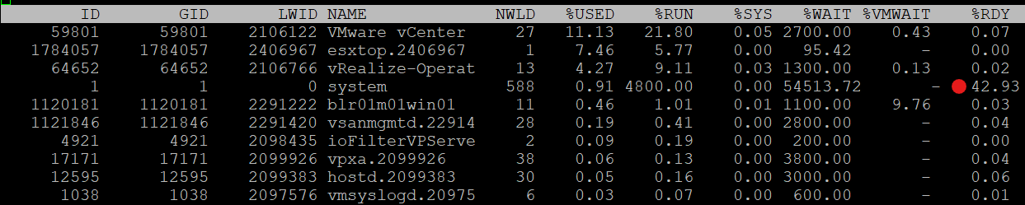

If you want to only show VMs, just type the capital letter **V**.

* Name based filtering allows [regular expression](https://en.wikipedia.org/wiki/Regular_expression) based filtering for groups and worlds.
* Type the capital letter **G** to only show groups that match given string. This should be useful when a host has large number of VMs and you want to focus on a single or set of interesting VMs.
* Once a group is expanded you can type the small letter **g** to show only the worlds that match the given string. This is useful when running a VM with many vCPUs and you want to focus on specific worlds like storage worlds or network worlds.

If you want to see all, how to tell which ones are VM? I use %VMWAIT column. This tracks the various waits that VM world gets, so it does not apply to non VM.

Notice the red dot in the picture. Why the Ready time is so high for system process?

Because this group includes the idle thread. Expand the GID and you will see Idle listed.

There are many columns, as shown below. The most useful one is the %State Times, which you get by pressing **F**.

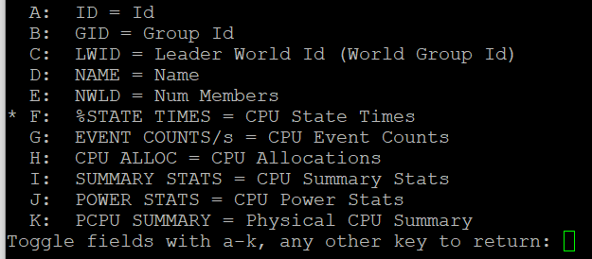

The rest of the information are relatively static or do not require sub-20 second granularity.

### CPU State

Review the metrics below, starting with %USED. Which one does *not* actually belong to a CPU state, meaning it’s not something you mix with the rest?

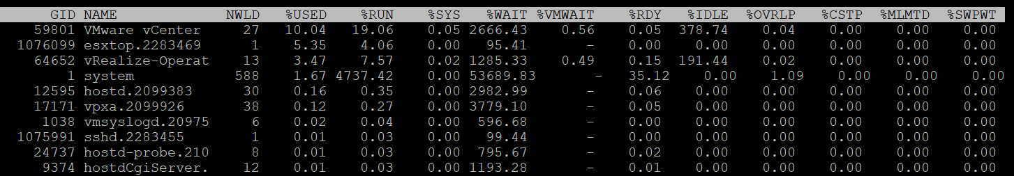

That’s right, it’s %USED.

|  |  |
| --- | --- |
| %USED | It should be excluded from this panel as it is influenced by power management and hyperthreading. We explained the reason why in CPU Metric chapter. That’s why it’s necessary to review the VM CPU states before reading each esxtop metric. |
| %RUN | Run is covered in-depth here under VM CPU Metrics. |
| %SYS | System time is covered in-depth here under VM CPU Metrics. |
| %WAIT | The wait counter and its components are covered in-depth here under VM CPU Metrics.  VMWAIT includes SWPWT. vRealize Operations does not show VM Wait and uses a new counter that excludes Swap Wait. The reason is the remediation action is different. You’re welcome. |
| %VMWAIT |
| %SWPWT |
| %IDLE |
| %RDY | Ready is covered in-depth here under VM CPU Metrics. As discussed in the CPU scheduling, each vCPU has its own ready time. In the case of esxtop, the metric is simply summed up, so it can go >100% in theory. |
| %CSTP | Co-Stop is covered in-depth here under VM CPU Metrics. This is also 100% per vCPU. |
| %OVRLP | Overlap is covered in-depth here under VM CPU Metrics. |
| %MLMTD | MLMTD is Max Limited, not some Multi Level Marketing scam 😊. It measures the time the VM was halted due to manual limit, as opposed to VMkernel has no CPU resource. |

### CPU Event Count

Note none of these counters exist in vSphere Client and vRealize Operations, as they are meant for internal use.

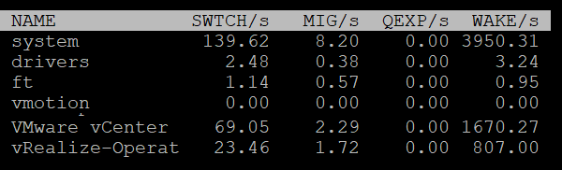

|  |  |
| --- | --- |
| SWTCH/s | Number of world switches per second, the lower the better. I guess this number correlates with the overcommit ratio, the number of VM and how busy they are.  What number will be a good threshold and why? |
| MIG/s | Number of NUMA and core migrations per second. It will be interesting to compare 2 VM, where 1 is the size of a single socket, and the other is just a bit larger. Would the larger one experience a lot more switches? |
| WAKE/s | Number of time the world wakeups per second. A world wakes up when its state is changes from WAIT to READY. A high number can impact performance. |

The metric QEXP/s (Quantum Expirations per second) has been deprecated from ESXi 6.5 in an effort to improve vCPU switch time.

### Power Stats

This complements the power management panel as it lists per VM and kernel module, while the power panel lists per ESXi logical CPU.

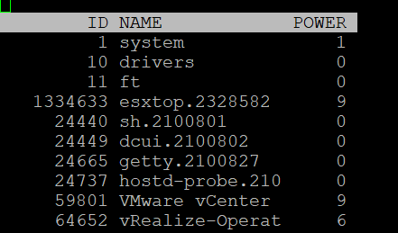

|  |  |
| --- | --- |
| POWER | Current CPU Power consumption in Watts. So it does not include memory, disk, etc. |

### Summary Stats

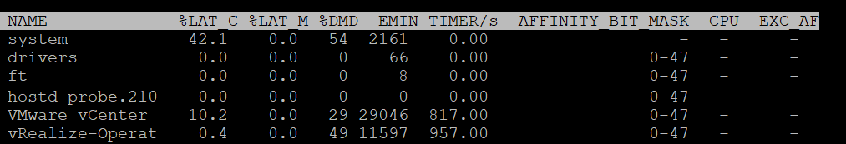

Other than the first 3 (which I’m unsure why they are duplicated here as they are shown in the CPU State already, the other metrics do not exist in vSphere Client UI and vRealize Operations.

|  |  |
| --- | --- |
| %LAT_C | This is covered in-depth here: CPU Contention |
| %LAT_M | This is covered in-depth here: Memory contention |
| %DMD | This is covered in-depth here: CPU Demand |
| EMIN | [e1: I’m not sure if this replaces AMIN, which measures reservation. There was also AMAX, which shows limit] |
| TIMER/s | Timer rate for this world |
| AFFINITY BIT MASK | Bit mask showing the current scheduling affinity for the world.  Not set for Latency Sensitive = High VMs |
| CPU | The physical or logical processor on which the world was running when esxtop obtained this information. [e1: I’m not 100% as this is always blank for me] |
| EXC_AF | Yes means the VM has exclusive affinity. This happens when you enabled the Latency Sensitivity setting. Use this feature very carefully. |

The column HTQ is no longer shown in ESXi 7.0. In earlier release, this indicates whether the world is quarantined or not. N means no and Y means yes.

### CPU Allocation

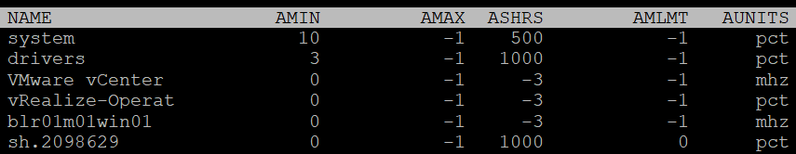

|  |  |
| --- | --- |
| AMIN | Attribute Minimum. Basically, the reservation |
| AMAX | Attribute Maximum. Basically, the limit. |
| ASHRS | Attribute shares |
| AMLMT | [e1: Attribute limit forced by |
| AUNITS | Attribute. For VM, this is in MHz. For VMkernel module, this is in percentage. |

### Power Consumption

Power management is given its own panel. This measures the power consumption of each physical thread. If you disable hyper-threading, then it measures at physical core

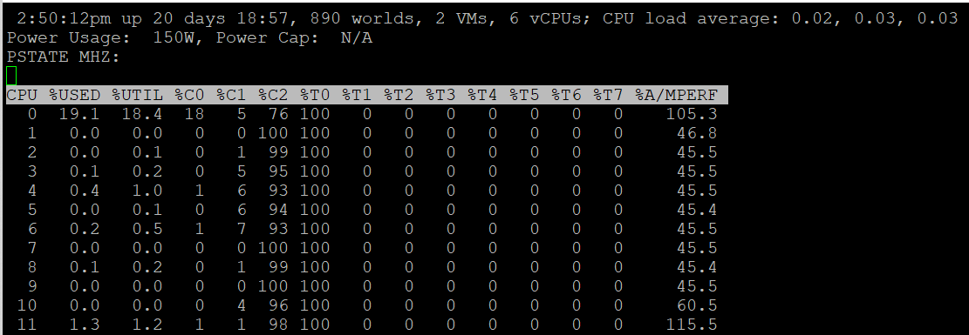

The Power Usage line tracks the current total power usage (in Watts). Compare this with what the hardware specification. Power Cap shows the limit applied. You only do this hard limit when there is insufficient power supply from the rack.

The PSTATE MHZ line tracks the CPU clock frequency for each state.

Now let’s go into the table. It lists all the physical core (or thread if you enable HT). Note it does not group them by socket.

|  |  |
| --- | --- |
| %USED | Used (%) metric is covered in-depth here under ESXi CPU metric section. |
| %UTIL | Utilization (%) metric is covered in-depth here under ESXi CPU metric section. |
| %CState | Percentage of time spent in a C-State, P-State and T-State.  Power management is covered here under ESXi CPU metric section. |
| %TState |
| %A/Mperf | Actual / Measured Performance, expressed in percentage. The word measured in this case means the nominal or static value. So a value above 100% means Turbo, while a value below 100% means power saving kicked in. If this number is not what you are expecting, check the power policy settings in BIOS and ESXi |

## Quiz! Time

By now I hope you vrealize that the various “utilization” metrics in the 4 key objects (Guest OS, VM, ESXi and Cluster) varies. Each has their own unique behaviour. Because of this, you are right to assume that they do not map nicely across the stack. Let’s test your knowledge with an example 😊

Review the following chart carefully. Zoom in if necessary.



The vCenter chart[12] above shows a VM utilization counters. It’s a large VM with 24 vCPU running controlled CPU test. The power management is fixed so it run at nominal clock speed. This eliminates CPU frequency scaling factor.

It starts at 50% “utilization”, with each vCPU pinned to a different physical core. It then slowly ramps up over time until it reached 100%.

Can you figure out why the three counters moved up differently? What do they measure?

Now let’s look at the impact on the parent ESXi. It only has a single VM, but the VM vCPU matches the ESXi physical cores. The ESXi starts at 50% “utilization”, then slowly ramp up over time until it reached 100%.



Can you figure out why the 3 counters moved up differently? What do they measure?

Let’s break it down…

### At the start of the test

The VM runs 12 vCPU, but each vCPU was pinned to each ESXi core. So all cores are 100% utilized, but each running 1 thread.

VM CPU Run (ms) is 240K milliseconds, which is 20K milliseconds x 12 (half of its 24 vCPU).

VM CPU Used (ms) is also at 240K milliseconds. There is no loss from overlap, the VM does not do much IO, and no efficiency loss/gain due to HT.

VM CPU Usage is 50%.

So at this point, all 3 counters of VM CPU are 50%.

The counter at ESXi tells a different story. The ESXi Core Utilization (%) immediately went up to 100% while Utilization went up to only 50%. The reason is Core Utilization measures whether the core is used or not. It’s unaware of HT.

Usage (%) is identical to Core Utilization in this case.

On the other hand, ESXi Utilization (%) looks at if each thread HT is running or not. It does not care about the fact that the 2 threads share a core, and simply roll up to ESXi level directly from thread level. This is why it’s showing 50% as it only cares whether a thread is running or not, at any point in time.

### During Ramp Up period

VM is being ramped up steadily. You can see all 3 counters went up in steps.

VM CPU Run (ms) ramps up from 240K to 480K. All 24 vCPU has 20K ms value, which equals to 100%.

VM CPU Used (ms) barely moved. From 240K to 300K. That’s 1.25x, demonstrating that Used understands HT only delivers 1.25x throughput.

VM CPU Usage (%) ramp up from 50% to 62.5%, also demonstrating awareness of contention due to HT.

Used (ms) = Usage (%)

ESXi CPU Usage (%) counter stayed flat at 100%. The reason is all 12 cores were already busy. That means VM CPU Usage (%) is aware of HT, but ESXi CPU Usage (%) is not.

ESXi CPU Core Utilization (%) matches VM Run. Both went 2x.

### Towards the end of the run

VM CPU Run is at 480K ms. This counter is suitable for VM Capacity sizing, as it correctly accounts that each vCPU is used by Guest OS.

VM CPU Used is at 300K milliseconds, which is 62.5%

VM CPU Usage (%) is at 62.5%. On average, each of the VM vCPU only gets 62.5%. If you use this for your VM capacity, you will get the wrong conclusion as it’s already running 100%

ESXi CPU Usage (%) is at 100%. This makes it suitable from Capacity viewpoint, albet too conservative. It is not suitable from Performance, as you can not tell if there is still room.

ESXi CPU Utilization (%) is at 100%. Because it tracks the ramp correctly, it can be used from Performance. You can use it for Capacity, but take note that 100% means you get performance hit from. In fact, at 50% the HT effect will kick in

Chapter 3

# Memory

## Introduction

We have covered CPU in depth in the previous chapter. Let's now take a trip down memory lane, pun intended.

Memory differs from CPU as it is a form of storage. CPU is highly transient in nature. Instructions enter and leave the execution pipelines in less than a nanosecond. Memory is basically a collection of pages (blocks) in physical DIMM. Information is stored in memory in standard block sizes, typically 4 KB or 2 MB. Each block is called a page. At the lowest level, the memory pages are just a series of zeroes and ones. MS Windows initializes its pages with 0, hence there is zero page counter in ESXi.

While CPU discards instructions as they leave the CPU pipeline, memory keeps information for a much longer period of time. We are comparing nanoseconds to seconds (or longer, up to months, depending upon the uptime of your VM).

Keeping this concept in mind is *critical* as you review the memory counters. Memory has a very different nature compared to CPU, and the storage nature of memory is the reason why memory monitoring is more challenging than CPU monitoring. Unlike CPU, memory has 2 dimensions: Speed and Space

* Speed is measured in nanoseconds. The only counter ESXi has is Memory Latency. This counter increases when the time to read from the RAM is longer than usual. The counter tracks the percentage of memory space that’s taking longer than expected. It’s not tracking the actual latency in nanosecond. This is the opposite of Disk, where we track the actual latency, but not the percentage of amount of space that is facing latency. Both are storage, but “server people” and “storage people” measure them differently!
* Space is measured in GB. This is the bulk of the counters.

## Virtual Memory

Before we talk about memory counter, we need to cover virtual memory, as it’s an integral part of memory management. The following shows how Windows or Linux masks the underlying physical memory from processes running on the OS.



From the process’ point of view, this technique provides a contiguous address space, which makes memory management easier. It also provides isolation, meaning process A can’t see the memory of process B. This isolation provides *some* level of security. The isolation is not as good as isolation by container, which in turn is inferior to isolation by VM.

Virtual Memory abstraction provides the possibility to overcommit. Linux may have 16 GB of physical RAM, but by using pagefile the total memory available to its processes can exceed 16 GB. The process is unaware what is backing its virtual address. It does not know whether a page is backed by Physical Memory or Swap File. All it experiences is slowness, but it won’t know why as there is no counter at process level that can differentiate the memory source.

On the other hand, some applications manage its own memory and do not expose to Windows or Linux. Example of such applications as are database and Java VM. [Oleg Ulyanov](https://www.linkedin.com/in/oulyanov-vmware/) shared in this [blog](https://blogs.vmware.com/apps/2020/11/monitoring-and-rightsizing-memory-resource-for-virtualized-sql-server-workloads.html) SQL Server has its own operating system called SQLOS. It handles memory and buffer management without communicating back to underlying operating system.

With virtualization, VM object adds yet another layer.

If you add ESXi, we actually have 4 layers from Process à Guest OS à VM à ESXi.

The only layer that manages the actual physical memory is the last layer. IMHO, the term “Guest physical memory” is illogical.

Each of these layers have their own address space. And that’s where the fun of performance troubleshooting begins 😉



From the VMs point of view, it provides a contiguous address space and isolation (which is security). The underlying physical pages at ESXi layer may not be contiguous, as it’s managed differently. The VM Monitor for each VM maps the VM pages to the ESXi pages[13]. This page mapping is not always 1:1. Multiple VM pages may point to the same ESXi pages due to transparent page sharing. On the other hand, VM page may not map to ESXi page due to balloon and swapped. The net effect is the VM pages and ESXi pages (for that VM) will not be the same, hence we need two sets of counters.

|  |  |
| --- | --- |
| **VM memory** | Counters tracks the VM Pages. There are 2 sets, one for each VM, and one a summation at ESXi level for all running VMs. Do not confuse the summation with ESXi memory counters.  Examples: Granted or Memory Shared |
| **ESXi memory** | Counters tracks the ESXi Pages. There are also 2 sets, but the summation at ESXi level contains VMkernel own memory and VM overhead  Examples: Consumed or Memory Shared Common |

This abstraction provides the possibility to overcommit, because the VM is unaware what is backing the physical address. It could be Physical Memory, Swap File, Copy On Write, zipped, or ballooned.



Take note the position of Granted and Consumed. While both are counters for VM, their context is different. One looks at it from the VM viewpoint, the other from ESXi.

Understanding the vantage point is required to make sense of the metrics. It will prevent you from comparing metrics that are not comparable (e.g. granted vs consumed) as they have different context.

Further reading: [vSphere Resource Management](https://www.vmware.com/techpapers/2006/resource-management-with-vmware-drs-401.html) technical paper.

If you need more convincing, here is from **VMware vSphere 6.5 Host Resources Deep Dive** by [Frank Denneman](https://frankdenneman.nl/) and [Niels Hagoort](https://www.linkedin.com/in/nielshagoort/). You will find it at Chapter 11 VMkernel Memory Management, page 243. I have highlighted with green the part you need to pay attention 😊

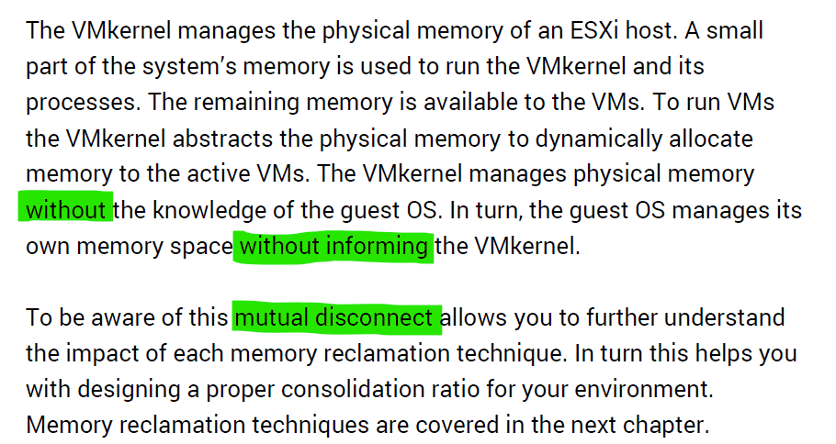

Read further and you will see that VMkernel large page setting contributes more to ESXi capacity and the VM performance.

## Guest OS vs VM

The following diagram compares the memory counters between VM and Guest OS,



Guest OS and VM counters do not map to each other. Neither the VMkernel nor the Guest OS have full visibility into each other.

Right off the bat, you will notice that popular counters such as Consumed, Shared, and Reservation do not exist in Windows.

ESXi Host cannot see how the Guest OS manages its memory pages, how it classifies the pages as Use, Modified, Cache and Free. ESXi also cannot see the virtual memory (page file).

ESXi can only see when the Guest OS performs reads or writes. That’s why vSphere VM main counters are basically what is active recently and what has been active. The first one is called Active, the second is called Consumed. All other counters are about ESXi memory management, and not about VM memory utilization. VM memory utilization impacts ESXi memory management, but they are clearly not the same thing.

### Example: Guest OS more accurate

Let’s take an example with a simple Microsoft Windows server running Active Directory. It has 4 GB of memory as it’s just serving a small number of objects in the Singapore office lab. Take a look at the following table, where I compared the counter from inside the Guest OS and the VM memory active counter.



There are four periods above where I made changes inside Windows. Let’s step through them.

|  |  |
| --- | --- |
| **Period** | **What happened** |
| A | Microsoft AD server in normal running condition. vCenter is reporting low utilization, around 15-20%. Note vCenter users the Active metric, not Consumed. |
| B | I installed the vRealize Operations agent, which is based on the open source [Telegraf](https://www.influxdata.com/time-series-platform/telegraf/). This gives the Guest OS metric, which is shown by the blue color. The agent collects data every 5 minutes, hence the regular spike. So far so good.  Notice the value from VM Active metric jumps to 100%. That’s fine, but then it stays at 100% for more than 12 hours. All I did was installing a small collection agent and that’s it.  I actually got an alarm in vCenter, even though the VM does not need the RAM obviously. What happened here prove that the Active counter is based on sampling, and that sampling could be wrong. More on that here. |
| C | The next morning, I decided to generate some load as the pattern does not change at all. Since Windows has not been patched for a long time, I started Windows patch. The entire process is mostly downloading and installing, which last for several hours.  The two metrics show no correlation at all. |
| D | After several hours, the entire Windows update process is completed. |

### Example: VM more accurate

Let’s now look inside the VM. I will use another VM to show a different example. This time around, I will take an idle VM so we can see how the counters behave. An idle VM will have minimal or 0 activity.

You can see that this Windows Server 2016 VM has 16 GB, but 0 GB is active. It is expected as we know the Guest OS is idle as nothing is installed. vCenter is showing the data correctly. So far so good….



What do you think you will see inside Windows?

Will the Windows In Use counter show that it’s using 0 GB or somewhere near there? You know that it won’t show 0 GB as it’s impossible that any OS does not use any memory while it’s running. So what number will the In Use counter show?



It’s showing 7.2 GB! That’s no where near 0%.

Look at the chart. What do you notice?

It portrays that it has been constantly or actively using that much of memory. In reality, we know it’s idle because ESXi is the one doing the actual reading and writing. The other proof that it is idle is Windows actually compressed 1.5 GB of this 7.2 GB.

One possible reason why Windows or Linux are showing high usage when there is none is applications that manage their own memory. These applications will ask for the memory upfront in 1 contiguous block. You can see in the example below:

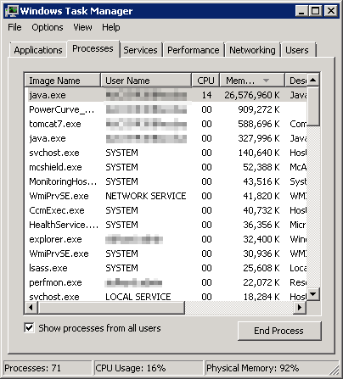

You can see that java.exe takes up 26 GB. JVM (Java Virtual Machine) manages that memory and Windows can’t see inside this block. Windows sees the entire block as used and committed, regardless whether the application actually uses it or not.

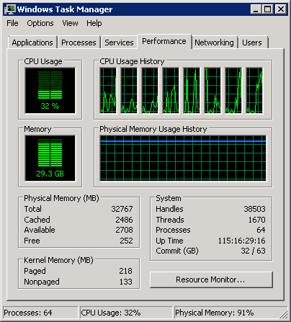

BTW, the above is taken from old blog article of Manny Sidhu. The blog no longer available, hence I could not provide the link.

I hope the above simple experiments shows that you should use the right counter for the right purpose.

## Guest OS

Windows memory management is not something that is well documented. [Ed Bott](https://www.zdnet.com/meet-the-team/us/ed-bott/) sums it [this](http://www.zdnet.com/article/windows-7-memory-usage-whats-the-best-way-to-measure/) article by saying “Windows memory management is rocket science”. Like what Ed has experienced, there is conflicting information, including the ones from Microsoft. [Mark Russinovich](https://www.linkedin.com/in/markrussinovich/), cofounder of Winternals software, explains the situation in [this](https://blogs.technet.microsoft.com/markrussinovich/2008/11/17/pushing-the-limits-of-windows-virtual-memory/) TechNet post.

Windows Performance Monitor provides many counters, some are shown below.

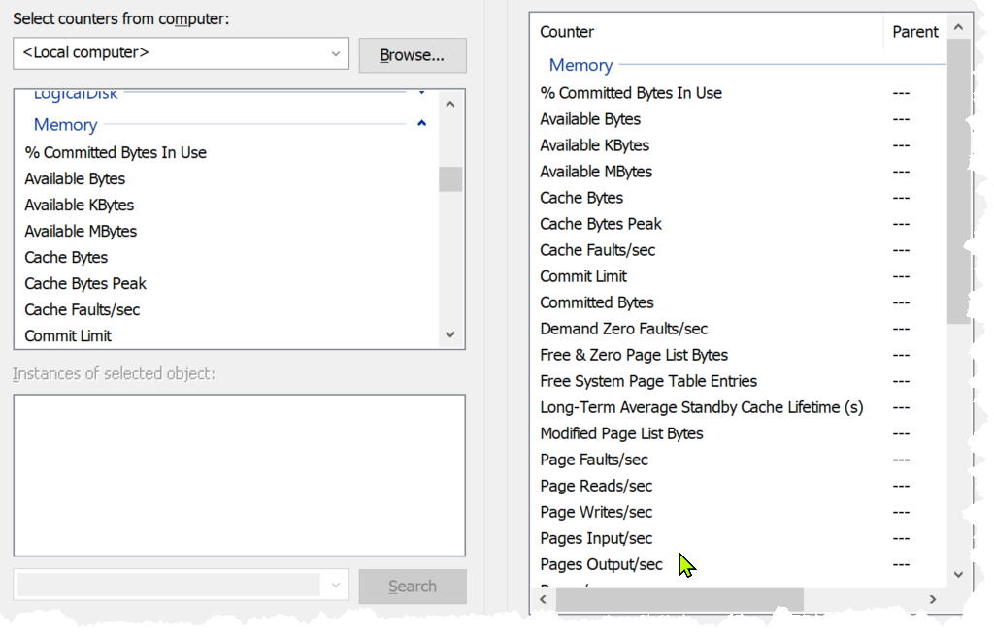

In formula, here is their definition:

* Cached = Standby + Modified
* Available = Standby + Free

It is easier to visualize it, so here it is:



Windows and Linux manage memory differently, and they also name their metrics differently. VMware Tools provide a set of universal metrics from these two popular types of Guest OSes. The following shows what it looks like in Linux

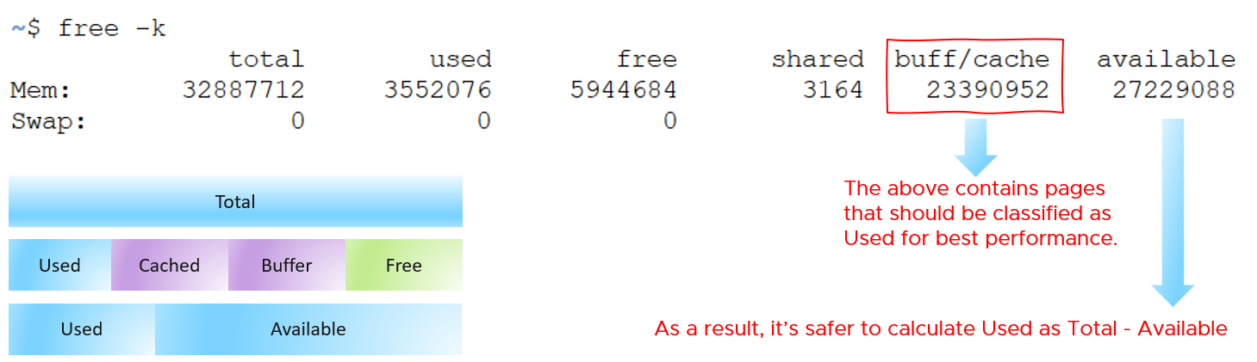

A popular tool for Windows monitoring is SysInternal. In addition to the above, it shows Transition and Zeroed.



### ****In Use****

This is the main counter used by Windows, as it’s featured prominently in Task Manager.



This is often thought as the minimum that Windows needs to operate. This is not true. If you notice on the preceding screenshot, it has compressed 457 MB of the 6.8 GB In Use pages, indicating they are not actively used. Windows compresses its in-use RAM, even though it has plenty of Free RAM available (8.9 GB available). This is a different behaviour to ESXi, which do not compress unless it’s running low on Free.

Look at the chart of Memory Usage above. It’s sustaining for the entire 60 seconds. We know this as the amount is too high to sustain for 60 seconds if they are truly active, let alone for hours.

Formula:

In use = Total – (Modified + Standby + Free)

A problem related to the In Use counter is [memory leak](https://en.wikipedia.org/wiki/Memory_leak). Essentially, the application or process does not release pages that it no longer needs, so over time it accumulates. This is hard to detect as the amount varies by application. The process will continue growing until the OS runs out of memory.

Take note this is a new metric in vRealize Operations 8.6. We call it Used Memory. You’re welcome.

### ****Modified****

Page that was modified but no longer used, hence it’s available for other usage but requires to be saved to disk first. It’s not counted as part of Available, but counted as part of Cache.

OS does not immediately write all inactive pages to disk, especially if the disk is on power saving mode. It will consolidate these pages and write them in one shot, minimizing IO to the disk. In the case, of SSD disk, it can shorten the life span as SSD has physical limits on the number of writes.

### ****Standby****

Windows has 3 levels of standby. As reported by VMware Tools, their names are:

* Standby Core
* Standby Normal
* Standby Reserve

Different applications use the memory differently, resulting in different behaviour of the metrics. As a result, determining what Windows actually uses is difficult.

The Standby Normal counter can be fluctuating wildly, resulting in a wide difference if it’s included in rightsizing. The following VM is a Microsoft Exchange 2013 server mailbox utility.



Notice the Standby Normal fluctuates wildly, reaching as high at 90%. The other 2 cache remains constantly negligible. The chart above is based on >26000 samples, so there is plenty of chance for each 3 counters to fluctuate.

Now let’s look at another example. This is a Windows Server 2016. I think it was running Business Intelligence software Tableau.



Notice the VM usable memory was increased 2x in the last 3 months. Standby Normal hardly move, but Standby Reserve took advantage of the increments. It simply went up accordingly, although again it’s fluctuating wildly.

### Cache

Cache is an integral part of memory management, as the more you cache, the lower your chance of hitting a cache miss. This makes sense. RAM is much faster than Disk, so if you have it, why not use it? Remember when Windows XP introduced pre-fetch, and subsequently Windows SuperFetch? It’s a clue that memory management is a complex topic. There are many techniques involved. Unfortunately, this is simplified in the UI. All you see is something like this:



Linux and VMkernel also has its fair share of simplifying this information. This [Linux Ate My RAM](http://linuxatemyram.com) documents it well. For ESXi, a common misperception is “we are short on RAM, but fine on CPU”, when it is actually the other way around. To prove it, check the **performance** counters for each cluster. You may see that the VMs have CPU performance while cluster CPU utilization is lower than cluster memory utilization.

### ****Free****

As the name implies, this is a block of pages that is immediately available for usage. This excludes the cached memory. A low free memory does not mean a problem if the Standby value is high. This number can reach below 100 MB, and even touch 0 MB momentarily. It’s fine so long there is plenty of cache. I’d generally keep this number > 500 MB for server VM and >100 MB for VDI VM. I set a lower number for VDI because they add up. If you have 10K users, that’s 1 TB of RAM.

When Windows or Linux frees up a memory page, it normally just updates its list of free memory; it does not release it. This list is not exposed to the hypervisor, and so the physical page remains claimed by the VM. This is why the Consumed counter in vCenter remains high when the Active counter has long dropped. Because the hypervisor has no visibility into the Guest OS, you may need to deploy an agent to get visibility into your application. You should monitor both at the Guest OS level (for example, Windows and Red Hat) and at the application level (for example, MS SQL Server and Oracle). Check whether there is excessive paging or the Guest OS experiences a hard [page fault](https://en.wikipedia.org/wiki/Page_fault). For Windows, you can use tools such as pfmon, a page fault monitor.

This is one the 3 major counters for capacity monitoring. The other 2 counters are Page-in Rate and Commit Ratio. These 3 are not contention counters, they are utilization counters. Bad values can contribute to bad performance, but they can’t measure the severity of the performance. Windows and Linux do not have a counter that measures how long or how often a CPU waits for memory.

In Windows, this is the Free Memory counter. This excludes the cached memory. If this number drops to a low number, Windows is running out of Free RAM. While that number varies per application and use case, generally keep this number > 500 MB for server VM and >100 MB for VDI VM. The reason you should set a lower number for VDI because they add up quickly. If you have 10K users, that’s 1 TB of RAM.

Further reading for Linux, read [this](http://www.chrisjohnston.org/ubuntu/why-on-linux-am-i-seeing-so-much-ram-usage).

It’s okay for this counter to be low, so long other memory counters are fine. The following table shows VMs with near 0 free memory. Notice none of them are needing more memory. This is the perfect situation as there is no wastage.



### ****Page File****

[Memory paging](https://en.wikipedia.org/wiki/Memory_paging) is an integral part of Guest OS Memory Management. OS begins using it even though it still has plenty of physical memory. It uses both physical memory and virtual memory at the same time. Microsoft recommends that you do not delete or disable the page file. See [this](http://windows.microsoft.com/en-us/windows/change-virtualmemory-size) for reference.



As shown on the diagram, processes see virtual memory, not physical memory. Guest OS presents this as system API to processes. The virtual memory is backed by the page file and physical memory. Guest OS shields the physical memory and hardware. Paging is an operation of reading/writing from the page file into the physical memory, not from physical disk into the page file.

Let Windows manages the pagefile size. This is the default setting, so you likely have it already. By default, windows sets the pagefile size to the same size with the physical memory. So if the VM has 8 GB of RAM, the pagefile is an 8 GB file. Anything above 8 GB indicates that Windows is under memory pressure.

The VM metric Guest \ Swap Space Remaining tracks the amount of swap space that's free.

The size of Page File is not a perfect indicator of the RAM usage, because they contain pages that are never demanded by the App. Windows does SuperFetch, where it predicts what pages will be used and prefetch them in advance. Some of these pages are never demanded by the application. Couple with the nature that Guest OS treats RAM as cache, including the page file will result in oversized recommendation. Paging rate is more realistic as it only considers the recent time period (300 seconds in vRealize Operations case)

A page would be used as cache if it was paged out at some point due to memory pressure and it hasn’t been needed since. The OS will reuse that page as cache. That means that at some point the OS was constrained on memory enough to force the page out to happen.

A page that was paged out earlier, has to be brought back first before it can be used. This creates performance issue as the application is waiting longer, as disk is much slower than RAM.

There are 2 types of page operations:

* Page In. This is a potential indicator for performance.
* Page-out. This is a potential indicator for capacity.

While Paging impacts performance, the correlation between the paging counters and performance varies per application. You can’t set a threshold and use it to monitor different applications or VM. The reason is paging is not always used when Guest OS runs out of memory. There are a few reasons why paging may not correlate to memory performance:

* Application binary. The initial loading causes a page-in. Nobody will feel the performance impact as it’s not even serving anyone.
* Memory mapped files. This is essentially a file that has a mapping to memory. Processes use this to exchange data. It also allows the process to access a very large file (think of database) without having to load the entire database into memory.
* Proactive pre-fetch. It predicts the usage of memory and pre-emptively reads the page and bring it in. This is no different to disk where the storage array will read subsequent blocks even though it’s not being asked. This especially happens when a large application starts. Page-in will go up even though there is no memory pressure (page out is low or 0).
* Windows performs memory capacity optimization in the background. It will move idle processes out into the page file.

If you see both Page-in and Page-out having high value, and the disk queue is also high, there is a good chance it’s memory performance issue.

The rate pages that are being brought in and out can reveal memory performance abnormalities. A sudden change, or one that has *sustained over time*, can indicate page faults. Page faults indicate pages aren’t readily available and must be brought in. If a page fault occurs too frequently it can impact application performance. While there is no concrete guidance, as it varies by application, you can judge by comparing to its past behaviour and its absolute amount.

Operating Systems typically use 4KB or 2MB page sizes. Larger page size will result in more cache, which translates into more memory required.

The counter %pagefile tracks how much of the pagefile is used, meaning the value 100% indicate the pagefile is fully utilized. While the lower the number the better, there is no universal guidance. If you know, let me know!

Reference: [this](https://docs.microsoft.com/en-US/troubleshoot/windows-server/performance/ram-virtual-memory-pagefile-management) is an old article as it covers 32 bit Windows. If you find a newer one, kindly let me know.

### Guest OS Paging metrics

There are 2 metrics. Page-in and Page-out.

The unit is in number of pages, not MB. It's not possible to convert due to mix use of Large Page (2 MB) and Page (4 KB). A process can have concurrent mixed usage of large and non-large page in Windows. The page size isn’t a system-wide setting that all processes use. The same is likely true for Linux Huge Pages.

The page-in rate metric tracks the rate OS brings memory back from disk to DIMM per second. Another word, the rate of reads going through paging/cache system. It includes not just swap file I/O, but cacheable reads as well (so it’s double pages/s).

Page Out is the opposite of the above process. It is not as important as Page In. Just because a block of memory is moved to disk that does not mean the application experiences memory problem. In many cases, the page that was moved out is the idle page. Windows does not page out any Large Pages.

The following shows the page out value at 99th percentile in the last 4 months. What do you observe?

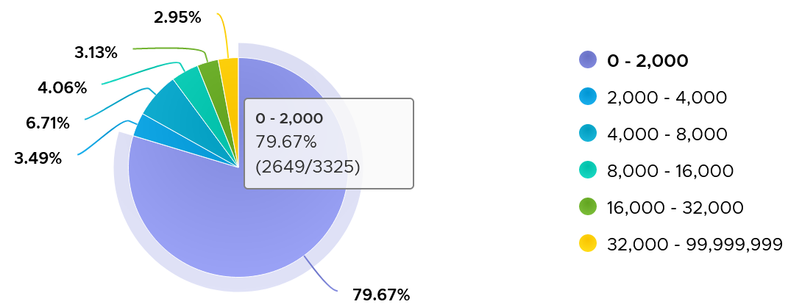

There are 3325 VM in the above chart. In the last 4 months, 97% of them have page-out rate of less than 32000 pages, on a 5-minute average basis.

How about the remaining 3%?

Surprisingly, a few of them can be well 500000, indicating there is a wide range. So majority of VMs do not page out, but those that do, they do it excessively.

The block size is likely 4 KB. Some applications like Java and databases use 2 MB pages. Using 8 KB as the average, 10000 pages per second sustained over 5 minutes means 80000 KB x 300 = 24 GB worth of data.

You can profile your environment to see which VMs are experiencing high paging. Create a view with the following 6 columns

* Highest Page-In. Color code it with 1000, 10000, and 100000 as the thresholds. That means red is 10x orange, which in turn is 10x yellow.
* Page-In value at 99th percentile. Same threshold as above.
* Highest Page-Out. Same threshold as above.
* Page-Out value at 99th percentile. Same threshold as above.
* Sum of Page-In
* Sum of Page-Out

Set the dates to the period you are interested, but make it at least 1 week, preferably 3 months. There 2016 data points in a week, so the 99th percentile ignores the highest 20 datapoints.

In the following example, I used 4 months. I listed the top VMs in terms, sorted by the highest page-in. What observation do you see?

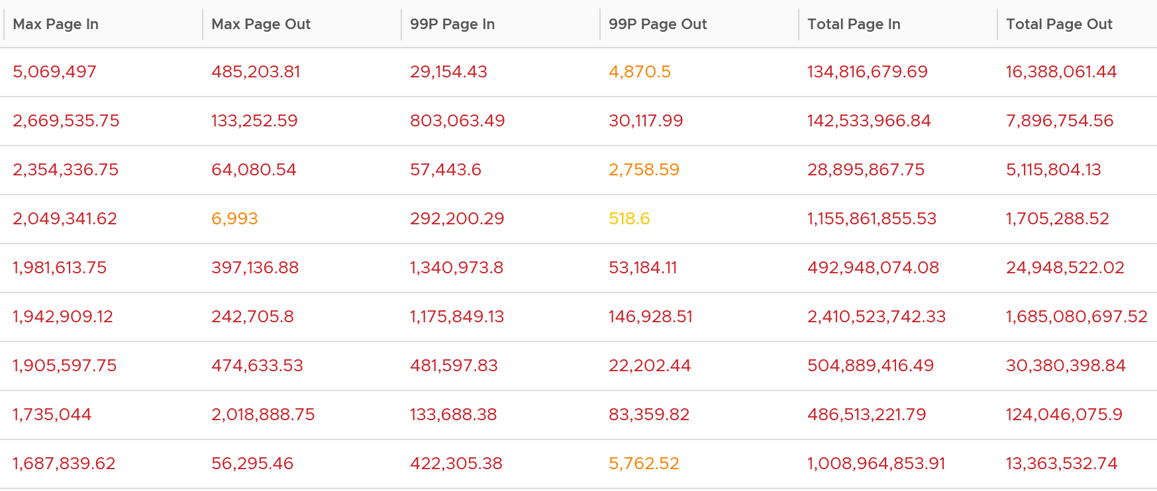

For a start, some of those numbers are really high!

They are above 1 millions. Assuming 8K block size, that’s 8 GB per second, sustained for 300 seconds.

What else do you notice?

Page-In is higher than Page-Out. I average all the 3K VMs and I got the following result:



Page-In is 4x higher in the max value. Page-In also sustains longer, while Page-Out drops significantly. At the 99th percentile mark, Page-In is 9x higher. I suspect it is the non-modifiable page, like binary. Since it cannot be modified, it does not need to be paged out. It can simply be discarded and retrieved again from disk if required.

The good news is both do not sustain, so the paging is momentary. The following shows that the value at 99th percentile can drop well below 5x.

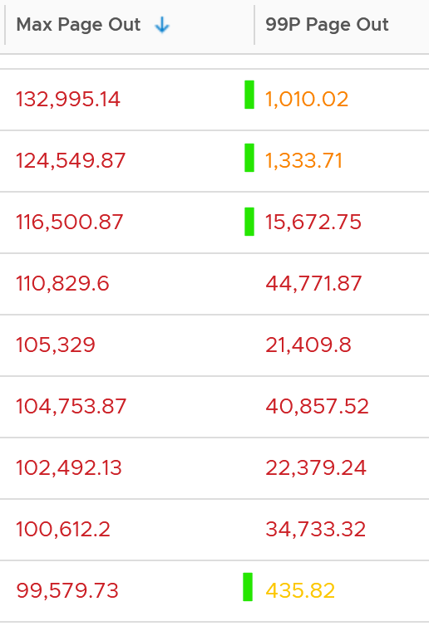 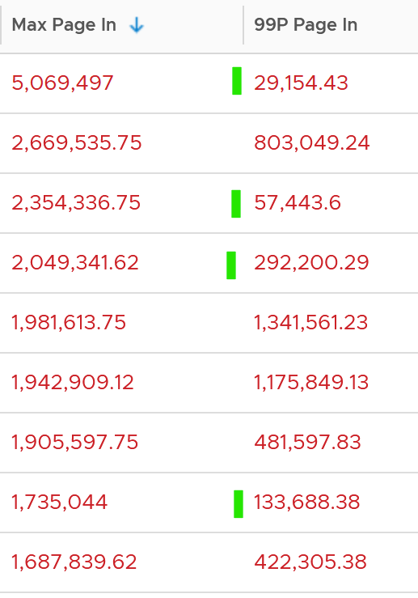

To confirm the above, I downloaded the data so I can determine if the paging is indeed momentarily. Using a spreadsheet, I build a ratio between the 99th percentile value and the maximum value, where 10% means there is a drop of 10x. I plotted around 1000 value and got the following.

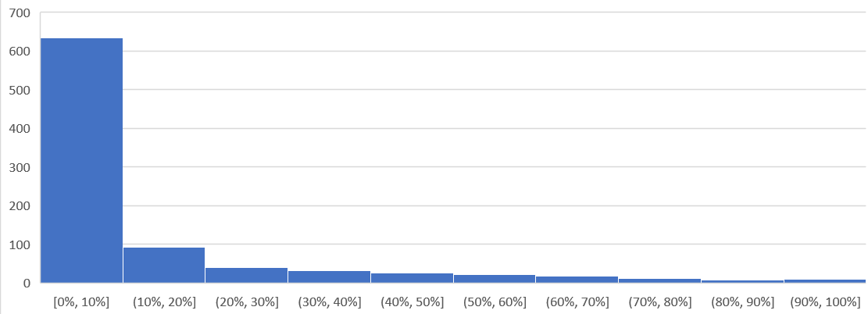

As you can see, majority of the paging drops drastically at 99th percentile.

Let’s dive into a single VM, so we can see pattern over time. I pick a database, as it does heavy paging. The following is a large Oracle RAC VM. Notice this has a closer ratio between page in and page out, and there is correlation between the two.

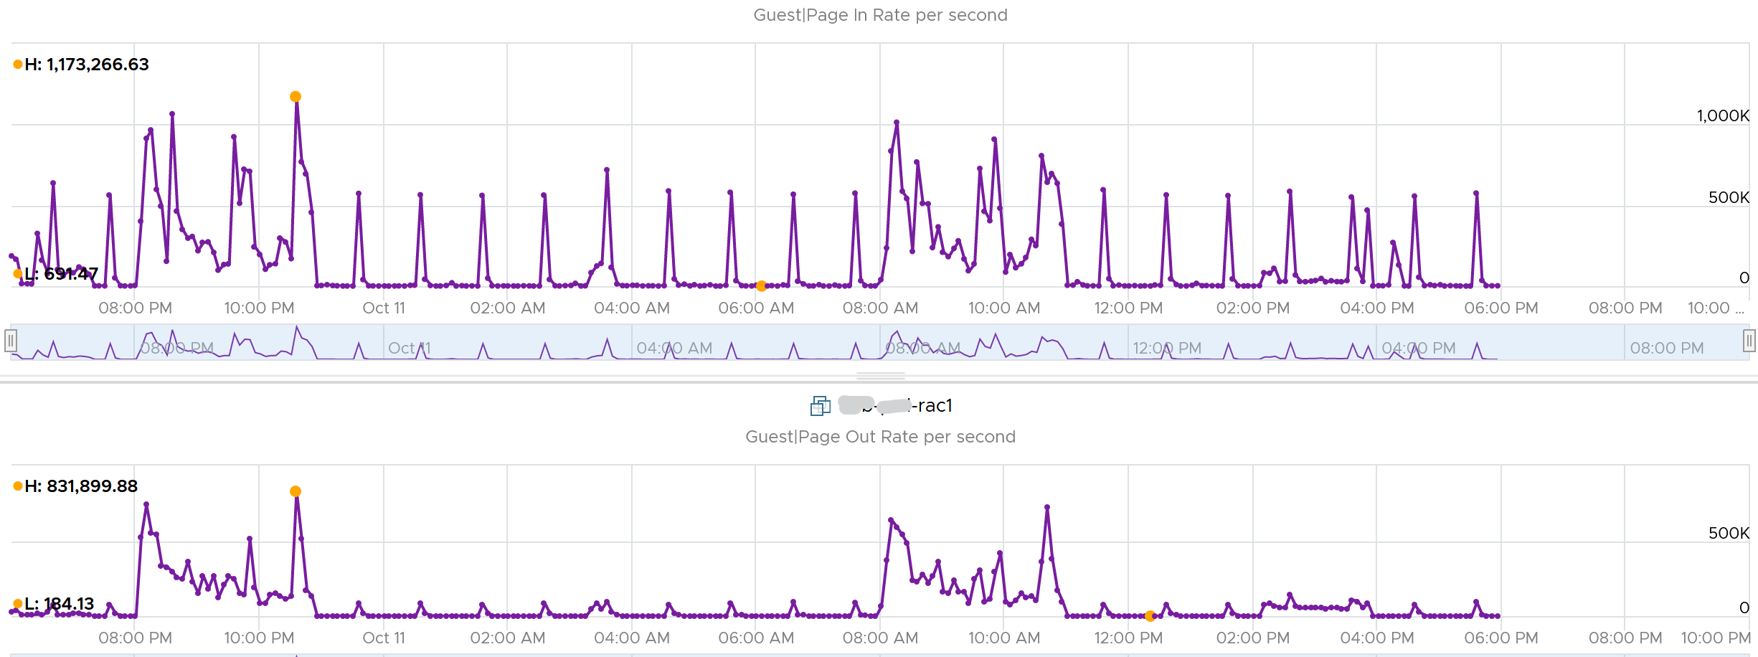

Assuming the page size is 4 KB, that means 100,000 pages = 400 MB/sec. Since vRealize Operations averages the value over 300 seconds, that means 400 MB x 300 = 120 GB worth of paging in 5 minutes!

### Committed

**This tracks** the currently committed virtual memory, although not all of them are written to the pagefile yet. It measures the demand, so commit can go up without In Use going up, as Brandon Paddock shares [here](http://brandonlive.com/2010/02/21/measuring-memory-usage-in-windows-7/). If Committed exceeds the available memory, paging activity will increase. This can impact performance.

**Commit Limit**: Commit Limit is physical RAM + size of the page file. Since the pagefile is normally configured to map the physical RAM, the Commit Limit tends to be 2x. **Commit Limit** is important as a growing value is an early warning sign. The reason is Windows proactively increases its **pagefile.sys** if it’s under memory pressure.

The pagefile is an integral part of Windows total memory, as explained by [Mark Russinovich](https://www.linkedin.com/in/markrussinovich/) explains [here](https://blogs.technet.microsoft.com/markrussinovich/2008/11/17/pushing-the-limits-of-windows-virtual-memory/). There is Reserved Memory, and then there is Committed Memory. Some applications like to have its committed memory in 1 long contiguous block, so it reserves a large chunk up front. Databases and JVM belong in this category. This reserved memory does not actually store meaningful application data or executable. Only when the application commits the page that it becomes used. Mark explains that “when a process commits a region of virtual memory, the OS guarantees that it can maintain all the data the process stores in the memory either in physical memory or on disk”.

Notice the word **on disk**. Yes, that’s where the pagefile.sys comes in. Windows will use either the physical memory or the pagefile.sys.

So how do we track this committed memory?

The metric you need to track is the Committed Byte. The % Committed metric should not hit 80%. Performance drops when it hits 90%, as if this is a hard threshold used by Windows. We disabled the pagefile to verify the impact on Windows. We noticed a visibly slower performance even though Windows 7 showing >1 GB of Free memory. In fact, Windows gave error message, and some applications crashed. If you use a pagefile, you will not hit this limit.

We have covered Free Memory and Committed Memory. Do they always move in tandem? If a memory is committed by Windows, does it mean it’s no longer free and available?

The answer is no. Brandon Paddock demonstrated [here](http://brandonlive.com/2010/02/21/measuring-memory-usage-in-windows-7/) that you can increase the committed page without increasing the memory usage. He wrote a small program and explained how it’s done. The result is Windows committed page is double that of memory usage. The Free Memory & Cached Memory did not change.

### Active File Cache Memory

This is the actively in-use subset of the file cache. Unused file cache and non-file backed anonymous buffers (mallocs etc) are not included.

This is the size of the portion of the system file cache which is currently resident and active in physical memory. The System Cache Resident Bytes and Memory \ Cache Bytes counters are equivalent. Note that this counter displays the last observed value only; it is not an average during the collection period.

In Linux, this is the amount of file cache memory, in kibibytes, that is in active use, or was in active use since the last time the system reclaimed memory. This is retrieved via the command:

$ cat /proc/meminfo | grep Active

Active: 50955636 kB

Active (anon): 30148196 kB

Active (file): 20807440 kB

For further reading, refer to [Linux](https://stackoverflow.com/questions/45487506/what-is-inactivefile-and-activefile-in-proc-meminfo) and [Windows](https://wutils.com/wmi/root/cimv2/win32_perfrawdata_perfos_memory/#systemcacheresidentbytes_properties)

### Linux Memory Metrics

As you can guess from above, Linux does it differently. These are the counters that we’re interested from right sizing use case.

Linux has 2 types of cache: Slab Reclaim and Cached.

vSphere Tools 10.3.5 provides the following counters:

* Total
* Available
* Free
* Buffers
* Used = total - free - buffers - cached
* Cached = guest.mem.cached + guest.mem.slabReclaim

From the [kernel documentation](https://git.kernel.org/pub/scm/linux/kernel/git/torvalds/linux.git/commit/?id=34e431b0ae398fc54ea69ff85ec700722c9da773), the definition are:

* “Cached includes memory that is not freeable as page cache, for example shared memory segments, tmpfs, and ramfs, and it does not include reclaimable slab memory, which can take up a large fraction of system memory on mostly idle systems with lots of files.”
* Available = An *estimate* of how much memory is available for starting new applications, without swapping. Calculated from MemFree, SReclaimable, the size of the file LRU lists, and the low watermarks in each zone. The estimate takes into account that the system needs some page cache to function well, and that not all reclaimable slab will be reclaimable, due to items being in use. The impact of those factors will vary from system to system.
* Buffers: Relatively temporary storage for raw disk blocks shouldn't get tremendously large (20MB or so)

I notice the above was committed by Linus himself, on Jan 2014. Hats off for doing low level things like this!

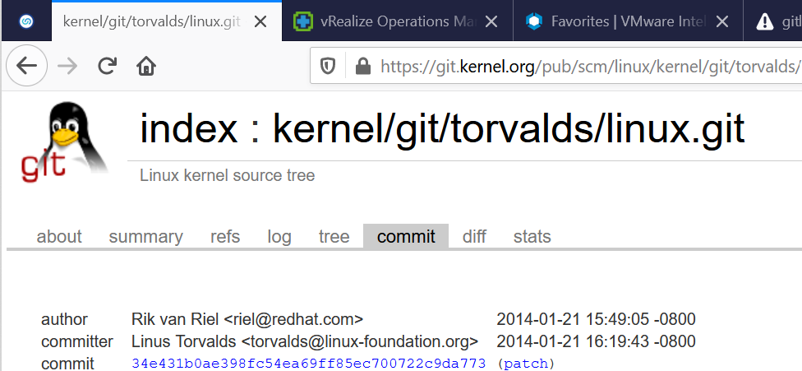

### Guest OS Needed memory

We shared earlier that the purpose of memory is to act as disk cache. So you want to utilize all the cache given to you. Because the static nature of memory consumption, you can create a heat map that plots all your VMs memory consumption. You want it near 100% while making sure the page in and page out rate within normal expectation.



This is *not* a raw counter from Windows or Linux. This is a derived counter provided by VMware Tools to estimate the memory needed to run with minimum swapping. It’s a more conservative estimate as it includes some of the cache.

The counter Needed memory tracks the amount of memory needed by the Guest OS. It has 5% buffer for spike, based on the general guidance from Microsoft. Below this amount, the Guest OS may swap.

Formula for Linux = physical memory – Maximum of (0, ( Available - 5 % of physical ))

Formula for Windows = physical memory - Maximum of (0, ( Unneeded - 5 % of physical ))   
where Unneeded = Free + Reserve Cache + Normal Priority Cache

Example: the VM has 10 GB of RAM. So the Physical RAM = 10 GB

So 5% of physical = 0.5 GB

**Situation 1: max memory utilization.**Memory Available = 0 GB.   
Tools will calculate Needed memory as  
= 10 GB - Maximum (0, 0 – 0.5)  
= 10 - Maximum (0, -0.5)  
= 10 - 0 GB  
= 10 GB  
Needed memory is the same as it’s already maxed.

**Situation 2: high memory utilization.**Memory Available = 2 GB.   
Tools will calculate Needed memory as  
= 10 GB - Maximum (0, 2 – 0.5)  
= 10 - Maximum (0, 1.5 GB)  
= 10 - 1.5 GB  
= 8.5 GB  
You actually still have 2 GB here. But Tools adds around 5%

**Situation 3: low memory utilization.**Memory Available = 8 GB.   
Tools will calculate Needed memory as  
= 10 GB - Maximum (0, 8 – 0.5)  
= 10 - Maximum (0, 7.5 GB)  
= 10 - 7.5 GB  
= 2.5 GB  
Again, Tools adds around 5%.

We’ve covered that you need to look at more than 1 metric before you decide to add more memory. I’m afraid it is case by case, as shown in the following table. All these VMs are low on free memory, but other than VM on row no 3, the rest has sufficient memory.



## VM

One way to know that VM memory management is fundamentally different Guest OS is the metrics. Both come dozens of metrics. Compared with Guest OS such as Windows, can you notice what’s missing and what’s added? Go ahead and open Windows PerfMon or SysInternal and compare with vSphere Client UI, and you will quickly notice major differences.

Just like the case for CPU, some metrics are for VMkernel consumption, not your operations.

### Overview

We will cover each metric in-depth, so let’s do an overview first. I will use the vSphere Client as the source of counters in the following screenshots.

For performance use case, the only counter tracking actual performance is Page-fault Latency.

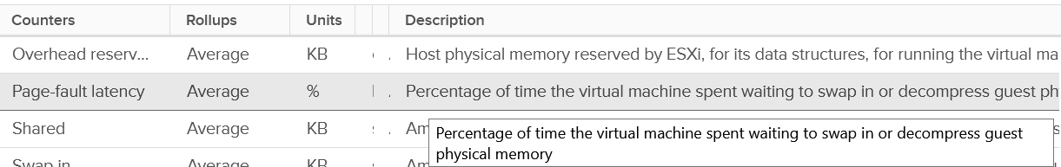

Next, check for swapping as it’s slower than compressed. You get 6 counters for it

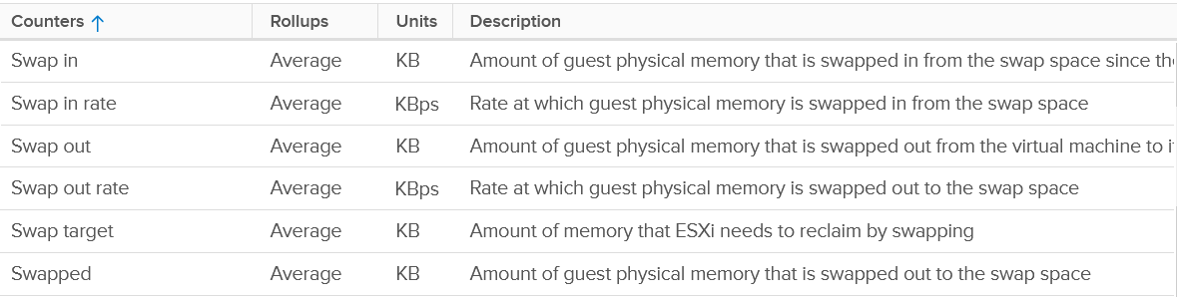

Next is compressed

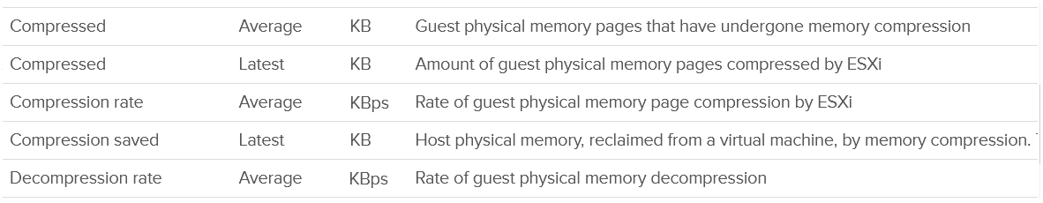

Host Cache should be faster than disk (at least I assume you designed it with faster SSD), so you check it last.

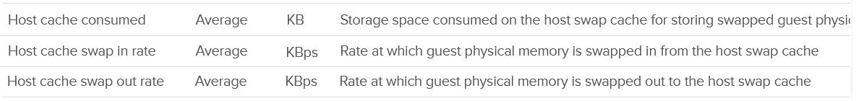

Lastly, there is the balloon.



Wait! Where is the Intel Optane memory metrics?

It does not exist yet, as that’s supposed to be transparent to ESXi.

Performance is essentially the only use case you have at VM level. For Capacity, you should look at Guest OS. The VM capacity metrics serve as input to the host capacity and are used in determining the VM memory footprint (e.g. when migrating to another ESXi).

You’ve got 5 counters, with consume being the main one.

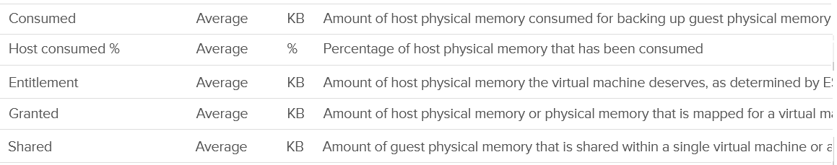

I’m going to add Active next, although I don’t see any use case for it. It’s an internal counter used by VMkernel memory management.



Lastly, you get the shared pages and 0 pages.

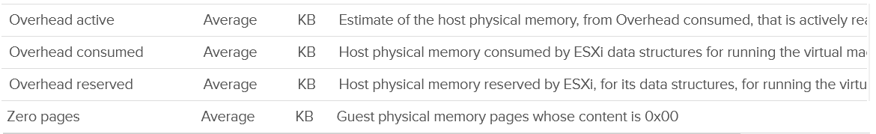

Now that we’ve got the overview, let’s dive into the first counter!

### Contention

Memory Latency, aka "Page-fault latency" is tracking the amount of time a vCPU spends waiting on the completion of a page fault. Its value is probably mostly swap wait, and probably minimally page decompression / copy-on-write-break. The counter is called %LAT_M in esxtop, while CPU Contention is called %LAT_C. This counter has the effect of reduced value of the Compressed metric and/or Swapped metric, and increased the value of Consumed & Granted.

This is the *only* performance counter for memory. Everything else does not actually measure latency. They measure utilization, because they measure the disk space occupied. None captures the performance, which is how fast that memory page is made available to the CPU.

Consider the hard disk space occupied. A 90% utilization of the space is not slower than 10%. It’s a capacity issue, not performance.

If a page is not in the physical DIMM, the VM has to wait longer. It could be in Host Cache, Swapped or Compressed. It will take longer than usual. vSphere tracks this in 2 counters: CPU Swap Wait and RAM Latency.

* CPU Swap Wait tracks the time for Swapped In.
* RAM Latency tracks the percentage of time VM waiting for Decompressed and Swapped In. The RAM Latency is a superset of CPU Swap Wait as it caters for more scenarios where CPU has to wait. vRealize Operations VM Memory Contention metric maps to this.

Latency is >1000x lower in memory compared to disk, as it's CPU basically next to the CPU on the motherboard. Time taken to access memory on the DIMM bank is only around 200 nanoseconds. Windows/Linux does not track memory latency. The closest counter is perhaps page fault. The question is does page fault includes prefetch? If you know, let me know please.

Does it mean we don’t track balloon, swapped and compressed?

No.

The higher the value is for balloon, swapped, and compressed, the higher the chance of a performance hit happening in the future if the data is requested. The severity of the impact depends on the VM memory shares, reservation, and limit. It also depends upon the size of the VM's configured RAM. A 10-MB ballooning will likely have more impact on a VM with 4 GB of RAM than on one with 512 GB.

Latency does not include balloon as that’s a different context. In addition, the hypervisor is not aware of the Guest OS internal activity.

Actions you can do to address high value:

* Store vswp file on higher throughput, lower latency storage, such as using Host Swap Cache.
* Increase memory shares and/or reservation to decrease amount of swapping. If the VM belongs to a resource pool, ensure the resource pool has sufficient for all its VMs.
* Reduce assigned memory. By rightsizing, you reduce the size of memory reclamation, hence minimizing the risk.
* Remove VM Limit.
* Unswap the swapped memory. You cannot do this via API, but you can issue the command manually. Review [this article](https://www.yellow-bricks.com/2016/06/02/memory-pages-swapped-can-unswap/) by Duncan Epping and Valentin Bondzio.
* If possible, reboot the VM as part of regular maintenance. This will eliminate the swap file, hence avoiding future, unexpected swap wait on that swapped page. Note this does guarantee the same page to be swapped out again.

#### Best Practice

In an environment where you do not do memory overcommit and place limit, the chance of hitting memory contention will be basically 0. You can plot the highest VM Memory Contention counter in all clusters and you will basically see a flat line. That would be a lot of line charts, so I’m using a pie chart to analyze 2441 VM in the last 4 months. For each VM, I took the highest value in the last 4 months. Only 13 VM had its worst VM Contention above 1%.



### Granted

I don’t think the English word granted accurately define this metric, so I will just put a picture for you to conclude what it is.

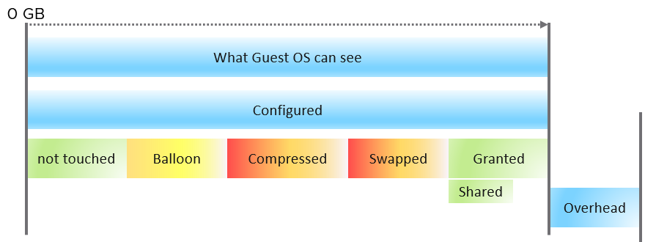

What the Guest OS can see is what is configured by vSphere. Guest OS can’t see the hypervisor memory overhead. Overhead is mostly negligible, as it’s just storing metadata or index information required by virtualization, such as the shadow page tables. Overhead value goes up as you configure more vCPUs and memory.

Say you have a VM configured with 16 GB RAM. Any part of these 16 GB of memory pages can fall under one of these:

|  |  |
| --- | --- |
| **Not touched** | The VM never uses the page since it’s powered on. |
| **Ballooned** | The page was reclaimed by the balloon driver. It has not been asked back by the Guest OS, hence it’s just seating there collecting pixie dust.  I put in yellow color as that’s not a green situation. The higher the balloon, the higher the chance a page will be required in the future |
| **Compressed** | These 2 are mutually exclusive and go together. What can’t be compressed will be swapped. Compressed is preferred as unzipping memory from DRAM is faster than bringing it from SSD disk. |
| **Swapped** |
| **Granted** | Whatever left is called Granted 😊  Granted metric includes the Shared memory. Shared counts the number of memory pages that are pointing to the same underlying block. Granted does not care about underlying usage as its vantage point is VM, not ESXi. |
| **Entitlement** | = Granted + Overhead. |

Ok, the above is the theory. How do you know I’m not making this stuff up, considering I’m pretty good at it?

Let’s take a VM and plot its value over time. As you can see, the value in the last 4 weeks is a constant 16 GB.

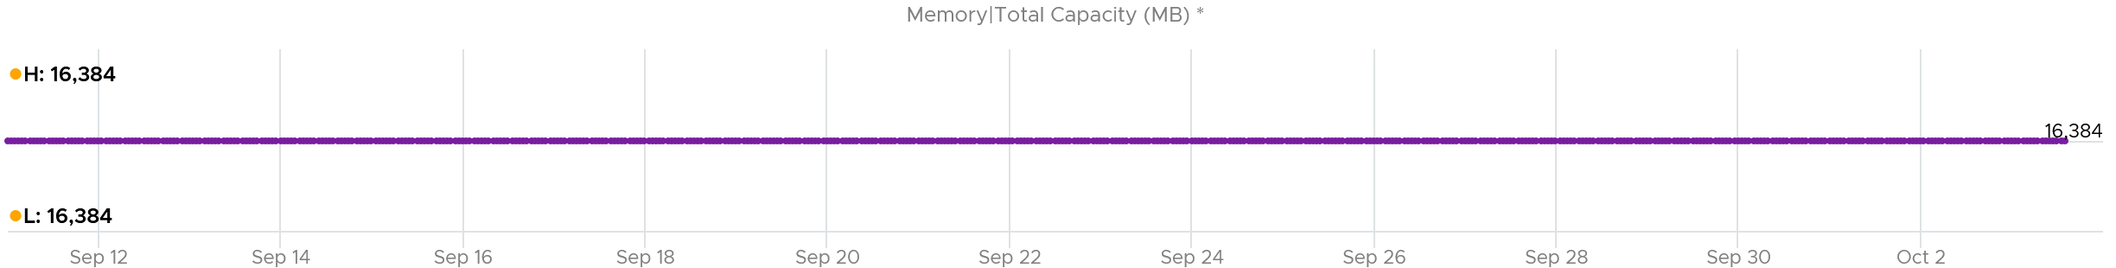

The line is a perfect flat. Both the Highest value and Lowest value show 16,384 MB.

The VM was ballooned. 63.66% of its memory was reclaimed. That’s a whopping 10,430 MB!

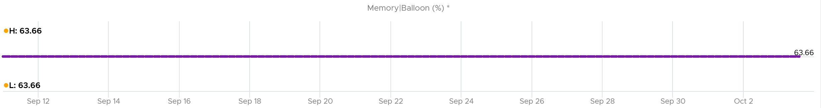

Why is the Ballooned not moving at all?

Because the Guest OS never needs any of those 10+ GB.

So Guest was playing with the remaining 6 GB.

So what do you expect if we plot Granted + Swapped + Compressed?

You got it. A flat line.

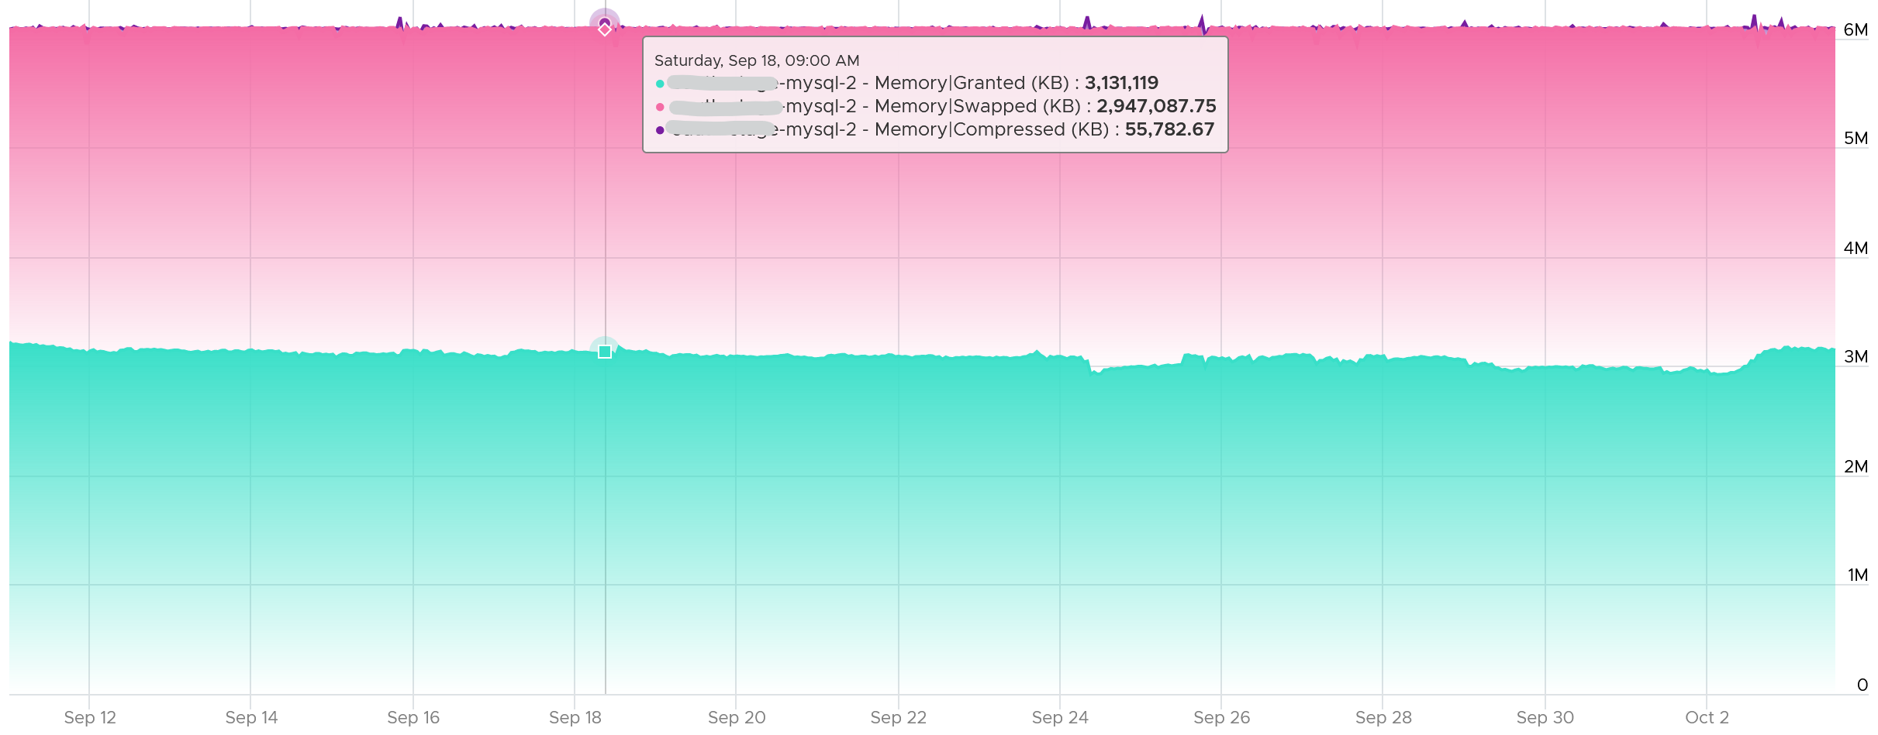

Looking at the diagram in Granted metric, can you explain why Limit is not there?

You are right, it operates at a different layer. Limit is about limiting the usage at the physical layer.

Let’s take an example. The following is VM is a Windows 2016 server, configured with 12 GB of RAM, but was limited to 8 GB (the flat line in cyan near the bottom). The purple line jumping up and down is Granted. Granted ignores the limit completely and run way above it.



Notice Consumed (KB) is consistently below Limit. Granted does not exceed 12 GB as it does not exceed configured.

### Balloon

Balloon is an application (kernel driver to be precise) running inside the Guest OS, but it can take instruction from VMkernel to inflate/deflate.

When it receives an instruction to inflate, it asks the Guest OS to allocate memory to it. This memory in the Guest OS is not backed up by physical memory in ESXi, hence it is available for other VMs. When ESXi is no longer under memory pressure, it will notify the Balloon to release its requested page inside Guest OS. This is a proactive mechanism to reduce the chance of the Guest OS doing paging. Balloon will release the page inside the Guest OS. The Balloon counter for the VM will come down to 0.

Guest OS will start allocating from the Free Pages. If insufficient, it will take from Cache, then Modified, then In Use. This by itself does *not* cause performance problem. What will cause performance is when the ballooned page is requested by Windows or Linux. The following shows a VM that is heavily ballooned as limit was imposed on it. Notice the actual performance happens rarely.



Just because Balloon asks for 1 GB of RAM, does not mean ESXi gets 1 GB of RAM to be freed. It can be less if there is TPS.

To use ballooning, Guest OS must be configured with sufficient swap space.

How much will be asked depends on Idle Memory Tax. I do not recommend playing with this setting.

Guest OS initiate memory reallocation. Therefore, it is possible to have a balloon target value of 0 and balloon value greater than 0. The counter **Balloon Target** tracks this target, so if you see a nonzero value in this counter, it means that the hypervisor has asked this VM to give back memory via the VM balloon driver.

Balloon is a memory request from ESXi. So it’s not part of the application. It should not be included in the Guest OS sizing, hence it’s not part of reclamation.

Balloon impacts the accuracy of Guest OS sizing. However, there is no way to measure it.

* When Balloon driver asks for pages, Guest OS will allocate, resulting in In Use to go up. This is because the balloon driver is treated like any other processes.
* If the page comes from Free, then we need to deduct it from In Use.
* If the page comes from In Use, then we can’t simply deduct the value of In Use. Guest OS pages out, so we need to add Page Out or Cache.

### Compressed or Swapped

Compressed and Swapped are different from ballooning, as the hypervisor has no knowledge of the free memory inside the Guest OS. It will *randomly* compress or swap. As a result, any value in this counter indicates that the host is unable to satisfy the VM memory requirement. This can have potential impact on performance.

You may notice that there is no compression target. Right?



The Consumed counter *includes* this metric. To be accurate, the Compressed counter should track the result of the compression, as that’s the actual amount consumed by the compressed pages.

It is possible to have balloon showing a zero value while compressed or swapped are showing nonzero values—even though in the order of ESXi memory reclamation techniques, ballooning occurs before compression. This indicates that the VM did have memory pressure *in the past* that caused ballooning, compression, and swapping then, but it no longer has the memory pressure. These events could have happened at different time. Data that was compressed or swapped out is not retrieved unless requested, because doing so takes CPU cycles. The balloon driver, on the other hand, will be proactively deflated when memory pressure is relieved.

There are other compression related metrics that are provided.

|  |  |
| --- | --- |
| **Counters** | **Description** |
| Average Compressed | Average amount of compressed memory in the reporting period. In vCenter case, this is the average of the last 20 seconds. In vRealize Operations case, this is the average of the last 5 minutes. |
| Latest Zipped | Last amount of compressed memory in the reporting period. In vCenter case, this is data in the 20th second. vRealize Operations then averages 15 of these datapoints to make a 300 second average. |
| Zip Saved | The present amount of memory saved from the compression. |
| Compression Rate | This complements the compressed size as it covers how much memory is compressed at any given period. A 10 MB compressed in 1 second is different to 10 KB compressed over 1000 seconds. Both results in the same amount, but the problem is different. One is a acute but short fever, the other is low grade but persistent fever. You don’t want neither, but good to know what exactly you’re dealing with. |
| Decompression Rate | Same as above, but for the opposite process. |
| Swap Target | We have a balloon target and swap target, so we should expect a compression target too right?  No, because both swap and compression work together to meet the swap target counter, the counter should actually be called Compression or Swap target.  This counter tracks the amount of RAM that is subjected to the compression process. It does not track what the resultant compressed amount. There are 2 levels of compression (4:1 and 2:1), so a 4 KB page may end up as 1 KB or 2 KB. If the compression result is less than that, the page will be swapped instead as that’s a cheaper operation. So it’s completely possible to have 0 swapped as all the pages were compressed instead |

Which one should you pay attention to?

The answer always goes back to: when you see the value, what are you going to do about it? Basing on the purpose or use case helps in applying the metrics in the context of operations.

### Limit

Does limit result in Balloon?

The answer is no. Why not?

They are at different level on memory management. Limit results in swapped or compressed.

Let’s take an example with a VM that is configured with 16 GB RAM. This is a My SQL database running on RHEL. You can see in the last 7 days, it’s using around 13.4 GB and increasing to 13.6 GB.

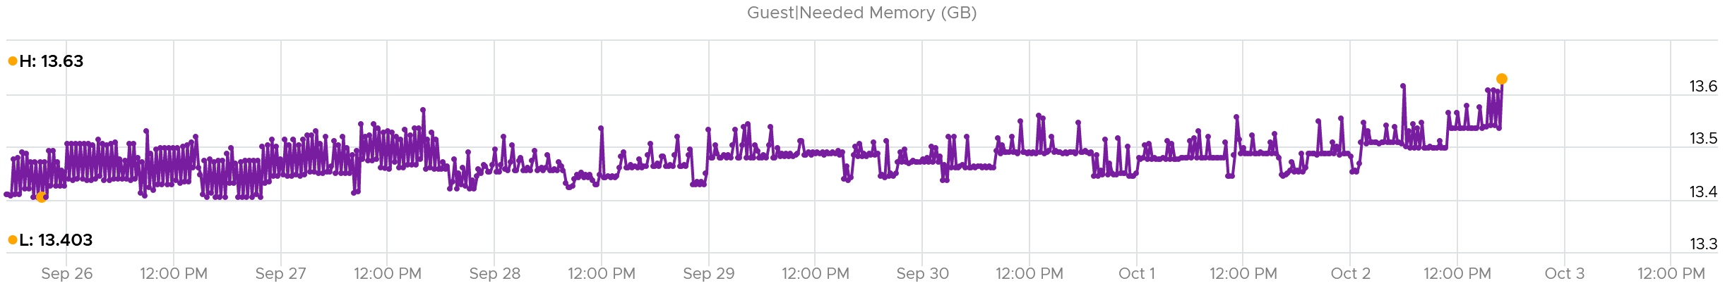

It’s given a bad limit of 2 GB.

In the last 7 days, we can see the limit is a perfectly flat line. It’s 2.12 GB as it includes the overhead value.

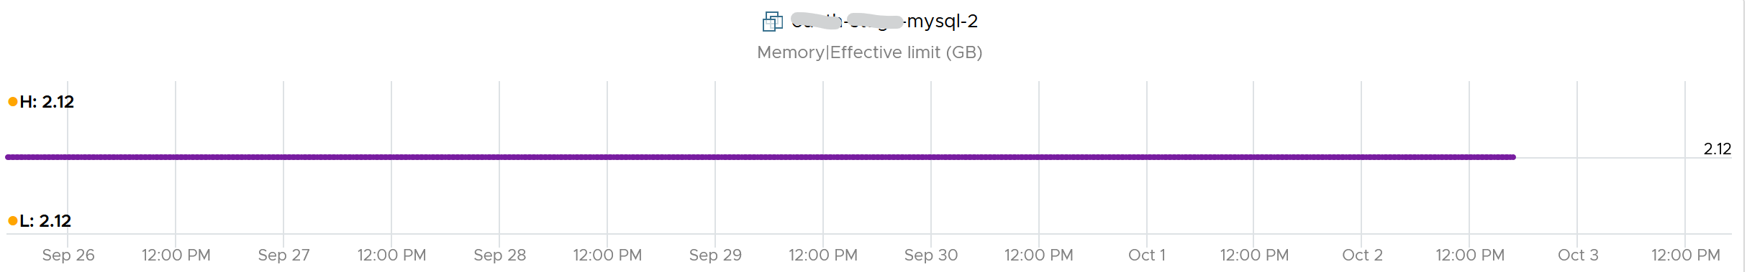

The VM, or rather the Guest OS, did ask for more. You can see the demand by looking at the Granted or Compressed or Swapped counters. I’m only showing Granted here:

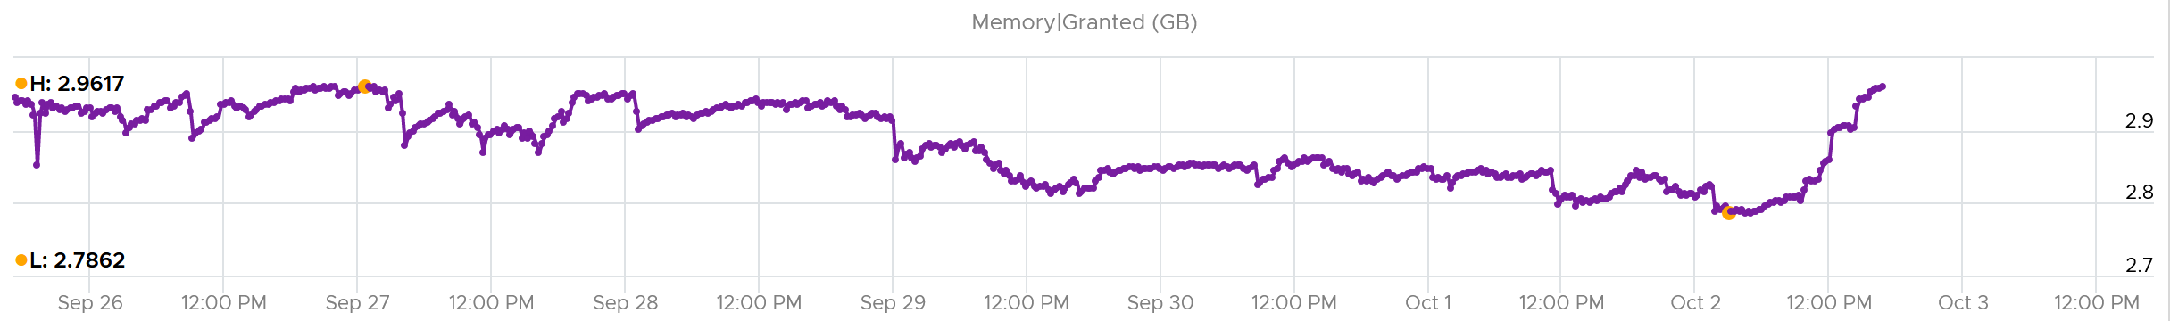

Because of the limit, the Consumed counter did not past the 2 GB. It’s constantly hovering near it as the VM is asking more than that.

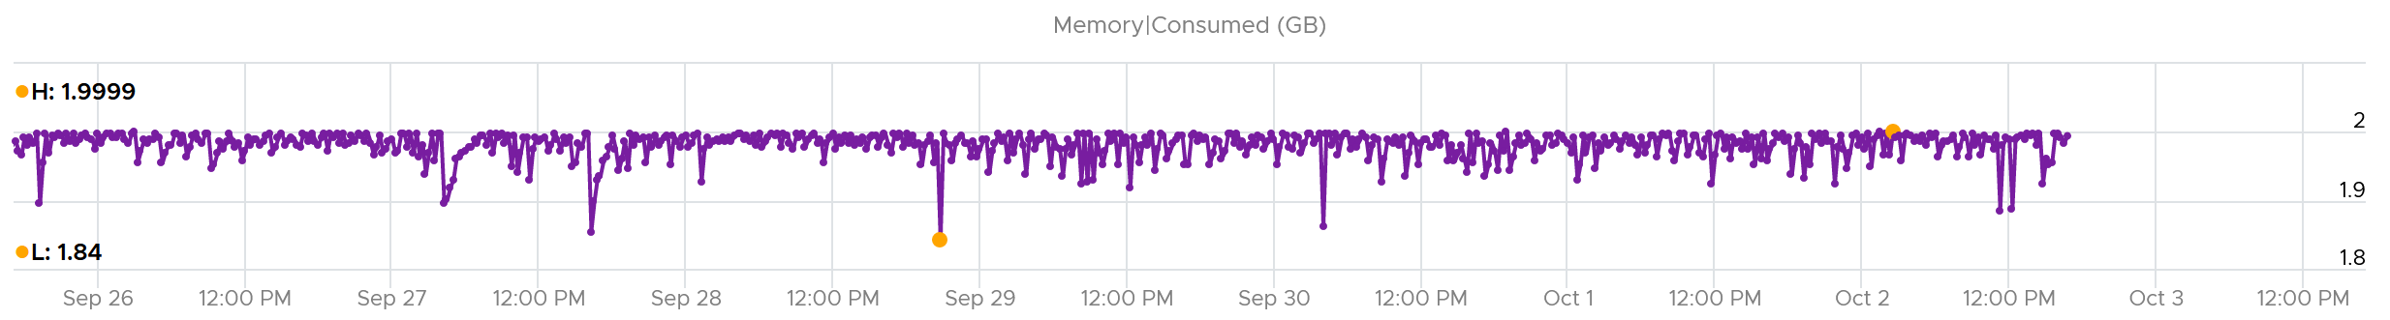

What do you expect to see the Balloon value?

If Balloon has something to do with it, it would not stay a perfectly flat line.

But this is what you got. A perfectly flat line, proving Limit had nothing to do with Balloon.

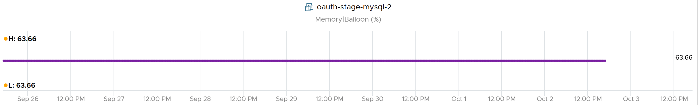

### Consumed

Consumed = Granted – Saving from Sharing

Consumed does not include overhead memory, although this number is practically negligible. I’m not sure why it does not, as the page is indeed for the VM.

Consumed does not include compressed memory. My guess is because the pages are not readily available for use.

Consumes includes memory that might be reserved.

Consumes tracks the ESXi Memory mapped to the VM. ESXi assigns large pages (2 MB) to VM whenever possible; it does this even if the Guest OS doesn’t request them. The use of large pages can significantly reduce TLB misses, improving the performance of most workloads, especially those with large active memory working sets.

The above is one reason why the Consumed metric is higher than the Guest OS In Use. The other reason is it contains pages that were active (and no longer active), but still mapped to the VM.

Here is a screenshot comparing Windows 10 Task Manager memory counters with vRealize Operations Memory \ Non Zero Active (KB) and Memory \ Consumed (KB). As you can see, none of the counters match.



When a Guest OS frees up a memory page, it normally just updates its list of free memory, it does not release it. This list is not exposed to the hypervisor, and so the physical page remains claimed by the VM. This is why the Consumed counter in vCenter remains high when the Active counter has long dropped.

It is a common mistake to think they are calculated in a similar, and simply differ based on aggressive vs conservative. The following test shows Active going down while Consumed going up!



Consumed is affected by Limit. The following is a VM configured with 8 GB RAM but was limited to 2 GB.



#### Mystery

This behaviour confuses me so if you know the answer let me know please. This 64-bit CentOS VM runs My SQL and is configured with 8 GB of RAM. However, a limit is set at 2 GB hence you saw consumed does not exist 2 GB.



Can you explain the dip in Consumed at around 9:30 pm? It went down from 2.09 GB to 1.6 GB, and then slowly going back up. Why did it suddenly consume 400 MB less in the span of 20 minutes? Both the configured limit and the runtime limit do not change. They are main at a constant 2 GB. This makes sense, else the Consumed would not be able to slowly go up again.



My guess is there must be activity by the VM and pages were compressed to make room for the newly requested pages. The Non Zero Active counter shows that there are activities.



The pages that are not used must be compressed or swapped. The Swapped value is negligible, but the Compressed metric shows the matching spike.



But what puzzles me is why did balloon go down by around 400 MB but then goes up immediately?



### Active

This is a widely misunderstood counter. ESXi calls this Touch as it better represents the purpose of the metric. Note that vCenter still calls it Active, so I will call it Active.

This counter is often used to determine the VM utilization, which is not what it was designed for. To know why, we need to go back to fundamental. Let’s look at the word **active**. It is an English word that needs to be quantified before we can use it as metric. There are 2 dimensions to consider before we apply it:

* Definition of active. In RAM context, this means read or write activity. This is similar to disk IOPS. The more read/sec or write/sec to *a page*, the more active that page is. Note that the same page can be read/written to many times in a second. Because a page may be accessed multiple times, the actual active pages could be lower. Example: a VM do 100 reads and 100 writes on its memory. However, 50 of the writes are on the page that were read. In addition, there are 10 pages that were read multiple times. Because of these 2 factors, the total active pages are far fewer than 300 pages. If the page is average 4 KB, then the total active is way less than 1200 KB.
* Active is time bound. Last week is certainly not active. Is 300 seconds ago active? What exactly, is recent? 1 second can be defended as a good definition of recent. Windows shows memory utilization in 1 second interval. IOPS is always measured per second, hence the name IOPS. So I think 1 second seems like a good definition of recent.

Applying the above understanding, the active counter is actually a rate, not a space. However, the counter reported by vCenter is in KB, not KB/s.

To translate from KB/s to KB, we need to aggregate based on the sampling period. Assuming ESXi samples every 2 seconds, vCenter will have 10 sampling in its 20 second reporting period. The 10 samplings can be sampling the same identical pages, or completely different ones. So in the 20 seconds period, the active memory can be as small as 1 sampling, or as large as 10 samplings.

Examples:

* First 2 seconds: 100 MB Active
* Next 2 seconds: 150 MB Active

In the above 4 seconds, the active page ranges from 150 MB to 250 MB.

Each sampling is done *independently*, meaning you could be sampling the same block again. But the value is then averaged it with previous samples. Because sampling and averaging takes time, Active won't be exact, but becomes more accurate over time to approximate the amount of active memory for the VM. This is why there is actually a longer version of Active, which you will see in esxtop (it is not available in vSphere Client).

VM Active is typically different from Guest OS working set estimate. Sometimes the difference may be big, because Guest OS and VMkernel use different working set estimate algorithm. Also, VM has a different view of active memory, due to ballooning and host swapping. Logically, ballooned memory is considered inactive, so, it is excluded from the sampling.

If you plot a vRealize Operations VM in vCenter real-time performance chart, you will see 12 peaks in that one-hour line chart. The reason is vRealize Operations pulls, process, and writes data every 5-minutes. The chart for CPU, disk and network will sport the same pattern. This is expected.

But if you plot the memory counters, be it total active, active write or consumed, you will not see the 12 peaks. This is what I got instead.



Consume is completely flat and high. Active (read and write) and Active Write (write only) is much lower but again the 12 peaks are not shown.

Can you figure it out?

My guess is the sampling size. That’s just a guess, so if you have a better answer let me know!

Now let’s go to vRealize Operations. In vRealize Operations, this metric is called Memory \ Non Zero Active (KB).

vCenter reports in 20 seconds interval*.* vRealize Operations takes 15 of these data and average them into a 300-second average. In the 300 second period, the same page can be read and written multiple times. Hence the active counter over reports the actual count.

Quiz: now that you know Active over reports, why is it lower than Consumed? Why is it lower than Guest OS counters?

Active is lower than both counters because these 2 counters do *not* actually measure how actively the page is used. They are measuring the disk space used, so it contains a lot of inactive pages. You can see it in the general pattern of Consume and Guest OS used counters. The following is vRealize Operations appliance VM. Notice how stable the metrics are, even over millions of seconds.



Both Active and Consumed are *not* suitable for sizing the Guest OS. They are VM level counters, with little correlation to the Guest OS memory usage. Read Guest OS Used counter for the counter we should use.

The reason is the use case. It is not about the IOPS. It is about the disk space used. Guest OS expects the non-active pages to be readily available. Using Active will result in a lot of paging.

Reference: [Active Memory](https://blogs.vmware.com/vsphere/2013/10/understanding-vsphere-active-memory.html) by [Mark Achtemichuk](https://blogs.vmware.com/vsphere/author/mark_achtemichuk).

#### Usage (%)

Usage in vCenter differs to Usage in vRealize Operations.

vRealize Operations counter Memory Usage (%) maps to Active. What you see on the vCenter UI is Active, not Consumed.



Mapping to Active makes more sense as Consumed contains inactive pages. As covered earlier, neither Active nor Consumed actually measures the Guest OS memory. This is why vRealize Operations maps Usage to Guest OS. The following shows what Usage (%) = Guest OS Needed memory over configured memory. The VM has 1 GB of memory, so 757 MB / 1024 = 74%.

Take note that there can be situation where Guest OS metrics do not make it to vRealize Operations. In that case, Usage (%) falls back to Active (notice the value dropped to 6.99%) whereas Workload (%) falls back to Consumed (notice the value jump to 98.95%).



### Shared

There are 2 types of shared pages:

* Intra-VM sharing: sharing within the same VM. By default, each page is 4 KB. If Guest OS uses the Large Page, then it’s 2 MB. The chance of sharing in 4 KB is much higher than 2 MB.
* Inter-VM sharing. Due to security concern, this is by default disabled in vSphere.

A commonly shared page is certainly the zero page. This is a page filled with just zeroes.

For accounting purpose, the Shared page is counted in full for each VM. Example:

VM 1: 1 GB private, 100 MB Shared within itself, 10 MB shared with other VMs (it does not matter how many and what VMs).

The 100 MB is the amount that is being shared. If not shared, they would consume 100 MB. But how much is actually consumed as a result of this sharing?

The 10 MB is shared with other VMs. VM 1 could be sharing 1 MB each with 10 other VMs, or the entire 10 MB with just 1 VM. The Shared counter merely counts that this 10 MB is being shared. VM 1 definitely consumes this 10 MB, and it’s not sharing within itself.

Shared includes zero pages.

Shared Saved metric tracks the estimated amount of machine memory that are saved due to page sharing.

Because the ESXi machine page is shared by multiple Guest OS physical pages, this metric charge "1/ref" page as the consumed machine memory for each of the guest physical pages, where "ref" is the number of references. So, the saved machine memory will be "1 - 1/ref" page. For example, if there are 4 pages pointing to the same physical DIMM, then the savings is 3 pages worth of memory.

## ESXi Host

vCenter provides even more counters at ESXi level: 38 counters for RAM plus 11 for VMkernel RAM. VMkernel has around 50 processes that are tracked. As a result, a cluster of 8 ESXi can have > 800 counters just for ESXi RAM! Most of them are not shown as a percentage, making it challenging to compare across ESXi hosts with different memory sizes.

### Overview

We will cover each metric in-depth, so let’s do an overview first.

Just like the case for VM, the primary counter for tracking performance is Page-fault Latency. Take note this is normalized average, so use the Max VM Memory Contention instead.

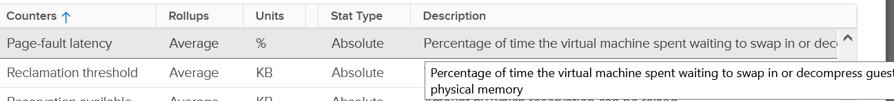

The contention could be caused by swapping in the past. You’ve got only 5, not 6 metrics for swap. Which counter is missing?

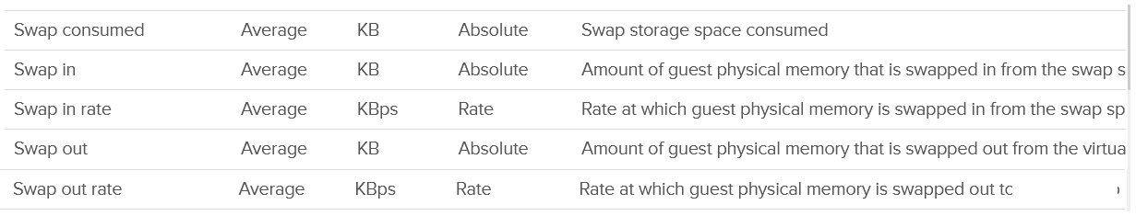

Swap target is missing. It can be handy to see the total target at ESXi level.

Swap and Compress go hand in hand, so we should check compressed metrics.

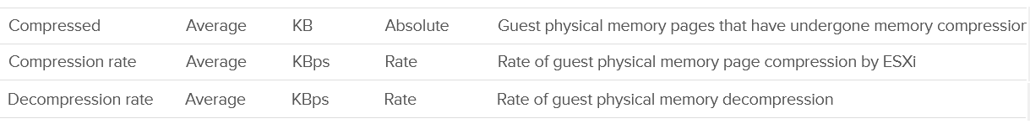

Lastly, the performance could be caused by memory being read from the Host Cache. While they are faster than disk, they are still slower than physical memory.

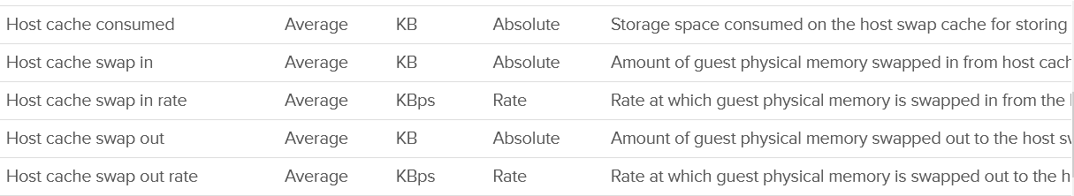

Wait! What about Balloon?

As will cover in-depth shortly, that’s more of capacity than performance metrics. One can even say that other than Page-fault Latency, the rest of the counters are actually for capacity not performance.

The famous balloon is a warning of capacity, assuming you do not play with limit.



When will ballooning kick in? There is a counter for that!



The memory state level shows one of the 5 possible states. You want to keep this at Clear state or High state.



For environment where performance matters more than cost, you want Balloon to be 0. That means Consume becomes your main counter for capacity. It is related to Granted and Shared.

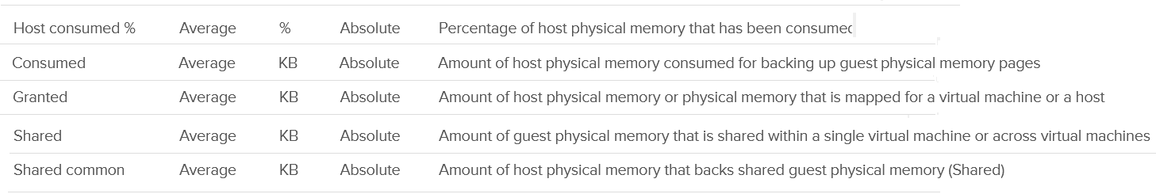

Reservation plays a big part in capacity management as it cannot be overcommitted.

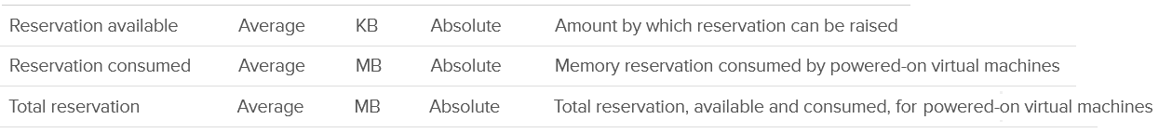

Active is not a counter for capacity or performance. It’s for VMkernel memory allocation.



There are a few counters covering 0 pages and overhead.

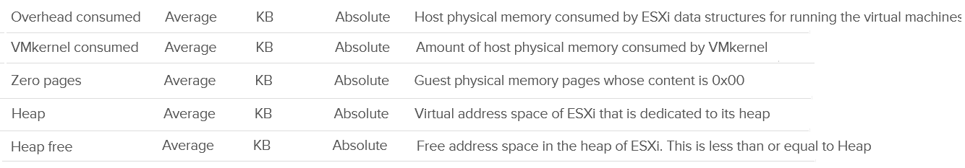

Lastly, there are a few counters for VMFS. I think they are internal, only used by VMkernel. Let me know if you have a real world use case them.

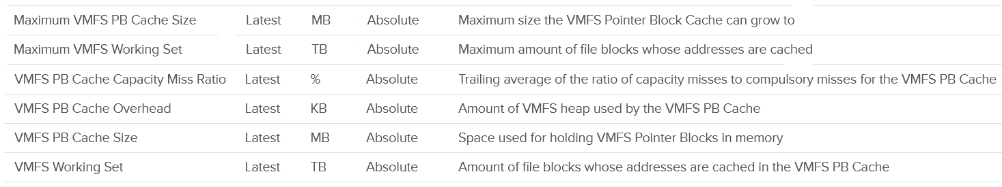

### Ballooned

Balloon is a leading indicator that an ESXi is under memory pressure, hence it’s one of the primary counters you should use in capacity. Assuming you’re not using Limit to artificially cap the resource, you should ensure that the balloon amount does not cause VM to experience contention.

We know that contention happens at hypervisor level, not at VM level. The VM is feeling the side effects of the contention, and the degree of contention depends on each VM's shares, reservation and utilization. ESXi begins taking action if it is running low on free memory. This is tracked by a counter called State. The State counter has five states, corresponding to the Free Memory Minimum (%) value

|  |  |  |  |
| --- | --- | --- | --- |
| **ESXi State** | **Threshold** | **1 TB ESXi** | **Example based on ESXi with 1 TB RAM** |
| High | 300% | 32.4 GB | First, we calculate the Free Memory Minimum value. There is many website to help you with this, such as [this](https://blogs.virtualmaestro.in/2020/06/02/vmware-vsphere-7-x-memory-reclamation-part-2-mem-memminfreepct/).  For 1 TB, the value is 10.8 GB. |
| Clear | 100% | 10.8 GB |
| Soft | 64% | 6.9 GB. Balloon starts here |
| Hard | 32% | 3.5 GB. Compress/Swap starts here |
| Low | 16% | 1.7 GB. Block execution |

Using the example above, let’s see at which point of utilization does ESXi triggers balloon process.

|  |  |  |  |
| --- | --- | --- | --- |
| **ESXi State** | **512 GB ESXi** | **1 TB ESXi** | **1.5 TB ESXi** |
| Balloon Threshold | 3.7 GB | 6.9 GB | 10.2 GB |
| Threshold | 508.3 GB | 0.99 TB | 1.49 TB |
| Threshold in % | 99.3% | 99.3% | 99.3% |

As you can see from all the 3 ESXi, balloon only happens after at least 99% of the memory it utilized. It’s a very high threshold. Unless you are deliberately aiming for high utilization, all the ESXi should be in the **High** state.

In addition, the spare host you add to cater for HA or maintenance mode will help in lowering the overall ESXi utilization. Let’s use example to illustrate

* No of ESXi in a cluster = 12
* Provisioned for HA = 11
* Target ESXi memory utilization = 99% (when HA happens or planned maintenance)
* Target ESXi memory utilization = 99% x 11 / 12 = 90.75% (during normal operations)

Using the above, you will not have any VM memory swapped as you won’t even hit the ballooned stage. If you actually see balloon, that means there is limit imposed.

The **Low Free Threshold** (KB) counter provides information on the actual level below which ESXi will begin reclaiming memory from VM. This value varies in hosts with different RAM configurations. Check this value only if you suspect ESXi triggers ballooning too early.

ESXi memory region can be divided into three: Used, Cached and Free

* Used is tracked by Active. Active is an estimate of recently touched pages.
* Cached = Consumed - Active. Consumed contains pages that were touched in the past, but no longer active. I'm not sure Ballooned pages are accounted in Consumed, although logically it should not. It should go to Free so it can be reused.
* Free = Total Capacity - Consumed.

The nature of memory as cache means the active part is far lower than the non-active part. It’s also more volatile. The following shows an ESXi with low memory usage, both active and consumed, in the last 3 months.



Let’s look at an opposite scenario. The following ESXi is running at 100%. It has granted more memory than what it physically has. Initially, since the pages are inactive, there is no ballooning. When the active rise up, the consumed counter goes up and the balloon process kicks in. When the VM is no longer using the pages, the active counter reflects that and ESXi begin deflating the balloon and giving the pages back.



I shared in the VM memory counter that just because a VM has balloon, does not mean it experiences contention. You can see the same situation at ESXi level. The following ESXi shows a constant and significant balloon lasting at least 7 days. Yes the worst contention experienced by any VM is not even 1%, and majority of its 19 VMs were not experiencing contention at all.



### Consumed

Total = VMkernel + VM + Overhead + Free, where

* Total is the hardware memory as reported by BIOS to ESXi
* VMkernel is the memory used by VMkernel and its loadable modules such as vSAN
* VM is the memory used by VM
* Overhead is the hypervisor virtualization overhead on each VM. This is typically negligible.

Consumed = VMkernel utilization (not reservation) + Granted to VM

Let’s take a look! This ESXi has 130693 MB, as vCenter use 1024 to convert from GB to MB.

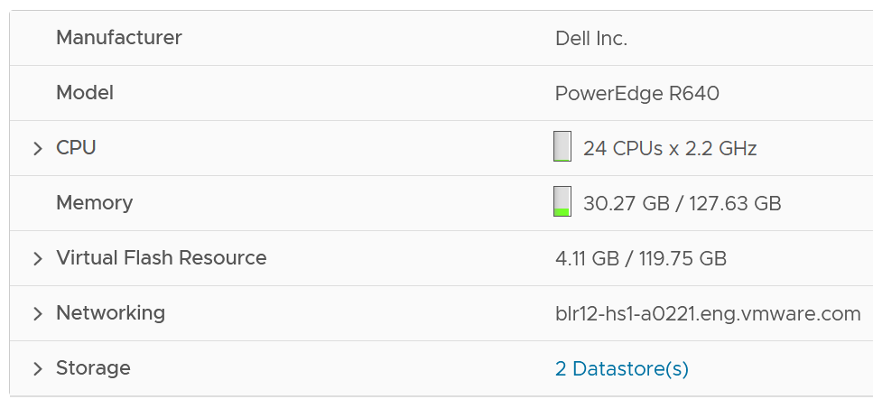

The box has 3 running VMs. One of them does not have VMware Tools.

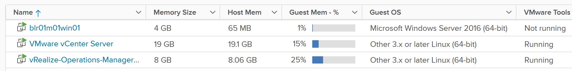

As we’re interested in ESXi level, look at the number under Host Mem column. They add up to 27876 MB.

I’m not 100% what the number under Guest Mem is. Need to validate if it’s based on Tools or not.

Now let’s see what ESX consume reports.

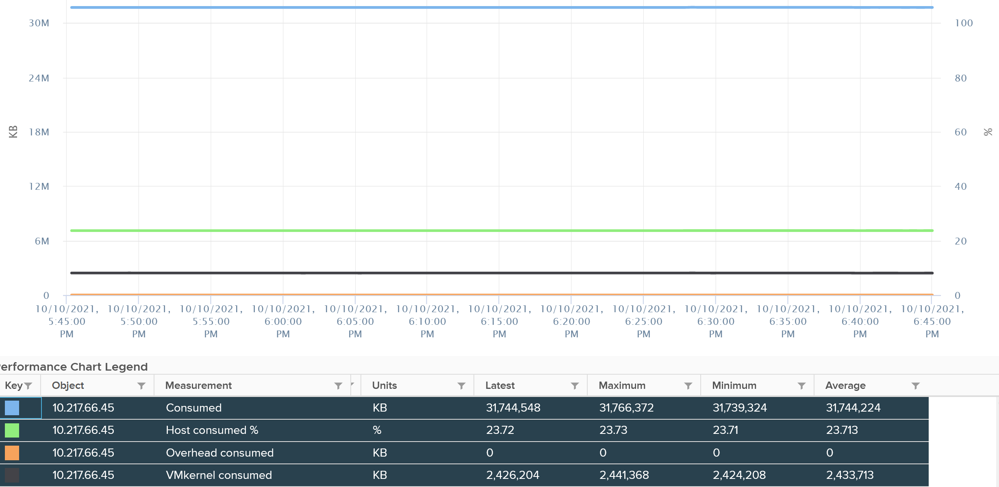

It reports 31744 MB. That means there is 3876 MB unaccounted. That should be VMkernel.

vCenter reports VMkernel is only consuming 2426. So there is 1441 MB unaccounted.

Regardless, it shows that Consumes includes VMkernel already.

You can also check at esxtop also match. See the PMEM total value. VMkernel consumes 2370 MB, and while VMs consumes 28245 MB. Free is 100076, which is 130692 – 2370 – 28245.

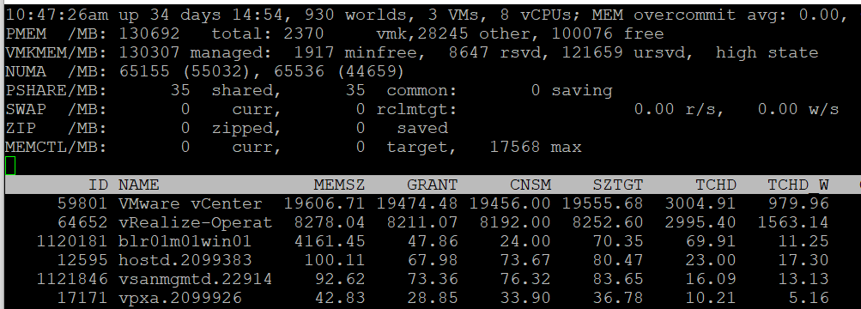

The ESXi runs 3 VM, shown above as the first 3 lines. If you sum them up, you get 28245.

What’s interesting is the numbers between esxtop and vCenter UI do not perfectly tally. I need to run more tests to figure it out.

Consumed does not include Balloned. This makes sense as the pages no longer backed by physical pages.

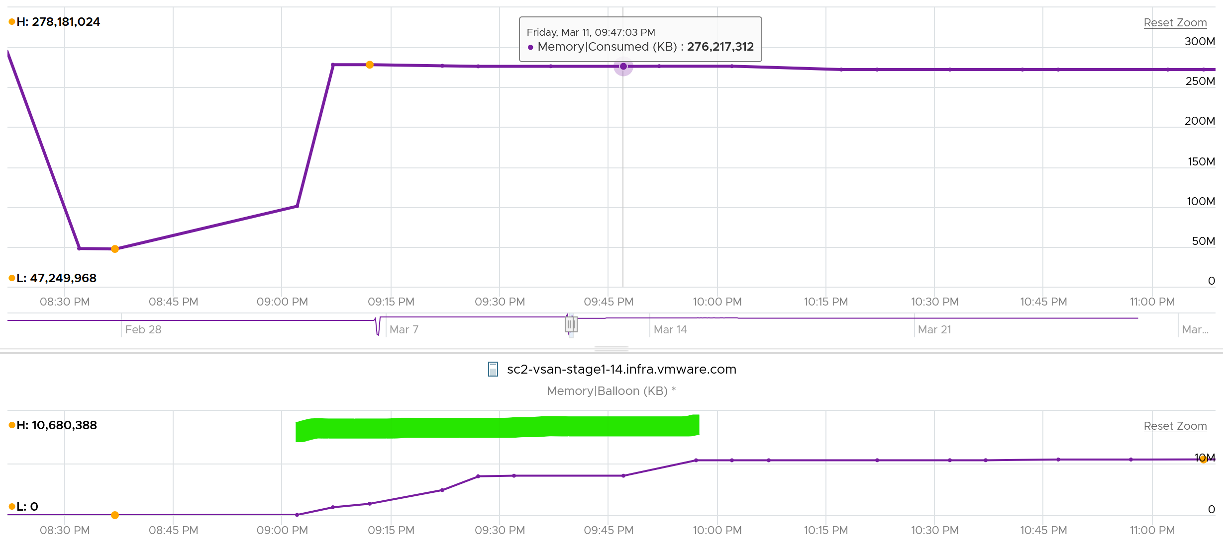

Consumed does not include swapped. This makes sense as the page are no longer in the physical memory.

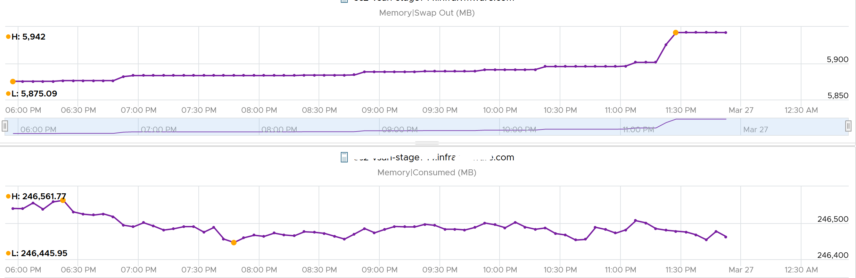

Consumed seems to include compressed. This seems logical as the pages still consumed the physical memory (it’s in the DIMM).

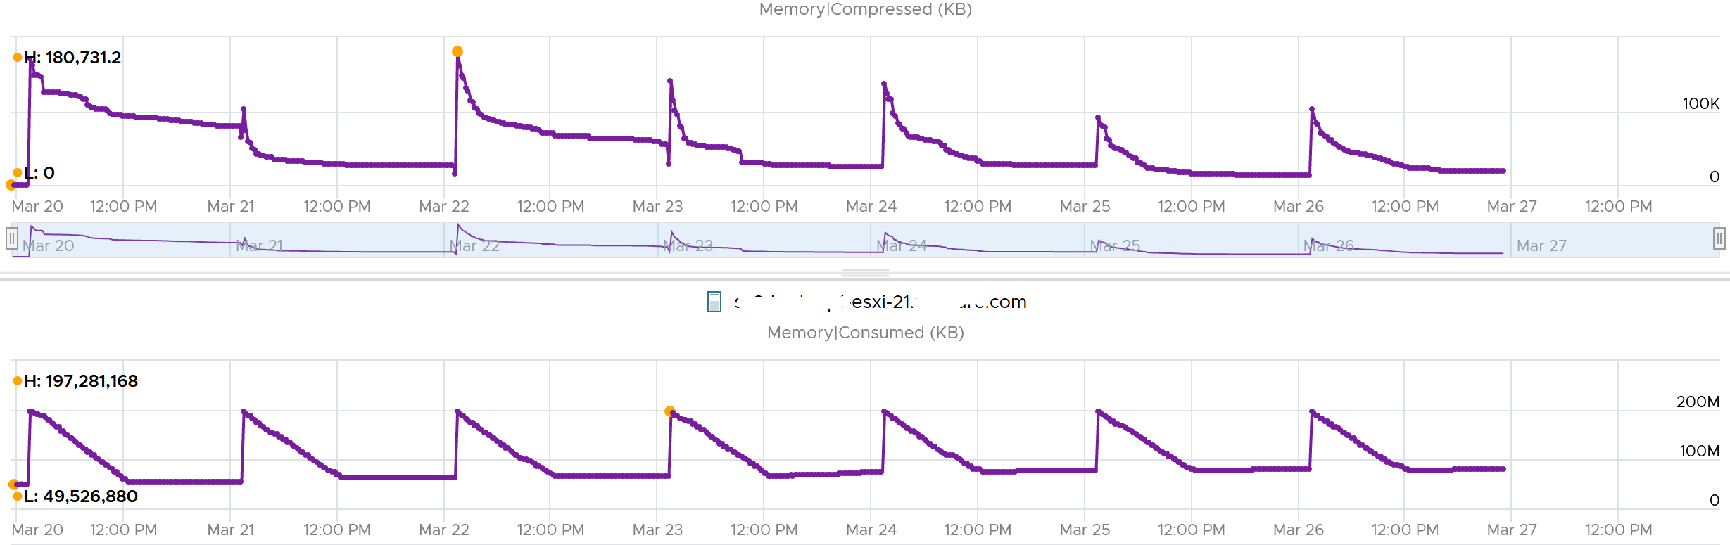

### Granted

The following example shows ESXi hosts with no running VM, so the Consumed counter is mostly made up of VMkernel. From the table, you can see that Consumed = VMkernel Consumed + Granted to VM.

I’ve sorted them by the **Granted** counter, as I’m not expecting it to have any values. Granted at the host is the total of the granted counters of VMs running on the host, so it should be 0 in this case. It includes the shared memory. My guess the extra memory is for non-VM user world process.



Let’s take one of the ESXi to see the value over time. This time around, let’s use vCenter instead.



You can verify that ESXi Consumed includes its running VMs Consumes by taking an ESXi with a single running VM. The ESXi below has 255 GB of total capacity but only 229 GB is consumed. The 229 GB is split into 191 GB consumed by VM and 36 GB consumed by VMkernel.



The VMkernel consumption is the sum of the following three resource pools.



### Demand

Demand, especially unmet Demand, is hard to measure as RAM is a form of storage. RAM does not have Ready or CoStop concept, as it’s just a disk space. ESXi uses 3 levels to manage demand:

|  |  |
| --- | --- |
| TPS | This happens automatically even if ESXi has plenty of RAM as it makes sense to do so. It’s not an indicative of unmet demand. Sharing the same page is the right thing to do, and not something that should be started only when physical pages are running low |
| Balloon | The first sign of unmet demand. It happens proactively, before ESXi is unable to meet Demand. Ballooning reduces cache. It does not mean ESXi unable to meet Demand. Demand is not met when Contention happen. That's the only time it is not met. |
| Compress/Swap | This happens proactively too.  It does not mean VMs were contending for RAM. It merely means ESXi Consumed is very high. That Consumed can contain a lot of cache |

Based on the above, my recommendation if you need to calculate demand is

Demand = Consumed + Ballooned + Compressed + Swapped + Swapped to Host Cache

Practically, I think consumed is good enough. It’s operationally hard for it to reach 99%, so in most cases the other 4 counters are near 0.

Why is memory contention not included?

Because it would result in an increase of consumed.

### Other Metrics

Memory shared is the sum of all the VM memory pages that are pointing to a shared page. Memory shared common is the sum of all the shared pages. As a result, Memory shared common is at most half the value of Memory shared, as sharing means at least two blocks are pointing to the shared page. If the value is a lot less than half, then you are saving a lot. Today's ESXi hosts are sporting the hardware-assisted memory virtualization from Intel or AMD. With this technology, VMkernel uses large pages to back the VM memory. As a result, the possibility of shared memory is low, unless the host memory is highly utilized. In this state, the large pages are broken down into small, shareable pages. So you can also use the Memory shared common counter to track for signs of host memory under pressure.

The Heap counter shows the memory used by VMkernel heap and other data. This is normally a constant and small value.

Reserved Capacity (MB) only counts reservation. Therefore, the value will be a lot lower than Total capacity if you do not use reservation. Note that it does not includes memory reserved by VMkernel, which varies from 2 GB to 64 GB. The following shows an ESXi with vSAN. This box has 1.5 TB RAM, and VMkernel usage is steady at 55 GB for at least 6 months. Reservation is very low at 1.4 GB, but it’s also steady.

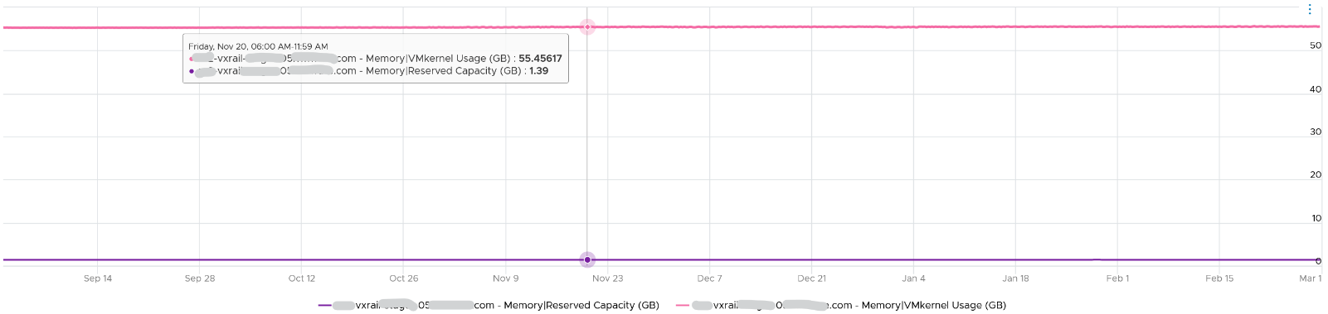

ESXi Reserved = the amount of machine memory that is currently reserved. It is the sum of reservation setting of the groups + the overhead reservation of the groups + minfree metric.

Managed = the total amount of machine memory managed by VMkernel. VMkernel "managed" memory can be dynamically allocated for VM, VMkernel, and User Worlds.

## esxtop

The top part of the screen provides summary at ESXi level. They are handy in seeing overall picture, before diving into each VM or VMkernel modules.

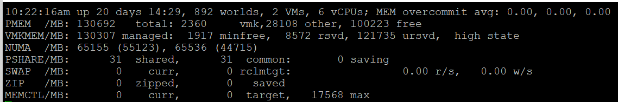

|  |  |
| --- | --- |
| **MEM overcommit avg** | Average memory overcommit level in the last 1-minute, 5-minute, and 15-minute, respectively. Calculation is done with [Exponentially Weighted Moving Average](https://en.wikipedia.org/wiki/Moving_average).  Memory overcommit is the ratio of total requested memory and the "managed memory" minus 1. According to [this](https://communities.vmware.com/t5/Storage-Performance/Interpreting-esxtop-4-1-Statistics/ta-p/2786881), VMKernel computes the total requested memory as a sum of the following components:   1. VM configured memory (or memory limit setting if set), 2. the user world memory, 3. the reserved overhead memory.   If the ratio is > 1, it means that total requested VM memory is more than the physical memory available. This is fine, because ballooning and page sharing allows memory overcommit.  I’m puzzled why we mix allocation and utilization. No 1 and no 3 make sense, but what exactly is no 2? My recommendation is you simple take the configured VM memory and ignore everything else. While it’s less accurate, since the purpose is capacity and not performance, it’s more than good enough and it’s easier to explain to management. There is no need to get other details. |
| PMEM | Physical Memory.  Total = vmk + Other + Free  Total is what is reported by BIOS.  vmk is ESXi VMkernel consumption. This includes kernel code section, kernel data and heap, and other VMKernel management memory.  Other is memory consumed by VM and non VM (user-level process that runs directly on the kernel) |
| VMKMEM | VMkernel memory. The following metrics are shown:   * Managed. The memory space that ESXi manage. Typically this is slightly smaller than the total physical memory, as it does not contain all the components of vmk metric. It can be allocated to VM, non VM user world, or the kernel itself. * Minfree. The minimum amount of machine memory that VMKernel would like to keep free. VMKernel needs to keep some amount of free memory for critical uses. Note that minfree is included in Free memory, but the value is tends to be negligible. * Reserved. The sum of the reservation setting of the groups + the overhead reservation of the groups + minfree. I think by group it means the world or resource pool. * Unreserved. It is the memory available for reservation.   I have not found a practical use case for the above 4 metrics. If you do, let me know!  State is the memory state. You want this to be on high state. |
| NUMA | In the preceding screenshot, there are 2 NUMA nodes.  For each node there are two metric: the total amount and the free amount.  Note that the sum of all NUMA nodes will again be slightly smaller than total, for the same reason why VMkernel managed is less than total.  If you enable Cluster-on-Die feature in Intel Xeon, you will see 2x the amount of nodes. For details, see [this](https://www.youtube.com/watch?v=pcNfxdMnpmc&t=3s) by Frank Denneman. |
| PSHARE | **shared**: the amount of VM physical memory that is being shared.  **common**: the amount of machine memory that is common across Worlds.  **saving**: the amount of machine memory that is saved due to page-sharing. |
| SWAP | Swapped counter is covered here under VM memory. What “cannot” be zipped is swapped. What you see on this line is sum of all the VMs.  The metric rclmtgt shows the target size in MB that ESXi aims to swap. |
| ZIP | Zipped counter is covered here under VM memory. What you see on this line is sum of all the VMs. |
| MEMCTL | Memory Control, also known as ballooning is covered here under VM memory. What you see on this line is sum of all the VMs. |

There are a lot of metrics in many panels. It’s easier to understand if we group them functionally.

### Contention

As usual, we start with the contention-type of metrics.

#### Balloon

I start with Balloon as this is the first level of warning. Technically, this is not a contention. Operationally, you want to start watching as Balloon only happens at 99% utilization. So it’s high considering you have HA enabled in the cluster.

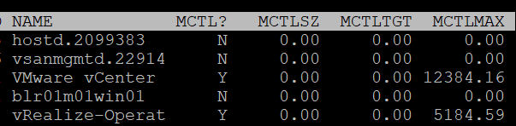

|  |  |
| --- | --- |
| MCTL? | Y means the line is a VM, as VMkernel processes is not subjected to ballooning. |
| MCTLSZ (MB) | Memory Control Size is the present size of memory control (balloon driver). If larger than 0 hosts is forcing VMs to inflate balloon driver to reclaim memory as host is overcommitted |
| MCTLTGT (MB) | Amount of physical memory the ESXi system attempts to reclaim from the resource pool or VM by way of ballooning. If this is not 0 that means the VM can experience ballooning. |
| MCTLMAX (MB) | Maximum amount of physical memory the ESXi system can reclaim from the resource pool or VM by way of ballooning. This maximum depends on the type of Guest OS. |

#### Compressed

I think that Swap and Compressed should be shown together as it’s what can’t be compressed enough is swapped.

Why am I showing Compressed first?

Because it’s faster than swapped.

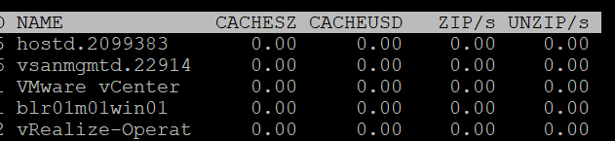

|  |  |
| --- | --- |
| CACHESZ (MB) | Compression memory cache size. |
| CACHEUSD (MB) | Used compression memory cache |
| ZIP/s (MB/s) | The rate at which memory pages are being zipped. Once zipped, it’s not immediately available for the VM.  This is a capacity problem. Your ESXi needs more RAM. If the pages being zipped is unused, the VMs will not experience memory contention.  Keep this number 0. See Capacity chapter for details. |
| UNZIP/s (MB/s) | The rate at which memory pages are being unzipped so it can be used by VM.  This is a performance problem. The pages are being asked. The VM CPU is waiting for the data. If you check the VM memory contention counter, it will not be 0%. Make sure that number is within your SLA or KPI. |

#### Swap

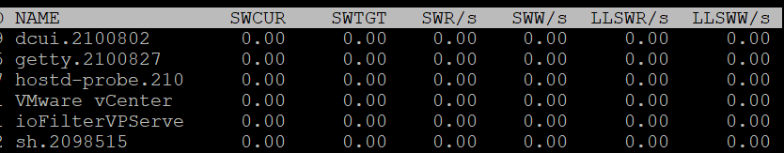

|  |  |
| --- | --- |
| SWCUR (MB) | Swapped Current is the present size of memory on swapped. It typically contains inactive pages. |
| SWTGT (MB) | The target size the ESXi host expects the swap usage by the resource pool or VM to be. This is an estimate. |
| SWR/s (MB) | Swapped Read per second and Swapped Write per second. The amount of memory in megabyte that is being brought back to memory or being moved to disk |
| SWW/s (MB) |
| LLSWR/s (MB) | These are similar to SWR/s but is about host cache instead of disk. It is the rate at which memory is read from the host cache. The reads and writes are attributed to the VMM group only, so they are not displayed for VM.  **LL** stands for Low Latency as host cache is meant to be faster (lower latency) than physical disk.  Memory to host cache can be written from both the physical DIMM and disk. So the counter LLSWW/s covers all these sources, and not just from physical DIMM. |
| LLSWW/s (MB) |

### Utilization

I group counters such as consumed, granted, overhead etc under utilization as the measure how much the VM or VMkernel module consumes.

#### Consumed

What are the use cases where you actually need these counters? I think it’s quite rare. Review this rightsizing and reclamation, as the answers might surprise you 😉

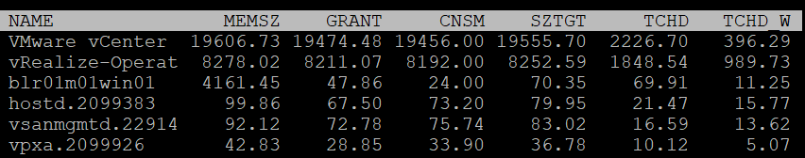

|  |  |
| --- | --- |
| MEMSZ (MB) | Amount of physical memory allocated to a resource pool or VM. The values are the same for the VMM and VMX groups.  MEMSZ = GRANT + MCTLSZ + SWCUR + "never touched" |
| GRANT (MB) | Granted is covered here. Do not confuse it with Consumed. |
| CNSM | Yup, this is that legendary Consumed metric. |
| SZTGT (MB) | Size Target in MB.  Amount of machine memory the ESXi VMkernel wants to allocate to a resource pool or VM. The values are the same for the VMM and VMX groups. |
| TCHD (MB) | Amount of Touched pages in MB  Working set estimate for the resource pool or VM. The values are the same for the VMM and VMX groups. |
| TCHD_W |  |

#### Overhead

I find overhead is a small amount that is practically negligible, considering ESXi nowadays sports a large amount of RAM. Let me know the use case where you find otherwise.

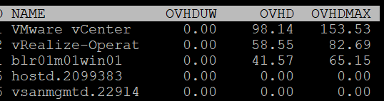

|  |  |
| --- | --- |
| OVHD (MB) | Current space overhead for resource pool. |
| OVHDMAX (MB) | Maximum space overhead that might be incurred by resource pool or VM. |
| OVHDUW (MB) | Current space overhead for a user world. It is intended for VMware use only. |

#### Shared

With Transparent Page Sharing limited to within a VM, I think shared becomes limited. Let me know the use case where you see it is material in your operations.

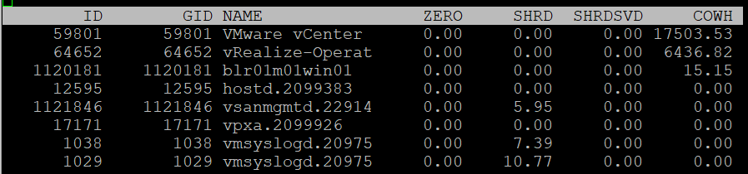

|  |  |
| --- | --- |
| ZERO (MB) | Resource pool or VM physical pages that are zeroed. |
| SHRD (MB) | Resource pool or VM physical pages that are shared. |
| SHRDSVD (MB) | Machine pages that are saved because of resource pool or VM shared pages |
| COWH (MB) | Copy on Write Hint. An estimate of the amount of Guest OS pages for TPS purpose. |

#### Active

The manual uses the word Guest to refer to VM. As described in Part 2 Chapter 3 Memory Metric, I distinguish between VM and Guest. Guest is an OS, while a VM is just a collection of processes. Guest has its own memory management that is completely invisible to the hypervisor.

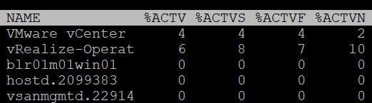

|  |  |
| --- | --- |
| %ACTV | Active is covered in-depth here. |
| %ACTVS | Percentage Active Slow and Percentage Active Fast.  Slow is the slow moving average, taking longer period. Longer is more accurate.  I don’t have a use case for the fast moving average. |
| %ACTVF |
| %ACTVN | Percentage Active Next. It predicts of what %ACTVF will be at next sample estimation. It is intended for VMware use only. |

#### Committed

Note none of these counters exist in vSphere Client and vRealize Operations, as they are meant for internal use. Committed page means the page has been reserved for that process. Commit is a counter for utilization but it’s not really used, especially for VM.

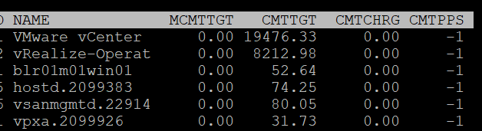

|  |  |
| --- | --- |
| MCMTTGT | Minimum Commit Target in MB. I think this value is not 0 when there is reservation, but I’m not sure. |
| CMTTGT | Commit Target in MB. |
| CMTCHRG | Commit Charged in MB. I think this is the actual committed page. |
| CMTPPS | Commit Pages Per Share in MB |

### Others

I’m grouping NUMA, allocation and checkpoint metrics under others just for ease of organization.

#### NUMA

NUMA Node = Socket / Package, as 1 socket can have >1 package (if you enable Cluster-on-Die feature of Intel Xeon).

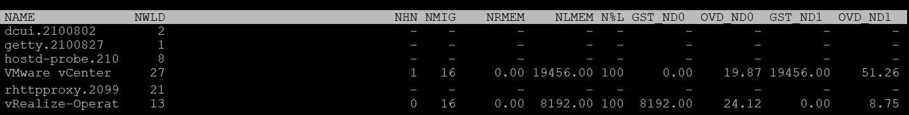

|  |  |
| --- | --- |
| NHN | Current home node for the resource pool or VM. This statistic is applicable only on NUMA systems. If the VM has no home node, a dash (-) appears.  When you enable CPU Hot Add, esxtop will report multiple home node. It also does not distinguish remote and local memory as memory is interleaved. For more information, see [this](https://frankdenneman.nl/2016/08/22/numa-deep-dive-part-5-esxi-vmkernel-numa-constructs/) by Frank. |
| NMIG | Number of NUMA migrations. It gets reset upon power cycle.  Migration is costly as all pages need to be remapped. Local memory starts at 0% again and grow overtime. Copying memory pages across NUMA boundaries cost memory bandwidth |
| NRMEM (MB) | Current amount of remote memory allocated to the VM or resource pool. Ideally this amount is 0. You increase the chance by making the Configured RAM small. A VM whose configured memory is larger than the ESXi RAM attached to a socket have higher chance of having remote memory. |
| N%L | Current percentage of memory allocated to the VM or resource pool that is local.  Anything less than 100% is not ideal. |
| GST_NDx (MB) | Guest memory allocated for a resource pool on NUMA node x, where GST_ND0 means the first node. The following screenshot shows the VMware vCenter VM runs non node 2 while the vRealize-Operat VM runs on node 1 |
| OVD_NDx (MB) | VMM overhead memory allocated for a resource pool on NUMA node x, where x starts with 0 for the first node. |

#### Allocation

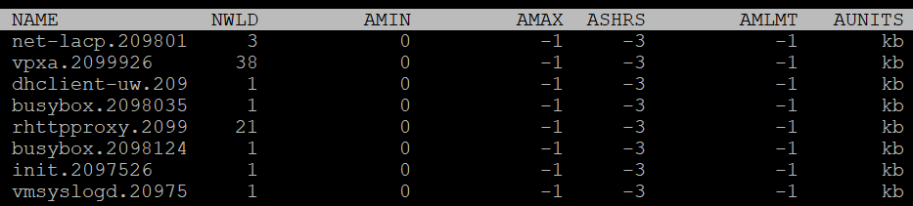

|  |  |
| --- | --- |
| AMIN | Memory reservation for this resource pool or VM. |
| AMAX | Memory limit for this resource pool or VM. A value of -1 means Unlimited. |
| ASHRS | Memory shares for this resource pool or VM. |
| AMLMT | Limit. You should expect the value -1, means no limit assigned. |
| AUNITS (KB) |  |

#### Checkpoint

Checkpoint is required in snapshot or VM suspension. You can convert a VM checkpoint into a core dump file, to debug the Guest OS and applications.

|  |  |
| --- | --- |
| CPTRD (MB) | Checkpoint Read. Amount of data read from checkpoint file. A large amount can impact the VM performance. |
| CPTTGT (MB) | Checkpoint Target. The target size of checkpoint file that VMkernel is aiming for.  I’m unsure why it needs to have a target, unless this is just an estimate of the final size and not a limit. |

Chapter 4

# Storage

## The Layers of Storage

Virtualization increases the complexity in monitoring storage performance. Just like memory, where we have more than one level, we have multiple layers of storage and each layer only has control over its own. In addition, each layer may not use the same terminology.

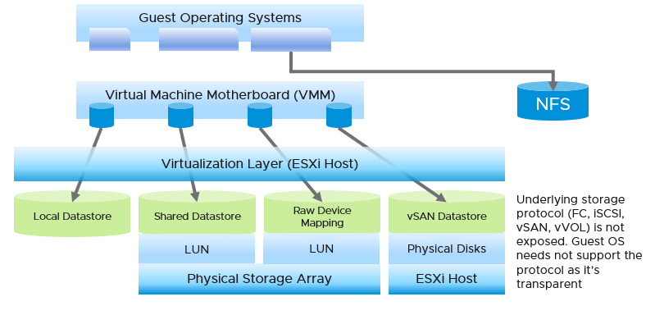

The most upper layer is the Guest OS. It sees virtual disks presented by the VM motherboard. Guest OS typically has multiple partition or drive. Each partition has its own filesystem, serving different purpose such OS drive, paging file drive, and data drive. A large database VM will have even more partitions. Partition may *not* map 1:1 to the virtual disk. There is no visibility to this mapping. This makes calculating unmapped blocks accurately an impossible task in the case of RDM disk.

To make it more complex, there is also networked drive. Windows or Linux mounts them over protocol such as SMB. These filesystems are not visible to the hypervisor.

At the VM layer, we deal with virtual disks. This can be RDM or virtual disk. Both are presented as Local SCSI disk, such as scsi0:0, so the Guest OS does not know of the underlying protocol. For example, you can actually have MS-DOS using drive on Fibre Channel network!

We are interested in data both at the VM level, and at the individual virtual disk level. If you are running a VM with a large data drive (for example, Oracle database), the performance of the data drive is what the VM owner cares about the most. At the VM level, you get the average of all drives; hence, the performance issue could be obscured.

**Below the VM**, we have the ESXi storage subsystem and the storage adapter. We do not deep dive into ESXi in our discussion of storage counters as in general it is not a cause of storage bottleneck. Yes, the VMkernel prioritizes and queues the I/Os, but all these operations should be less than 1 millisecond. If the I/O is held at the kernel, there is a good chance that the physical device latency is more than 10 milliseconds.

In a typical shared storage, multiple VMs run on the same ESXi, and multiple VMs share a datastore. So it is common to have an I/O blender effect, where sequential writes on individual vmdk files become random writes at the datastore level. It also changes the read/write ratio. This can occur in either VMFS or NFS. This certainly increase complexity in troubleshooting. Complexity also increases when the IO needs to go over the network, especially across different physical data centers asynchronously.

**Below the ESXi**, we have the datastore level. What you can see at this level, and hence how you monitor, depends on the storage architecture. We will cover the centralized storage architecture first as it is a more deployment. We will cover the distributed architecture (e.g. vSAN) separately due to major differences in monitoring.

**Below the datastore**, we have the physical storage. The datastore is normally backed one to one by a LUN, so what we see at the datastore level matches with what we see at the LUN level. Multiple LUNs reside on a single array.

### Type of Metrics

Storage metrics can be largely grouped into two:

|  |  |
| --- | --- |
| **Speed** | Speed is measured in 2 ways (contention and utilization).  Utilization is further divided into IOPS and Throughput. Throughput = IOPS x Block Size  Contention consists of both queue and latency.  Latency can happen when IOPS and throughput are not high, because there are multiple stacks involved and each stack has their own queue. It begins with a process, such as a database, issuing IO request. This gets processed by Windows or Linux storage subsystem, and then send to the VM storage driver.  If you are using IP storage, take note that Read and Write do not map 1:1 to Transmit (Tx) and Receive (Rx) in Networking counters. Read and Write are both mapped to Transmit counter as the ESXi host is issuing commands, hence transmitting the packets |
| **Space** | Space as in disk space, is measured in bytes, such as gigabyte.  Space has no concept of slowness. 1% full is not slower/faster than 99% full. At 100% full, the storage will stop and your application will crash. |

For example, the term disk, LUN and device may mean the same thing. A device is typically physical (something you can hold, like an SSD card). LUN is typically virtual, a striping across physical devices in a volume.

### Contention Metrics

The main counters for performance are IOPS and latency. The rest is supporting counters, typically used in troubleshooting. Latency is part of contention counters, which includes disk queue, outstanding IO (queued), aborted SCSI commands, and dropped frame.

For Storage, the counter for contention is clear. First, ensure that you do not have packet loss for your IP Storage, dropped FC frames for FC protocol, or SCSI commands aborted for your block storage. They are a sign of contention as the datastore (VMFS or NFS) is shared. The counters Bus Resets and Commands Aborted should be 0 all the time. As a result, it should be fine to track them at higher level objects. Create a super metric that tracks the maximum or summation of both, and you should expect a flat line.

Once you have ensured that you do not have packet loss on IP Storage or aborted commands on block storage, use the latency counter and outstanding IO for monitoring. For troubleshooting, you will need to check both read latency and write latency, as they tend to have different patterns and value. It’s common to only have read or write issue, and not both.

Total Latency is not (Read Latency + Write Latency) / 2. It is not a simple summation. In a given second, a VM issues many IOPS. For example, the VM issues 100 reads and 10 writes in a second. Each of these 110 commands will have their own latency. The “total” latency is the average of these 110 commands. In this example, the total latency will be more influenced by the read latency, as the workload is read dominated.

## Guest OS

Windows provides rich set of metrics, both at disk and filesystem. I’m not sure if this includes networked fileshare. You will find the disk metrics in Performance Monitor under Physical Disk. It’s interesting it’s still called Physical. Does it mean it’s unaware it’s actually virtual?

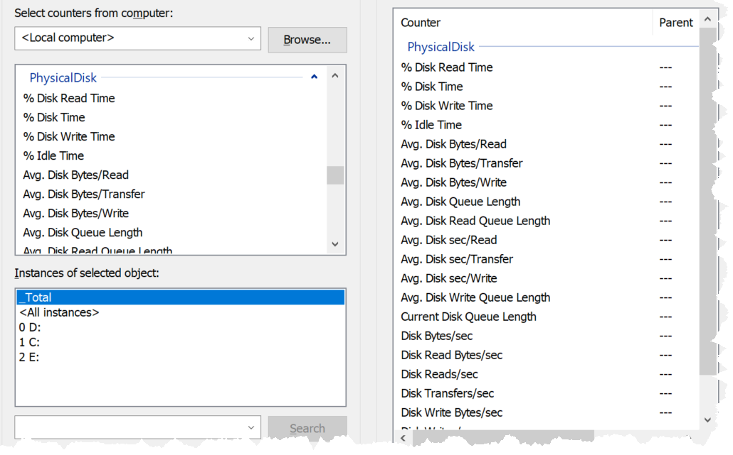

Source is [here](https://docs.microsoft.com/en-us/previous-versions/ms804037(v=msdn.10)?redirectedfrom=MSDN).

|  |  |
| --- | --- |
| Current Disk Queue Length | This is the primary counter for performance, hence I show it first. It is covered in-depth after this summary. |
| Avg. Disk Queue Length |
| Avg. Disk Write Queue Length |
| Avg. Disk Bytes/transfer | This is block size in bytes. It should be 4KB or 2 MB. |
| Avg. Disk Bytes/read |
| Avg. Disk Bytes/write |
| Avg. Disk Sec/transfer | This is latency, but strangely shown in second instead of millisecond. |
| Avg. Disk Sec/read |
| Avg. Disk Sec/write |
| Disk Bytes/sec | This is disk throughput in bytes. So you have the total throughput, read throughput and write throughput.  The word transfer here means being read from or written to the disk. |
| Disk Read Bytes/sec |
| Disk Write Bytes/sec |
| Disk Transfers/sec | This is IOPS |
| Disk Reads/sec |
| Disk Writes/sec |
| Free (Megabytes) |  |
| Split IO/sec | From the manual: Shows the rate at which that I/O requests to the disk were split into multiple requests. A split I/O may result from requesting data in a size that is too large to fit into a single I/O or that the disk is fragmented on single-disk systems. |

### Guest OS Disk Queue

With VMware Tools, you get Guest OS visibility into the partitions and disk queue. The first one is critical for capacity, while the second is critical for performance.

This counter tracks the queue inside Linux or Windows storage subsystem. It’s not the queue at SCSI driver level, such as LSI Logic or PVSCSI. If this is high then the IO from applications did not reach the underlying OS SCSI driver, let alone the VM. If you are running VMware storage driver, such as PVSCSI, then discuss with VMware Support.

For Windows, the number is the snapshot at the collection period. For example, if the collection is every 5 minute, then it’s number on the 300th second, not the average of 300 numbers. Interestingly, [Windows documentation](https://docs.microsoft.com/en-us/previous-versions/ms804035(v=msdn.10)?redirectedfrom=MSDN) said that “Multi-spindle disk devices can have multiple requests active at one time, but other concurrent requests await service. Requests experience delays proportional to the length of the queue minus the number of spindles on the disks. This difference should average < 2 for good performance.”

For Linux, there are 2 metrics. One is a point in time (guest.disk.requestQueue) and the other is average across the entire collection cycle (guest.disk.requestQueueAvg). The counters get the pending IO from /proc/diskstats across all active block devices

High disk queue in the guest OS, accompanied by low IOPS at the VM, can indicate that the IO commands are stuck waiting on processing by Windows/Linux. There is no concrete guidance regarding these IO commands threshold as it varies for different applications. You should view this in relation to the Outstanding Disk IO at the VM layer.

Based on 3000 production VMs in the last 3 months, the value turn out to be sizeable. Almost 70% of the value is below 10. Around 10% is more than 100 though, which I thought it’s rather high.

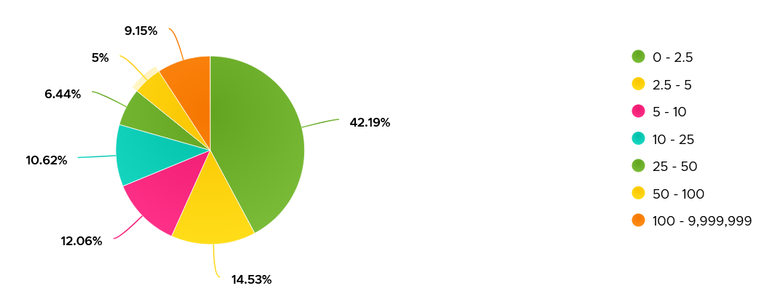

Strangely, there are values that seem to *off the chart*. I notice this in a few counters already, including this. Look at the values below. Do they look like a bug in the counter, or severe performance problem?

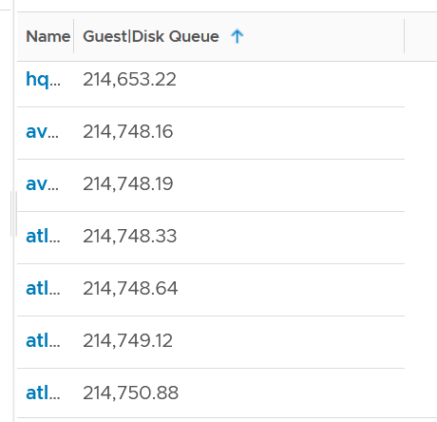

Unfortunately, we can’t confirm as we do not have latency counter at Guest OS level, or even better, as application level. I am unsure if the queue is above the latency, meaning the latency counter does not start counting until the IO command is executed.

I plot the values at VM level, which unsurprisingly does not correlate. The VM is tracking IO that has been sent, while Guest OS Disk Queue tracks the one that has not been sent.

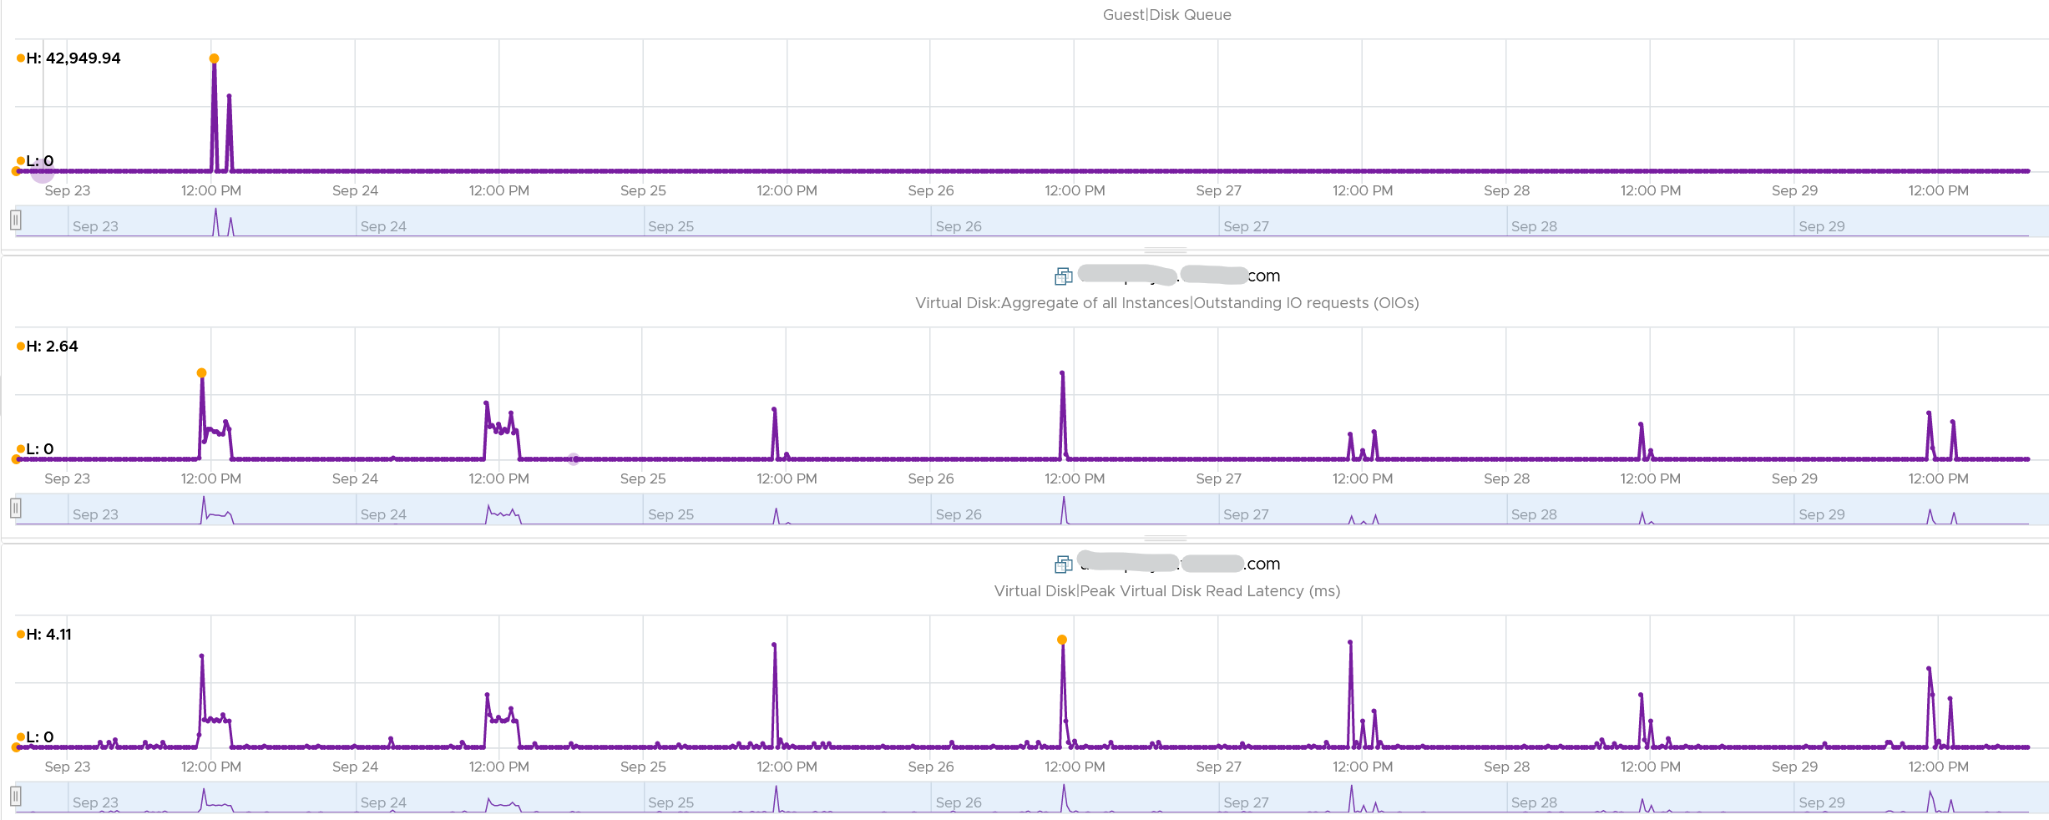

The preceding line chart also reveals an interesting pattern, which is disk queue only happens rarely. It’s far less frequent than latency. Let’s find out more. From the following heat map, you can see there are occurrences where the value is >100.

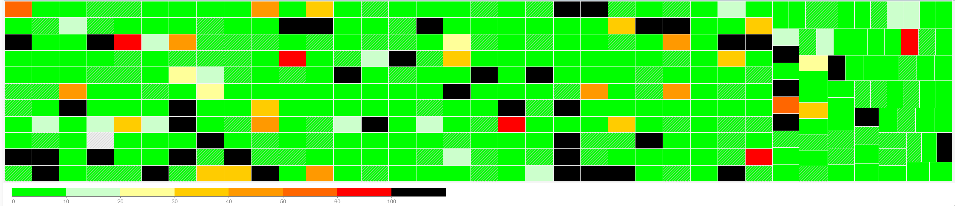

However, when we compare between current value and maximum value, the value can be drastically different.



Let’s take one of the VMs and drill down. This VM has regular spikes, with the last one exceeding 1000.



Their values should correlate with disk outstanding IO. However, the values are all low. That means the queue happens inside the Guest OS. The IO is not sent down to the VM.



Which in turn should have some correlation with IOPS, especially if the underlying storage in the Guest OS (not VM) is unable to cope. The queue is caused by high IOPS which cannot be processed.



Finally, it would manifest in latency. Can you explain why the latency is actually still good?



It’s because that’s from the IO that reaches the hypervisor. The IO that was stuck inside Windows is not included here.

The application feels latency is high, but the VM does not show it as the IO is stuck in between.

## VM

A VM does not see the underlying shared storage. It sees local SCSI disks only. So regardless of whether the underlying storage is NFS, VMFS, VSAN or RDM, it sees all of them as virtual disks. You lose visibility in the physical adapter (for example, you cannot tell how many IOPSs on vmhba2 are coming from a particular VM) and physical paths (for example, how many disk commands travelling on that path are coming from a particular VM).



VMs consume storage in 3 different ways

* Virtual disk. This can be VMFS, vSAN, vVOL, NFS, RDM. If it’s vmdk files, they can reside in different datastores and/or RDM
* Network mount point, from inside Windows or Linux. This is not feasible by the hypervisor. Both the space, and the IO are not visible. It goes out as network throughput.
* Overhead. This is not visible to the Guest OS. They are shown in blue in the following diagram.



There are more file types than shown above. However, from monitoring and troubleshooting viewpoint, the above is sufficient.

### Overview

We will cover each metric in-depth, so let’s do an overview first.

At the VM level, you can look at counters at the individual virtual disk level, at the datastore level, and at the disk level. Which ones should you when?



|  |  |
| --- | --- |
| **Virtual Disk** | Use the **virtual disk** counters to see VMFS vmdk files, NFS vmdk files, and RDMs. However, you don’t get data below the virtual disk. For example, if the VM has snapshot, the data does not know about it. Also, a VM typically has multiple virtual disks (OS drive, swap drive, data drive), so you need to add them manually if you use vCenter. In vRealize Operations, you use the “aggregate of all instances”. |
| **Datastore** | Use the **datastore** counters to see VMFS and NFS, but not RDM. Because snapshots happen at Datastore level, the counter will include it. Datastore figures will be higher if your VM has a snapshot. You don’t have to add the data from each virtual disk together as the data presented is already at the VM level. It also has the Highest Latency counter, which is useful in tracking peak latency |
| **Disk** | Use the **disk** counters to see VMFS and RDM, but not NFS. The data at this level should be the same as at Datastore level because your blocks should be aligned; you should have a 1:1 mapping between Datastore and LUN, without extents. It also has the Highest Latency counter, which is useful in tracking peak latency |

If all the virtual disks of a VM are residing in the same datastore, and that datastore is backed by 1 LUN, then all the counters will be identical. The following VM has 2 virtual disks (not shown). Notice all 3 counters are identical over time.

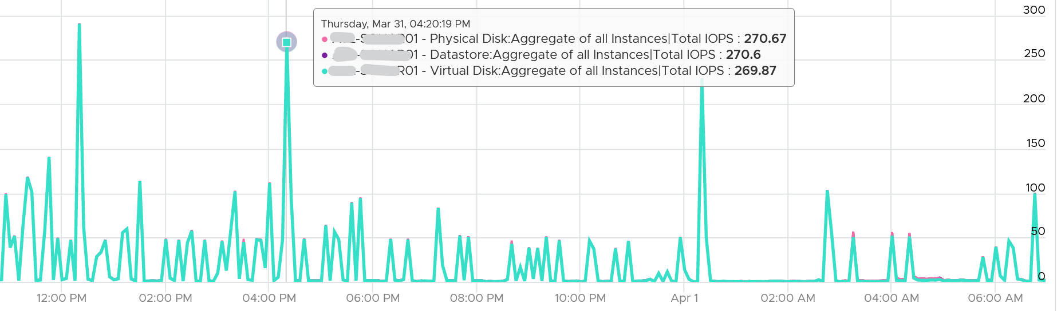

#### Virtual Disk Metrics

Storage wise, a VM consists of virtual disk, which can be VMDK or RDM. Networked fileshare mounted within the Guest OS is not visible to the VM and hence it’s not a VM virtual disk.

Take note that vSphere Client does not provide summary at VM level. Notice the target objects are individual scsiN:N, and there is no VM name as the option in Target Objects column below.

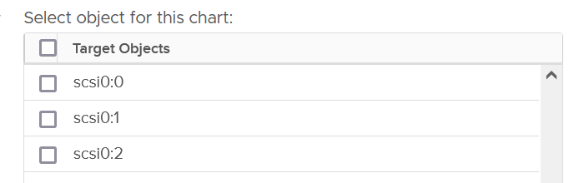

##### Contention counters

The main counters are latency. They are provided in both ms and microsecond.

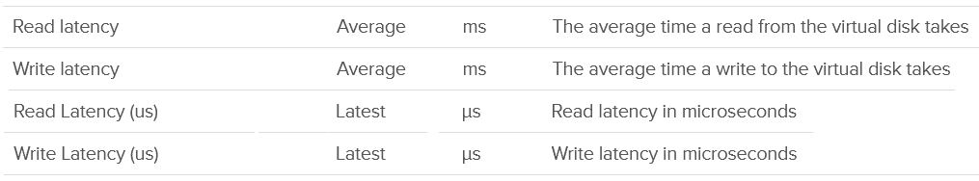

If latency is not high but Guest OS layer is showing high latency, then check the outstanding IO metrics.



##### Utilization counters

A typical suspect for high latency is high utilization. As you can expect, you’re given both IOPS and throughput metrics.

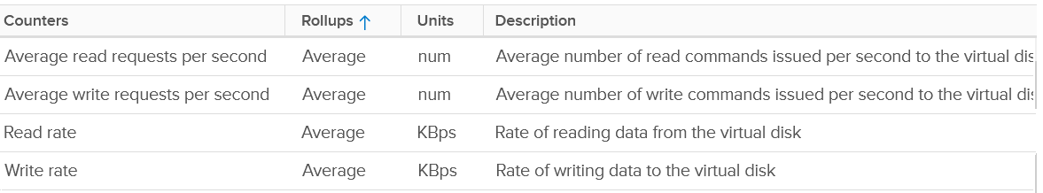

If the IOPS is low, but the throughput is high, then the block size is large. Compare this with your expected block size, as they should not deviate greatly from plan.

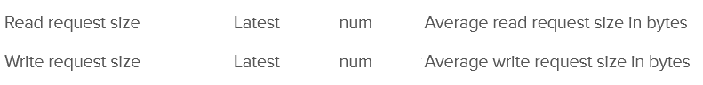

Lastly, there are storage DRS metric and seek size.

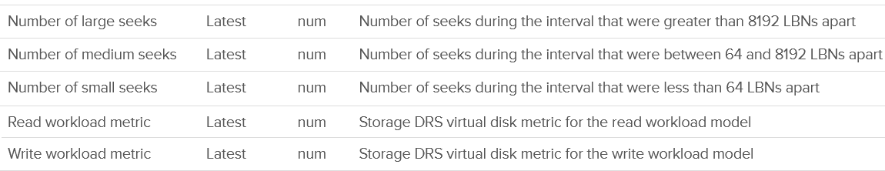

#### Disk Metrics

Disk means device, so we’re measuring at LUN level or RDM level. It’s great to know that we can associate the counters back to the VM. Notice we can’t associate it to specific virtual disk.

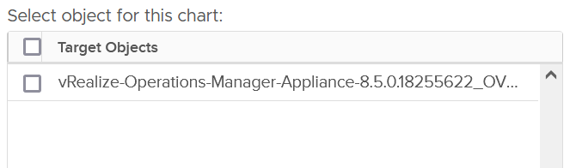

Also, depending on the metric, the association is at the disk level. So I’m not 100% sure if the value is per VM or per disk (which typically has many VM).

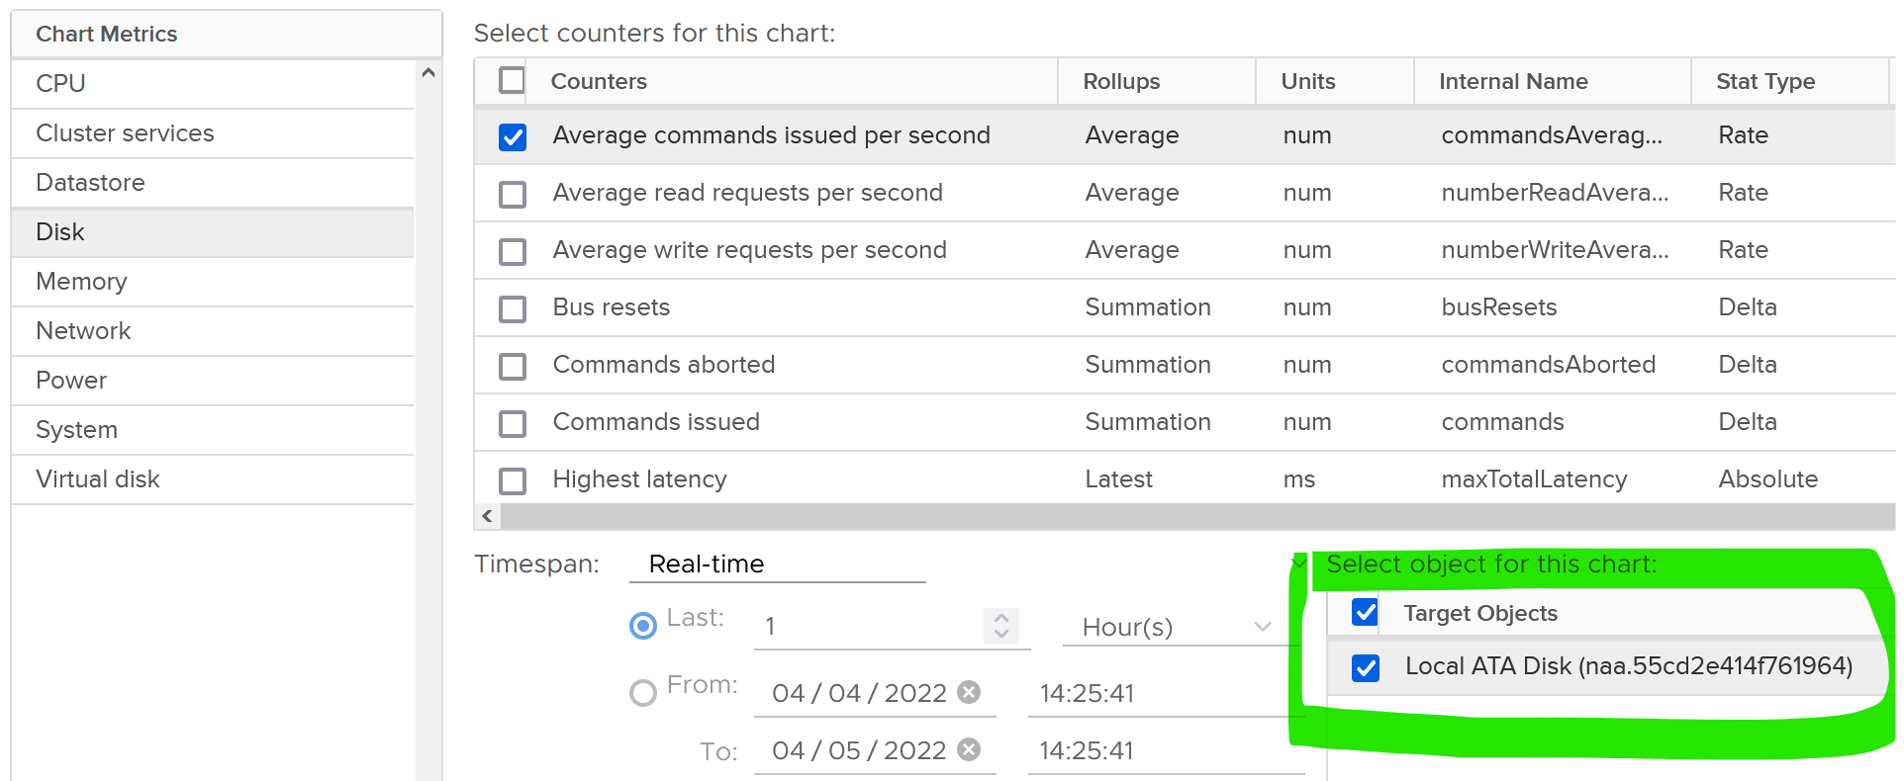

As usual, we start with error counters before we look at latency.



For latency, there is no breakdown. It’s also the highest among all disks. Take note the roll-up is latest.



There are 2 sets of counters for IOPS. Both are basically the same. One if the total number of IO in the collection period, while the other one is average of 1 second.

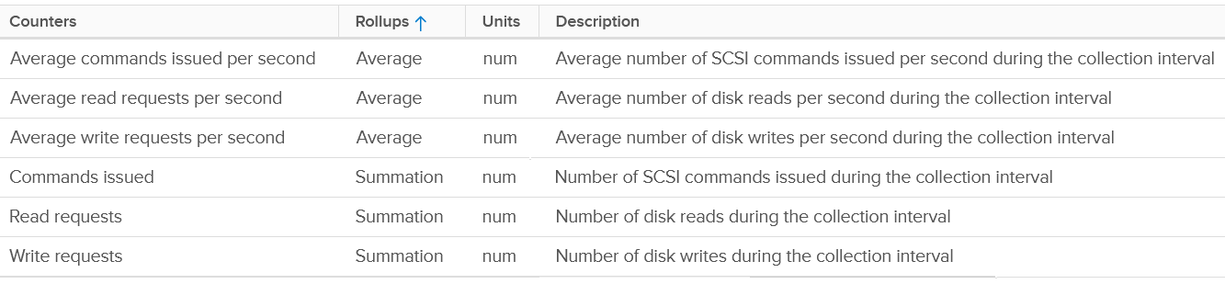

There are the usual counters for throughput.



It will be great to have block size, especially the maximum one during the collection period.

#### Datastore

Just like LUN level, we lose the breakdown at virtual disk. The metric is only available at VM level.



For contention, only latency is provided. There is no outstanding IO.

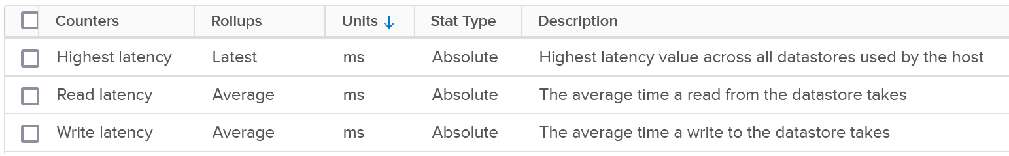

The highest latency is useful for VMs with multiple datastores. But take note the roll-up is Latest, not average.

For the read and write latency, the value in vRealize Operations is a raw mapping to these values datastore.totalReadLatency.average and datastore.totalWriteLatency.average

For utilization, both IOPS and throughput are provided.

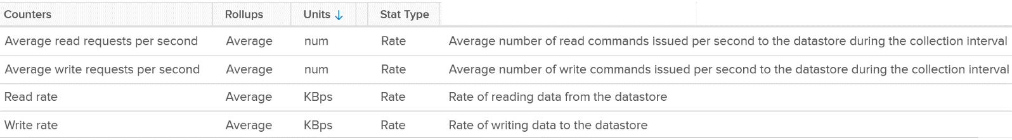

For the IOPS, the value in vRealize Operations is a raw mapping to these values datastore.numberReadAveraged.average and datastore.numberWriteAveraged.average

Review the following screenshot. Notice something strange among the 3 metrics?

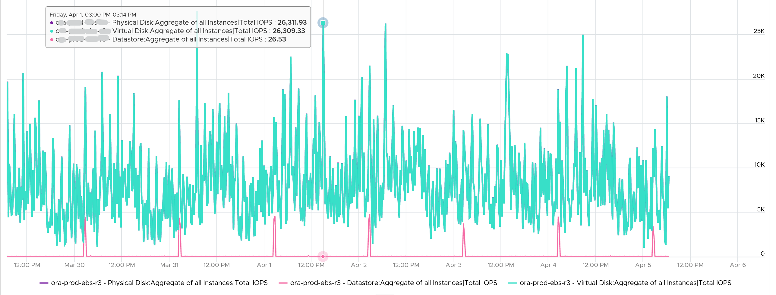

Yes, the total IOPS at datastore level is much lower than the IOPS at physical disk and virtual disk levels. The IOPS at physical disk and virtual disk are identical over the last 7 days. They are quite active.

The IOPS at datastore level is much lower, and only spike once a day. This VM is an Oracle EBS VM with 26 virtual disks. Majority of its disks are RDM, hence the IOPS hitting the datastore is much less.

### Outstanding IO

vSphere also provides information about the number of I/Os that have been issued, but not yet completed. They are waiting in the queue, hence this counter is a good counter to track if the storage subsystem is unable to cope with demand.

The Number of Outstanding I/O counter tracks these, and it provides a separate counter for read and write. The number is provided for each virtual disk. This means it can cover RDM disk too.

The formula is

Outstanding IO = Latency x IOPS

You can prove the above formula by plotting the latency metric. In the following example, this Windows 10 VM has good latency, constantly below 5 ms except for 1 occasion.

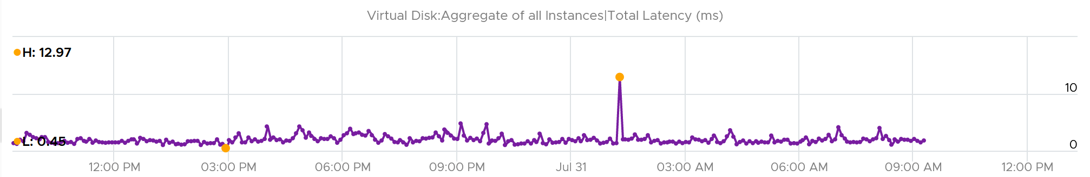

If we plot the IOPS, it reveals a different pattern. There is a regular spike, albeit the number is very low. There is a one time spike near the start of the chart.

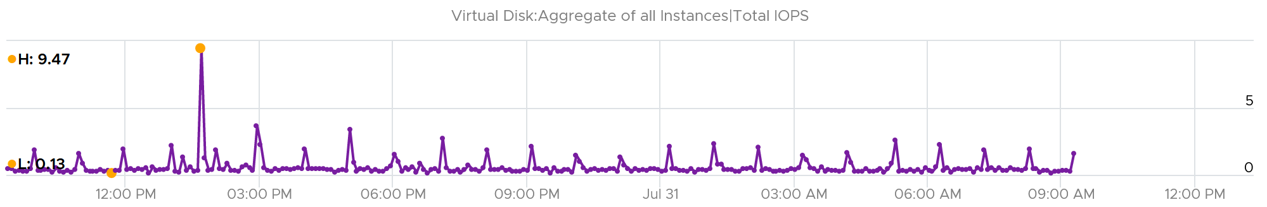

What do you expect the Outstanding IO chart to look like?

Well, since we know the formula, we expect the chart to “combine” both latency and IOPS. And the following is exactly what we got:

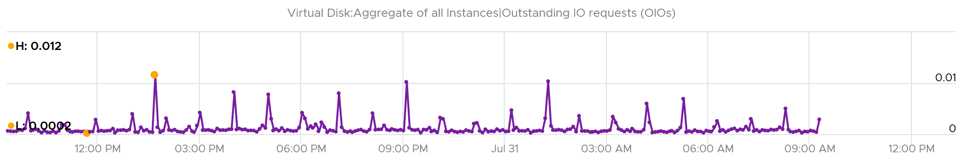

Outstanding IO should be seen in conjunction with latency. It can be acceptable to have high number of IO in the queue, so long the actual latency is low.

Since your goal is maximum IOPS and minimum latency, the metric is less useful as its value is impacted by IOPS. See [this KB article](https://kb.vmware.com/s/article/2150017) for VSAN specific recommendation on the expected value.

What should be the threshold value?

That depends on your storage, because the range varies widely. Use the profiling technique to establish the threshold that is suitable for your environment.

In the following analysis, we take more than 63 million data points (2400 VM x 3 months worth of data). Using data like this, discuss with the storage vendor if that’s inline with what they sold you.



### IOPS and Throughput

VM Disk IOPS and throughput vary widely among workload. For a single workload or VM, it also depends on whether you measure during its busy time or quiet time.

In the following example, I plotted from a 3500 production VMs. They are sorted by the largest IOPS on any given 5 minute. What’s your take?

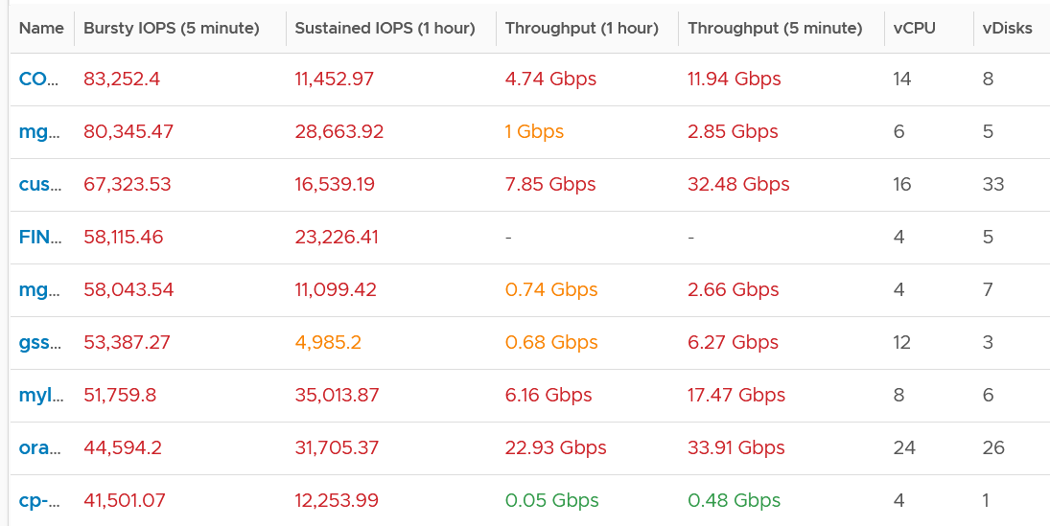

I think those numbers are high. At 1000 IOPS averaged over 5 minutes, that means 300,000 total IO commands that need to be processed. So 10K IOPS translates into 3 millions commands, which must be completed within 300 seconds.

A high IOPS can also impact the pipe bandwidth, as it’s shared by many VMs and VMkernel. If a single VM chews up 1 Gb/s, you just need a handful of them to saturate 10 Gb ethernet link.

There is another problem, which is sustained load. The longer the time, the higher the chance that other VMs are affected.

In the following example, it’s a burst IOPS. Regardless, discuss with the application team if it is higher than expected. What’s normal from one application may not be for another.

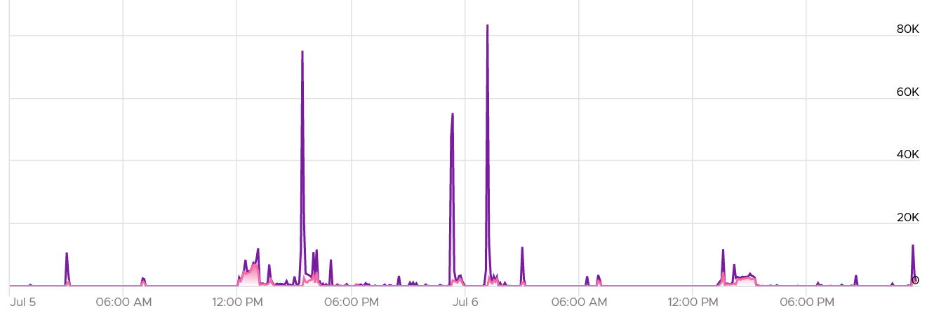

While there is no such thing as normal distribution or range, you can analyse your environment so you get a sense. I plotted all the 3500 VMs and almost 85% did not exceed 1000 IOPS in the last 1 week. The ones hitting >5K IOPS only form around 3%.

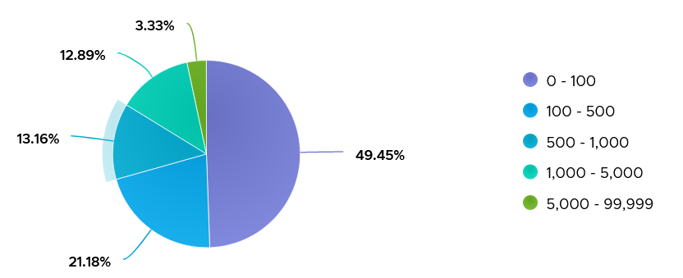

#### IOPS Limit

You can set the limit for a VM. Note that the limit is per virtual disk, not per VM.

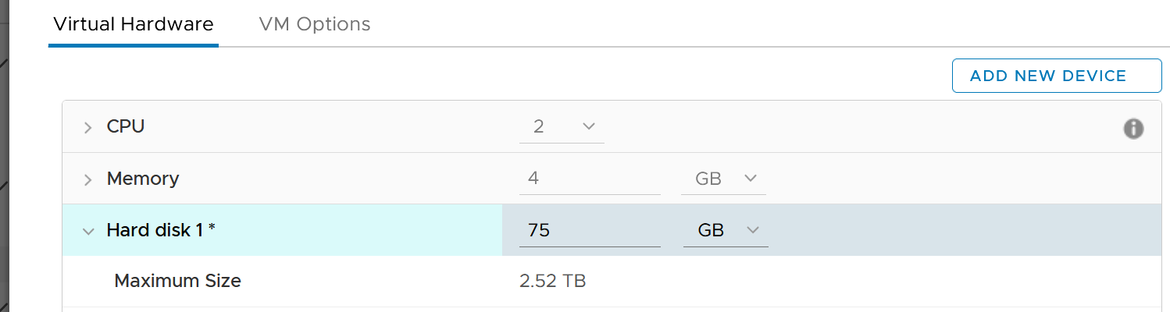

A few rows below, and you will see the following.



The default setting is no limit, which is what I recommend.

Take note that since the limit is applied at VM level, the metrics that will show high latency is at Guest OS levels. The VM metric will not show high latency, as the IO that were allowed to pass was not affected by this limit. This is no different to any problem at Guest OS layer. For example, if LSI Logic or PVSCSI driver is causing problem, the VM will not report anything as it’s below the Guest OS driver.

### Snapshot Impact

Snapshot requires additional read operations, as the reads have to be performed on all the snapshots. The impact on write is less. I’m not sure why it goes up so high, but logically it should be because many files are involved. Based on the manual, a snapshot operation creates .vmdk, -delta.vmdk, .vmsd, and .vmsn files. Read more [here](https://docs.vmware.com/en/VMware-vSphere/7.0/com.vmware.vsphere.vm_admin.doc/GUID-38F4D574-ADE7-4B80-AEAB-7EC502A379F4.html).

For Write, ESXi just need to write into the newest file.



The pattern is actually identical. I take one of the VM and show it over 7 days. Notice how similar the 2 trend charts in terms of pattern.



You can validate if snapshot causes the problem by comparing before and after snapshot. That’s exactly what I did below. Notice initially there was no snapshot. There was a snapshot briefly and you could see the effect immediately. When the snapshot was removed, the 2 lines overlaps 100% hence you only see 1 line. When we took the snapshot again, the read IOPS at datastore level is *consistently* higher.



How I know that’s IOPS effect as the throughput is identical. The additional reads do not bring back any data. Using the same VM but at different time period, notice the throughput at both levels are identical.



And here is the IOPS on the same time period. Notice the value at datastore layer is consistently higher.



For further reading, [Sreekanth Setty](https://blogs.vmware.com/performance/author/sreekanth_setty) has shared best practice [here](https://blogs.vmware.com/performance/2021/06/performance-best-practices-for-vmware-snapshots.html).

In addition of latency and IOPS, snapshot can also consume more than the actual space consumed by the virtual disk, especially if you are using thin and you take snapshot early while the disk is basically empty. The following VM has 3 virtual disks, where the snapshot file _1-00001.vmdk is much larger than the corresponding vmdk.

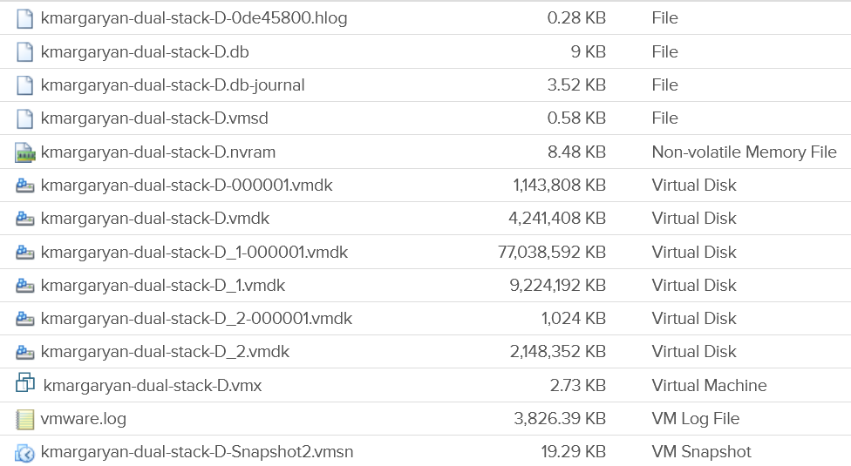

## ESXi Host

Look at the ESXi metric groups for storage in the vCenter performance chart. There are 4 metrics groups, as shown in the following screenshot:

* Datastore
* Storage adapter
* Storage path
* Disk.

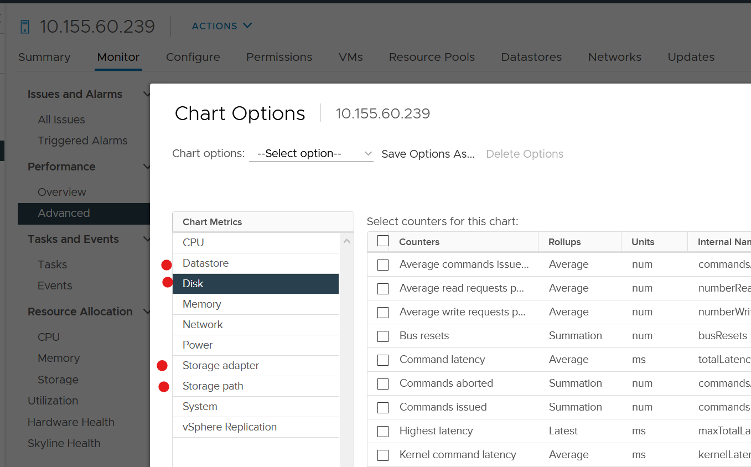

How do they relate to one another? When do we use which metric group? How do they work in distributed storage such as vSAN?

To answer the above, we need to cover some concept first.

The following diagram explains the relationship between the 4 groups. The green boxes are what you are likely to be familiar with. You have your ESXi host, and it can have NFS Datastore, VMFS Datastore, vSAN Datastore, vVOL datastore or RDM objects. vSAN & vVOL present themselves as a VMFS datastore, but the underlying architecture is different. The **blue** boxes represent the metric groups you see in vCenter performance charts.

Storage at ESXi is a lot more complex than storage at VM level. Reason is ESXi virtualizes the different physical storage subsystem, and VM simply consumes all of them as local SCSI drive.



Can you figure out why there is no path to the vSAN Datastore?

We’ll do a comparison, and hopefully you will realize how difference distributed storage and central storage is from performance monitoring point of view.

In the central storage architecture, NFS and VMFS datastores differ drastically in terms of counters, as NFS is file-based while VMFS is block-based.

* For NFS, it uses the vmnic, and so the adapter type (FC, FCoE, or iSCSI) is not applicable. Multipathing is handled by the network, so you don't see it in the storage layer.
* For VMFS or RDM, you have more detailed visibility of the storage. To start off, each ESXi adapter is visible and you can check the counters for each of them. In terms of relationship, one adapter can have many devices (disk or CDROM). One device is typically accessed via two storage adapters (for availability and load balancing), and it is also accessed via two paths per adapter, with the paths diverging at the storage switch. A single path, which will come from a specific adapter, can naturally connect one adapter to one device. The following diagram shows the four paths:



The counter at ESXi level contains data from all VMs and VMkernel overhead. There is no breakdown. For example, the counter at vmnic, storage adapter and storage path are all aggregate counters. It’s not broken down by VM. The same with vSAN objects (cache tier, capacity disk, disk group). None of them shows details per VM.

### VMkernel

The kernel does the IO on behalf of all the VMs. It also has its own kernel modules, such as vSAN, that also need to be served. This creates what is popularly termed “IO Blender” effect. Sequential operations from each VM and kernel modules become random when combined together. The opposite is when the kernel rearrange these independent IOs and try to sequence them, so on average the latency is lower.

ESXi is pretty good in optimizing the IO, so in a healthy environment, the value of Q Latency should be within 0.5 ms.

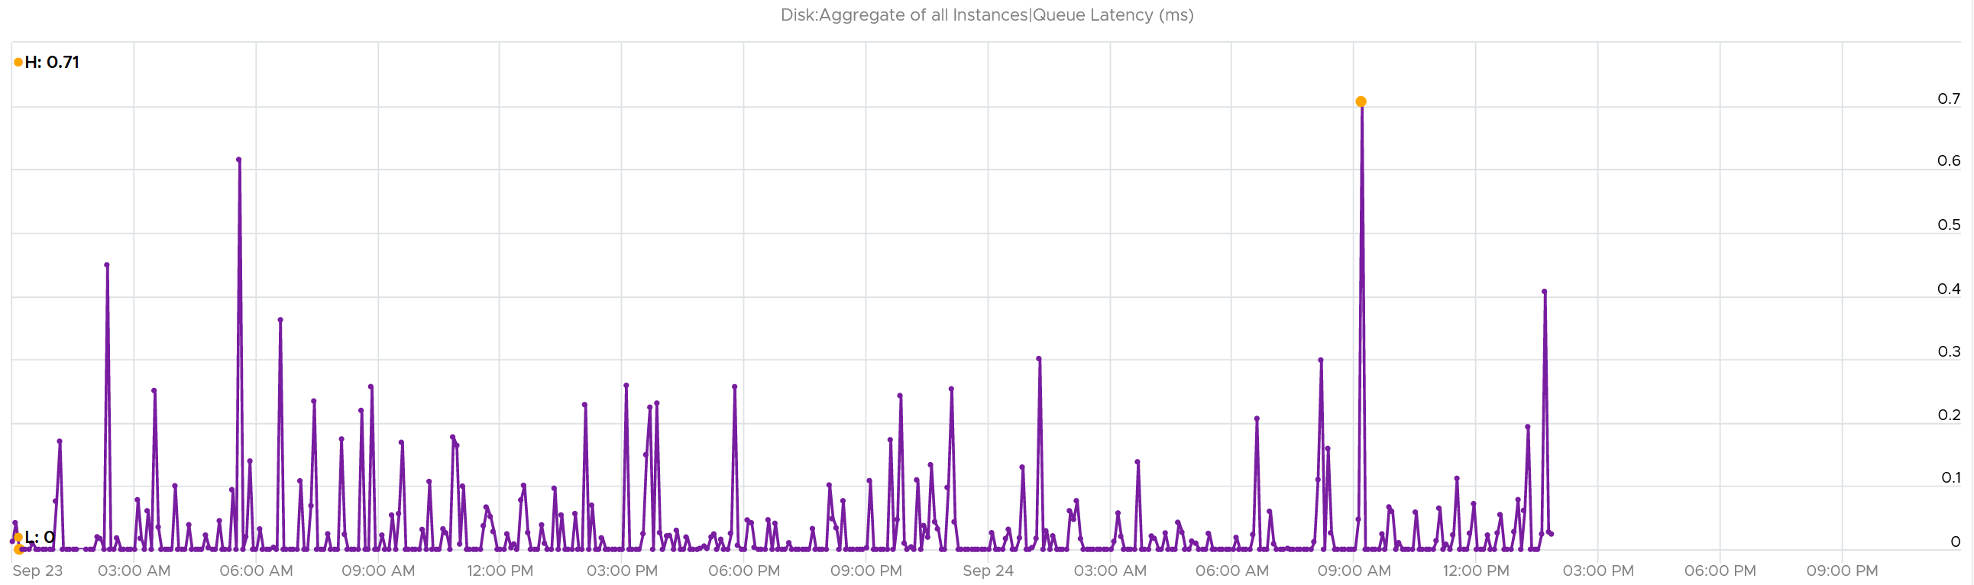

The kernel latency chart should closely mimic the queue latency, as the value is largely dominated by the Queue. Notice the pattern below is basically identical.

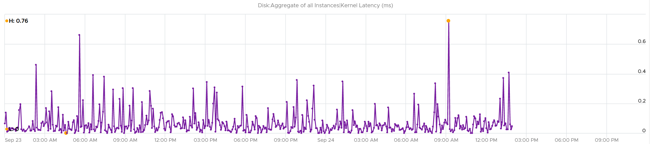

The bulk of the latency should come from the Device. In a healthy environment, it should be well within 5 ms. As you can see below, it’s below 1.75 ms. Notice the kernel latency is 0.2 ms at all times except in 1 spike.

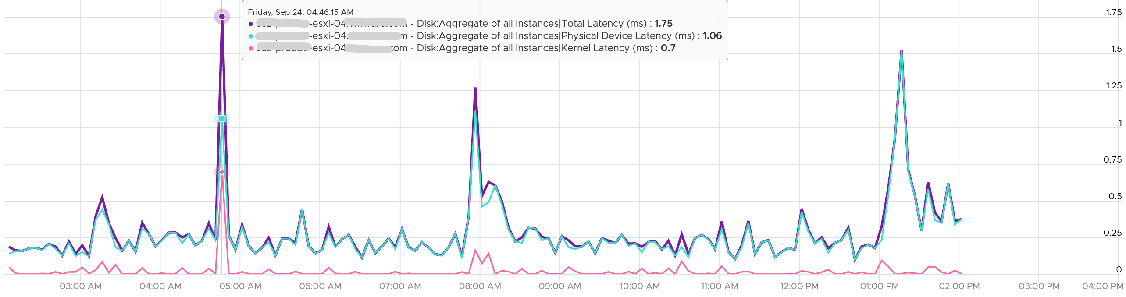

### Storage Adapter

The screenshot shows an ESXi host with the list of its adapters. We have selected vmhba2 adapter, which is an FC HBA. Notice that it is connected to 5 devices. Each device has 4 paths, giving 20 paths in total.



What do you think it will look like on vSAN? The following screenshot shows the storage adapter vmhba1 being used to connect to two vSAN devices. Both devices have names begin with “Local”. The storage adapter has 2 targets, 2 devices and 2 paths. If you are guessing it is 1:1 mapping among targets, devices and paths, you are right.

We know vSAN is not part of Storage Fabric, so there is no need for Identifier, which is made of WWNN and WWPN.



Let’s expand the **Paths** tab. We can see the LUN ID here. This is important. The fact that the hypervisor can see the device is important. That means the VMkernel can report if there is an issue, be it performance or availability. This is different if the disk is directly passed through to the VM. The hypervisor loses visibility.



#### Metrics

Now that we get the concept done, let’s look at the actual metrics provided. As usual, we start with contention first.

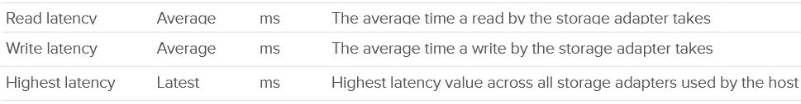

Next is utilization. The most common one is IOPS.

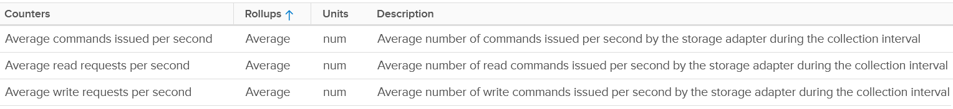

And we have throughput.

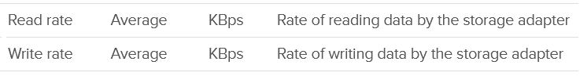

What metrics are missing from the above? Personally, I’d like to see block size. Average block size, largest block size, minimum block size.

vRealize Operations provide the Storage Adapter|Outstanding Requests metric, which is required to track if the adapter is struggling to meet demands.

### Storage Path

Continuing our comparison, the last one is Storage Path. In a fibre channel device, you will be presented with the information shown in the next screenshot, including whether a path is active or not.



Note that not all paths carry I/O; it depends on your configuration and multipathing software. Because each LUN typically has four paths, path management can be complicated if you have many LUNs.

What does Path look like in vSAN? As shared earlier, there is only 1 path.



#### Metrics

Now that we get the concept done, let’s look at the actual metrics provided.

As expected, the counters are identical to what you get in adapter, so I’ll just put the screenshot here. Refer to Adapter for the description.

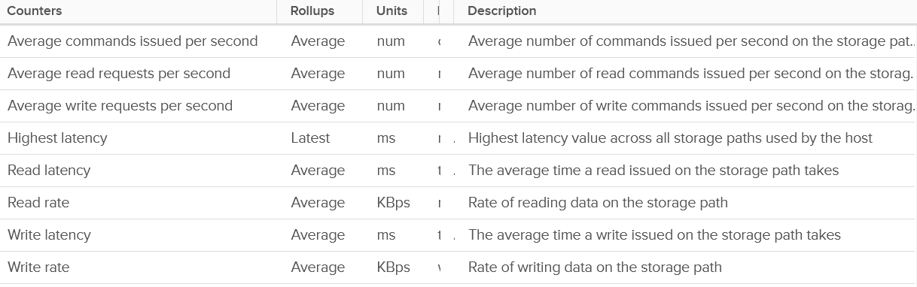

### Storage Devices

The term drive, disk, device, storage can be confusing as they are often used interchangeably in the industry. In vSphere, this means a physical disk or physical LUN partition mounted by the host. The following shows that the ESXi host has 3 storage devices, all are flash drive and the type = disk. The first two are used in vSAN datastore and are accessed via the adapter vmhba1.



A storage path takes data from ESXi to the LUN (the term used by vSphere is Devices), not to the datastore. So if the datastore has multiple extents, there are four paths per extent. This is one reason why you should not use more than one extent, as each extent adds 4 paths. If you are not familiar with VMFS Extent, Cormac Hogan explains it [here](http://blogs.vmware.com/vsphere/2012/02/vmfs-extents-are-they-bad-or-simply-misunderstood.html).

For VMFS (non vSAN), you can see the same counters at both the Datastore level and the Disk level. Their value will be identical if you follow the recommended configuration to create a 1:1 relationship between a datastore and a LUN. This means you present an entire LUN to a datastore (use all of its capacity). The following shows a VMFS datastore with a NetApp LUN backing it.



In vSAN, there is no connectivity and Multipathing menu. There is no also **Capability Sets** menu. vSAN datastore is not mapped to a LUN. It is supported by disk groups.

#### Metrics (DRAFT)

Now that we get the concept done, let’s look at the actual metrics provided. Compared with Adapter or Path, you get a lot more metrics.

##### Error



##### QAVG

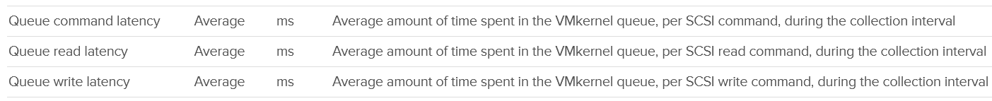

##### KAVG

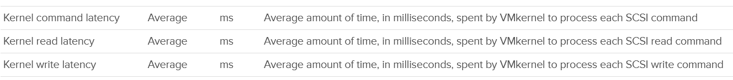

##### DAVG

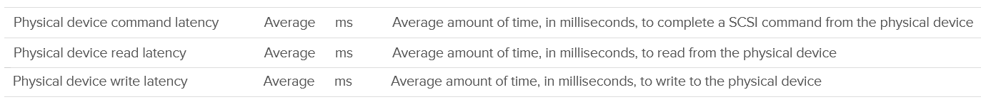

##### GAVG



##### ?

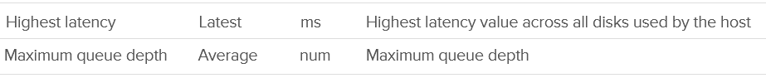

##### IOPS and IO

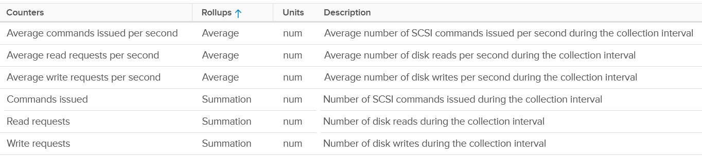

##### Throughput



### Datastore (DRAFT)

For shared datastore, the counters do not show the same value with the one at datastore object. All these counters are only reporting from this ESXi viewpoint, not the sum from all ESXi mounting the same datastore.

#### General counters

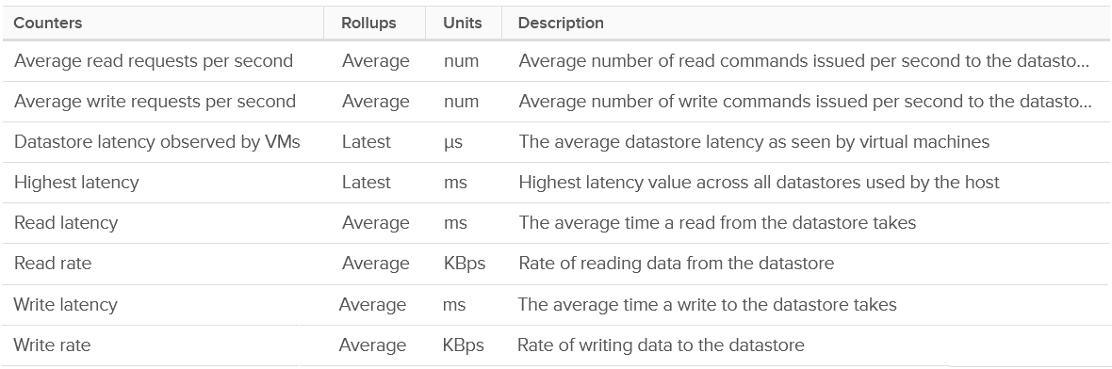

#### Unmapped Counter

They do not measure the potential amount to be reclaimed. They measure the unmap operations, both the IOPS generated by unmap operations and the amount being unmapped.



#### Storage DRS counters

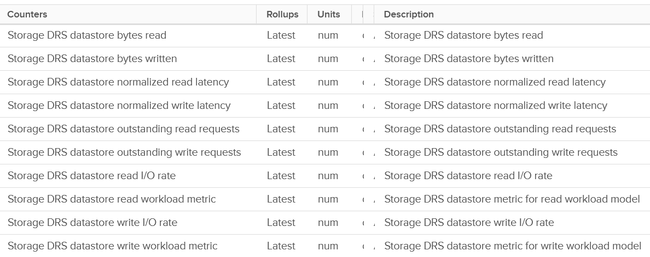

#### Storage IO Control counters

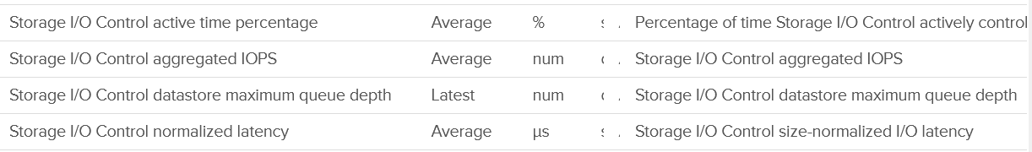

## vSAN

Distributed storage means the actual disks are spread across many physical gears, which are typically ESXi servers.

From monitoring and troubleshooting viewpoint, not all distributed storage are equal. vSAN runs as a kernel module in VMkernel, which results in a different context than if vSAN were running as a VM. The metrics are different because the architecture is different.

In vSAN, you need to know where VM storage is located. So a VM now has 1 Compute Host and >1 Storage Hosts. The storage hosts vary, depending on which part of the disks are being accessed.

### Performance Monitoring

While vSAN provide storage service, it requires network to deliver that. So we need to look at both storage and network in analysis. vSAN is basically a collection of ESXi Hosts, so we need to consider compute metrics also.

A large vSAN cluster can have many components. Each of these components can have multiple performance metrics. The total number of KPI can reach hundreds of metrics. Take the following example, which is a 10 node cluster.

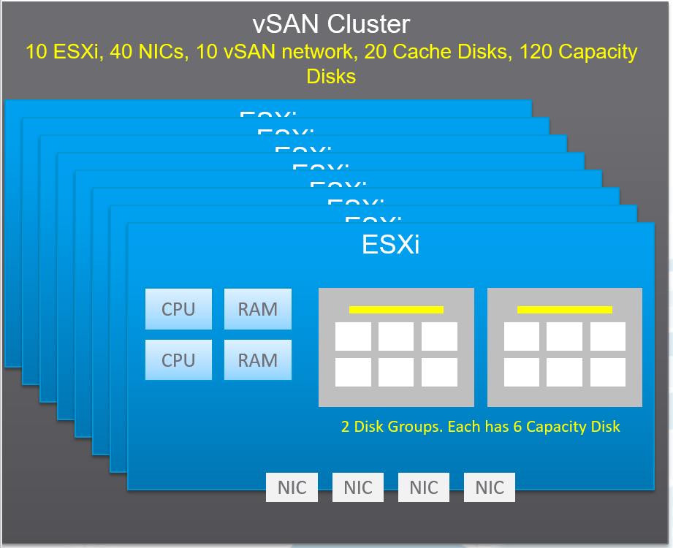

Here are some of the questions you want to ask in day-to-day operations:

* Is any of the ESXi hosts in the cluster running high CPU utilization?
* Is any of the ESXi hosts running high Memory utilization?
* Is any of the NIC cards in any of the ESXi hosts running high utilization?   
  In the above example, with 4 NIC cards per ESXi, you have 40 TX + 40 RX metrics.
* Is the vSAN VMkernel network on any of the ESXi hosts congested?
* Is the Read Cache on any of the Disk Groups sufficient? If you have a lot of cache miss, it can impact performance.
* Is the Write Buffer on any of the Disk Groups sufficient?
* Is the Cache Tier performing fast? Each disk has 4 metrics: Read Cache Read Latency, Read Cache Write Latency, Write Buffer Write Latency, Write Buffer Read Latency. Since there are 20 disks, you need to check 80 counters
* Are the Capacity Disks performing fast? Check both Read and Write latency as they typically have different results.  
  In our example above, there are 120 x 2 = 240 counters.
* Is any of the Disk Groups running low on space?
* Is any of the Disk Groups facing congestion? You want to check both the max and count the number of occurrences > 50 or 60. Congestion is an internal vSAN counters. Congestion can happen at relatively low IOPS if the throughput is high (due to large block size).
* Is there outstanding IO on any of the Disk Group?

If you add them up, you are looking at 530 metrics for this vSAN cluster. And that’s just 1 point in time. It will be difficult to show hundreds of datapoint on a screen, even if you can color code them all. We need a way to zoom in on the early warning.

The above is just a point in time. What if you want to see the trend *over time*? In 1 month, you are looking at 530 x 8766 = 4.6+ million data points. And that’s just for 1 cluster. So there is a need for a better technique.

vRealize Operations use the formula Min(), Max(), and Count() to pick the early warning. This was covered earlier in this section. It combines the key metrics into a set of KPI. With these vSAN KPIs, you only have 12 metrics to check instead of 530, without losing any insight. In fact, you get better early warning, as we hide the average. Early Warning is critical as buying hardware is more than a trip to local DIY hardware store.

The following tables show the KPIs and their formula.

|  |  |
| --- | --- |
| Name | What it is |
| Max Capacity Disk Latency (ms) | Highest Latency among all Capacity Disks. We take the worst, not average, as the latency in a single Capacity Disk is already an average of all its VMs. If there are 50 VMs on the disk, and 30 are issuing IO on it, then it’s a average among 30. |
| Min Disk Group Write Buffer Free (%) | Lowest free capacity among all the Disk Group Write Buffers. If this number is low, one of your buffer is not enough. While you want to maximize your cache, a low number is an early warning for capacity management. |
| Max Disk Group Read Cache/Write Buffer Latency (ms) | Each disk has Read Cache Read Latency, Read Cache Write Latency (for writing into cache), Write Buffer Write Latency, Write Buffer Read Latency (for de-staging purpose). This takes the highest among these 4 numbers, then the highest among all disk groups. It’s the Max of Max, because each of 4 datapoint is average of all the VMs on it. |
| Sum Disk Group Errors | Sum of Bus Reset + Sum of Commands Aborted among all the Disk Groups. We sum, not get the max, as each member should return 0. |
| Count Disk Group Congestion Above 60 | The number of Disk Group congestion greater than 60. 60 is hardcoded in the MP as it’s good starting point. As any congestion above 60 serves as early warning, we count how many of such occurrence happens. |
| Max Disk Group Congestion | The highest congestion among all the disk groups. A high number indicates at least 1 Disk Group is not performing. See [this KB](https://kb.vmware.com/s/article/2150012) for details. |
| Min Disk Group Capacity Free (%) | The lowest free capacity among all disk groups. A low space will trigger rebalance. |
| Min Disk Group Read Cache Hit Rate (%) | The lowest hit rate among the disk group read cache. Ensure this number is high, indicating read is served by cache. |
| Sum vSAN Port Group Packets Dropped (%) | Sum of all vSAN VMkernel port RX Dropped Packet + TX Dropped Packet.  You should expect no dropped packet in your vSAN network |

From the above, we need to reduce it to a single metric so we can report many vSAN clusters. The following diagram shows why.

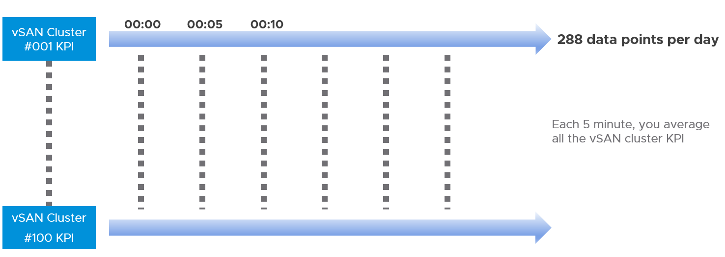

#### Congestion

If you’re experiencing slowness, [this KB article](https://kb.vmware.com/s/article/2150012) provides more details on what to look.

Congestion is a feedback mechanism to reduce the rate of incoming IO requests from the vSAN DOM client layer to a level that the vSAN disk groups can service. This reduction of the incoming IO request rate is done by introducing an IO delay that is equivalent to the delay the IO would have occurred due to the bottleneck at the lower layer. Thus, it is an effective way to shift latency from the lower layers to the ingress without changing the overall throughput of the system. This avoids unnecessary queuing and tail dropped queues in the vSAN LSOM layer and therefore avoids a lot of wasted CPU cycles in processing IO requests that might eventually be dropped.

Hence, regardless of the type of congestion, temporary and small values of congestion are usually OK, and not beneficial to the system performance. However, sustained and large values of congestion may lead to higher latency and lower throughput than desired, and therefore warrant attention and resolution in order to get a better benchmark performance.

### Performance Troubleshooting

The above KPI metrics are good enough for monitoring. It tells you if there is a problem. To know what’s causing the problem, you need to deeper. The first step is to recognise that there are two broad layers: VM layer and back end layer.

I’ve put the two screens side by side for ease of comparison. What do you notice?

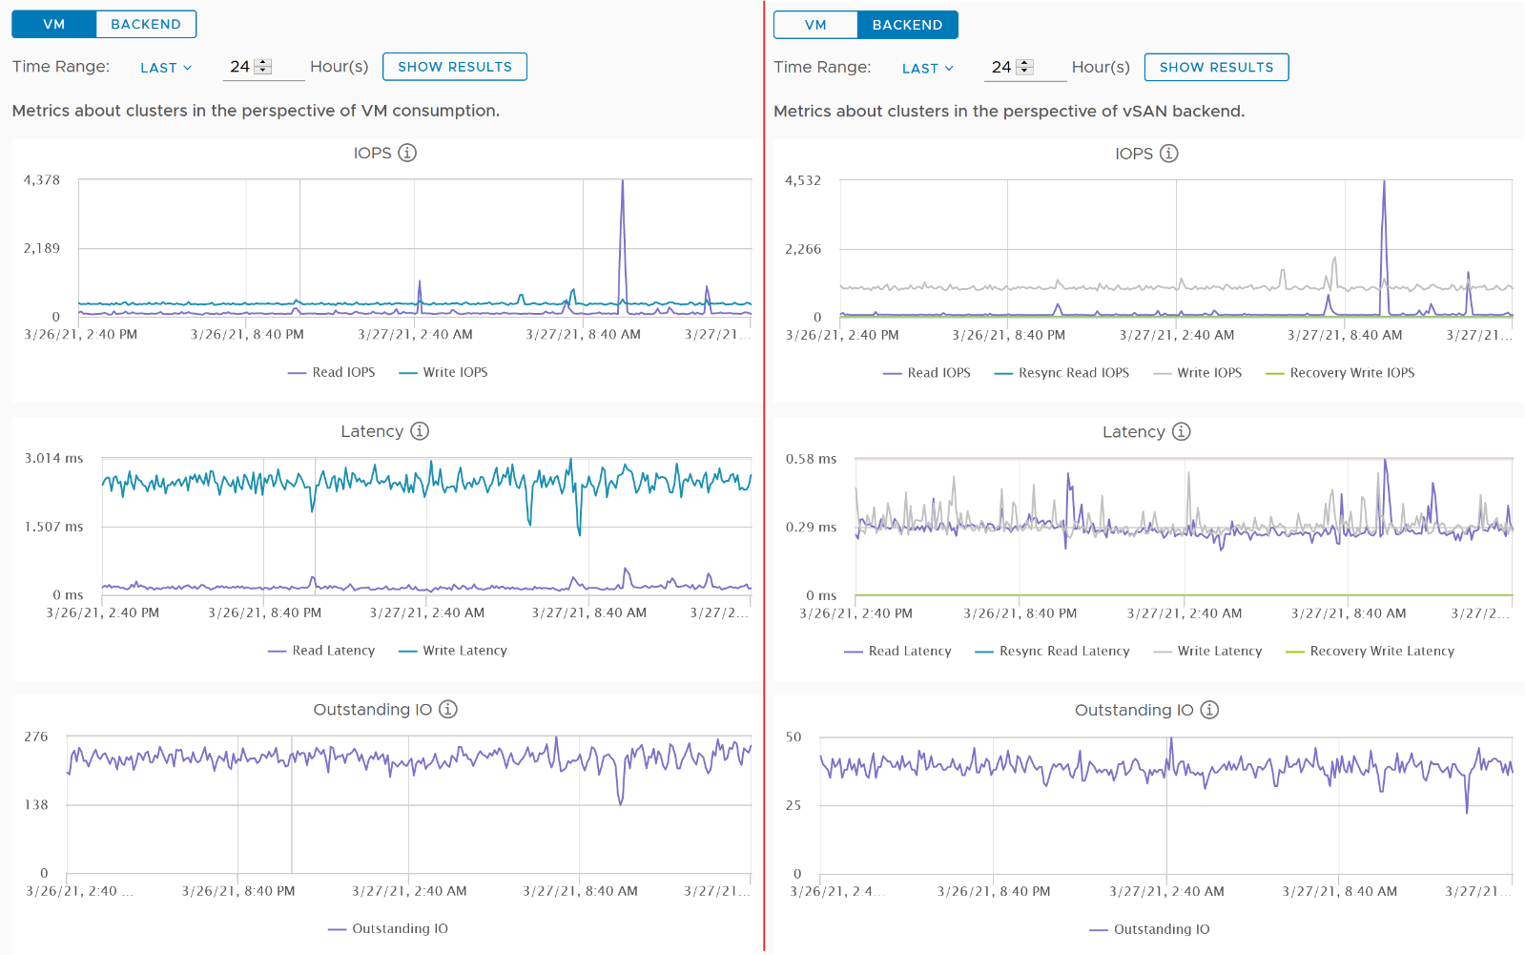

Just like other storage subsystems, you will expect the latency & outstanding IO at the backend layer to be lower. This is because it’s a subset of the entire path taken by the IO command of the VM.

Let’s dive deeper to peel the layer. The following diagram shows the key components and how the latency counters are measured. It visualizes the hardware and software component using different box style.

* Software: VM, vSAN software and Network kernel loadable module
* Hardware: IO Controller Card, Cache Disk, Capacity Disk, and Network Card

The white arrows show a single Write command, and the yellow arrow show a single read command. Both have double arrows to show the acknowledgement when the command has been completed.

* The write request is written to the cache disk, and acknowledged. The de-staging to capacity disk is done post acknowledgement, hence it’s not part of the VM disk latency. In this example, we are showing that the writing happens to be on local ESXi host.
* The read request is shown as remote so we can cover both local and remote scenarios. Notice the read does not touch the local IO Controller Card. It goes into the network subsystem, which drives the physical network card. On the destination host, the vSAN software will first read from the cache. If there is a miss, it will read from the capacity disk.

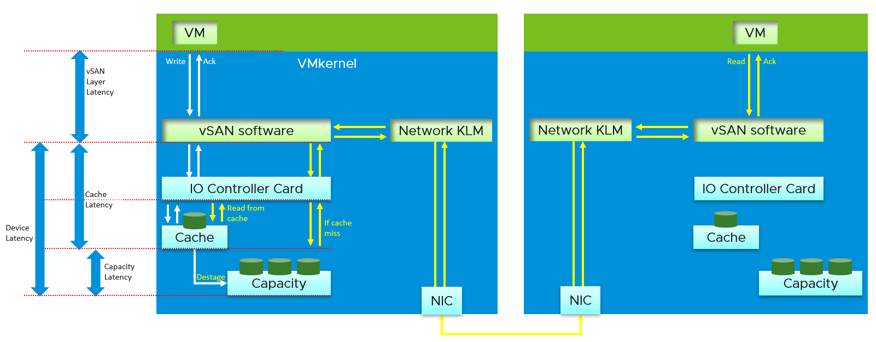

[Pete Kohler](https://www.linkedin.com/in/pekoehler/) shares the following diagram in [this](https://core.vmware.com/blog/performance-troubleshooting-understanding-different-levels-vsan-performance-metrics) blog. I recommend you read it.

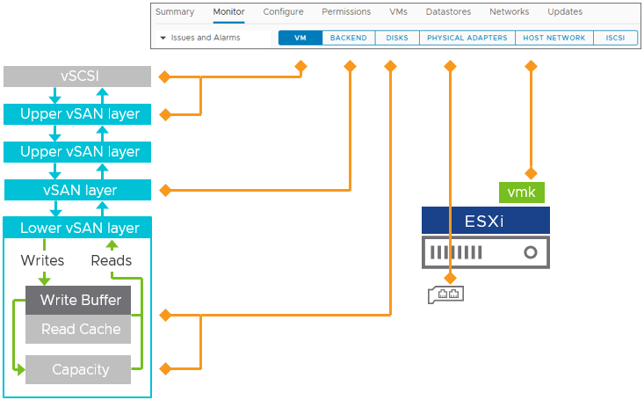

## esxtop

The Storage monitoring sports 3 panels:

* VM
* Adapter
* Device

An ESXi host has adapter, path and devices. I’m unsure why esxtop does not have a panel for path. It would be convenient to check dead path or inactive path as the value will be all 0. If your design is active/active, it can be useful to compare if their throughput is not lopsided.

Datastore is also missing. While VMFS can be covered with Device (if you do 1:1 mapping and not using extent), NFS is not covered.

On the other hand, esxtop does provide metrics that vSphere Client does not. I will highlight those.

ESXi uses adapter to connect to device. As a result, their main contention and utilization counters are largely similar. I’ve put them side by side here, and highlight the similar metric *groups* with vertical green bar. I highlighted the word group, as the group name may be identical, but the actual metrics within the group differ.

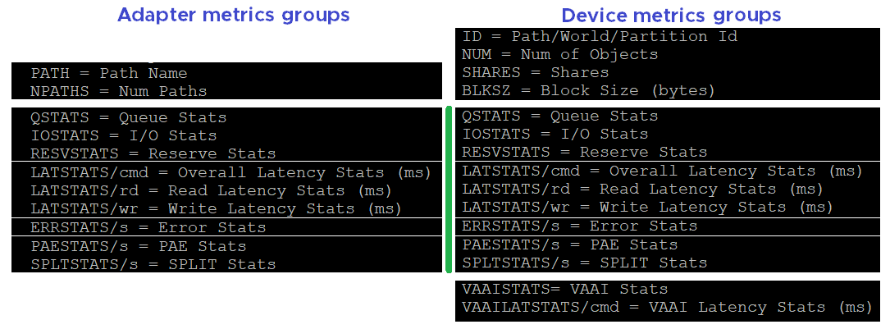

### Disk VM panel

We begin with VM as that’s the most important one. It complements vSphere Client by providing unmap and IO Filter metrics.

You can see at VM level, or virtual disk level. In the following screenshot, I’ve expanded one of the VM.

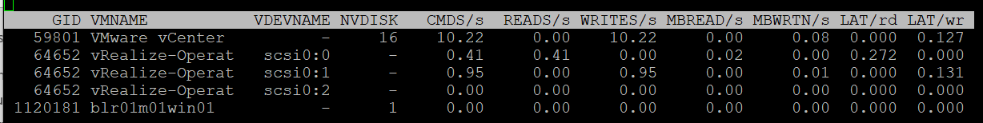

#### Contention

There are only 2 counters. There is no outstanding IO metric.

|  |  |
| --- | --- |
| LAT/rd | Average latency (in milliseconds) per read. |
| LAT/wr | Average latency (in milliseconds) per write. |

#### Utilization

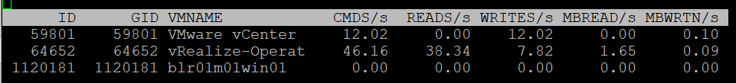

|  |  |
| --- | --- |
| CMDS/s | Count of disk IO commands issued per second. This is basically IOPS.  Both the Read IOPS and Write IOPS are provided. |
| READS/s |
| WRITES/s |
| MBREAD/s | Total disk amount transferred per second in MB. This is basically throughput.  Both the read throughput and write throughput are provided. |
| MBWRTN/s |

#### Unmap

It has unmap statistics. This can be useful that there is no such information at vSphere Client. In the UI, you can only see at ESXi level.



|  |  |
| --- | --- |
| SC_UMP/s | Successful, Failed and Total Unmaps per second.  Unmap can fail for a variety of reason. One example that was addressed in vSphere 6.7 Patch ESXi670-202008001 and documented in in KB is Guest OS does not refresh unmap granularities and keep sending unmap based on older value. Eventually limit is reached and the operation fail. |
| FL_UMP/s |
| UMP/s |
| SC_UMP_MBS/s | As above, but in MB/second. |
| FL_UMP_MBS/s |

#### IO Filter

I/O Filter in ESXi enable VMkernel to manipulate the IO sent by Guest OS before processing it. This obviously opens up many use cases, such as replication, caching, Quality of Service, encryption.

There is no such metric at vSphere Client. You will not find IO Filter metrics at both VM object and ESXi object.

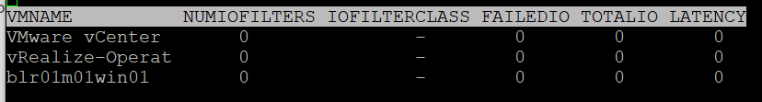

|  |  |
| --- | --- |
| NUMIOFILTERS | Number of IO Filters |
| IOFILTERCLASS | Type of IO Filter Class |
| FAILEDIO | I think Failed IO should be 0 at all times. |
| TOTALIO |
| LATENCY | I’m unsure if this latency measures the additional overhead introduced by IO Filter, or the total latency as seen by the VM. |

#### Configuration

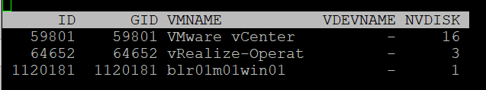

|  |  |
| --- | --- |
| ID | Resource pool ID or VSCSI ID of VSCSI device. |
| GID | Resource pool ID. |
| VMNAME | Name of the resource pool. |
| VSCSINAME | Name of the VSCSI device. |
| NDK | Number of VSCSI devices |

### Disk Adapter

ESXi uses adapter to connect to device, so let’s begin with adapter, then device.

The panel has a lot of metrics and properties, so let’s group them for ease of understanding.

#### Errors

I’m always interested in errors first, before I check for contention and utilization.

BTW, none of these counters are available at vSphere Client UI.

|  |  |
| --- | --- |
| FCMDS/s | Number of failed commands issued per second. How does this differ to Reset and Aborted? I’m not sure why this is a rate and not accumulative as the total number should be 0.  Number of failed read commands issued per second.  Number of failed write commands issued per second. |
| FREAD/s |
| FWRITE/s |
| FMBRD/s | Megabytes of failed read operations per second.  Megabytes of failed write operations per second. |
| FMBWR/s |
| CONS/s | Number of SCSI reservation conflicts per second. This number should stay 0?  Number of failed SCSI reservations per second, if the conflict can’t be solved timely.  Number of SCSI reservations per second. This number should stay within the limit, but how to know what the limit is? |
| FRESV/s |
| RESV/s |
| ABRTS/s | Number of commands cancelled per second. I’m not sure why this is a rate and not accumulative as the total number should be 0. |
| RESETS/s | Count of disk commands reset per second. Same with aborted command. This type of problem is best monitored as accumulation within the reporting period as any value other than 0 should be investigated. |

#### Queue

For storage, the queue gives insight into performance problem. It’s an important counter so I was hoping there will be more.

|  |  |
| --- | --- |
| AQLEN | Current queue depth of the storage adapter. The storage adapter queue depth. This is the maximum number of ESX Server VMkernel active commands that the adapter driver is configured to support  This counter is not available in vSphere Client UI |

#### Contention

As explained in Part 1 Chapter 2 of the book, check contention before utilization.

From esxtop context, there are 2 major layers in the VMFS storage stack:

* VMkernel. This is measured by the KAVG counter and QAVG counter.
* Device. Well, that basically means from the HBA to the device and back. VMkernel cannot actually see anything in between, so there is no breakdown. This entire round trip is measured by the DAVG counter.

From the VM (not Guest OS), the end to end latency is represented by the metric GAVG. It’s simply KAVG + DAVG, where Guest latency = Kernel latency + Device latency.

[Frank Denneman](https://frankdenneman.nl/), whose blog and book are major sources in this book, shows the relationship in the following diagram:

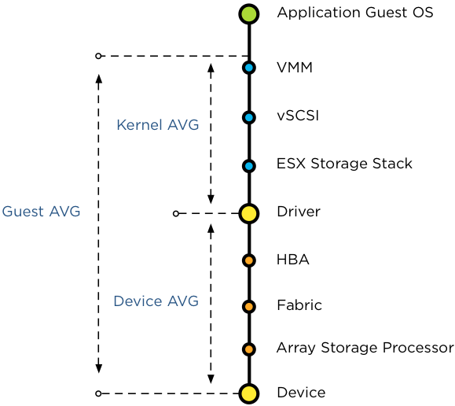

DAVG measures the time from ESXi physical card to the array and back. Typically, there is a storage fabric in the middle. The array typically starts with its frontend ports, then CPU, then cache, backend ports, and physical spindles. So if DAVG is high, it could be the fabric or the array. If the array is reporting low value, then it’s the fabric of the HBA configuration.

For further reading, review [this](https://frankdenneman.nl/2012/07/23/to-which-host-level-latency-statistic-is-the-sioc-congestion-threshold-related/) explanation by Frank, as that’s where I got the diagram from.

I’m unsure what DAVG measures when it’s vSAN and the data happens to be local.

QAVG, which is queue in the kernel, is part of KAVG. If QAVG is high, check the queue depths at each level of the storage stack. [Cody](https://www.codyhosterman.com/about/) explains why QAVG can be higher than KAVG [here](https://www.codyhosterman.com/2018/03/what-is-the-latency-stat-qavg/).

Now that we’ve got metrics defined, you expect to get 4 sets. For each set, you expect read, write, and total. 12 metrics, and that’s exactly what you got below.

|  |  |
| --- | --- |
| DAVG/cmd | Average latency per command in milliseconds.  It’s an average number, not the last number in the reporting period. If you have 1000 IOPS, that means 5K IOPS over the 5 second reporting period.  It’s a weighted average between read and write. If the IO commands are mostly read, then high latency from write could be masked out. |
| KAVG/cmd |
| GAVG/cmd |
| QAVG/cmd |
| DAVG/rd | Average read latency per read operation in milliseconds. The same set of counters as above, except it only counts the reads.  It’s useful to see read and write separately as the numbers tend to be different. More importantly, the remediation action is different. |
| KAVG/rd |
| GAVG/rd |
| QAVG/rd |
| DAVG/wr | The same set of counters as above, except it only counts the writes. |
| KAVG/wr |
| AVG/wr |
| QAVG/wr |

#### Utilization

Now that we get the more important counters (errors, queue, and contention) done, you then check utilization counter. In this way you have better context.

|  |  |
| --- | --- |
| ACTV | The definition is “Number of commands that are currently active”. I don’t know how it differs to IOPS, and what does the word “active” exactly mean here.  This is worth profiling. |
| CMDS/s | I combine these 3 metrics as they are basically IOPS. Total IOPS, read IOPS and write IOPS. |
| READS/s |
| WRITES/s |
| MBREAD/s | I combine them as they measure throughput. Interestingly, there is no total throughput metric, but you can simply sum them up.  Read the string MBWRTN as MB Written. |
| MBWRTN/s |

#### PAE and Split

|  |  |
| --- | --- |
| PAECMD/s | PAE Command per second and PAE Copy per second.  I think PAE (Physical Address Extension) no longer applicable in 64-bit and modern drivers/firmware/OS, as the size is big enough. Copy operations here refer to VMkernel copies the data from high region (beyond what the adapter can reach) to low region.  This statistic applies to only paths. |
| PAECP/s |
| SPLTCMD/s | Splt Cmd per second.  Disk IO commands with large block size have to be split by the VMkernel. This can impact the performance as experience by the Guest OS. |
| SPLTCP/s | Number of split copies per second. |

#### Configuration

The panel provides basic configuration. I use vSphere Client as it provides a lot more information, and I can take action on them. The following is just some of the settings available.

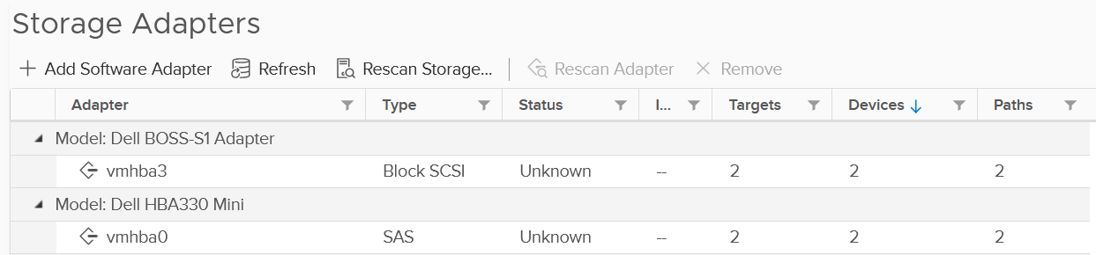

Compare the above with what esxtop provides, which is the following:

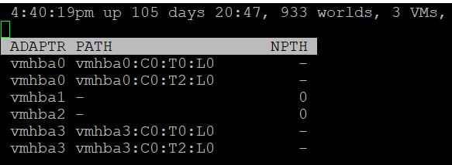

|  |  |
| --- | --- |
| NPTH | Number of path. This should match your design. An adapter typically has more than 1 path, which is why I said it would be awesome to have a panel for path |

### Disk Device panel

The device panel has a lot of metrics and properties, so let’s group them for ease of understanding.

#### Errors

I’m always interested in errors first, before I check for contention and utilization.

|  |  |
| --- | --- |
| ABRTS/s | Number of commands cancelled per second. Expect this to be 0 at all times. |
| RESETS/s | Number of commands reset per second. Expect this to be 0 at all times. |

#### Queue

You’ve seen that there is only 1 counter for queue in Disk Adapter. How many do you expect for Disk Device?

Interestingly, there are 6 counters for queue, as shown below.

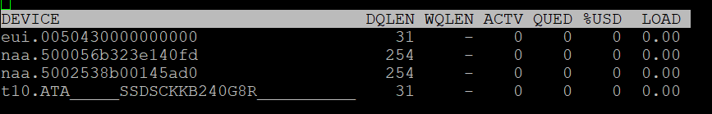

|  |  |
| --- | --- |
| LOAD | The formula is  (active commands + ESXi VMkernel queued commands) / queue depth.  If LOAD > 1, check the value of the QUED counter. |
| QUED | Number of commands in the ESXi VMkernel that are currently queued. You want this to be as low as possible, well below the queue depth. |
| %USD | USD (%) = ACTV / QLEN  For world stats, QLEN is WQLEN. For LUN (aka device) stats, QLEN is DQLEN.  Percentage of the queue depth used by ESXi VMkernel active commands.  So this does not include the queued command? Does it mean that if this number is not 100%, then there is nothing in the queue, as queue should only develop when it’s 100% used?  Obviously when Used = 100% it means the queue is full. That will introduce outstanding IO, which in turn will increase latency |
| DQLEN | I combine this together as a device can have 1 or more world, and there is a per-device maximum.  DQLEN is the device configured queue length. The corresponding counter for adapter is called AQLEN  WQLEN is the world queue depth. The manual states “This is the maximum number of ESXi VMkernel active commands that the world is allowed to have”. So it does not look like a present number. I am confused why we show max for world, and present for device. |
| WQLEN |
| ACTV | The definition is “Number of commands that are currently active”. I think this means the IO in flight, which makes it an interesting counter. This is worth profiling and I expect it to be small most of the time. |

#### Contention

See Disk Adapter as both sport the same 12 metrics.

#### Utilization

See Disk Adapter as both sport the same 5 metrics.

#### PAE and Split

See Disk Adapter as both sport the same 4 metrics.

#### Configuration

As you can expect, esxtop provides minimal configuration information. They are shown below.

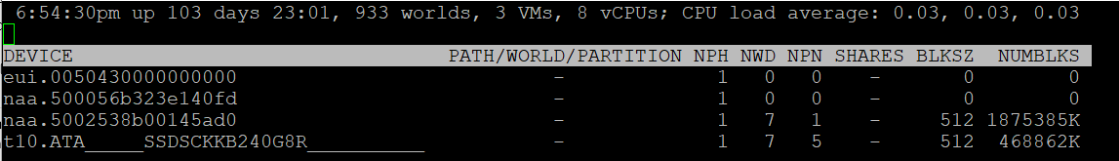

##### Path/World/Partition

They are grouped as 1 column, and you can only see one at a time.

By default, none of them is shown. To bring up one of them, type the corresponding code. In the following screenshot, I’ve type the letter **e**, which them prompted me to enter one of the device.

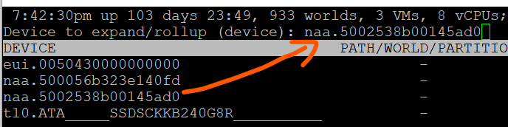

Path is obviously the path name, such as vmhba0:C0:T0:L0.

A disk device can have >1 world, which I’m unsure why. You can see each world ID, and you get the statistics per world.

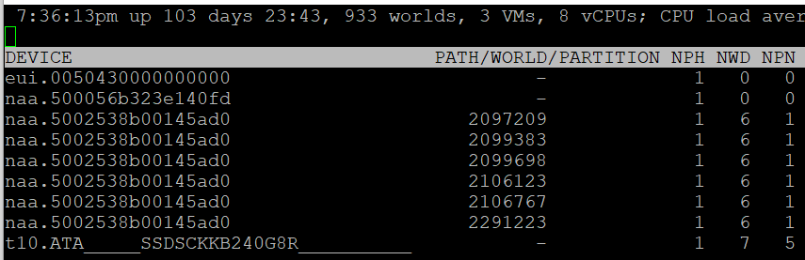

Partition shows the partition ID. Typically this is a simple number, such as 1 for the first partition. vSphere Client provides the following, which is more details yet easier.

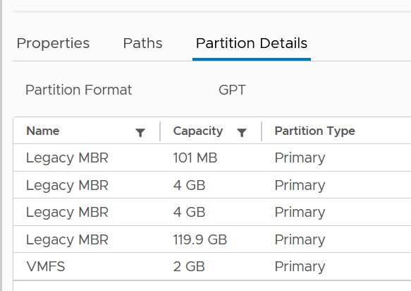

##### Others

Let’s cover the rest of the metrics.

|  |  |
| --- | --- |
| NPH | Number of paths. This should not be 1 as that means a single point of failure. |
| NWD | Number of worlds. If you know the significance of this in troubleshooting, let me know. |
| NPN | Number of partitions. Expect this to be 1 for VMFS |
| SHARES | Number of shares. This statistic is applicable only to worlds.  This is interesting, as that means each world can have their own share? Where do we set them then? |
| BLKSZ | Block size in bytes.  I prefer to call this sector format. International Disk Drive Equipment and Materials Association (IDEMA) increased the sector size from 512 bytes to 4096 bytes (4 KB).  This is important, and you want them to be in 4K ([Advanced Format](https://en.wikipedia.org/wiki/Advanced_Format)) or at least 512e (e stands for emulation). Microsoft provides additional information [here](https://docs.microsoft.com/en-us/troubleshoot/windows-server/backup-and-storage/support-policy-4k-sector-hard-drives). |
| NUMBLKS | Number of blocks of the device. Multiply this with the block size and you get the total capacity. In vSphere UI, you get the capacity, which I think it’s more relevant. |

For configuration, I use vSphere Client as it provides a lot more information, and I can take action on them. The following is just some of the settings available. More at Part 2 Chapter 4 Storage Metrics.

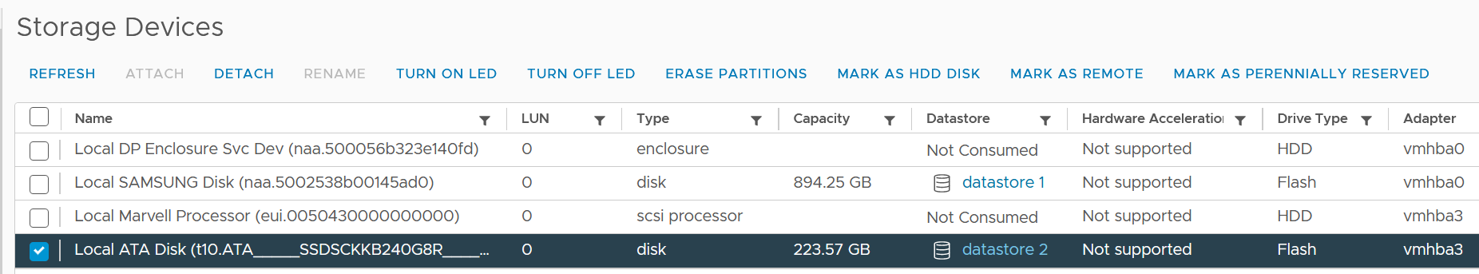

#### VAAI

VMware vSphere Storage APIs - Array Integration ([VAAI](https://docs.vmware.com/en/VMware-Validated-Design/5.0/com.vmware.vvd.sddc-design.doc/GUID-6FE55EFD-6A7D-4A2F-8142-6A88126BB7D6.html)) offloads storage processing to the array, hence improving performance or reducing overhead. This is obviously vendor-dependant. There is no VAAI counter at adapter level or path level, as the implementation is at back-end array.

The VAAI has a lot of metrics. They are grouped into 2 (non latency and latency counters). I find it more logical to group by function, which is also what [this](https://kb.vmware.com/s/article/2065193) KB article does. It’s last updated on 14 May 2017 and does not cover vSphere 7.0, so I’m following up.

As with counters, check for contention type of counters first. There are counters that track failed operations, such as CLONE_F, ATSF and ZERO_F.

I saw this note from VMware vSphere Storage APIs – Array Integration (VAAI) document by Cormac Hogan, which I think it’s worth mentioning. Because the nature of VAAI as an offloads, you will see higher latency value of KAVG metric. Other latency metrics are not affected, so there is no issue unless there are other symptoms present.

At this moment, I have not found the need to document them further. So what you get here is mostly from the KB article above. [Andreas Lesslhumer](https://www.linkedin.com/in/andreas-lesslhumer-2bb2725b/) also has useful information in [this](https://www.running-system.com/esxtop-vaai-counters/) blog article.

##### Extended Copy

Hardware Accelerated Move (the SCSI opcode for XCOPY is 0x83)

|  |  |
| --- | --- |
| Clone_RD | RD stands for reader.  The number of CLONE commands successfully completed where this device was a source.  WR stands for writer.  The number of CLONE commands successfully completed where this device was a destination  The number of failed CLONE commands |
| Clone_WR |
| Clone_F |
| LCLONE_RD | The same set of 3 counters, except for Linked Clone. |
| LCLONE_WR |
| LCLONE_F |
| MBC_RD/s | MBC = megabytes of clone data.  RD/s is read per second, and WR/s is written per second |
| MBC_WR/s |
| AVAG/suc | The average clone latency per successful command  The average clone latency per failed command |
| AVAG/f |

##### Atomic Test & Set

Hardware Accelerated Locking on Single Extent Datastore or on Multi Extent Datastore (SCSI code 0x89)

|  |  |
| --- | --- |
| ATS | The number of Atomic Test & Set (ATS) commands successfully completed |
| ATSF | The number of ATS commands failed. Expect this to be 0? |
| AAVG/suc | The Average ATS latency per successful command |
| AAVG/f | The Average ATS latency per failed command |

##### Write Same

Hardware Accelerated Initialize or Zeroed out blocks (SCSI code 0x93 or 0x41)

|  |  |
| --- | --- |
| ZERO | The number of ZERO commands successfully completed |
| ZERO_F | The number of ZERO commands failed |
| MBZERO/s | The megabytes zeroed per second |
| ZAVG/suc | The average zero latency per successful command |
| ZAVG/f | The average zero latency per failed command |

##### Unmapped

Unmapped block deletion (SCSI code 0x42). We discussed unmapped block (TRIM) in Part 1 Chapter 3 Capacity Management.

|  |  |
| --- | --- |
| DELETE | The number of successful DELETE commands |
| DELETE_F | The number of failed UNMAP commands, this value should be 0 |
| MBDEL/s (MB/s) | The rate at which the DELETE command getting processed. Measured in Megabytes per second |

##### Others

|  |  |
| --- | --- |
| RESSPACE | Reservation Space.  The number of commands which were successful while doing space reservation for a VMDK file in thick Provisioning format.  RESSPACE_F captures the failure. |
| RESSPACE_F |
| EXTSTATS | Extended Statistics  The number of commands which were successful in reporting extended statistics of a clone after the cloning process had been completed.  EXTSTATS_F captures the failure |
| EXTSTATS_Fchapter |
| CAVG/suc | The average clone latency per successful command. Unit is millisecond per clone.  CAVG/f captures the failures. |
| CAVG/f |
| LCAVG/suc | As per above, but for Linked Clone. |
| LCAVG/f |
| RAVG/suc | The average latency (in ms) per successful VAAI Space Reservation command.  RAVG/f captures the failures |
| RAVG/f |
| ESAVG/suc | As per above, but for Extended Statistics |
| ESAVG/f |

### vSAN

I group the vSAN panel under Disk as it only covers storage related information.

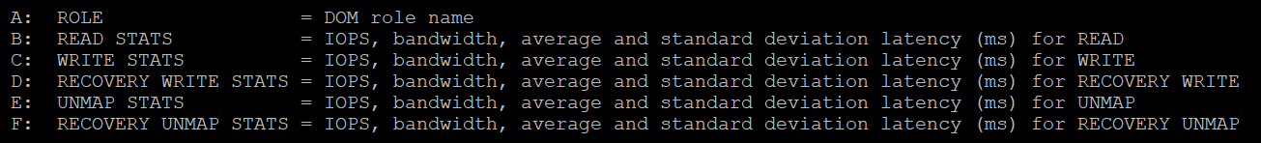

esxtop provides visibility into 5 types of IO operations:

* Read
* Write
* Recovery Write
* Unmap
* Recovery Unmap

For each, it provides the IOPS, bandwidth, average latency (ms) and standard deviation latency (ms). Take note that some use MB, while others use GB.

|  |  |
| --- | --- |
| ROLE | The Distributed Object Manager (DOM) role of that component, such as client, owner, and component manager. |
| READS/s  MBREAD/s  AVGLAT  SDLAT | Reads/second is the number of reads operations. This is IOPS.  MBReads/s is read throughput in Megabytes/second.  AvgLat is the average latency.  Standard deviation of latency, when above 10ms latency. |
| WRITES/s  MBWRITE/s  AVGLAT  SDLAT | Same set of metrics, like above, but for write |
| RECOWR/s  MBRECOWR/s  AVGLAT  SDLAT | Same set of metrics, like above, but for Recovery Write. Recovery covers component rebuild task (e.g. from disk failure).  Read the string MBRECOWR as MB Reco Wr. |
| UNMAPS/s  GBUNMAP/s  AVGLAT  SDLAT | Same set of metrics, like above, but for unmap operations. I think this number should be within your expectation, as excessive unmap can impact performance.  GBUNMAP/s = Unmapped rates in Gigabytes/second  Read the string GBUNMAP as GB Unmap |
| RECOUN/s  GBRECOUN/s  AVGLAT  SDLAT | Same set of metrics, but for Recovery Unmap operations.  Read the string GBRECOUN as GB Reco Un.  RecoUn/s is the number of recovery unmapped operations per second.  GBRecoUn/s is the amount of disk space in GB/second by Recovery Unmapped. |

Chapter 5

# Network

## Why Network Monitoring is Unique

Network monitoring is complex, especially in large data centers. Adding network virtualization takes the complexity of performance troubleshooting even higher.

Just like CPU, Memory and Disk, there is also a new layer introduced by virtualization. There are virtual network cards on each VM, and software-based switch on each ESXi bridging the VM card to the physical NIC card. The various ESXi VMkernel modules also do not “talk” directly to the physical card. Basically, what used to be the top of rack switch are now living inside each ESXi as an independent switch.

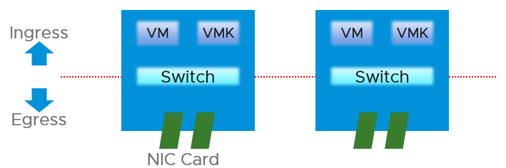

From performance and capacity management point of view, network has different fundamental characteristics to compute or storage. The key differences are summarized below.

|  |  |  |
| --- | --- | --- |
|  | Compute or Storage | Network |
| Net available resource to VM | Relatively high | Low |
| Resource allocation at VM level | Granular | Coarse |
| Hardware | Single purpose | Multi-purpose |
| Nature | A node | An interconnect |
| Upper Limit | Yes | No |
| Monitoring | Simpler | Harder |
| Location | Fewer | Many |

Let’s explain the above in more detail.

### Net Available Resource

At the end of the day, the net available resources to the VMs are what we care about. What the IaaS platform used is considered an overhead. The more ESXi VMkernel, NSX, vSAN, vSphere Replication use, the lesser you have left for the business workload.

An ESXi host has a fixed specification (for example, 2 CPUs, 60 cores, 512 GB RAM, 2 x 25 GE NIC). This means we know the upper physical limit. How much of that it available to the VMs? Another word, what is the usable capacity for the business workload?

For compute, the hypervisor consumes a relatively low proportion of resources. Even if you add a software-defined storage such as vSAN, you are looking at around 10% total utilization but depends on many factors.

The same cannot be said about network. Mass vMotion (for example, when the host enters maintenance mode), storage vMotion (in IP storage case), VM provisioning or cloning (for IP storage), and vSAN all take up significant network bandwidth. In fact, the non-VM network takes up the majority of the ESXi resources. If you have 2 x 25 GE NIC, majority of it is *not* used by VM. The following screenshot shows that VM only gets 100 shares out of 500 shares. So the overhead can be as high as 80%!



### Allocated Resource

This means the resource that is given to a single VM itself. For compute, we can configure a granular size of CPU and RAM. For the CPU, we can assign one, two, three, four, etc. vCPUs.

With network, we cannot specify the vNIC speed. It takes the speed of the ESXi vmnic assigned to the VM port group. So each VM will either see 1 GE or 10 GE or 25 GE (you need to have the right vNIC driver, obviously). You cannot allocate another amount, such as 500 Mbps or 250 Mbps in the Guest OS. In the physical world, we tend to assume that each server has 10 GE and the network has sufficient bandwidth. You cannot assume this in a virtual data center as you no longer have 10 GE for every VM at the physical level. It is shared and typically oversubscribed.

A network intensive VM can easily hit 1 Gbps for both egress and ingress traffic. The following chart shows a Hadoop worker node receiving more than 5 Gbps worth traffic multiple times. You need to be careful in sizing the underlying ESXi if you want to run multiple VMs. While you can use Network I/O Control and vSphere Traffic Shaping, they are not configuration property of a VM.



### Hardware

The networking hardware itself can provide different functionalities.

For compute, you have servers. While they may have different form factors or specifications, they all serve the same purpose—to provide processing power and a set of working memory for hypervisor or VM.

For network, you have a variety of network services (firewall and load balancer) in addition to the basic network functionalities (switch, router, and gateway). You need to monitor all of them to get a complete picture. These functionalities can take the form of software or hardware.

Unlike storage, network has concept of duplex. A full duplex means it has 100% on both direction. For example, an ESXi with a 25 Gb port can theoretically handle 25 Gb TX + 25 Gb RX as its [full duplex](https://en.wikipedia.org/wiki/Duplex_(telecommunications)).

Blade servers and other HCI form factors blur the line between server and network.

### Nature of Network

The fourth difference is the nature of network. Compute and storage are nodes. When you have a CPU or RAM performance issue on one host, it doesn't typically impact another host on a different cluster. The same thing happens with storage. When a physical array has a performance issue, generally speaking it does not impact other arrays in the data center.

Network is different. A local performance issue can easily be a data center-wide problem. Here is a good [read](https://blog.ipspace.net/2019/05/real-life-data-center-meltdown.html) by shared [Ivan Pepelnjak](https://www.ipspace.net/About_Ivan_Pepelnjak). To give a recent example (H2 2021), here is one from a world-class network operator[14]:

[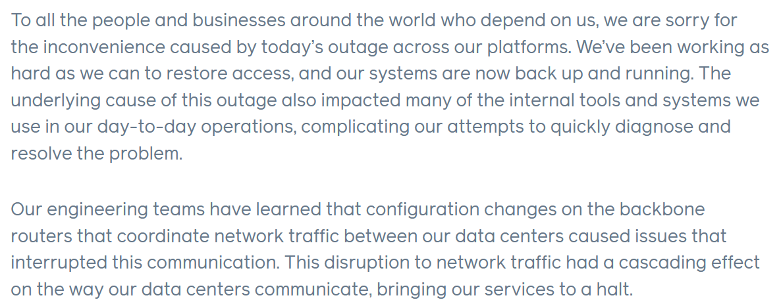](https://engineering.fb.com/2021/10/04/networking-traffic/outage/)

Being an interconnect, it also connects users and servers to the Internet. If you have a global operation, you likely have multiple entry points, provided by different providers. These connectivity needs to be secured and protected with HA, preferably from 2 different ISPs.

There are typically many paths and routes in your network. You need to ensure they are available by testing the connectivity from specific points.

### Upper Limit

CPU or RAM workload have a per VM physical limit. This makes capacity management possible, and aids in performance troubleshooting.

While network has a physical limit, it can be misleading to assume it is available to all VMs all the time. Because the physical capacity of the network is shared, you have a dynamic upper limit for each workload. The VM Network port group will have more bandwidth when there is no vMotion happening. Furthermore, each VM has a dynamic upper limit as it shares the VM Network port group with other VMs.

The resource available to VM also varies from host to host. Within the same host, the limit changes as time progresses. Unlike Storage I/O Control, Network I/O Control does not provide any counters that tell you that it has capped the bandwidth.

In many situations, the bandwidth within the ESXi host may not be the smallest pipe between the originating VM and its destination. Within the data center, there could be firewalls, load balancers, routers, and other hops that the packet has to go through. Once it leaves the data center, the WAN and Internet are likely to be a bottleneck. This dynamic nature means every VM has its own practical limit.

### Monitoring and Troubleshooting

A distributed system is harder to monitor than a single node, especially if workload varies among the components that make up the system.

The network resource available to VM also varies from host to host. Within the same host, the limit changes as time progresses. Unlike Storage I/O Control, Network I/O Control (NIOC)ndoes not provide any counters that tell you that it has capped the bandwidth.

NIOC can help to limit the network throughput for a particular workload or VM. If you are using 10 GE, enable NIOC so that a burst in one network workload does not impact your VM. For example, a mass vMotion operation can saturate the 10 Gb link if you do not implement NIOC. In vCenter 7, there is no counter that tracks when NIOC caps the network throughput. As a result, vRealize Operations will not tell you that NIOC has taken action.

The primary contention counters are

* Latency.
* Dropped Packets
* Retransmit Packets. For TCP, dropped packets will be retransmitted.
* Jitter. This measures the inconsistency of the latency. An application may tolerate poor latency better than variable latency.

Note there is no latency and retransmit metrics in vSphere.

### Location

Server and storage tend to be located fewer places. Even in the [ROBO](https://www.vmware.com/asean/products/vsphere/remote-office-branch-office.html) office, they are typically located in a rack, with proper cooling and physical security. Network switch, especially Wireless Access Points, need to be placed in multiple places within the building, if that’s required to provide enough network coverage.

Solution such as SDWAN even requires a network device to be deployed at employee home. I actually have the Dell edge device at my home.

### Conclusion

Because of all these differences, the way you *approach* network monitoring should also be different. If you are not the network expert in your data center, the first step is to partner with experts.

BTW, there are other things which I did not cover. For example, in network there are basic services such as DNS and NTP. All these services need to be monitored, typically for availability and reliability.

## SDDC Network Monitoring

The arrival of software-defined infrastructure services also changes the way you monitor your network. The following diagram shows a simplified setup of an ESXi host.

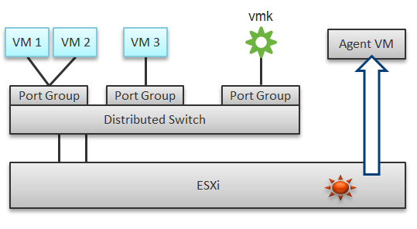

In a single ESXi host, there are 4 areas that need to be monitored for a complete network monitoring:

* VM network
* VMkernel network
* ESXi kernel modules
* Agent VMs

In the preceding example, we have 3 VMs running in the host. VM 1 and VM 2 are connected to the same VXLAN (or VLAN). VM 3 is on a different VXLAN (or VLAN), hence it is on a different port group. Monitoring at port group level complements monitoring at VM level and ESXi level.

Traffic at Distributed Switch level carries more than VM traffic. It also carries VMkernel traffic, such as vMotion and VSAN. Both VMkernel network and VM network tend to share the same physical uplinks (ESXi vmnic). As a result, it’s easier to monitor at port group level.

Sounds good so far. What is the limitation of monitoring at distributed port group level?

The hint is at the word **distributed**.

Yes, the data is the aggregate of all the ESXi hosts using that distributed port group!

By default, VM 1 and VM 2 can talk to each other. The traffic will not leave the ESXi. Network monitoring tools that are not aware of this will miss it. Traffic from VM 3 can also reach VM 1 or VM 2 if NSX Distributed Logical Router is in place. It is a VMkernel module, just like the NSX Distributed Firewall. As a result, monitoring these kernel modules, and the host overall performance, becomes an integral part of network monitoring.

The 4th area we need to monitor is Agent VM. An Agent VM is mapped to 1 ESXi Host. It does not need HA protection as every ESXi host has one, hence it typically resides on the host local datastore.

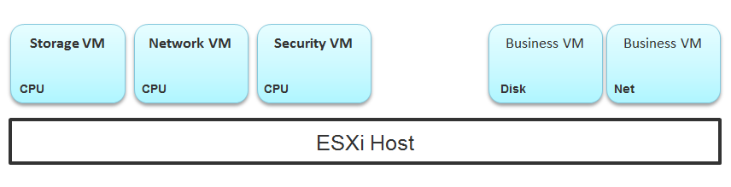

The above example shows an ESXi host with 3 agent VMs. The first VM provides a storage service (an example is Nutanix CVM), the second VM provides Network service, and the 3rd VM provides a Security VM.

Let’s use the Security service as an example. A popular example here is Trend Micro Deep Security virtual appliance. It is in the data path. If the Business VMs are accessing files on a fileserver on another network, the files have to be checked by the security virtual appliance first. If the agent VM is slow (and it could be due to factor that is not network related), it will look like a network or storage issue as far as the business VMs are concerned. The Business VMs do not know that their files have been intercepted for security clearance, as it is not done at the network level. It is done at the hypervisor level.

### Source of Data

A complete network monitoring requires you to get the data from 5 different sources, not just from vSphere. In SDDC, you should also get data from the application, Guest OS, NSX and NetFlow/sFlow/IPFIX from VDS and physical network devices. For VDI, you need to get data at application level. We have seen packet loss at application-layer (Horizon Blast protocol) when Windows sees no dropped packet. The reason was the packet arrives out of order and hence unusable from protocol viewpoint.

The following shows a simplified stack. It shows the five sources of data and the 4 tools to get the data. It includes a physical switch as we can no longer ignore physical network once you move from just vSphere to complete SDDC.

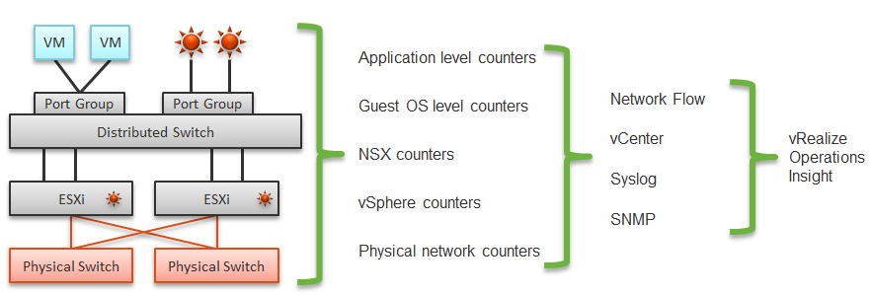

The network packet analysis comes in 2 main approaches: Header analysis and full packet analysis. The header analysis is certainly much lighter but lack the depth of full analysis. You use this to provide overall visibility as it does not impose heavy load on your environment.

The impact of virtualization on network monitoring goes beyond what we have covered. Let’s add NSX Edge into the above, so you can see the traffic flow when the edge services are also virtualized. You will see that a network problem experienced by a VM on one ESXi could be caused by another VM running on another ESXi. The following diagram is a simplified setup, showing a single NSX Edge residing on another cluster.

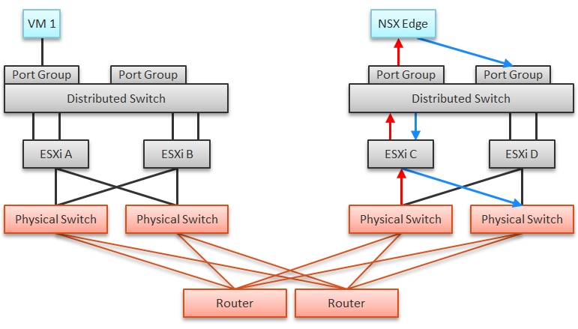

In the above example, let’s say VM 1 needs to talk to outside world. An NSX Edge VM provides that connectivity, so every TCP/IP packet has to go through it. The Edge VM has 2 virtual NICs, one for each network. If the NSX Edge VM has CPU issue, or the underlying ESXi has RAM issue, it can impact the network performance of VM 1.

### Traffic Type

Majority of traffic should be unicast, as ESXi or VM should not be broadcasting to all IP addresses in the network or multicasting to many destination.

vRealize Operations provides these counters at VM, ESXi, Distributed Port Group and Distributed Switch level. As vSphere Tanzu Pod is basically a VM, it also has the metric.

BTW, one way to check what objects in what adapter have the specific metric is in the vRealize Operations policy. Open any policy, and search the metric using its name. The list of matching metrics will be shown, grouped by the objects.

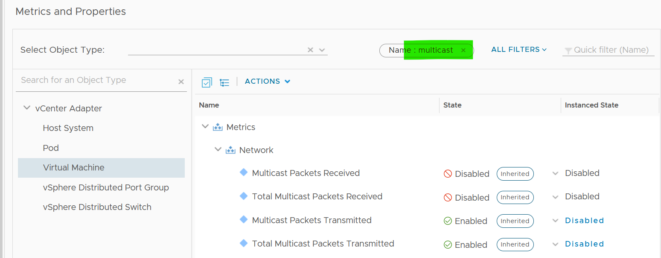

As you can see from above, there is no aggregation at higher level, so create super metric for the time being. I have not created those metric out of the box as I’m yet to use them in dashboard or alert.

#### Packet Size

It’s typically 1500 byte, or 9000 bytes if you enable [jumbo frames](https://en.wikipedia.org/wiki/Jumbo_frame)). Special purpose packet such as [ping](https://en.wikipedia.org/wiki/Ping_(networking_utility)) test is smaller. But they should be a small percentage of your network.

### NSX Edge

You may be wondering if an Edge VM does a lot of processing. Let’s look at a real example. How much traffic do you think this Edge VM is doing? The number is kilobytes not kilobit, so don’t forget to multiply by 8.

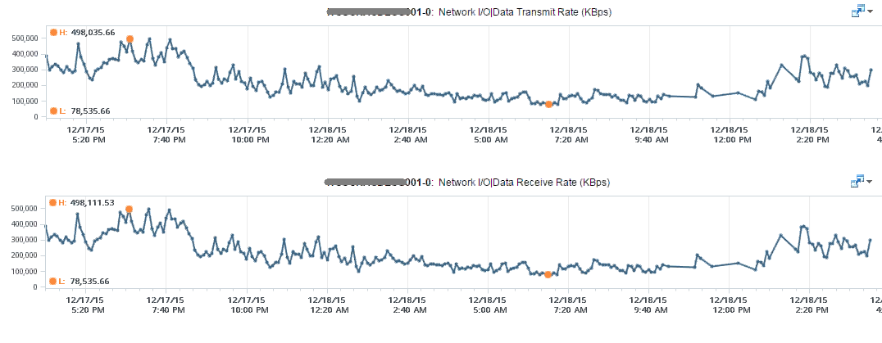

At near 1 million KBps, the application VM is processing a total of 8 Gbps worth of data on both network cards, 4 Gbps incoming from one vNIC and 4 Gbps outgoing on another vNIC at the same time. This number is the sum of Receive and Transmit, so the theoretical limit is 20 Gbps as this VM uses a 10 Gbps NIC. Notice the pattern for both Receive and Transmit is identical, as NSX Edge is practically a gateway.

This NSX Edge happens to be the only VM on a host. This means we can expect the data at the Host level to mimic that. The host does not run distributed storage (e.g. VSAN) so there is no other traffic other than this VM. The following chart below confirms that.

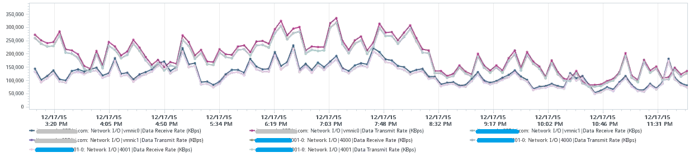

There are practically 2 lines, even though we actually plot 8 line charts. What do the 2 lines map to?

Yes, they map to North-South traffic and South-North traffic. An end user requesting data from a web server would be South to North, while the web server response would be North to South.

“Wait!” you might say. There should only 4 lines. Why do we have 8 lines?

Can you figure it out from the following diagram?

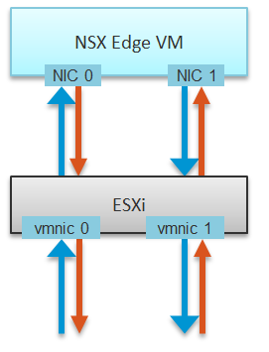

The above 8 arrows map to the 8 lines. There is 1 line chart for every arrow. There are 4 NICs, and each has Receive and Transmit.

If you use NSX, there is a good chance that you will have multiple NSX Edge VMs. We have a customer with >100 VMs. On the same host, you may also run distributed storage (e.g. VSAN) as an Edge cluster is typically isolated. We have customers with multiple Edge VMs, and monitoring the health of these Edge VMs becomes an integral part of network monitoring.

Good network management is about understanding the application. In a way, we should treat VMware Cloud Foundation as an application. There are now two layers of applications in SDDC:

* Infrastructure applications (e.g. vSAN, NSX, F5, Trend Micro)
* Business Applications (e.g. your company intranet, database, web server)

This is consistent with the fact that you will have two layers of network, when the network is virtualized. You will use VXLAN for your VM and VLAN for your infrastructure.

## Guest OS

Understanding network counter at Guest OS level is important as the data inside the guest provides better visibility.

### Windows

Windows provides visibility at multiple levels. It provides a good set of metrics at each of these levels:

* adapter
* interface
* process
* TCP connection

The following screenshot from Performance Monitor shows some of the metrics at Network Adapter and Network Interface

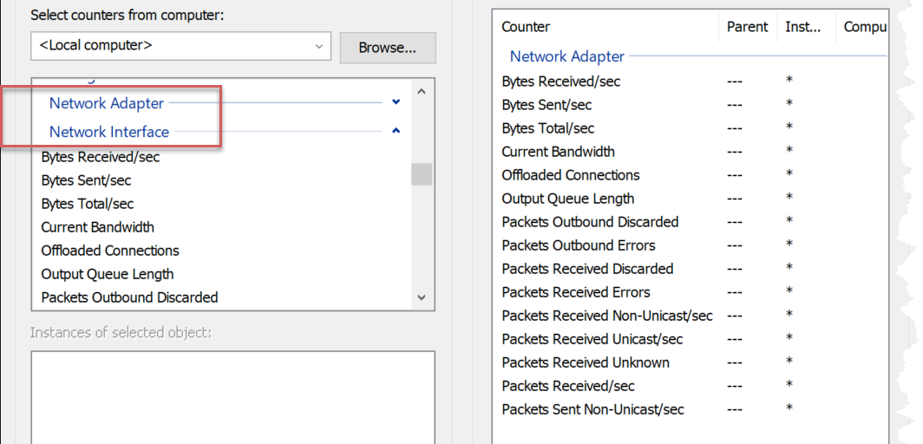

|  |  |
| --- | --- |
| Packets Received Errors | Expect these to be 0 at all times? |
| Packets Outbound Errors |
| Packets Received Discarded | For example, they arrive out of order hence can’t be used. |
| Packets Outbound Discarded |
| Offloaded Connections |  |
| Output Queue Length | It measures the length of the output packet queue, in packets.  Windows manual states that saturation exists if this value is >2. If you know why the queue length is low, let me know. |
| Current Bandwidth |  |
| Bytes Received/sec | It measures the rate at which bytes are sent and received over each network adapter, including framing characters.  Windows manual in this [link](https://docs.microsoft.com/en-us/learn/modules/monitor-windows-server-performance/2-use-performance-monitor-to-identify-performance-problems) states that the network is saturated if >70% utilization. I think this is on the low side, and I’d like to see proof of saturation (e.g. dropped packet, retransmit) |
| Bytes Sent/sec |
| Bytes Total/sec |
| % Usage |  |
| % Usage Peak |
| Packets Received Non-unicast/sec | Take note that there is no unknown packet sent, because all packets sent are of known type. |
| Packets Received Unicast/sec |
| Packets Received Unknown |
| Packets Received/sec |
| Packets Sent Non-unicast/sec | Interesting to see that Windows also has unknown-type packet. ESXi VMkernel, being an OS, also has this unknown packet. |
| Packets Sent Unicast/sec |
| Packets Sent/sec |
| Packets/sec | This can be an important counter as t |
| Paging File |  |

The following screenshot shows Windows 10 Resource Monitor. You will notice quickly that a lot of this information is not available at the hypervisor layer. The VM does not report process level information. Looking at the columns in the table, what critical counters are missing at the VM layer?

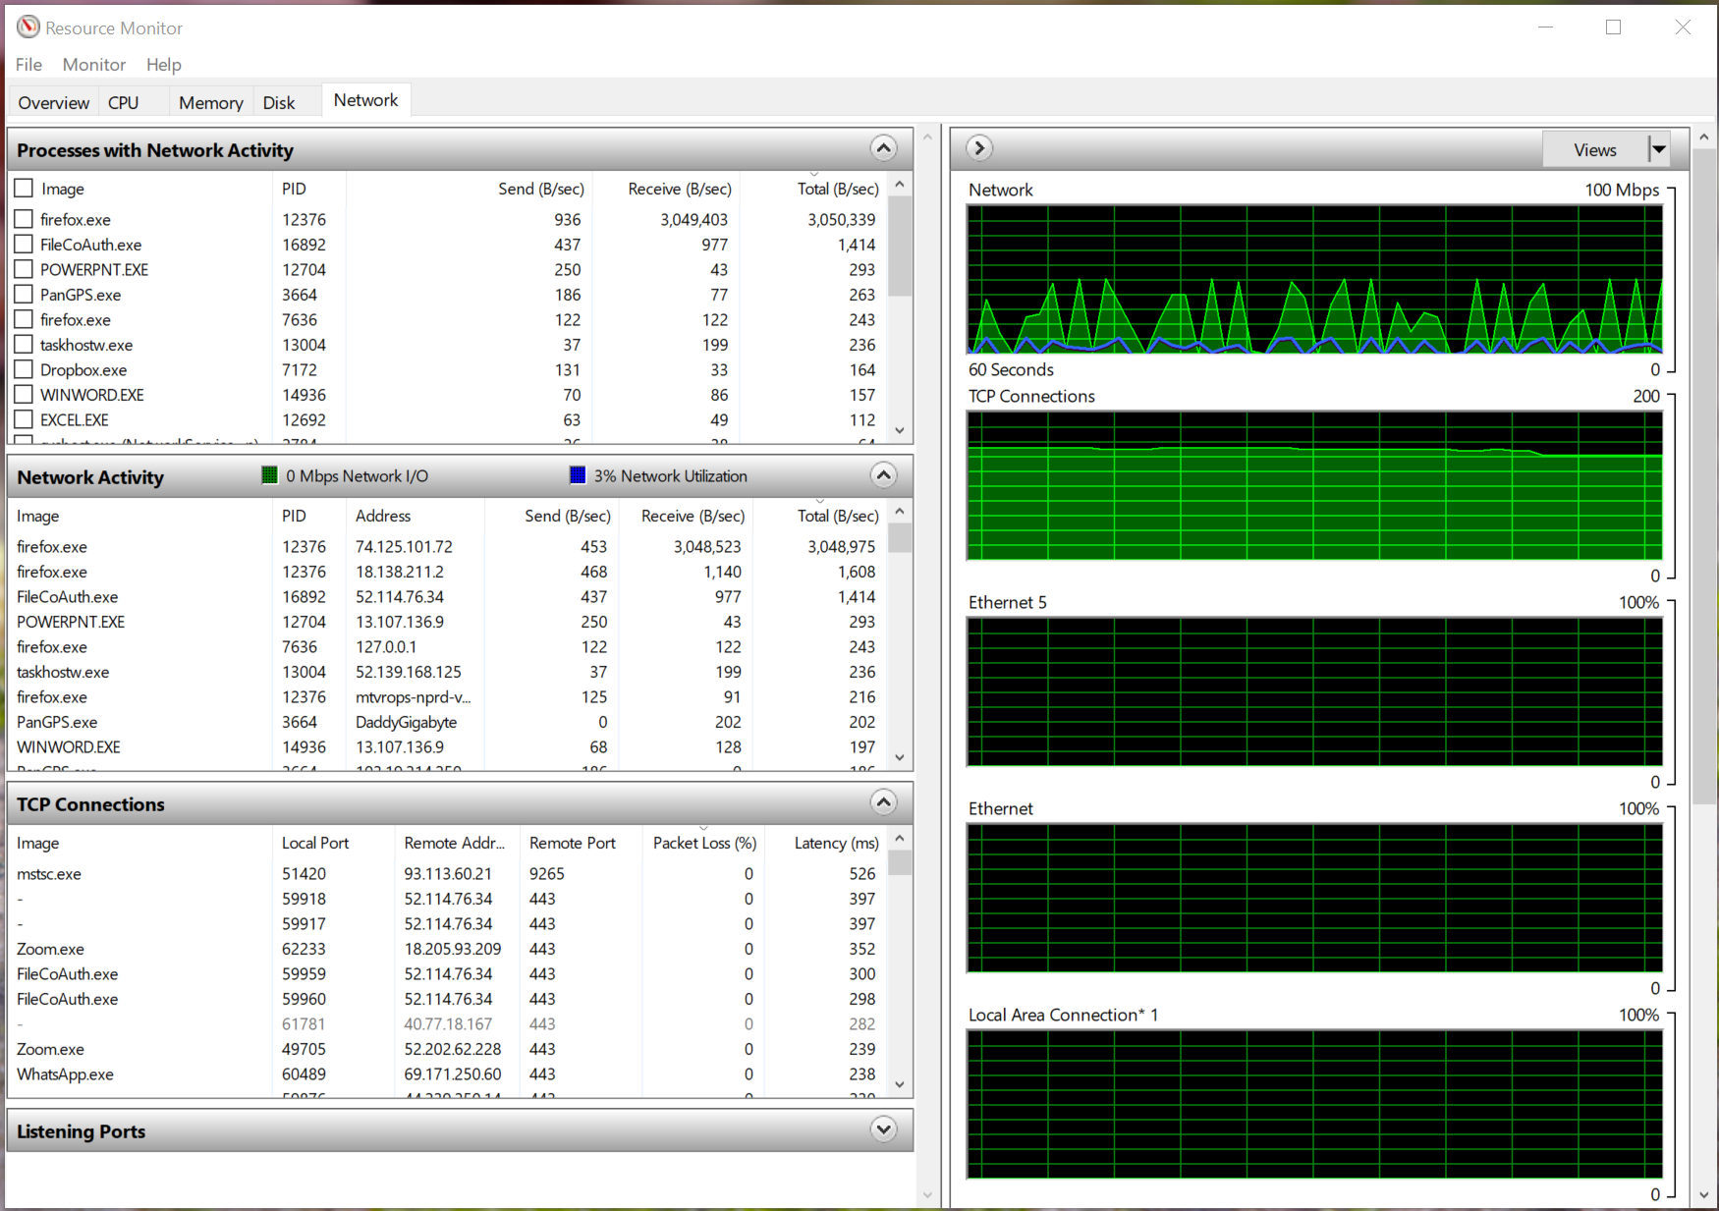

Windows reports the packet loss (%) and latency (ms) counters per TCP connections. This is crucial in troubleshooting at application level. Unfortunately, Windows does not report the overall latency and overall packet loss.

Take note that Windows mixes bit and byte, which it should not. The chart is showing in bit, while the table is showing in byte.

Another counter that could be potentially useful is Output Queue Length. You can monitor it on a per network adapter basis, as shown in the Performance Monitor screenshot below. I said it could be useful, because unfortunately the value is always 0. As you can see in the screenshot, Windows 10 states that “since the requests are queued by the Network Driver Interface Specification (NDIS) in this implementation, this will always be 0. “

### Linux

[Heinrich Hartmann](https://www.circonus.com/author/heinrich-hartmann/) shared in [this article](https://www.circonus.com/2017/08/system-monitoring-with-the-use-dashboard) that we need to be careful with the accuracy of the networking metrics in Linux. Being familiar with Solaris kernel and ESXi VMkernel, I agree with him that Linux kernel is a big world, and some parts of the codes that produces the metrics aren’t well documented. The article further points to the work of [Joe Damato](https://blog.packagecloud.io/author/joe-damato), which explains complications such as how [ethtool](https://en.wikipedia.org/wiki/Ethtool) is not implemented consistently by networking drivers. Joe also shares how Linux networking works [here](https://blog.packagecloud.io/illustrated-guide-monitoring-tuning-linux-networking-stack-receiving-data/).

## VM

VM is not an Operating System, so it has far less networking metric than Windows or Linux.

We will cover each metric in-depth, so let’s do an overview first.

As usual, we start with contention. There is no latency metric

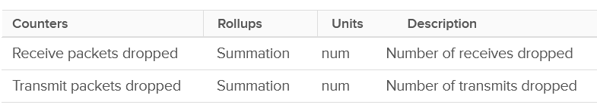

Next, you check if there are unusual traffic. Your network should be mostly unicast, so it’s good to track the broadcast and multicast packets. They might explain why you have many dropped packets.

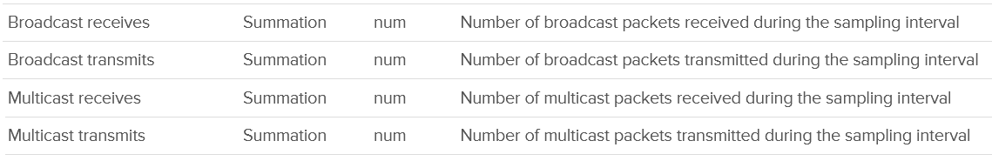

Next you check utilization. There are 6 counters, but I think they are triplicate.

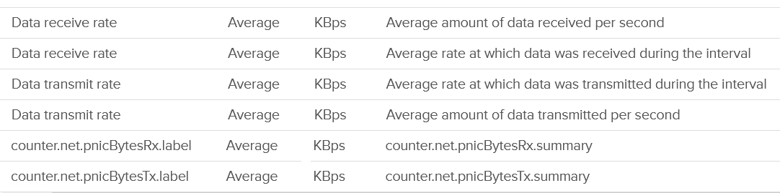

There are 2 main counters to measure utilization: throughput and packets.

Both matter as you may still have bandwidth but unable to process that many packets per second. [This outage](https://communities.vmware.com/t5/VMware-vSphere-Discussions/Limit-on-network-packets-per-second-for-VMs/td-p/2312644) shows 700K packets per second that only consumes 800 Mbps as the packet is small. The broadcast packet is only 60 bytes long, instead of the usual 1500 bytes.

Each packet takes up CPU for processing, so it’s good to check if the packet per second becomes too high



The counters are available at each individual vNIC level and at the VM level. Most VMs should only have 1 vNIC, so the data at VM level and vNIC level will be identical.

The vNICs are named using the convention "400x". That means the first vNIC is 4000, the second vNIC is 4001, and so on. The following is a vCenter VM. Notice it receives a few broadcast packets, but it’s not broadcasting (which is what you expect). It also does not participate in multicast, which is again expected.

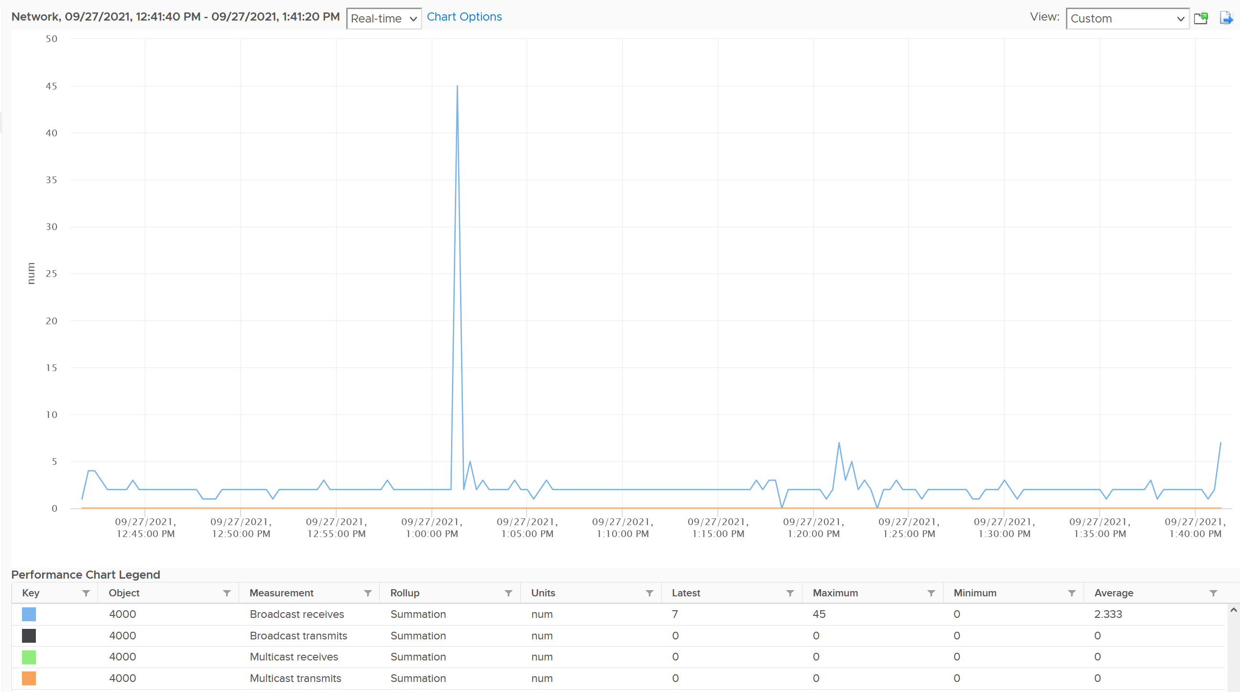

The counters are grouped into 2:

* Transmit for outgoing
* Receive for incoming.

For each group, the following counters are provided:

|  |  |
| --- | --- |
| Broadcast packets | Count of packets.  It is the sum during the sampling window, not the rate (which is packet/second).  Multicast packet and broadcast packet are listed separately. This is handy as they are supposed to low for most VM. Understand the nature of the applications so you can check if the behaviour is normal or not. |
| Multicast packets |
| Packet dropped |
| Total packets | The total includes the broadcast and multicast, but not the dropped ones. |
| Throughput per second | This is measured in kilobyte, as packet length is typically measured in bytes. While there are other packet size, the standard packet is 1500 bytes.  BTW, esxtop measures in megabit.  I assume this includes broadcast and multicast, but not the dropped packet. |

Guess what counters are missing?

* Retransmit. This can be useful in troubleshooting TCP packet. It naturally does not apply to UDP traffic.
* Latency. A normalized latency would help, especially if it’s broken into internal network and external network. Network latency could be impacted by CPU. CPU might not fast enough to process the packet. In VM, this could also be due to the VM having CPU contention.
* Packets per second. This can be derived by packet count / sampling window. If you have 200 packets in 20 seconds, that means 10 packets per second.
* Packet size. This can be computed by throughput / packet count. Expect this to be around 1500 byte.

BTW, if you see a pair of metric with identical name, but one of them is prefixed with “Total”, avoid the one without Total. They are averaged over 15 data points, so their value is 15x lower.

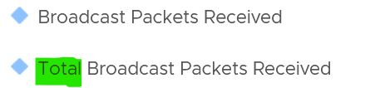

### Dropped Packet

As usual, let’s approach the counters starting with Contention. There are no latency counter nor retransmit counter so you cannot track how long it takes for a packet to reach its destination. There are, however, counters that track packet loss.

For TCP connection, dropped packet needs to be retransmitted and therefore increases network latency from application point of view. The counter will not match the values from Guest OS level as packets are dropped before it’s handed into Guest OS, or after it left the Guest OS. ESXi dropped the packet because it’s not for the Guest OS or it violates the security setting you set.

The following summary proves that receive packet gets dropped many more times than transmit packet. This is based on 3938 VMs. Each shows the last 1 month, so approximately 35 million data points in total. The average of 35 million data points show that dropped RX is significantly higher than dropped TX. This is why it’s not in the SLA.

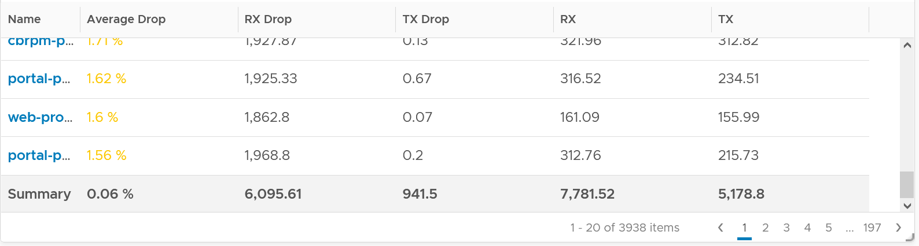

The following table shows that the drop is short and spiky, which is a good thing. The value at 99th percentile is 35x smaller than the value at 100th percentile.

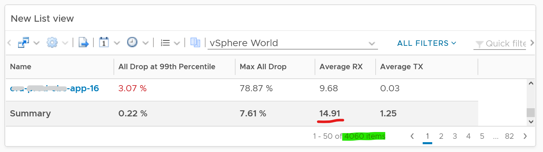

The high value in receive can impact the overall packet dropped (%) counter, as it’s based on the following formula

dropped = Network|Received Packets Dropped + Network|Transmitted Packets Dropped

total = Network|Packets Received + Network|Packets Transmitted

Network|Packets Dropped (%) = dropped / total * 100

I’ve seen multiple occurrences where the packet dropped (%) jumps to well over 95%. That’s naturally worrying. They typically do not last beyond 15 minutes.

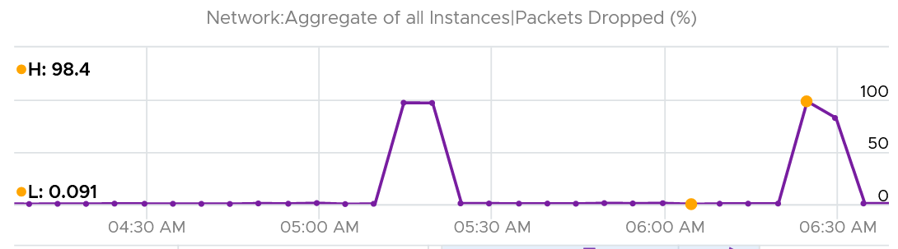

In this, plot the following 4 metrics. You will likely notice that the high spike is driven by *low* network throughput and *high* received packet dropped.

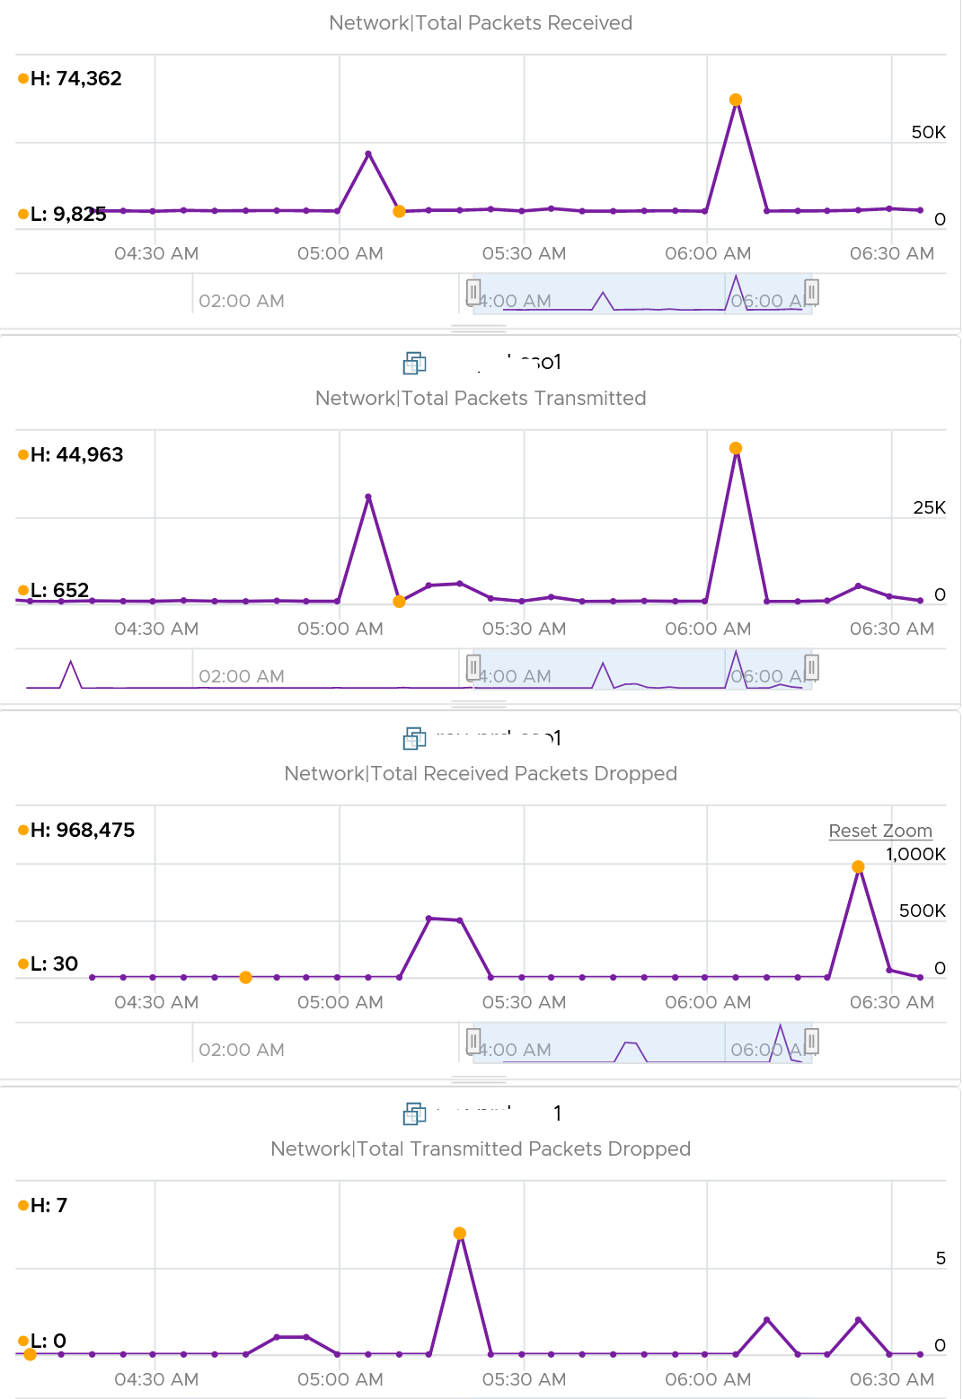

Because of the above problem, profile your VM dropped packets, focusing on the transmit packets. I notice in several customers production environment they exist, yet no one seem to complain. The following is one way to do it, giving surprising results like this:

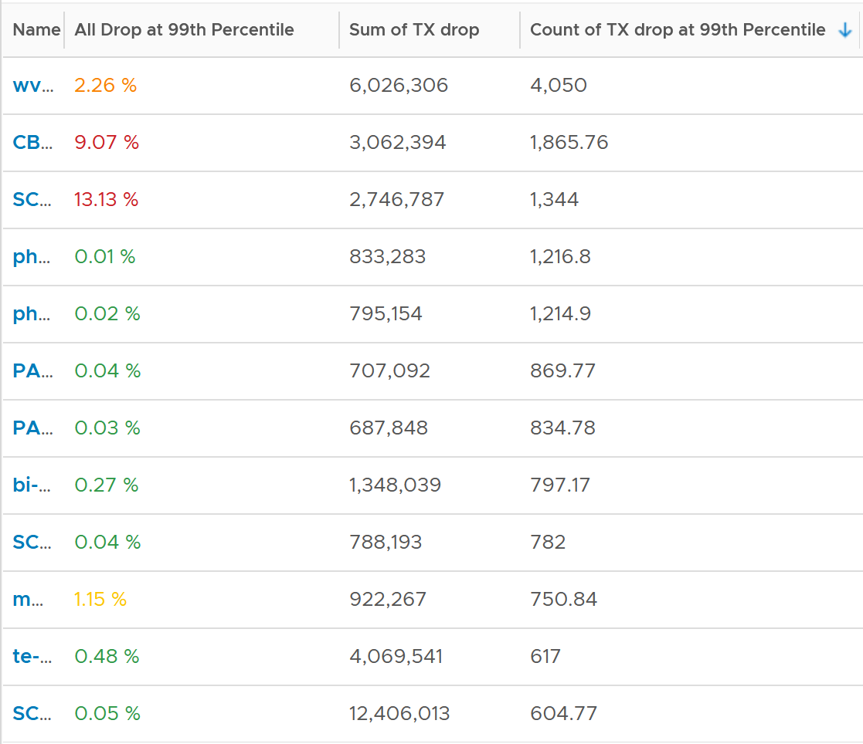

The design of the preceding table is:

* First column calculates the percentage packets dropped. I took 99th percentile else many of the results will be 100%.
* Second column sums all the transmitted dropped packets (actual packet counts).
* Third column takes the 99th percentile maximum of dropped packet within any 300 seconds. Each network packet is typically 1500 bytes. Using 1.5 KB packet size, 1 thousand packets dropped = 1500 MB worth of packets within 300 seconds.

I don’t expect dropped packets in data center network, so to see millions of dropped packets over a month needs further investigation with network team. More over, those counters are Transmit, not Received. So the VM sent them but they got dropped.

What I typically notice is the spike rarely happens. They look like an outlier, especially when the number is very high. The following is an example. I only showed in the last 1 month as the rest of the 6 months had similar pattern. The jump is well cover 100 millions packets, and they were all dropped. Assuming each packet is 1 KB, since vRealize Operations reports every 5 minutes, that’s 333 MB per second sustained for 300 seconds.

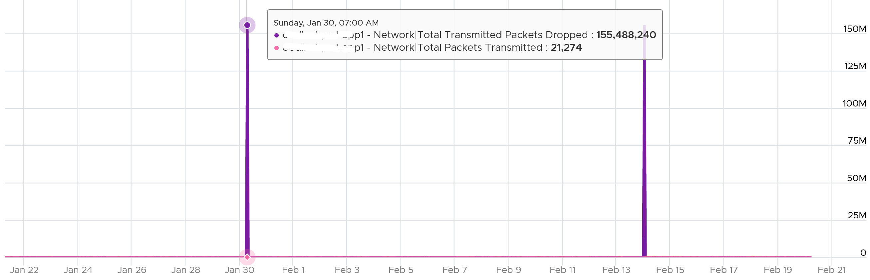

I also notice regular, predictable pattern like this. This is worth discussing with network team. It’s around 3800 packets each 5-minute, so it’s worth finding out.

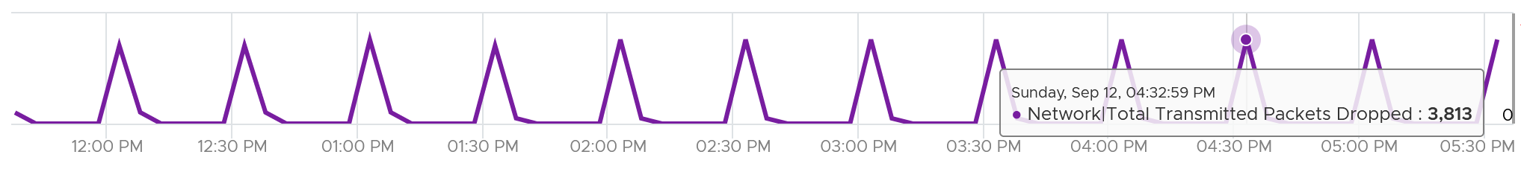

## ESXi Host

Just like the case for CPU, memory and disk, there are also 2 layers of networking. vSphere Client shows the 2 layers side by side (personally I prefer up and down, with the physical layer placed below).

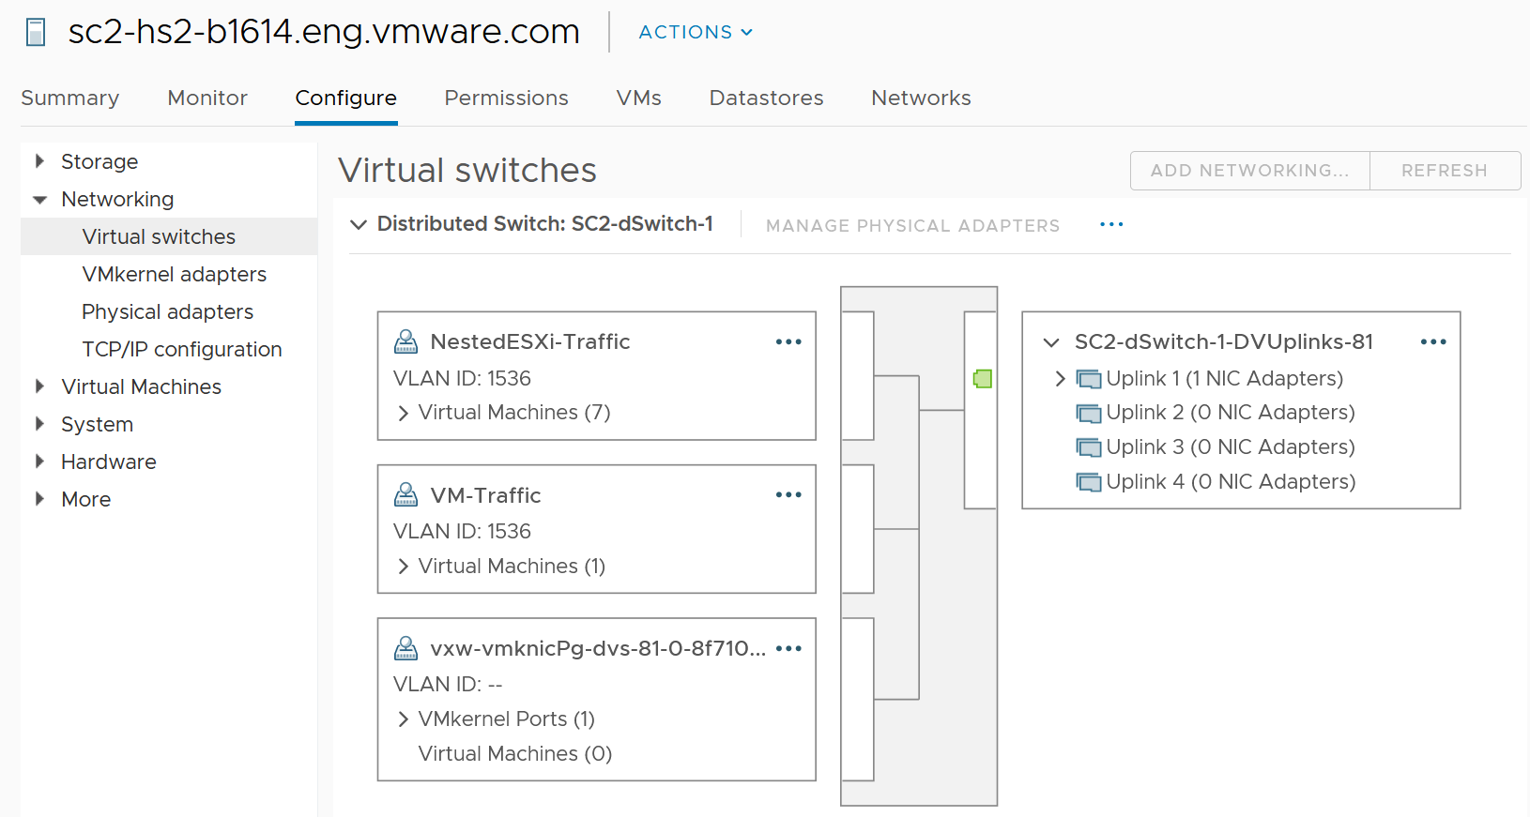

The 2 layers are the physical network and the virtual network:

* Virtual is the port groups.   
  There are 2 types: VMkernel and VM.   
  They do not mix, for security reason.  
  The VMkernel port group runs specific traffic, such as vMotion and vSAN.  
  The VM port group runs VM.
* Physical is the physical network card, although they are called vmnic. Metrics at this level do not have per-VM breakdown, or per VMkernel interface breakdown.

In vSphere Client, you can’t see the virtual network traffic. The following shows that you can only see the physical network card.

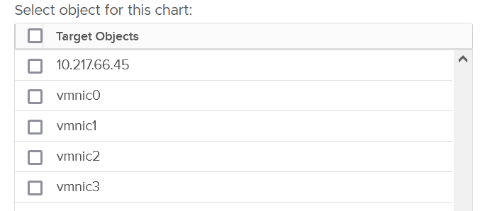

The counters are provided at both physical NIC card and ESXi level. The counter at host level is basically the sum of all the vmnic instances. There could be small variance, which should be negligible.

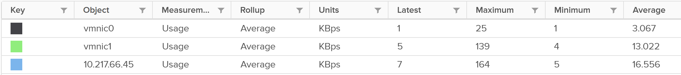

### Bad Packets

As usual, the first thing to check if there is anything wrong. Compare with VM counters, vCenter UI provides three additional counters for ESXi. It can track Packet receive errors, Packet transmit errors, and Unknown protocol frames.

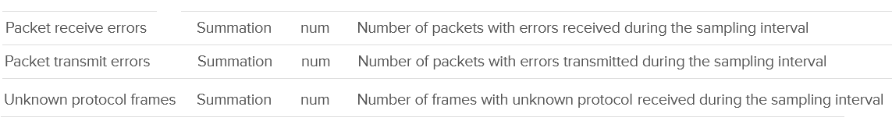

A packet is considered unknown if ESXi is unable to decode it and hence does not know what type of packet it is. You need to enable this metric in vRealize Operations as it’s disabled by default.

Expect these error packets, unknown packets and dropped packets to be 0 at all times. The following shows from a single ESX:

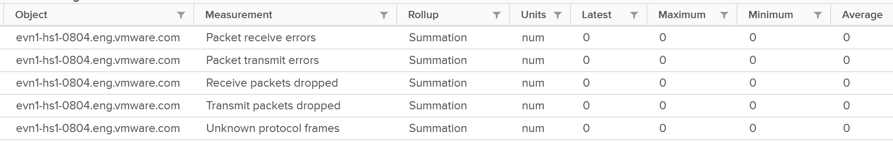

To see from all your ESXi, use the view “vSphere \ ESXi Bad Network Packets”.

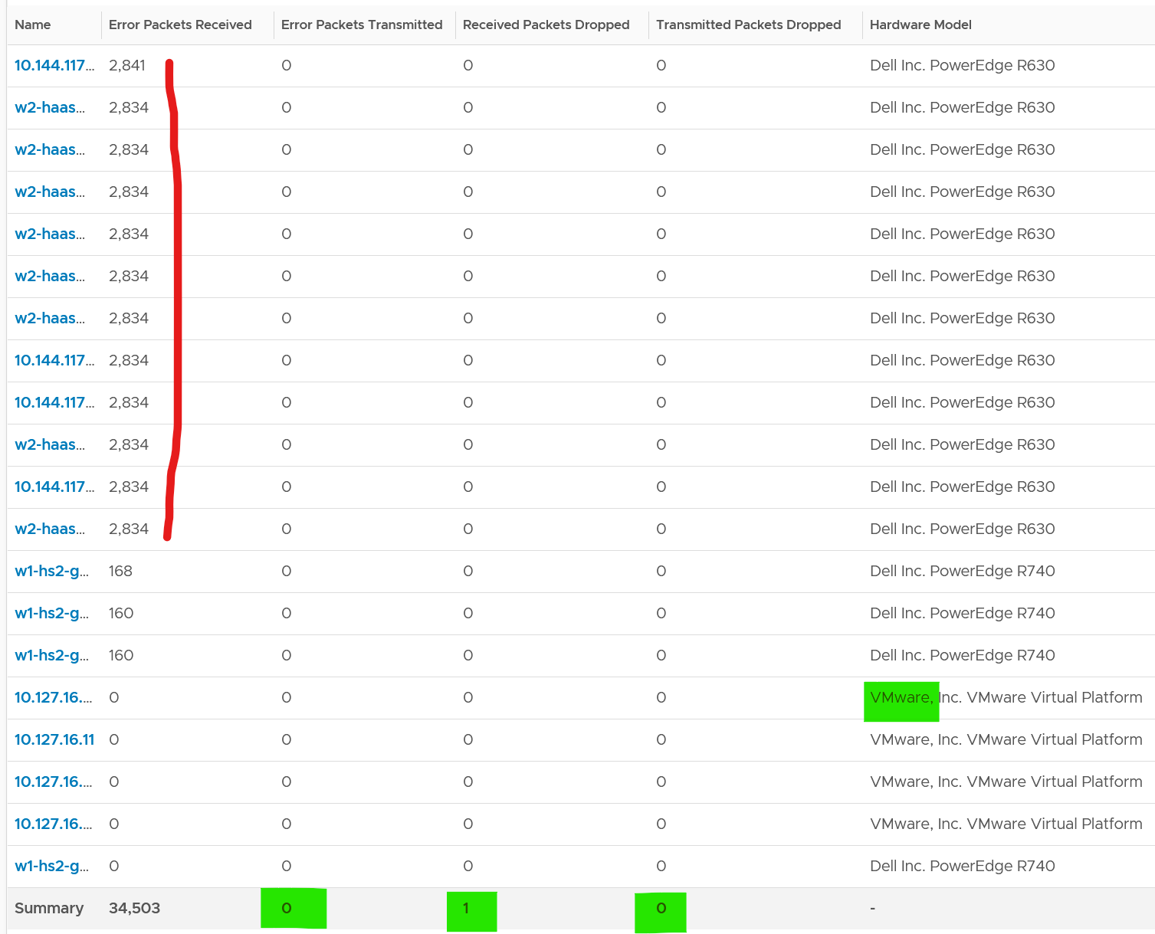

The hosts with error RX spans across different clusters, different hardware models and different ESXi build number. I can’t check if they belong to the same network.

If you see a value, drill down to see if there is any correlation with other types of packets. In the following example, I do not see any correlation

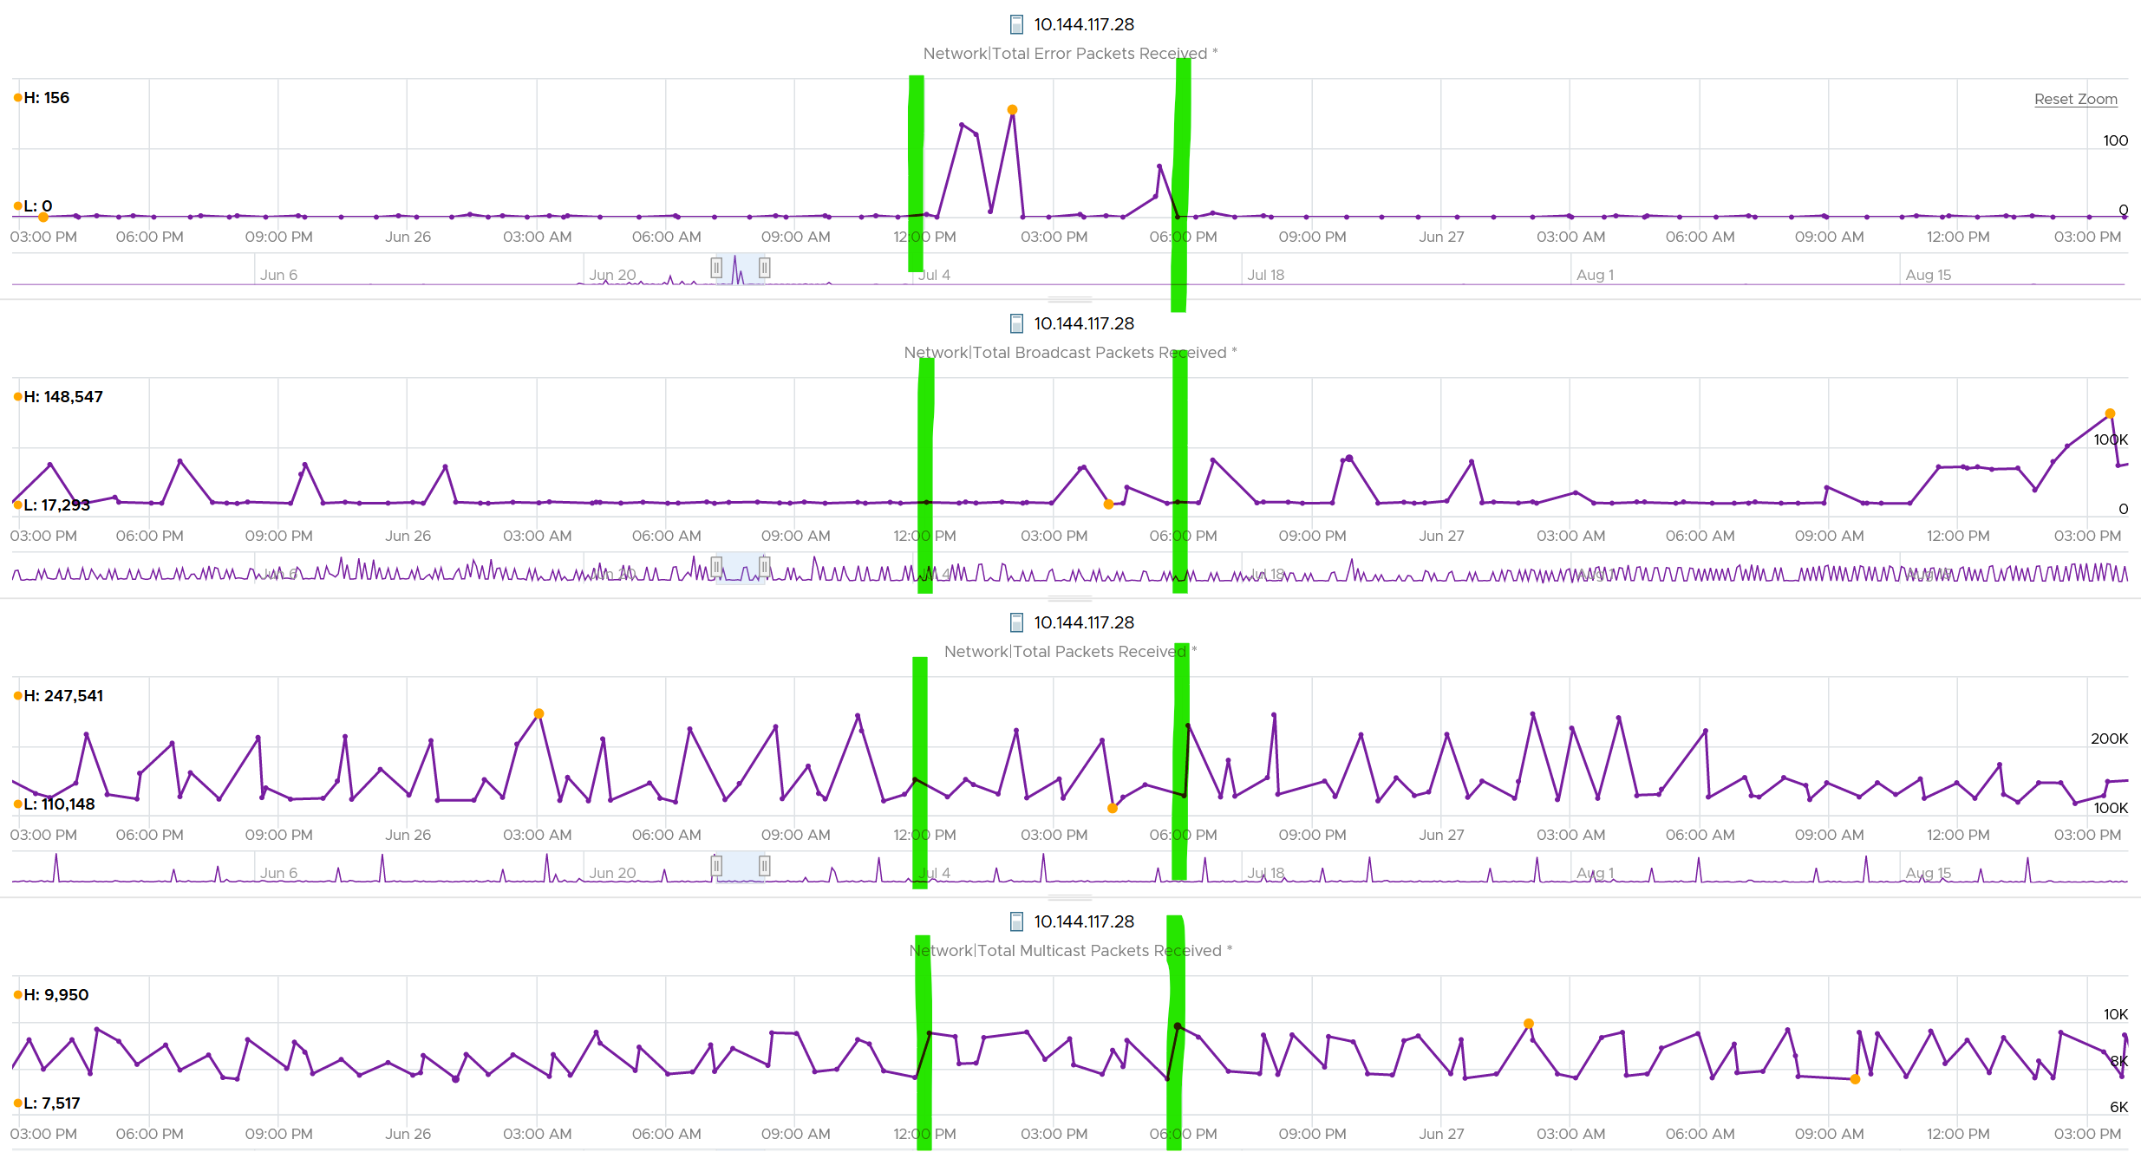

What I see though, is a lot of irregular collection. I marked with red dots some of the data collection.

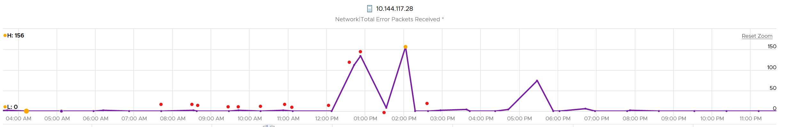

You can see they are irregular. Compare it with the Error Packet Transmit counter, which shows a regular collection.

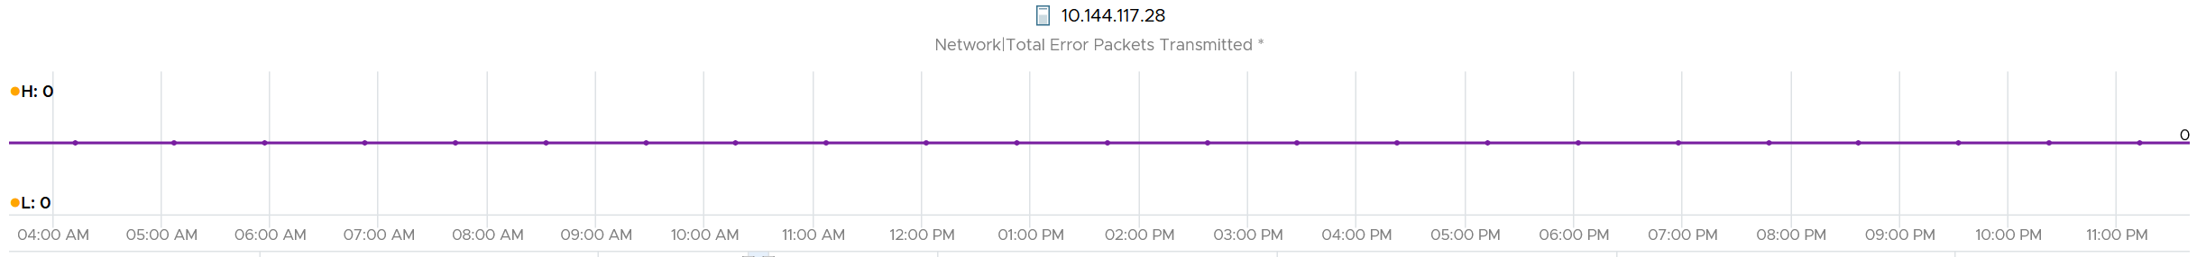

### Dropped Packet

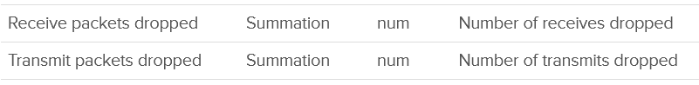

You’ve seen the dropped packet situation at VM. That’s a virtual layer, behind the ESXi. What do you expect to see at ESXi layer, as it’s physically cabled to the physical top of rack switches?

I plotted 319 production ESXi hosts, and here is what I got for Transmit. What do you think?

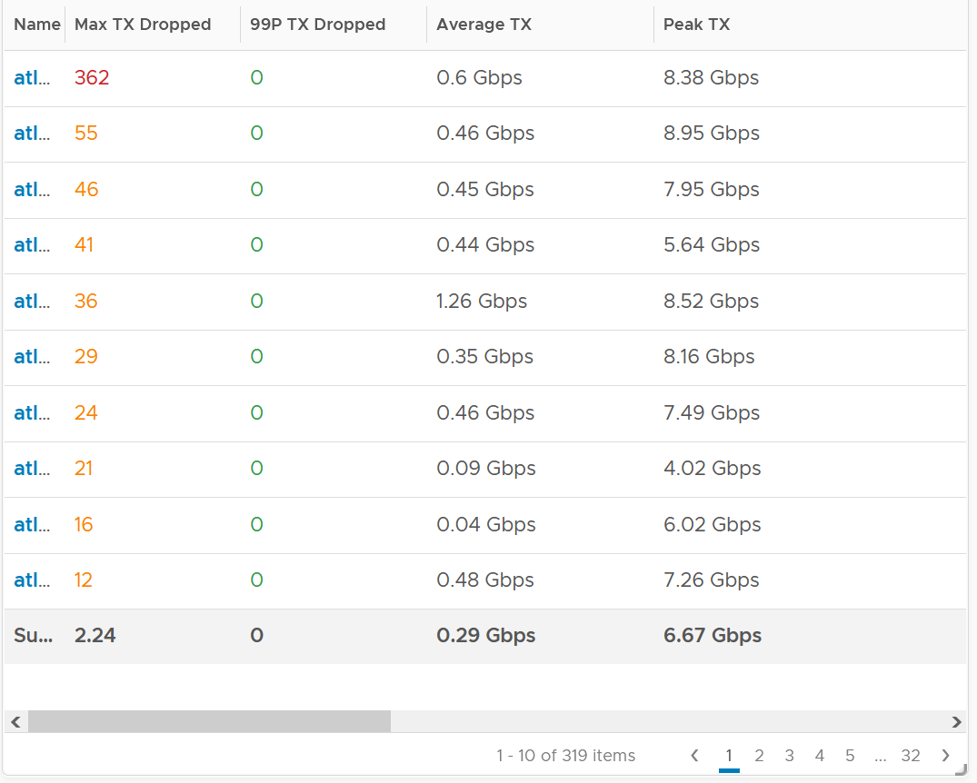

There are packet drops, although they are very minimal. Among 319 hosts, one has 362 dropped transmit packet in the last 3 months. That host was doing 0.6 Gbps on average and peaked at 8.38 Gbps.

As expected, the dropped packet rarely happened. At 99th percentile, the value is perfectly 0.

I tested with another set of ESXi hosts. Out of 123 servers, none of them has any dropped TX packet in the last 6 months. That’s in line with my expectation. However, a few of them experienced rather high dropped RX packets.

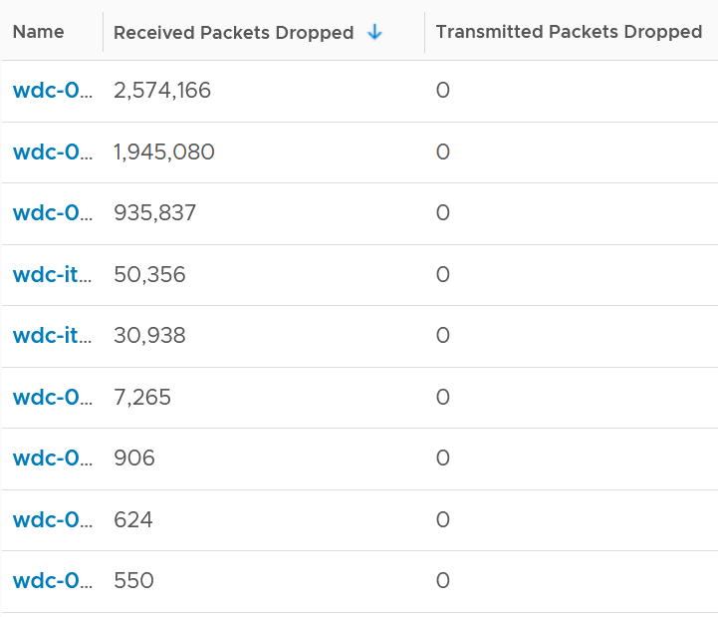

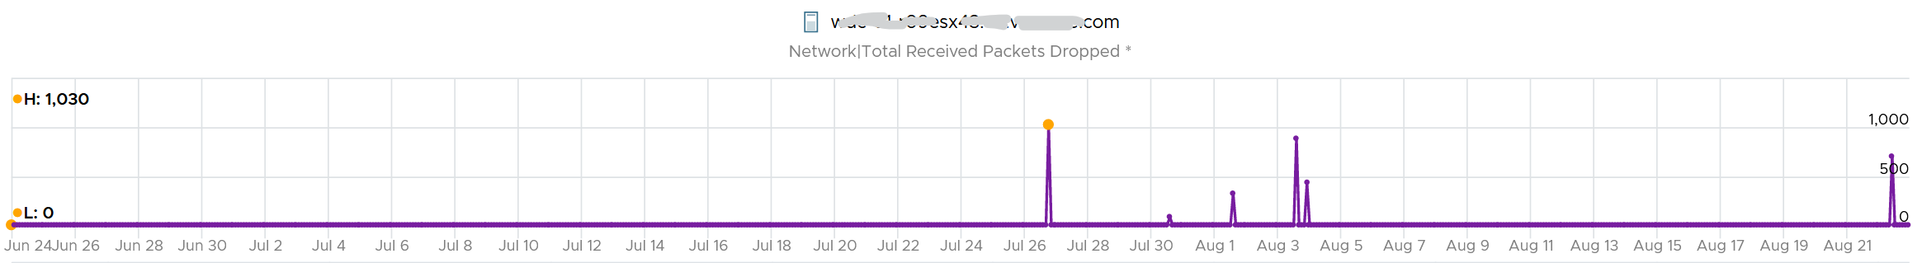

The dropped only happened since the ESXi had an increased load

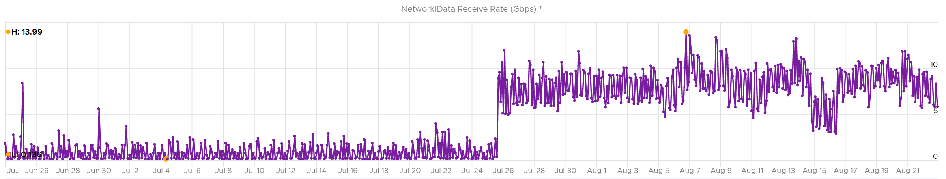

If you see something like this, you should investigate which physical NIC card is dropping packet, and which VMK interface is experiencing it.

While the number is very low, many hosts have packet drops, so my take is I should discuss with network team as I expect datacenter network should be free of dropped packets.

#### Received

What do you think you will see for Received?

Remember how VM RX is much worse than VM TX? Here is what I got:

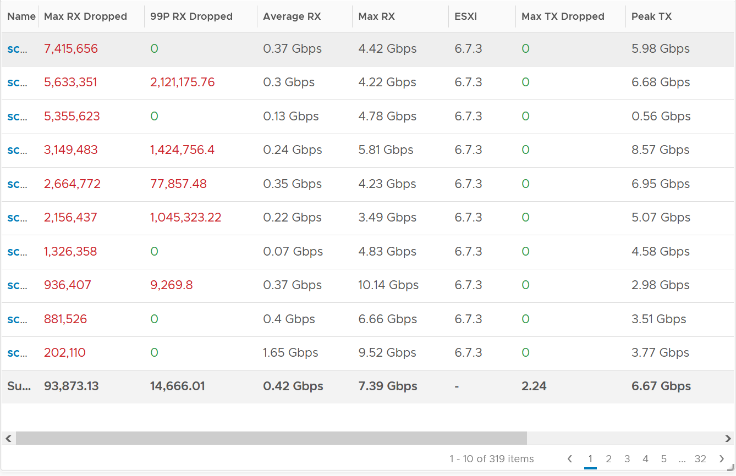

Surprisingly, the situation is the same for ESXi.

Some of them have >1 millions packet dropped in 5 minute. Within these set of ESXi, some have regular packet dropped, as the value at 99th percentile is still very high. Notice none of the ESXi is dropping any TX packet.

I plotted the 2nd ESXi from the table, as it has high value at 99th percentile. As expected, it has sustained packet dropped lasting 24 hours. I marked the highest packet drop time, as it mapped to the lowest packets received.

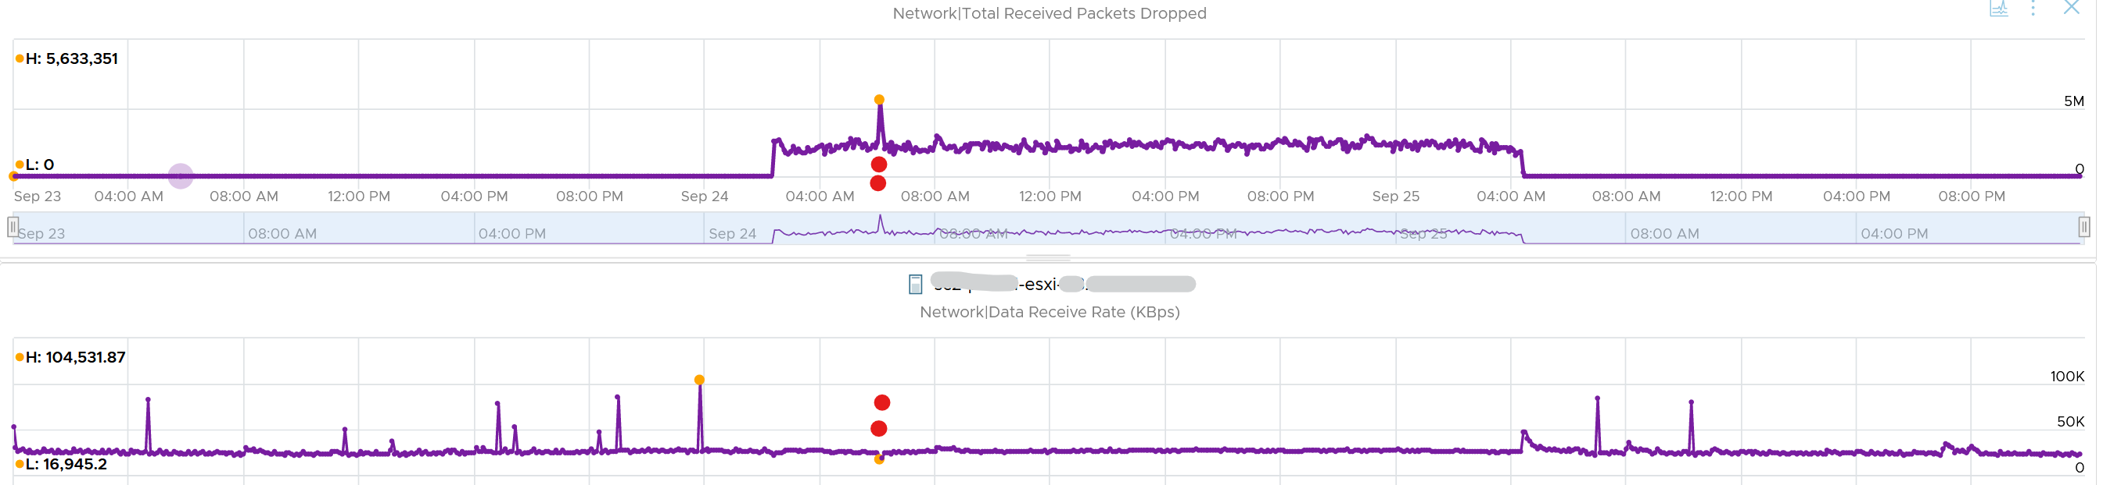

#### vsish

vsish provides more information that is not available in vSphere Client UI and vRealize Operations.

vsish -e get /net/portsets/DvsPortset-0/ports/67109026/clientStats

port client stats {

pktsTxOK:154121

bytesTxOK:63326625

droppedTx:0

pktsTsoTxOK:0

bytesTsoTxOK:0

droppedTsoTx:0

pktsSwTsoTx:0

droppedSwTsoTx:0

pktsZerocopyTxOK:45817

droppedTxExceedMTU:0

pktsRxOK:339700

bytesRxOK:257901191

droppedRx:2620 🡨 the reason will appear on the next output below

pktsSwTsoRx:0

droppedSwTsoRx:0

actions:0

uplinkRxPkts:0

clonedRxPkts:0

pksBilled:0

droppedRxDueToPageAbsent:0

droppedTxDueToPageAbsent:0

}

We saw dropped packets, so we probe deeper for the reason

vsish -e get /net/portsets/DvsPortset-0/ports/67109026/vmxnet3/rxSummary

stats of a vmxnet3 vNIC rx queue {

LRO pkts rx ok:0

LRO bytes rx ok:0

pkts rx ok:340093

bytes rx ok:257984247

unicast pkts rx ok:253678

unicast bytes rx ok:245663220

multicast pkts rx ok:42220

multicast bytes rx ok:7497292

broadcast pkts rx ok:44195

broadcast bytes rx ok:4823735

running out of buffers:2620 🡨 the reason for 2620 packets dropped

pkts receive error:0

1st ring size:512

2nd ring size:512 🡨 the ring size is on the small side. I’d say set to 2K.

# of times the 1st ring is full:354 🡨 this line shows the first ring is full 354x

# of times the 2nd ring is full:0

fail to map a rx buffer:0 🡨 other reasons look good

request to page in a buffer:0

# of times rx queue is stopped:0 🡨 other reasons look good

failed when copying into the guest buffer:0 🡨 other reasons look good

# of pkts dropped due to large hdrs:0

# of pkts dropped due to max number of SG limits:0

pkts rx via data ring ok:0

bytes rx via data ring ok:0

Whether rx burst queuing is enabled:0

current backend burst queue length:0

maximum backend burst queue length so far:0

aggregate number of times packets are requeued:0

aggregate number of times packets are dropped by PktAgingList:0

# of pkts dropped due to large inner (encap) hdrs:0

number of times packets are dropped by burst queue:0

number of times packets are dropped by rx try lock queueing:0

number of packets delivered by burst queue:0

number of packets dropped by packet steering:0

number of memory region lookup pass in Rx.:0

number of packets dropped due to pkt length exceeds vNic mtu:0

number of packets dropped due to pkt truncation:0

}

### Unusual Packets

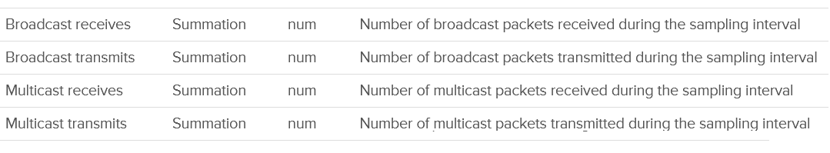

Your VM network should be mostly unicast traffic. So check that broadcast and multicast are within your expectation. Your ESXi Hosts should also have minimal broadcast and multicast packets.

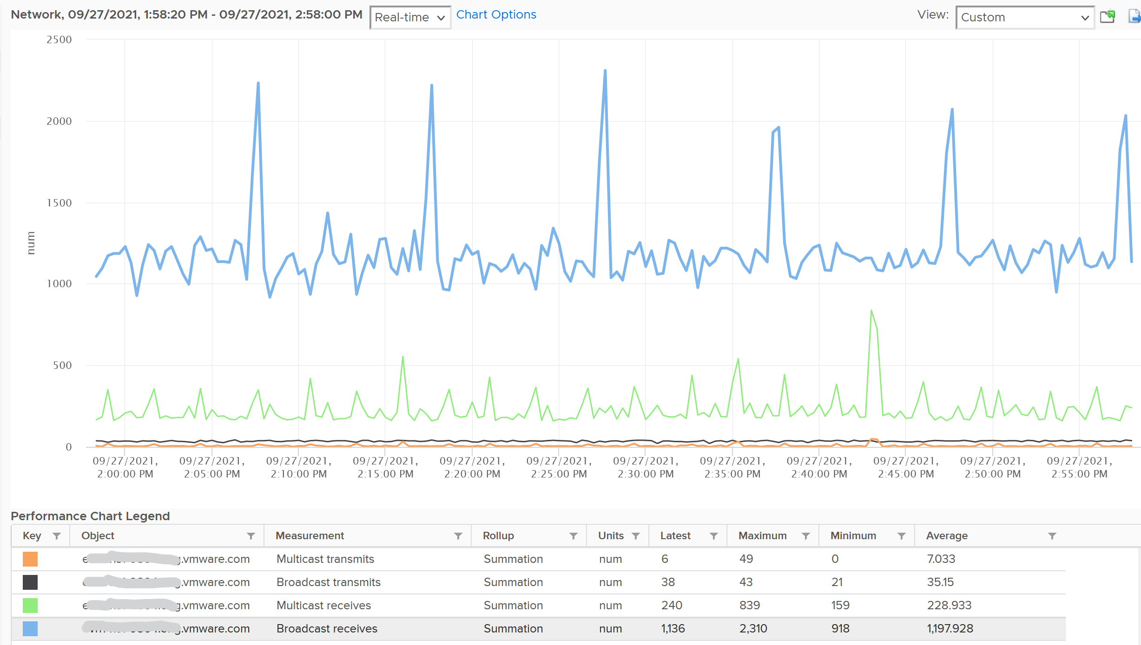

### Utilization

Remember that Storage has 2 metrics (IOPS and Throughput)? Network also has these 2 types, except the more popular one is the throughput. The PPS (packet per second) is a lot less popular although they are useful in gaining insight into your network. It can take up a significant CPU time to process high number of packets, as you can see in NSX edge VM.

The throughput (bandwidth consumption) metrics are:

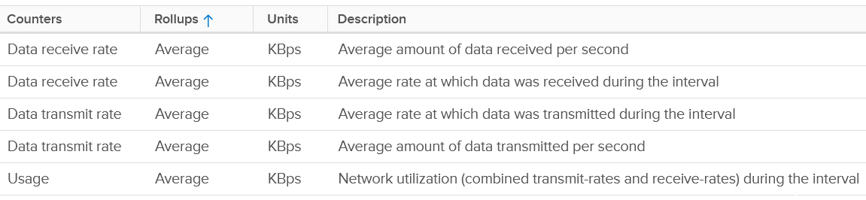

I’m unsure why there are duplicates counters.

The packet per second metrics are:

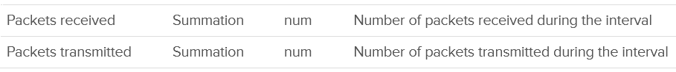

## esxtop

There are 2 levels of network due to virtualization, and their utilization logically do not match. There is virtual network and physical network. Virtual network consist of VM and VMK ports. If the traffic is just a VM to VM traffic, within the same ESXi, the packets does not reach the physical network, hence the counters do not register it.

Network traffic are grouped into 2 by their direction:

* TX for outgoing (sent) and
* RX for incoming (received).

### Contention

As usual, we check contention first. There is no network latency and packet retransmit metric.

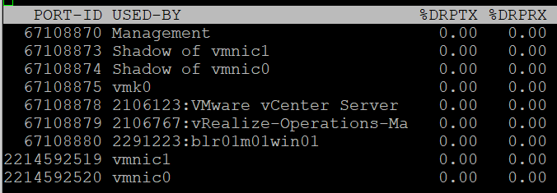

|  |  |
| --- | --- |
| %DRPTX | Percentage of Dropped Packet.  Expressed in percentage, which makes it easier as you expect this not to exceed 0.x%. In dedicated network such as vSAN and vMotion, this should be flat 0% non stop for every single ESXi.  Transmit and Receive have different nature. A high drop in transmit means your physical NIC card or uplink switch is unable to cope. A high drop in receive means the your ESXi or VM may not have enough CPU to process the packet, or the ring buffer size is too small. |
| %DRPRX |

### Utilization

The virtual network does not have the limit that physical network does, if the traffic remains in the box. This makes it harder to use this metric as the 100% is not statically defined. So instead of just monitoring the throughput metric, you should also check the packet per second metric.

#### Non-Unicast Packets

Check the broadcast and multicast packets first, as they should be an exception. Using vRealize Operations, you can see which VMs send the most broadcast or multicast at any given period.

|  |  |
| --- | --- |
| PKTTXMUL/s | Number of multicast packets transmitted or received per second.  Read the string PKTTXMUL as Pkt Tx Mul, which is Packet TX Multicast. Same with PKTRXMUL. |
| PKTRXMUL/s |
| PKTTXBRD/s | Number of broadcast packets transmitted or received per second.  Read the string PKTTXBRD as Pkt Tx Brd, which is Packet TX Broadcast. Same with PKTRXBRD |
| PKTRXBRD/s |

#### Utilization

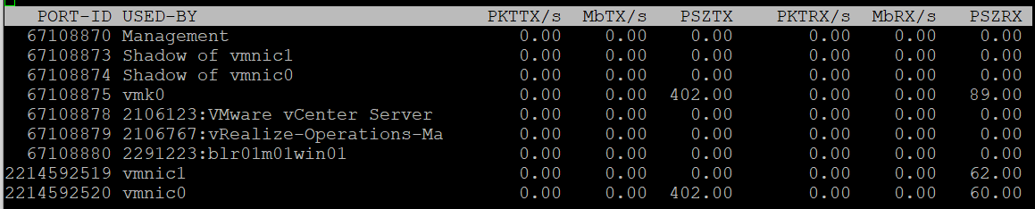

|  |  |
| --- | --- |
| PKTTX/s | This is the total packets, so it includes multicast packet and broadcast packet.  Multicast packet and broadcast packet are listed separately. This is handy as they are supposed to low most of the time. |
| PKTRX/s |
| MbTX/s | This is measured in bit, unlike vCenter Client UI which shows in byte.  Packet length is typically measured in bytes. A standard packet is 1500 bytes, so a 10 Gb NIC would theoretically max out at 833,333 packets on each direction.  Compare this with your ESXi physical network card. |
| MbRX/s |
| PSZTX | This is convenient. If you see a number far lower than 1500, it’s worth discussing with network team. |
| PSZRX |

There is another metric **ACTN/s, which is the n**umber of actions per second. The actions here are VMkernel actions. It is an internal counter used, not relevant for day to day operations.

### Configuration

This panel mixes physical and virtual. For virtual, it shows both the VMkernel network and VM network. I find it easier to use the information in vSphere Client.

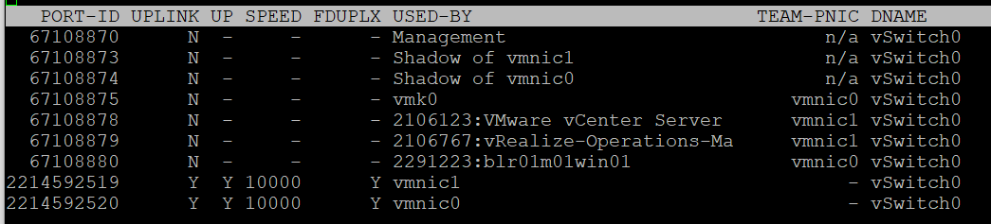

|  |  |
| --- | --- |
| PORT-ID | Virtual network device port ID. |
| UPLINK | Y means that the corresponding port is an uplink. N means it is not. The physical NIC cards (vmnic0, vmnic1, etc.) serve as the uplink |
| UP | Y means that the corresponding link is up. N means it is not. |
| SPEED | Link speed in Megabits per second. |
| FDUPLX | Y means the corresponding link is operating at full duplex. N means it is not, which is a problem. |
| USED-BY | Virtual network device port user. |
| DNAME | Virtual network device name. |

The metric DTYP (Virtual network device type, where H means Hub and S means switch) does not seem to be available anymore.

vSphere Client separates the components. You can see the virtual switches, VMkernel network and physical cards. The level of details is more comprehensive.

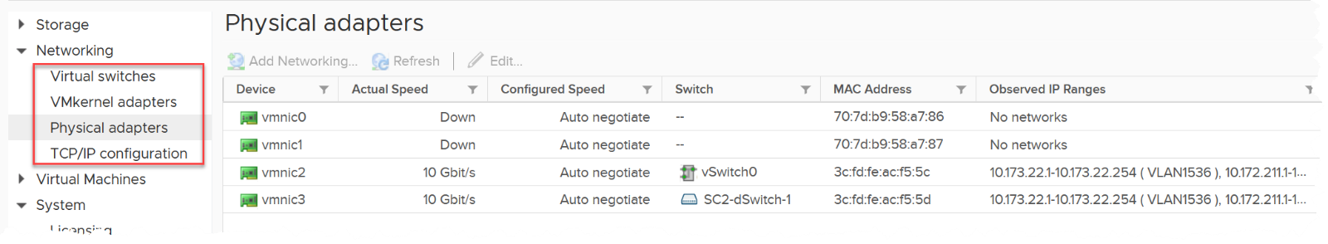

1. Technically speaking, mapping usage to active for VM and consumed for ESXi makes sense, due to the two-level memory hierarchy in virtualization. At the VM level, we use active as it shows what the VM is actually consuming (related to performance). At the host and cluster levels, we use consumed because it is related to what the VM claimed (related to capacity management). This confusion has resulted in customers buying more RAM than what they need.
2. I like the name [The USE Method](https://www.brendangregg.com/usemethod.html) by Brendan and [The RED Method](https://www.weave.works/blog/the-red-method-key-metrics-for-microservices-architecture/) by Weave Works. Maybe I should call my method the 3C Method?
3. In reality, the CPU frequency varies on a per core basis. It also varies over time. For ease of accounting, we assume it’s static for entire box.
4. Pronounced as V S I S H, not vSish. It stands for VMkernel Sys Info Shell
5. If you suspect that I can’t create professional graphic like this, you are right! That’s done by [Abhishek Chouksey](https://www.linkedin.com/in/abhishek-chouksey-75615161/)
6. Understanding how an OS works is paramount and well worth it. Here is a [3.5 hour lecture](https://www.youtube.com/watch?v=mXw9ruZaxzQ) by
7. Designing an OS for multiple hardware classes is hard. Notice Apple MacOS, iPhone OS, and iPad OS. Google has Android and ChromeOS.
8. Asked to me by Valentin Bondzio in one of the VMworld where we got to meet. Those were the days!
9. Based on [this KB article](https://kb.vmware.com/s/article/2000058?lang=en_US), snapshot increases the read operations as every snapshot has to read to ensure you’re fetching the correct data. Write is not impacted as you simply write a new block and not updating existing one.
10. I use 20 second as it’s a familiar number. That’s what you see in the real time chart in vCenter client, and 20000 ms is often used as the 100% when converting millisecond unit to percentage.
11. 16 Source: VMworld presentation HCP2583 by Richard Lu and Qasim Ali
12. Provided by Valentin Bondzio
13. Other documents use the term Guest Physical Page and Machine Page. I find it unnecessarily confusing, so I just call it VM pages and ESXi pages. IMHO, physical is something you can hold in your hand.
14. The name of this Internet giant is irrelevant for this purpose, as it could have happened to anyone. It happens more often on smaller companies